

Plant Guide

# Yellow Beeplant

## Cleome lutea Hook.

Plant Symbol = CLLU2

#### Contributed by: NRCS Plant Materials Center, Aberdeen, ID

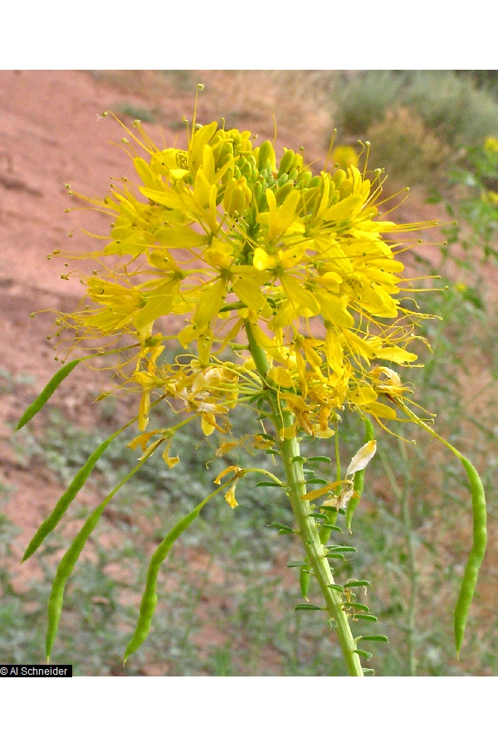***Yellow beeplant. Photo by Al Schneider @ USDA-NRCS PLANTS Database.***

### Alternate Names

### Beeflower, yellow spiderflower; Nevada bee plant

*Peritoma lutea*

### Uses

### *Pollinator:* Yellow beeplant is a valuable native forage species for bees wasps and butterflies. Over 140 species of native bees have been observed foraging for nectar or pollen on yellow beeplant in southern Utah (Cane, 2008). Yellow beeplant is an annual forb which could provide food to insects in the first growing season of a range seeding (Ogle and others, 2011a). This available food source could sustain pollinators until perennial forb species produce flowers, typically in the second growing season.

*Range revegetation:* Yellow beeplant has potential for use in range seedings throughout the arid to semi-arid regions of the Intermountain West. It provides little to no forage to large mammals, and its sparse stems provide limited cover to small vertebrates. The seeds are likely eaten by birds and rodents. Its primary value is as a pollinator food source.

*Ethnobotanical:* Yellow beeplant was used in ceremonial medicine by the Navajo and Kayenta peoples. It was also used as a dermatological aid for ant bites (Moerman, 1998). Some Plateau Indian tribes used the stems and flowers to create an infusion for a treatment for cold (Hunn, 1990).

### Status

Consult the PLANTS Web site and your State Department of Natural Resources for this plant’s current status (e.g., threatened or endangered species, state noxious status, and wetland indicator values).

### Description

*General*: Formerly placed in the Caper family (Capparaceae) but now considered an early offshoot of the cabbage family (Brassicaceae). Yellow beeplant is a tap rooted annual forb. It has one to several branched or simple erect stems reaching 0.3 to 1.5 m (60 in) in height. The leaves are palmate with 3 to 5 oblong to lanceolate leaflets, each leaflet 1 to 5 cm (0.4 to 2.0 in) long and 2 to 10 mm (0.08 to 0.4 in) wide. The inflorescence is a terminal indeterminate raceme. The flowers are similar to those found in the mustard family (Brassicaceae). They have four petals, four sepals, 6 stamens and the fruit is a two-valved silique. The petals are yellow, approximately 6 mm (0.25 in) long (Spellenberg, 1994). The stamens, unlike those in the mustard family, are long and greatly exerted from the flower. The fruit also differs from a mustard fruit in that the pod sits atop a 6 to 12 mm (0.25 to 0.5 in) long stalk or stipe (Welsh and others 2003). The pod is 1 to 4 cm (0.4 to 1.6 in) long and bears approximately 8, 2 to 4 mm (0.08 to 0.16 in) diameter seeds (Cane, 2008). Seed counts range from 150,000 to 220,000 seeds/kg (70,000 to 100,000 seeds/lb) (Cane, 2008; USDA-NRCS, 2011).

Yellow beeplant plants produced two types of flowers, hermaphroditic and staminate (Cane, 2008). The staminate flowers begin as hermaphroditic buds, but the pistil fails to completely form. Racemes alternate between staminate and hermaphroditic flower production (Murneek, 1937). When the raceme is laden with developing fruit, the plant switches to staminate flower production. This allows the plant to produce fruit indeterminately throughout the blooming period (Cane, 2008).

Yellow beeplant is self-fertile. The stamens coil inward in the latter part of the day causing the anthers and pollen to come in contact with the stigma (Cane, 2008).

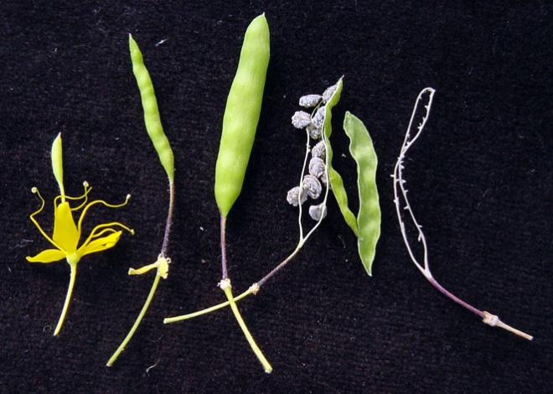

***Flower, fruit and seed of yellow beeplant. Photo by Jim Cane, USDA ARS, Logan, Utah***

*Distribution*: Yellow beeplant is known to occur in arid to semi-arid regions from the central Great Plains to Washington and south to California and New Mexico. For current distribution, consult the Plant Profile page for this species on the PLANTS Web site.

*Habitat*: Yellow beeplant grows in warm and cold desert shrub communities in desert to semi-desert plains and valleys (Welsh and others, 2003). It can be found growing among or near shadscale, sagebrush, horsebrush pinyon-juniper and black greasewood plant communities. It is often found in disturbed areas or areas formerly filled with water (Spellenberg, 1994). The plants reseed readily and often form large colonies in recently disturbed areas. Its ability to self pollinate, allows populations to increase in disturbed areas that may have sparse native pollinators (Cane, 2008).

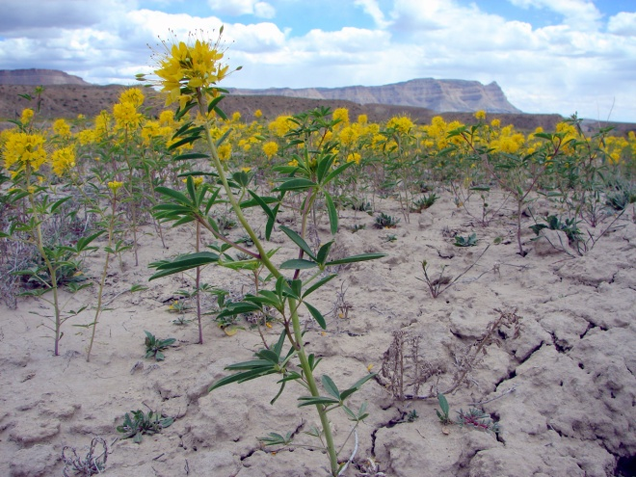

***A yellow beeplant population in its native habitat. Photo by Jim Cane, USDA ARS, Logan, Utah***

**Adaptation**

Yellow beeplant is adapted to fine to medium textured soils in the 20 to 45 cm (8 to 18 in) precipitation zone (USDA-NRCS, 2011). It tolerates a pH range of approximately 6.0 to 8.0 (USDA-NRCS, 2011). This species is not shade tolerant and prefers open, disturbed sites with well-drained soil.

### Establishment

Yellow beeplant should be planted in late fall to allow for natural stratification. Yellow beeplant has been most successfully established in areas where winter soils are moist. Fall plantings have been successful in Logan, Utah where soils remain wet during most of the winter. No germination was observed in field plantings in Worland, Wyoming, where dry soils prevail during the winter. It should be seeded with a drill or broadcast into a weed-free seed bed at a depth of 3 to 6 mm (0.125 to 0.25 in). The full stand seeding rate is 11 kg pure live seed (PLS) per ha (10 lbs PLS per acre). When planted in a mixture, the seeding rate of yellow beeplant should be adjusted to reflect the desired proportion of the mix.

### Management

Yellow beeplant should be used as a minor component of restoration seed mixtures. Management strategies should be based on the key species in the established plant community. Grazing should be deferred on seeded lands for at least two growing seasons to allow for full stand establishment (Ogle and others, 2011b).

Yellow beeplant is a capable colonizer of disturbed areas. The plants readily reseed and produce volunteers. In disturbed or burned areas with limited pollinators, the plants can self-pollinate and increase in numbers.

**Pests and Potential Problems**

Powdery mildew (*Leveillula taurica*) has been observed on yellow beeplant. Western cabbage flea beetles (Phyllotreta cruciferae) have been observed causing significant damage to yellow beeplant foliage.

### Environmental Concerns

Yellow beeplant is native to western North America. It will spread under favorable conditions but does not pose any environmental concern to native plant communities.

### Seed and Plant Production

### Yellow beeplant seed requires a cold stratification or vernalization period to germinate (B&T World Seed, 2011). Seed should be stratified in lightly moistened peat or sand at 4 to 5° C (39 to 41° F) for 30 to 190 days. Stratified seed will germinate in 10 to 14 days after planting under greenhouse conditions.

### Although yellow beeplant is self-fertile, pollinators are required for maximum seed production. Plants with access to pollinators produced two to three times more fruit than self-pollinating plants (Cane, 2008). Native bees are not necessary for pollination. Commercially managed generalist bee species such as European honeybee (*Apis mellifera*) and alfalfa leaf-cutting bees (*Megachile rotundata*) can be utilized for pollination of seed production fields.

Fruit and seed of yellow beeplant ripen indeterminately. This poses difficulties in harvesting seed for maximum yield. Yields of mature seed can be increased by leaving swathed plants to dry for a week before harvesting seed. Seed can also be harvested by hand or by using a vacuum-type harvester.

### Cultivars, Improved, and Selected Materials (and area of origin)

### Common wildland collected seed is available through commercial sources. There are currently no commercial releases of yellow beeplant.

### References

B & T World Seeds. 2011. URL: b-and-t-world-seeds.com. (accessed Nov. 15, 2011). Aigues-Vives, France.

Cane, J. 2008. Breeding biologies, seed production and species-rich bee guilds of *Cleome lutea* and *Cleome serrulata* (Cleomaceae). Plant Species Biology 23: 152-158.

Holmgren, N.H., Holmgren, P.K. and A. Cronquist. 2005. Intermountain Flora: Vascular plants of the Intermountain West. New York: The New York Botanical Garden. 488 p.

Hunn, E.S. 1990. Nch’i-Wana, “The Big River”: Mid-Columbia Indians and Their Land. University of Washington Press. 352p.

Moerman, D.E. 1998. Native American Ethnobotany. Timber Press. 927 p.

Murneek, A.E. 1937. The physiological basis of intermittent sterility with special reference to the spider flower. University of Missouri Agricultural Experiment Station Research Bulletin 106: 1-37.

Ogle, D., Tilley, D., Cane, J., St. John, L., Fullen, K., Stannard, M., and P. Pavek. 2011. Technical Note 2A: Plants for pollinators in the Intermountain West. USDA-NRCS. Boise, ID. ID-TN2A. 40p.

Ogle, D., St. John, L.,. Stannard, M. and L. Holzworth. 2011. Technical Note 24: Conservation plant species for the Intermountain West. USDA-NRCS, Boise, ID-Salt Lake City, UT-Spokane, WA. ID-TN 24. 57p.

Spellenberg, , R. 1994. National Audubon Society Field Guide to North American Wildflowers, Western Region. Alfred A. Knopf, Inc. New York, NY.862 p.

[USDA NRCS] USDA Natural Resources Conservation Service. 2011. The PLANTS Database. URL: http://plants.usda.gov (accessed Nov. 8, 2011). Baton Rouge (LA): National Plant Data Center.

Welsh, S.L., Atwood, N.D. Goodrich, S., and L.C. Higgins. 2003. A Utah Flora. Third Edition, revised. Brigham Young University, Provo, UT.

**Prepared By**

Derek Tilley, USDA NRCS Plant Materials Center, Aberdeen, Idaho

Jim Cane. USDA-ARS. Bee Biology and Systematics Laboratory. Logan, Utah.

Loren St. John, USDA NRCS Plant Materials Center, Aberdeen, Idaho

Dan Ogle, USDA NRCS, Boise, Idaho

Nancy Shaw. USDA-FS. Rocky Mountain Research Station. Boise, Idaho.

#### **Citation**

Tilley, D., Cane, J., St. John, L., Ogle, D. and N. Shaw. 2012. Plant guide for yellow beeplant (*Cleome lutea*). USDA Natural Resources Conservation Service. Aberdeen, ID.

Published January 2012

Edited: 16Nov11djt; 17Nov1ls;18Nov11jc

For more information about this and other plants, please contact your local NRCS field office or Conservation District at <http://www.nrcs.usda.gov/> and visit the PLANTS Web site at <http://plants.usda.gov/> or the Plant Materials Program Web site <http://plant-materials.nrcs.usda.gov>.

PLANTS is not responsible for the content or availability of other Web sites.

**USDA IS AN EQUAL OPPORTUNITY PROVIDER AND EMPLOYER**