|  |
| --- |
| american wild carrot |
| *Daucus pusillus* Michx. |
| Plant Symbol = DAPU3 |

# *Contributed By: USDA NRCS Nacogdoches (TX) Technical Office and the National Plant Data Center*

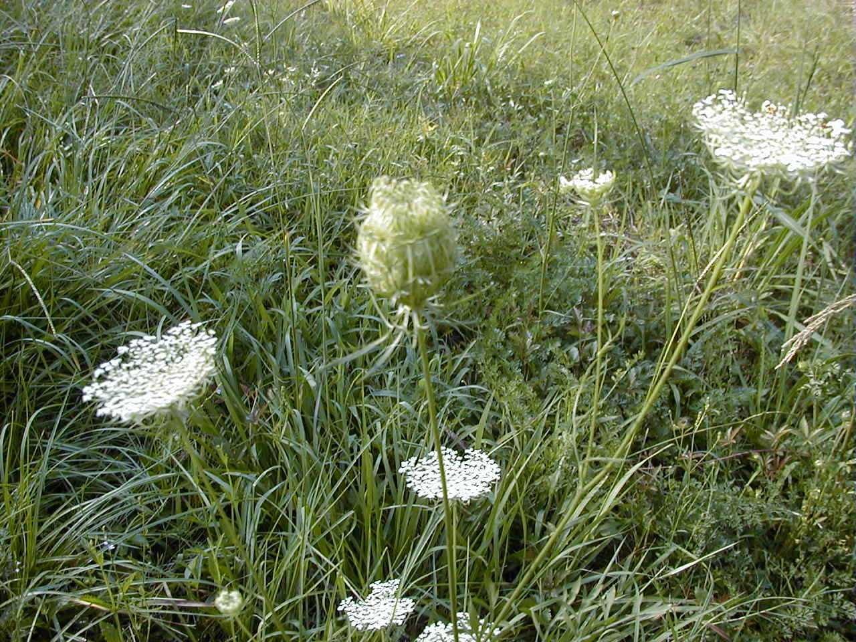

© Lee Davis

USDA, NRCS, Nacogdoches Technical Office

## Alternate Names

Rattlesnakeweed, southwestern carrot, seedticks, rattlesnake-weed, yerba del vibora

## Uses

*Ethnobotanic:* Native Americans ate the roots raw and cooked (Epple 1995).

*Medicinal:* In California this species is called rattlesnake weed, because the herbage is reputed to be efficacious in the treatment of snakebites (Moldenke 1949). A poultice of the chewed plant has been applied to snakebites (Moerman 1998). A decoction has been used to treat colds, itches and fevers (Ibid.).

## Status

Please consult the PLANTS Web site and your State Department of Natural Resources for this plant’s current status (e.g. threatened or endangered species, state noxious status, and wetland indicator values).

**Description***General*: Celery Family (Apiaceae). *Daucus pusillus* is a native annual found most commonly during the early-mid part of the growing season. In most parts of Texas, this species has gone to seed by mid-summer. Rattlesnake-weed resemble their cultivated relative, the garden carrot. The stem is normally slender, from 2-4 feet in height and unbranched or only a single weak branch as compared to the introduced *Daucus carota,* which is sometimes heavily branched and more robust. The flower is a white umbel. Upon maturity, the flower cluster (umbel) closes to form a cup or bird’s nest. The leaves are pinnately compound and finely cut. Leaflets are deeply serrated (saw-toothed). The seed of *Daucus* *carota* have fine hairs rather than the stiff bristles common to *Daucus* *pusillus*. Another distinguishing characteristic between the two species is the central flower of each individual umbellet is rose or purple in *Daucus carota* rather than being white throughout as found in *Daucus pusillus.*

American wild carrot is self-fertile. The flowers are hermaphrodite, having both male and female organs, and are pollinated by flies and bees.

A similar species is water parsnip (*Sium suave),* which has a corrugated main stem and leaves only once compound. Bishop’s weed *(Ammi majus*) andwater hemlock (*Cicuta maculata*)have white umbels, but the leaflets are not deeply serrated or carrot like.

## Distribution

*Daucus (pusillus or carota*) is likely the most common and widespread plant with white umbels growing along Texas’ roadsides. It is known from the U.S. West Coast and the southern half of the U.S. For current distribution, please consult the Plant Profile page for this species on the PLANTS Web site.

**Establishment***Adaptation*: It is very common along road right-of-ways. It can also become quite dominant in some pastures and prairies. Rattlesnake weed prefers moist, loamy sites, but not wet sites. The exotic, *Daucus carota*, tolerates a much broader site in Texas, ranging from blackland to rock outcrops.

American wild carrot requires moist, well-drained soil and prefers sandy, loamy and clay soils. It grows best in a sunny position and cannot tolerate shade. This species occurs in rocky prairies, openings in woodland, and rocky open, frequently limestone, glades, and edges of bluff escarpments, sometimes along roadsides and railroads (Steyermark 1963).

*Propagation by Seed*: American wild carrot seeds are best sown in the autumn. Always aim to sow thinly and evenly to permit adequate room for the seedlings to grow and develop freely (Heuser 1997). The seeds will germinate better if they are cold stratified.

## Cultivars, Improved and Selected Materials (and area of origin)

These plant materials are readily available from commercial sources. Contact your local Natural Resources Conservation Service (formerly Soil Conservation Service) office for more information. Look in the phone book under ”United States Government.” The Natural Resources Conservation Service will be listed under the subheading “Department of Agriculture.”

**References**Abrams, L. 1944. *Illustrated flora of the Pacific States:Washington, Oregon and California.* Vol III. Stanford University Press, Stanford, California.

Davis, L. 2000. *Texas plant fact sheet: Daucus pusillus*. USDA, NRCS, Nacogdoches Technical Office #2, Nacogdoches, Texas.

Epple, A.O. 1995. *A field guide to the plants of Arizona*. Falcon Press, Helena, Montana.

Heuser, C.W. 1997. *The complete book of plant propagation*. The Taunton Press, Newtown, Connecticut.

Moerman, D. 1998. *Native American ethnobotany*. Timber Press, Portland, Oregon.

Moldenke, H.N. 1949. *American wildflowers*. D. Van Nostrand Company, Inc., New York, New York.

Muenscher, W.C. 1955. *Weeds*. 2nd ed. Cornell University Press, Ithaca, New York.

Munz, P.A. & Keck, D.D. 1965. *A California flora*. University of California Press, Los Angeles, California.

Radford, A.E., H.E. Ahles, & C. Bell 1968. *Manual of the vascular flora of the Carolinas*. The University of North Carolina Press, Chapel Hill, North Carolina.

Steyermark, J.A. 1963. *Flora of Missouri*. The Iowa State University Press, Ames, Iowa.

USDA, NRCS 2000. *The PLANTS database*. <http://plants.usda.gov>. 001206. National Plant Data Center, Baton Rouge, Louisiana.

## Prepared By

# *Lee Davis*

USDA, NRCS, Nacogdoches Technical Office #2, Nacogdoches, Texas

# *Lincoln Moore*

USDA, NRCS, National Plant Data Center, Baton Rouge, Louisiana

## Species Coordinator

# *Lee Davis*

USDA, NRCS, Nacogdoches Technical Office #2, Nacogdoches, Texas

Edited: 29jan02 jsp; 24feb03 ahv; 06jun06 jsp

For more information about this and other plants, please contact your local NRCS field office or Conservation District, and visit the PLANTS Web site<<http://plants.usda.gov>> or the Plant Materials Program Web site <<http://Plant-Materials.nrcs.usda.gov>>

*The U.S. Department of Agriculture (USDA) prohibits discrimination in all its programs and activities on the basis of race, color, national origin, sex, religion, age, disability, political beliefs, sexual orientation, and marital or family status. (Not all prohibited bases apply to all programs.) Persons with disabilities who require alternative means for communication of program information (Braille, large print, audiotape, etc.) should contact USDA's* [*TARGET Center*](http://www.usda.gov/oo/target.htm) *at 202-720-2600 (voice and TDD).*

*To file a complaint of discrimination write USDA, Director, Office of Civil Rights, Room 326-W, Whitten Building, 14th and Independence Avenue, SW, Washington, DC 20250-9410 or call 202-720-5964 (voice or TDD). USDA is an equal opportunity provider and employer.*

*Read about* [*Civil Rights at the Natural Resources Convervation Service*](http://www.nrcs.usda.gov/about/civilrights/)*.*