

Plant Guide

# Purple Prairie Clover

## Dalea purpurea Vent.

Plant Symbol = DAPU5

Contributed by: USDA NRCS Plant Materials Center, Manhattan, Kansas

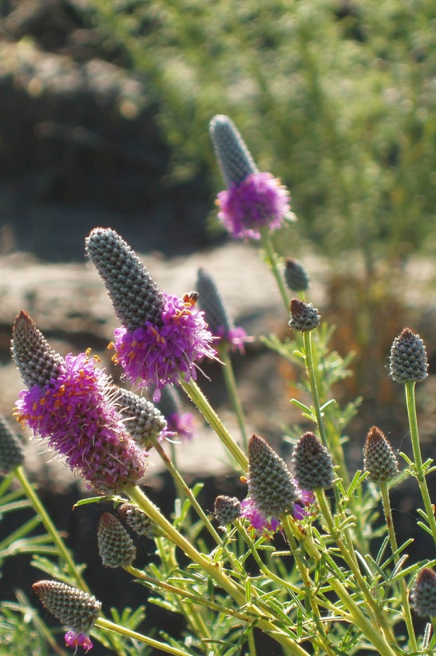

R. Alan Shadow, East Texas PMC, Nacogdoches, TX

### Alternate Names

*Common Alternate Names:* violet prairie clover, red tassel flower, thimbleweed, and wanahcha (Lakota)

### Uses

This leguminous forb produces excellent forage for livestock and wildlife. It is high in protein and highly palatable, although it may cause bloat. (Stubbedieck and Conard 1989) This species will decrease and disappear under persistent overgrazing. It is an important legume in native grasslands because of nitrogen fixation. Purple prairie clover is used in seed mixtures for re-vegetation and prairie restoration. It is a potentially useful plant for roadside and rest area beautification, park plantings and recreational garden natural area plantings. This species is also used in mixtures on dam face structures and critical area plantings. Native Americans ate fresh and boiledleaves of purple prairie clover. Bruised leaves were steeped in water and applied to fresh, open wounds. Ponca Indians chewed the roots for their pleasant flavor and made tea from the leaves. Pawnee Indians used the bundled stems to make brooms. (Stubbendieck et al. 1989).

### Status

Please consult the PLANTS Web site and your State Department of Natural Resources for this plant’s current status (e.g., threatened or endangered species, state noxious status, and wetland indicator values).

### Description

*General*: The Legume family (Fabaceae). Purple prairie clover is a native, warm season, herbaceous, perennial, leguminous forb. The plant has an erect type growth habit that typically grows to a height of

30 to 90 cm. It can be identified by its alternate, pinnately compound leaves and multiple stems which arise annually from a woody caudex. The inflorescence is a terminal spike (2-4 cm), numerous, many-flowered and cylindrical in shape. The flower petals which are rose-purple with projecting gold-orange anthers are small and simple compared to many pea shaped flowers of typical legumes. The calyx is densely villous. Flower petals are 6 mm long, 4 of the petals and the five stamens are joined near the calyx tip and the banner petal is separate. The first flowers to bloom are located at the bottom of the spike and the circle of flowers moves upward along the spike as new buds open and old flowers fade. Pollination is accomplished by a host of native insects ranging from bumblebees to beetles (Art, 1991). The fruit is a one seeded legume pod enclosed by the persistent calyx which is 2-2.5 mm long. The legume seed is yellowish-green to brown and is 1.5-2.0 mm long and punctuate. Purple prairie clover flowers the last of May to September in the central Great Plains. It flowers some what later (July-August) in the northern Great Plains. This plant is deep rooted with a 2.0 meter tap root. It also has three to seven lateral roots within the upper 30 cm of tap root which extend horizontally up to 45 cm before turning downward (Weaver, 1954).

*Distribution*: For current distribution, please consult the Plant Profile page for this species on the PLANTS Web site. Purple prairie clover ranges from Indiana to Saskatchewan and Montana, south to Tennessee, Arkansas, Texas and New Mexico. It is also found in Alabama and has been introduced east into New York State.

*Habitat*: Purple prairie clover occurs in prairies, rocky open glades, along railroad tracks, and rocky or open woods.

**Adaptation**

This species grows on prairies, plains, and hills

in soils ranging from clay loams to loamy sands. Found growing more vigorously on well drained sites and moderately alkaline calcareous soils. Thrives in 40 to 50 cm precipitation zones, but found in suitable sites in the 30 to 38 cm rainfall zones. Purple prairie clover is moderately drought tolerant, has fair fire tolerance in its dormant state, and fairly shade tolerant and medium in competitiveness. Local ecotypes are fairly winter hardy and plants have been found up to about 2,200 meters in elevation in the Rocky Mountains. Purple prairie clover is normally found growing in association with native warm-season grasses such as *Sorghastrum nutans, Bouteloua curtipendula, Andropogon gerardii, Schizachyrium scoparium,* and *Panicum virgatum.*

### Establishment

This species is easily established from seed and the seed is commercially available through plant vendors. Germination of this species is rather poor without some type of scarification procedure. Mechanical scarification using sandpaper or a laboratory scarifier is acceptable. Purple prairie clover should be planted on a prepared, weed free, firm seedbed. The seedbed should be firm enough to allow planting at a 6 to 12 mm depth. Seed should be inoculated with the proper *Rhizobium* (Nitragin-type F) strain prior to planting.

Planting using a drill with depth bands and a legume box would provide good seed depth placement and seed to soil contact. The use of broadcast seeding will require a greater overall seeding rate to compensate for a less accurate delivery system. A normal seeding rate of 323 to 388 PLS seeds per square meter would have to be increased to accommodate a broadcast seeding.

Fischbach et al. (2005) found that in Minnesota in a seeding rate experiment that purple prairie clover had increased number of seedlings the year after establishment at all seeding rate levels tested. All legumes in the test had the highest percentage of seeds that develop into plants at the lowest seeding rate and the lowest seeds that develop into plants at the highest seeding rate. Launchbaugh and Owensby (1970), working with several native grass species, also noticed an inverse relationship between increased seeding rates and final plant establishment.

### Management

Weed control during establishment of native forbs is essential to produce healthy plant stands. Mowing at a height that will not affect purple prairie clover seedlings is one method of reducing weed competition. Masters et al. (1996) found that the use of Imidazolinone herbicides was successfully used to establish purple prairie clover. Irrigated and non-irrigated plots of purple prairie clover experienced greater foliar cover when treated with herbicides when compared to non-herbicide treated plots (Masters et al. 1996).

McGraw et al. (2004) found that while purple prairie clover tended to have good forage quality, it had relatively poor forage yields when compared to other native legumes. Posler et al. (1993) found that the influence of purple prairie clover was positive on forage digestibility when compared to values for grasses alone. They concluded that the use of mixtures of purple prairie clover with adapted warm-season grasses as forage crops appeared promising.

### Pests and Potential Problems

Grasshoppers and small rodents in moderate numbers can cause damage to seedling stands.

### Environmental Concerns

Purple prairie clover does not spread aggressively by seed or vegetatively (Platt and Harder 1991).

### Seeds and Plant Production

McGraw et al. (2004) determined seed production potential by measuring the weight of seeds per plant and the number of seeds per plant. Purple prairie clover which produced only 2.1 g of seed per plant, produced as many seeds per plant as the top three legumes due to its relatively smaller seed size. Purple prairie clover averaged 698 seed per gram which yields 698,000 seeds per kilogram which would be 317,000 seeds per pound for this species. Seed can be collected by hand stripping pods from mature plants and then hammer milling and re-cleaning in a fanning mill. Field size stands can be harvested with a standard combine and then cleaned in a fanning mill.

Five year average seed yields at Manhattan Plant Materials Center (PMC) were 136.5 kg per hectare. Purity of harvested, processed seed is typically 99 percent or better with a germination range of 36 to 83 percent (including germination and hard seed). A long term seed storage study conducted by the Manhattan PMC indicates that ‘Kaneb’ purple prairie clover can be stored successfully under ideal (cool and dry) conditions for up to 26 years and retain good germination. Kaneb’s initial germination was 81 percent and after 26 years of storage the germination result was still 77 percent. There was however, a much lower percentage of hard seed in the latest test results when compared to the initial test results.

### Cultivars, Improved, and Selected Materials (and area of origin)

Contact your local Natural Resources Conservation Service office for more information. Look in the phone book under ”United States Government.” The Natural Resources Conservation Service will be listed under the subheading “Department of Agriculture.”

‘Kaneb’ purple prairie clover was released by the Manhattan, Kansas Plant Materials Center in 1975 in cooperation with the Nebraska Agriculture Experiment Station in Lincoln, Nebraska. It was first collected in 1948 in a native grassland area in Riley County, Kansas. Testing indicated it was superior in stand, height and vigor to other collected accessions. This accession was also grown and tested at SCS Plant Materials Center’s in North Dakota and New Mexico. Foundation seed is maintained by the Manhattan Plant Materials Center.

Bismarck Germplasm is a selected class release from the Bismarck, North Dakota Plant Materials Center. It was collected originally in 1975 in Lyman County, South Dakota by Tom Pozarnsky. Bismarck was compared to ten purple prairie clover accessions and was selected for its superior vigor, forage abundance and above average seed yield. Generation 1 seed is maintained by the Bismarck Plant Materials Center and is available in limited quantities for commercial seed increase.

Central Iowa Germplasm is a source identified release from the Elsberry, Missouri Plant Materials Center. It is a composite of collections of purple prairie clover made through out central Iowa. Breeder’s seed is maintained by the Elsberry Plant Materials Center and the University of Northern Iowa (UNI) at Cedar falls, Iowa. Source identified seed will be available to interested seed producers.

### References

Art, H.W. 1991. The Wildflower Gardener’s Guide: Midwest, Great Plains, and Canadian Prairies Edition. Storey Communications Inc. Pownal, VT.

Fischbach, J.A., N.J. Ehlke, P.R. Peterson, D.L. Wyse, D.R. Swanson, and C.C. Shaeffer. 2005. Seeding rate affects establishment of native perennial legumes in the upper Midwestern U.S. Native Plants. Spring 2006.

Launchbaugh, J.L. and C.E. Owensby. 1970. Seeding rate and first year stand relationships for six native grasses. J. of Range Man. 23:414-417.

Masters, R.A., S.J. Nissen, R.E. Gaussoin, D.D. Beran, and R.N. Stougaard. 1996. Imidazolinone herbicides improve restoration of Great Plains grasslands. Weed Technology. 10(2): 392-403.

McGraw, R.L., F.W. Shockley, J.F. Thompson, and C.A. Roberts. 2004. Evaluation of native legume species for forage yield, quality, and seed production. 2004. Native Plants. Fall 2004.

Platt, D.R. and L.H. Harder. 1991. Growing Native Wildflowers: The Kansas Wildflower Society Handbook. Kauffman Museum, Bethel College, Newton, KS.

Posler, G.L., A.W. Lenssen, and G.L. Fine. 1993. Forage yield, quality, compatability, and persistence of warm- season grass-legume mixtures. Agron. J. 85: 554-560.

Stubbendieck, J and E.C. Conard. 1989. Common Legumes of the Great Plains. Lincoln: University of Nebraska Press.

Stubbendieck, J., J.T. Nichols, C.H. Butterfield. 1989. Nebraska Range and Pasture Forbs and Shrubs. University of Nebraska Cooperative Extension Bulletin EC 89-118-S.

Weaver, J.E. 1954. North American Prairie. Lincoln(NE): Johnsen Publishing Co.

Prepared By: Richard Wynia, USDA NRCS Manhattan Plant Materials Center, Manhattan, Kansas, and Jimmy Henry (Retired), Elsberry Plant Materials Center, Elsberry, Missouri

### Citation

Wynia, R., 2008. Plant Guide for purple prairie clover (*Dalea purpurea*  Vent.*)* USDA-Natural Resources Conservation Service, Manhattan Plant Materials Center, Manhattan, KS 66502.

Published February 2008

Edited: 080128 jsp

For more information about this and other plants, please contact your local NRCS field office or Conservation District at <http://www.nrcs.usda.gov/> and visit the PLANTS Web site at <http://plants.usda.gov/> or the Plant Materials Program Web site <http://plant-materials.nrcs.usda.gov>.

PLANTS is not responsible for the content or availability of other Web sites.

**USDA IS AN EQUAL OPPORTUNITY PROVIDER AND EMPLOYER**