

Plant Guide

## PROSTRATE BUNDLEFLOWER

## Desmanthus virgatus (L.) Willd. var. depressus (Willd.) B. L. Turner

Plant Symbol = DEVI3

*Contributed by*: USDA NRCS E. “Kika” de la Garza Plant Materials Center

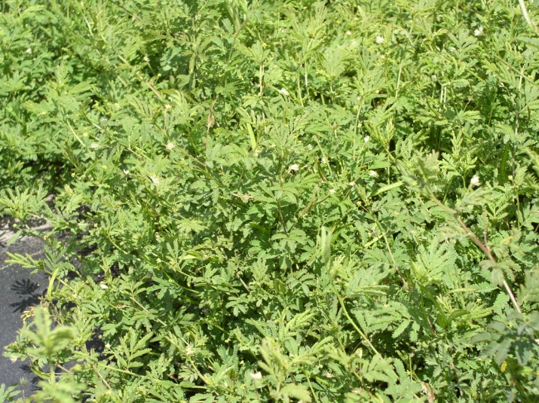

Prostrate bundleflower plants, Shelly D. Maher USDA NRCS

### Alternate Names

Desmanthus, wild tantan, creeping bundleflower

### Uses

*Livestock:* Prostrate bundleflower produces forage for cattle (Everitt, Drawe and Lonard 1999) and is very tolerant of heavy grazing (Cook et al. 2005).

*Wildlife*: Prostrate bundleflower provides forage for deer and seed for bobwhite quail, scaled quail and mourning doves (Everitt et al. 1999).

### Status

Please consult the PLANTS Web site and your State Department of Natural Resources for this plant’s current status (e.g., threatened or endangered species, state noxious status, and wetland indicator values).

### Description

*General*: Prostrate bundleflower is a native, perennial legume. It is a sprawling or occasionally erect herbaceous plant with stems 75 cm or longer. Leaves are bipinnate, alternate and 2.4-6.0 cm long. The flower heads are white. The fruits are legume pods 2.2-8.8 cm long, dehiscent along both sutures, and contain 9-27 seeds per pod. Seeds are 2.1-2.9 mm long, 1.4-2.7 mm wide, flattened, and red or golden-brown in color (Luckow 1993). The plants produce seed from April through December. Prostrate bundleflower has an average of 62,000 seeds per pound.

*Distribution*: Prostrate bundleflower is found in Florida as well as in the southern half of Texas and down into the northern states of Mexico (Richardson and King 2011). For current distribution, please consult the Plant Profile page for this species on the PLANTS Web site.

*Habitat*: It is found on various range sites from Gray sandy loams to saline clays (USDA-SCS 1985 & 1988). Best performance of this seed source has been observed on medium to fine textured soils. It is associated with native grasses such as false Rhodesgrass, plains bristlegrass Hall’s panicum, hooded windmillgrass, curly mesquite and buffalograss. It is also associated with orange zexmenia, bush sunflower and snoutbean (M.C. Johnston 1963).

**Adaptation**Prostrate bundleflower is very persistent in arid and subhumid environments. It is tolerant of alkaline, sodic, saline and heavy clay soils.

### Establishment

### Seedbed preparation should begin well in advance of planting. Planting can be scheduled for early spring or where there are few cool-season weeds, it can be planted in the fall. Establish a clean, weed-free seedbed by either tillage or herbicides. Prior to planting, the site should be firm and have accumulated soil moisture.

### Prostrate bundleflower is best seeded using a native-grass drill to ensure a good planting of the seed on rough, irregular rangeland. Broadcast seeding may be used in areas not easily planted with a drill, but some type of additional coverage such as culti-packing or light dragging will be beneficial to ensure good seed to soil contact.

### Balli Germplasm prostrate bundleflower will generally be used in planting mixtures. As such the seeding rate will need to be adjusted according to the percent of prostrate bundleflower in the mixture. For calibration purposes, a seeding rate of five pounds of pure live seed (PLS) per acre would be the single species recommendation. Seed should be planted 1/4 to 1/2 inch deep. A brief mechanical scarification will improve seed germination of its hard seed. If one plant per square foot has become established than the planting has been successful.

### Soil analysis should be performed prior to planting to determine the necessary levels of phosphorus and potassium. No nitrogen fertilizer is necessary since prostrate bundleflower is a legume and forms a symbiotic relationship with rhizobial bacteria to fix atmospheric nitrogen for use by the plant.

### Management

Prostrate bundleflower should be deferred from grazing for 90 days to allow plants to become established. After a stand is established, either continuous or rotational grazing can be used. It is recommended that a minimum 3 inch stubble height be maintained under grazing. Plants should be allowed to produce seed annually to ensure stand health. Prostrate bundleflower is a long-lived perennial that is extremely drought tolerant once established.

### Pests and Potential Problems

Control of the pests may be necessary in order to produce seed crops in dry years under irrigation. There are a host of insects that feed on the seed of prostrate bundleflower and will continue to feed on the seed after harvest unless treated. In order to reduce the detrimental effects of these insects, it is recommended that following harvest and seed drying, seed should be placed in a freezer for a minimum of 48 hrs to kill seed-feeding insects. It is possible that an insecticide treatment prior to harvest may eliminate this problem . However, this has not been tested.

### Environmental Concerns

There are no known environmental concerns with prostrate bundleflower.

### Seeds and Plant Production

Seed production for Balli Germplasm can be started from transplants or direct seeded on beds or flat ground. Rapid spread and growth has been observed in transplant established stands providing seed harvests within the first year. Furthermore, transplanted stands facilitate better weed control in the seed production fields.

Seed is best harvested using a combine with a grain-style header. The seed of prostrate bundleflower dehisces at maturity, however about 75% of the seed ripens uniformly. Seed can be harvested before peak ripeness; however, harvesting too early has resulted in lower seed quality making the added yields negligible. Following harvest, trash can be removed using a Clipper seed cleaner. After the trash has been removed, seed can be further cleaned using a gravity table. This will be used to remove light (immature) seed, which will greatly increase the purity of the seedlot.

Well managed seed fields have produced 775 bulk pounds of clean seed per acre. Purity of the seed is usually around 80-90% and germination rates for scarified seed ranges from 80 to 90%. Adequately stored seed in humidity and temperature controlled facilities can be expected to stay viable for over 10 years.

### Cultivars, Improved, and Selected Materials (and area of origin)

Balli Germplasm prostrate bundleflower was released by the USDA NRCS E. “Kika” de la Garza Plant Materials Center and the *South Texas Natives* Project of the Caesar Kleberg Wildlife Research Institute at Texas A&M University-Kingsville in 2013. It was selected for its survivability, plant vigor, forage production and seed production characteristics. It is predominantly adapted to clay loam and saline clay range sites in south Texas. Breeder seed is maintained by *South Texas Natives*.

### References

Cook, B.G., Pengelly, B.C., Brown, S.D., Donnelly, J.L., Eagles, D.A., Franco, M.A., Hanson, J., Mullen, B.F., Partridge, I.J., Peters, M. and Schultze-Kraft, R. 2005. Tropical Forages: an interactive selection tool. [CD-ROM], CSIRO, DPI&F(Qld), CIAT and ILRI, Brisbane, Australia. Accessed July 2013.

Everitt, J.H., D.L. Drawe and R. I. Lonard. 1999. Field Guide to the Broad-Leaved herbaceous Plants of South Texas. Texas Tech University Press, Lubbock, TX.

Johnston, M.C. 1963. Past and Present Grasslands of Southern Texas and Northeastern Mexico. Ecology 44(3): 456-466.

Luckow, M. 1993. Monograph of Desmanthus (Leguminosae-Mimosoideae). Systematic Botany Monographs. 38:1-166.

Richardson, A, and K. King. 2011. Plants of Deep South Texas A Field Guide to the Woody and Flowering Species. Texas A&M University Press. College Station, TX.

USDA-SCS. 1985. Soil Survey of Webb County, Texas. United States Department of

Agriculture, Washington, D.C.

USDA-SCS. 1988. Soil Survey of Refugio County, Texas. United States Department of

Agriculture, Washington, D.C

**Prepared By**:

*John Lloyd-Reilley*, Manager

*Shelly Maher*, Soil Conservationist

USDA NRCS E. ‘Kika’ de la Garza Plant Materials Center, Kingsville, Texas

### Citation

Lloyd-Reilley, J. and S. Maher. 2013. Plant guide for prostrate bundleflower (*Desmanthus virgatus* var. *depressus*). USDA Natural Resources Conservation Service, E. “Kika” de la Garza Plant Materials Center. Kingsville, TX 78363.

Published July 2013

For more information about this and other plants, please contact your local NRCS field office or Conservation District at <http://www.nrcs.usda.gov/> and visit the PLANTS Web site at <http://plants.usda.gov/> or the Plant Materials Program Web site <http://plant-materials.nrcs.usda.gov>.

PLANTS is not responsible for the content or availability of other Web sites.

**USDA IS AN EQUAL OPPORTUNITY PROVIDER AND EMPLOYER**