

Plant Guide

# COMMON spikerush

*Eleocharis palustris* (L.) Roem. & Schult.

Plant Symbol = ELPA3

*Contributed by*: USDA NRCS Idaho Plant Materials Program

### *common spikerush*

### Common spikerush. Derek Tilley, USDA-NRCS.

### Alternate Names

*Common Alternate Names:* creeping spikerush

*Scientific Alternate Names: E. calva; E. smallii;*

### Uses

*Wildlife and Livestock*: Creeping spikerush has a moderately high protein content in the spring and good digestibility. The tops are heavily grazed by both livestock and big game animals, especially after the seeds have ripened. It produces nesting cover for waterfowl and ducks eat the seeds and geese graze the shoots.

### *Conservation Uses*: This species has utility for erosion control, constructed wetland system applications, wildlife food and cover, wetland creation and restoration, and for increasing plant diversity in wetland and riparian communities. Its dense root mass makes this species an excellent choice for soil stabilization in riparian and wetland sites. The rhizomes also form a matrix for many beneficial bacteria making this plant an excellent choice for wastewater treatment.

### Status

Please consult the PLANTS Web site and your State Department of Natural Resources for this plant’s current status (e.g., threatened or endangered species, state noxious status, and wetland indicator values).

### Description

### *General*: Rush Family (Cyperaceae). Creeping spikerush is a perennial, heavily rhizomatous wetland plant that is found from low to mid elevations. It has a dense root mass that extends deeper that 40 cm (16 in) in the soil profile. The stems are singular or in small clusters and it will continue to grow to keep the heads out of the water if the water rises slowly. The stems are upright, round, and may reach 1.2 m (4 ft) in height (height is dependent on the depth of water in the growing environment). The leaves are reduced to sheaths clustered at the base of the stems. The flowers are borne in a terminal spikelet, 1 flower per scale with 2 stigmas. Plants typically flower from June through September. The seeds are yellow to brown lenticular achenes, 1.5-2.5 mm (0.06-0.1 in) long including tubercle, and subtended by up to 8 bristles (Welsh et al., 2003). The seed ripens in late August to October. Seeds are held tightly in the seed head for a long period of time.

*Distribution*: Common spikerush is found from the West Coast of the US, east to the Upper Peninsula of Michigan, and south to Louisiana. For current distribution, please consult the Plant Profile page for this species on the PLANTS Web site.

*Habitat*: Common spikerush grows in wet meadows, irrigation ditches, springs, seepage areas, freshwater marshes, rivers, and along lakeshores. It has a broad elevational range from 0 to over 3,000 m (10,000 ft) and will thus be found associated with a wide assortment of plant species (Welsh et al., 2003).

**Adaptation**

It is a pioneering species that populates mud flats very quickly as the water draws down. It can grow in areas that are flooded in the spring and saturated in the fall. It can grow in flooded conditions where the water is up to one meter deep for most of the growing season. It is a wetland obligate plant. It grows on fine texture soils in neutral to alkaline or saline conditions. It spreads rapidly by rhizomes and occasionally seed. It will spread into areas that are too deep for seedling establishment. It will develop a thick root mass that is resistant to compaction and erosion. However, its roots grow less deeply than Nebraska sedge (*Carex nebrascensis*). It can fix atmospheric nitrogen and make it available to other plants in the wetland community.

Creeping spikerush grows on sites that are either permanently flooded or seasonally flooded. The plants can grow and thrive in permanent water up to 1 m deep or they can survive in areas where the water table drops to 30 cm (12 in) below the surface late in the season. Creeping Spikerush grows in areas that can be totally inundated for up to 3-4 months.

### Establishment

Planting plugs (either from the greenhouse or wild transplants) is the surest way to establish a new stand of this species. Plug spacing of 30-45 cm (12-18 in) will fill in within one growing season. The soil should be kept saturated. Allow no more than 8 cm (3 in) of standing water at any time during the first growing season. Fluctuating water levels during the establishment year will speed the spread of the plants. Water levels should be managed to enhance rhizome spread.

### Management

Standing water should be no deeper than 1 m (3 ft) and should fluctuate throughout the growing season. If deeper water levels are desirable, increase the depth slowly over the course of the growing season. This species can tolerate periods of drought and total inundation. Water levels can be managed to enhance or reduce spread as well as control terrestrial weeds.

### Pests and Potential Problems

Few insect or disease problems have been encountered in the greenhouse. Aphids will feed on the stems, but little or no damage has been noted and the vigor of the plant has not been affected.

### Environmental Concerns

Common spikerush is native to western North America. It can spread under favorable conditions but does not pose any environmental concern to native plant communities.

### Seeds and Plant Production

*Collection and cleaning*: Seeds may be collected by hand striping the seed from the plant or clipping it using a pair of hand shears. A power seed harvester may also be used.

A hammer mill is used to break up the large debris and knock the seed loose from the stem. Cleaning can be accomplished using a seed cleaner with a No. 12 top screen and a solid bottom screen. Screens should be sized so desired seed will fall through and debris and weed seed are removed. Air velocity should be adjusted so chaff is blown away. Air flow and screen size may require adjustment to optimize cleaning process for given situation.

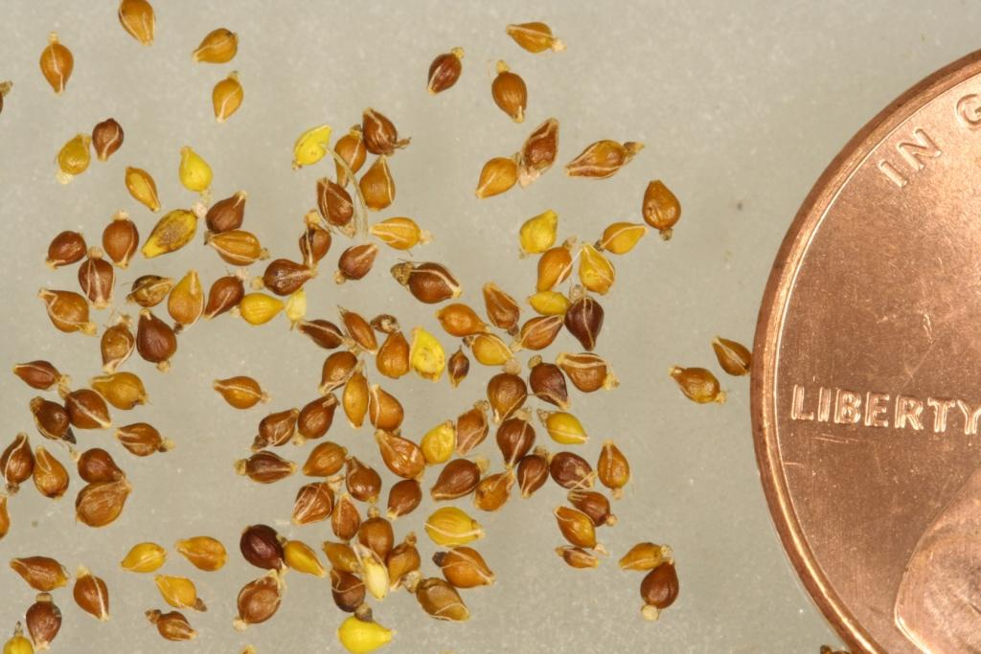

Common spikerush seed. Derek Tilley, USDA-NRCS.

*Special procedures*: The germination rate may be enhanced by lightly scarifying the seed and then stratifying the seed in a mixture of water and sphagnum moss at 2°C (36° F) for 30-45 days.

*Greenhouse*: Seeds need light, moisture, and heat for germination. Place the seeds on the surface of the soil and press in lightly to assure good soil contact. Do not cover the seed. Soil should be kept moist. The greenhouse should be kept hot, 32°C to 38°C (90 to 100° F). Germination should begin within about one to two weeks. Maintain the moisture until the plants are transplanted.

*Wild transplants*: Wild plants can be collected and transplanted directly into the desired site. As long a section no more than 4 dm² ( 1 ft2), 1and 3-15 cm (5-6 in) deep, is removed from any 1 meter2 (3ft2) area, the hole will fill in within one growing season. Care should be taken not to collect plants from weedy areas as these weeds can be relocated to the transplant site, and the hole left at the collection site may fill with undesirable species.

### Cultivars, Improved, and Selected Materials (and area of origin)

### There are no cultivars, improved, or selected materials of common spikerush. Common wildland collected seed is available from commercial sources (Native Seed Network).

### References

Native Seed Network. http://www.nativeseednetwork.org (Accessed September 15, 2012)

USDA NRCS. *Wetlant plant fact sheet – creeping spikerush (Eleocharis palustris)*. Interagency Riparian/Wetland Project, Plant Materials Center, Aberdeen, Idaho.

Welsh, S.L., Atwood, N.D., Goodrich, S. and L.C. Higgins. 2003. A Utah Flora. Brigham Young University. Provo, UT. 912p.

**Prepared By**:

Dan Ogle, USDA NRCS Idaho State Office, Boise, Idaho.

### Derek Tilley, USDA NRCS Plant Materials Center, Aberdeen, ID

Loren St. John, USDA NRCS Plant Materials Center, Aberdeen, ID

### Citation

Ogle, D., Tilley, D., and L. St. John. 2012. Plant Guide for common spikerush (*Eleocharis palustris)*. USDA-Natural Resources Conservation Service, Aberdeen Plant Materials Center. Aberdeen, Idaho 83210.

Published *October 2012*

Edited: 15Sep2012djt;13Sep 2012ls

For more information about this and other plants, please contact your local NRCS field office or Conservation District at <http://www.nrcs.usda.gov/> and visit the PLANTS Web site at <http://plants.usda.gov/> or the Plant Materials Program Web site <http://plant-materials.nrcs.usda.gov>.

PLANTS is not responsible for the content or availability of other Web sites.

**USDA IS AN EQUAL OPPORTUNITY PROVIDER AND EMPLOYER**