

Plant Guide

# slender wheatgrass

***Elymus trachycaulus* (Link) Gould ex Shinners**

Plant Symbol = ELTR7

*Contributed by*: USDA NRCS Idaho Plant Materials Program

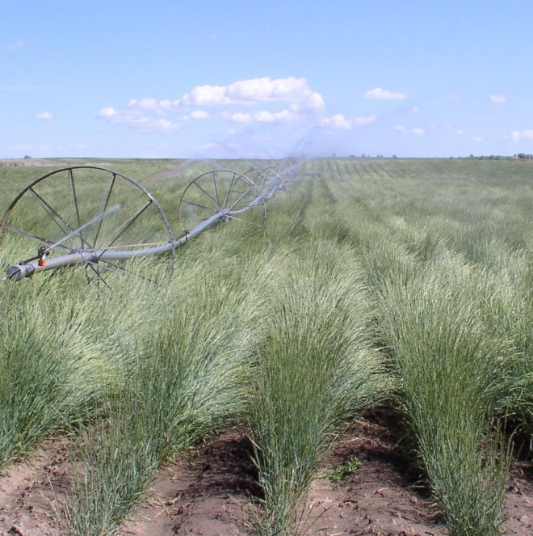

**Slender wheatgrass seed production field at Aberdeen, Idaho. Photo by Loren St. John, USDA-NRCS**

### Alternate Names

*Agropyron trachycaulum*

Bearded wheatgrass

Rough-stemmed wheatgrass

### Uses

*Grazing/rangeland/pasture*:

Slender wheatgrass is both palatable and nutritious to livestock. Crude protein averages 22 to 25% in the spring and drops below 10% in late summer to fall. Average dry matter yield is between 1000 and 2300 lb/acre.

*Wildlife*:

Upland game birds and small mammals utilize the seed for food and the foliage for cover. Large ungulates, especially elk and bighorn sheep at higher elevations, readily graze this species.

*Erosion control*:

Slender wheatgrass is a short-lived perennial with good seedling vigor. It germinates and establishes quickly when seeded making it a good choice for quick cover on disturbed sites. It persists long enough for other, slower developing components of seeding mixtures to establish.

*Reclamation*:

Slender wheatgrass was among the first native grasses widely used for reclamation seedings in western Canada and the U.S (Alderson and Sharp, 1994). It has been successfully used for the reclamation of mine spoils, oil sands, roadsides right-of-ways, wildfire areas and other disturbed sites. It is especially valuable for use in saline soils.

### Status

Slender wheatgrass is considered a species of special concern in Connecticut, endangered or extirpated in Maryland, endangered in New Jersey, and threatened in Ohio (USDA-NRCS, 2011).

Consult the PLANTS Web site and your State Department of Natural Resources for this plant’s current status (e.g., threatened or endangered species, state noxious status, and wetland indicator values).

**Taxonomy**

Historically, slender wheatgrass has borne many different names. Carl Linnaeus originally placed all wheatgrasses in the genus *Triticum* along with cultivated wheat. Later authors classified slender wheatgrass as *Agropyron caninum*, however, it was separated to *A. trachycaulum* from that Old World species by having broader glumes (5 to 7 nerves instead of 3), glumes with membranous margins (not rigid), and having anthers averaging 1.5 mm (0.06 in) long as opposed to 2mm (0.08 in). More recently, it was determined through the use of molecular, morphological and cladistic analysis that in North America, the genus *Agropyron* should be left to the introduced crested wheatgrass complex (*A. cristatum*, *A. desertorum* and *A*. *fragile*), which moved slender wheatgrass to the genus *Elymus*. This move also required the change of the epithet to *trachycaulus* in order to match the Latin genders (Barkworth, 1997).

### Description

*General*: Grass Family (Poaceae). Slender wheatgrass is a relatively short-lived (3 to 5 years) perennial, cool-season C3 type, bunchgrass native to Western North America. Plants are perennial, occasionally producing short rhizomes. Culms are erect or decumbent at the base, reaching a height of 0.5 to 1.0 m (20 to 40 in) tall. Stems are noted as having a reddish to purplish tinge at the base. The leaves are flat, usually 2 to 8 mm (0.08 to 0.31 in) wide, stiffly ascending or somewhat lax. Sheathes are commonly glabrous or somewhat scabrous with auricles short or lacking. The inflorescence is a long, spicate raceme ranging from 5 to as much as 25 cm (2 to 10 in) long. Spikelets are solitary at each node of the rachis, 3 to 7 flowered and about 10 to 20 mm (0.4 to 0.8 in) long. Spikelets overlap along the inflorescence, the rachis internodes being 5 to 8 mm (0.2 to 0.in) long. Glumes are lanceolate to oblong with 5 to 7 nerves. The first glume ranges from 6 to 10 mm (0.24 to 0.4 in) long, while second glumes are slightly longer, from 7 to 12 mm (0.3 to 0.5 in) (Cronquist et al., 1997). Slender wheatgrass is self-pollinated and chromosome number is 2n=28 (Heath, etal, 1985).

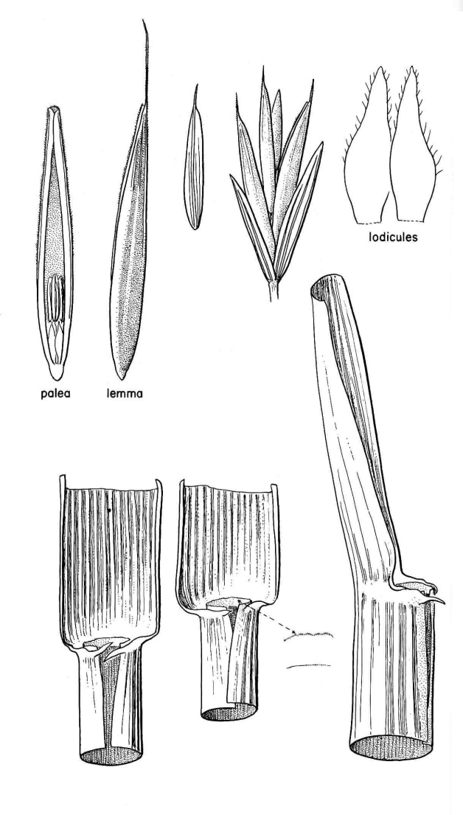

**Slender wheatgrass seed and collar characteristics. Illustration by Jeanne R. Janish with permission from University of Washington Press**

**Distribution**

Slender wheatgrass is found from 1,300 to 3,500 m (4,300 to 11,500 ft) in elevation. The species range includes Canada, Siberia, Mexico and all states except those in the southeastern U.S.

For current distribution, consult the Plant Profile page for this species on the PLANTS Web site.

*Habitat*:

Slender wheatgrass is found in many plant communities including Wyoming, basin and mountain big sagebrush, mountain brush, aspen, ponderosa, spruce-fir and lodgepole pine.

**Adaptation**

Slender wheatgrass grows naturally in moist to dry sites receiving more than 25 cm (10 in) annual precipitation. This species is less drought tolerant than crested and thickspike wheatgrass and may succumb to drought due to its late maturation. It prefers loamy to clayey soils. Slender wheatgrass is well adapted to basic soils (up to pH=8.8) and moderately saline conditions with a salinity tolerance ranging from 10 to 20 mmhos/cm.

**Establishment**

Seeds should be planted in a firm, weed-free seed bed. Dormant fall planting is preferred for dryland seedings made in areas receiving less than 16 inches mean annual precipitation. Areas receiving over 16 inches of mean annual precipitation and fields that are irrigated can be seeded in late fall or early spring (Skinner, 2004). (Note: dormant fall seedings are more prone to be negatively affected by soil crusting and mid to late spring seedings are more prone to drying out).

Seeds should be drilled to a depth of ¼ to ¾ inch at a Pure Live Seed (PLS) rate of approximately 6 lb PLS/acre for field plantings.

For critical area plantings, turf applications and broadcast plantings the PLS seeding rate should be 1.5 to 2.0 times the drill seeding rate.

For native seed mixtures, limit slender wheatgrass to 1 pound PLS/acre because higher rates effect the establishment of slower developing native species.

Fertilizer is not recommended for establishment, as it usually benefits the weeds. On disturbed sites fertilizer should be applied according to soil test results.

### Management

Slender wheatgrass is best suited as a filler component in seed mixtures containing slower establishing, long-lived perennials (Ogle et al., 2010). It does well for hay and pasture when combined with legumes. Because this species is short-lived and only moderately tolerant of grazing, stands should be managed carefully to ensure seed production occurs every other year for long-term survival.

### Pests and Potential Problems

Slender wheatgrass is susceptible to head smut (Ustilago bullata) and stripe smut (U. striiformis) (Wheeler and Hill, 1957) and may be susceptible to infestations of the grass billbug (Heath, etal, 1985).

### Environmental Concerns

Although slender wheatgrass is native to Western North America, it can be viewed as “weedy” due to its ability to quickly establish in disturbed areas.

Consult with your local NRCS Field Office, Cooperative Extension Service Office or state natural resource or agriculture department regarding this species’ status and use. Weed information is also available from the PLANTS Web site.

### Seed and Plant Production

Plant at a rate of approximately 3.4 pounds PLS/acre or 25 to 30 seeds per linear foot of drill row at 36 inch row spacing (Ogle et al., 2010).

For stand establishment, apply 55 lb/acre of 11-55-0 (high phosphorus fertilizer) as a soil amendment prior to planting or during seeding. If planting into grain stubble, after initial seedling establishment, apply 30 lb/acre nitrogen for dryland or 60 to 80 lb/acre nitrogen for irrigated fields. No additional nitrogen is necessary if planting into summer fallow. Irrigate enough to keep soil moist for establishment and to prevent soil crusting. Seeds should germinate within 8 to 10 days. Weeds can be controlled after the 3 to 5 leaf stage with low rates of Bromoxynil. Be sure to read and follow all label directions when using any pesticide. Caution should be exercised when using cultivation on young seedlings because of the possibility of uprooting.

For established stands, apply 50 lb/acre nitrogen each year in late fall on dryland and 60 to 80 lb/acre nitrogen in late fall under irrigation.

On established stands keep soil moisture above fifty percent field capacity during the growth period. Before the flowering stage apply enough water to carry plants through pollination. After pollination, irrigate to recharge the soil profile for seed set (Cornforth and Ogle, 2001).

Control weeds chemically (Bromoxynil, Metribuzin, 2, 4-D or dicamba), by roguing or mechanical cultivating. Always read and follow label and safety instructions for each control method. USDA-NRCS does not guarantee or warranty any products or control methods named, and other products may be equally effective.

Seed is ready for harvest in late July to early August. The recommended harvest method is by direct combining or by swathing followed by combining. Windrows should be allowed to dry in the field for 6 to 7 days before combining.

Seed yields range from 200 to 400 lb/acre in dryland to 500 to 600 lb/acre under irrigation. Seed should be dried to 12 percent or less moisture prior to storage. When stored properly, cleaned seed should retain its viability for about five years. Stands can be expected to survive for 3 to 5 years.

Cultivars, Improved, and Selected Materials

‘Adanac’ was released by the Agriculture Canada, Saskatoon Research Station and the Agriculture Canada Experiment Farm in 1990. Plants are taller than those of Revenue, but have fewer leaves. Adanac averaged 7% higher hay yields than Revenue during a four-year study. Adanac also rated higher than Revenue in establishment, persistence, seed yield and productivity under saline conditions. However, digestibility and protein content are somewhat below those of Revenue. This release is recommended for use in Saskatchewan, Canada. Breeder seed is maintained by the Agriculture Canada, Saskatoon Research Station and the Agriculture Canada Experiment Farm, Indian Head.

‘AEC Hillcrest’ was released by the Alberta Environmental Centre in 1994. Its primary uses are in reclaiming and revegetation of disturbed sites in the mountains and foothills of Alberta. This cultivar belongs to a different subspecies than the others discussed here (*Elymus trachycaulus* ssp. *subsecundus*) and is therefore difficult to compare directly. Data show AEC Hillcrest producing similar plant cover to Revenue at elevations around 1800 meters. Hillcrest seeds also tend to ripen two weeks earlier than Revenue, an important quality in the shortened growing season of Alberta (Darroch and Acharya, 1995). Breeder seed is maintained by the Alberta Environmental Centre, Vegreville, Alberta. Foundation and Certified seed is maintained by Peace Valley Seeds, Rycroft, Alberta.

Copperhead Selected Class Germplasm was officially released in 2007 by the Bridger, Montana Plant Materials Center. This release is from a collection of at least 20 plants originating from approximately one-half mile north of Highway 1 across from the junction to Wisdom, Montana. The collection site was severely impacted by smelter fallout, surface wind, and water transported contaminates, as well as historic overflow from the canal transporting waste material to sediment ponds. The original collection site had a soil surface pH of 4.3, an average annual precipitation of 13.93 inches and an elevation of 5,000 feet. The accession was compared to two other collections from acid/heavy-metal impacted sites and four released cultivars: ‘Pryor’ (Montana), ‘San Luis’ (Colorado), ‘Revenue’ (Canada), and ‘Highlander’ (Canada). Copperhead germplasm has been field tested at three impacted sites in the Anaconda area and in a controlled greenhouse environment utilizing contaminated soil. Copperhead germplasm has exhibited superior emergence, survival, and biomass production on amended acid/heavy metal impacted soil. Copperhead germplasm is intended for use on severely impacted sites with low pH and high concentration of heavy metals. G1 seed of Copperhead germplasm slender wheatgrass is available from the USDA-Natural Resources Conservation Service (NRCS) Plant Materials Center (PMC) in Bridger, Montana, through the Foundation Seed Program at Montana State University-Bozeman or the University of Wyoming.

‘First Strike’ was released in 2006 by the USDA-Agricultural Research Service and the US Army-Engineer Research and Development Center for use on arid and semiarid rangelands as a rapidly establishing revegetation grass in the Intermountain Region and Northern Great Plains of the western U.S. First Strike was selected for persistence and overall plant vigor in response to drought. In seeded trials at Yakama Washington, Guernsey, Wyoming, Fillmore, Utah and Malta, Idaho, First Strike had significantly more seedlings per unit area than Pryor during the establishment year. At Guernsey, Wyoming, forage production was 27% greater in First Strike than Pryor Jensen et al., 2007). Foundation seed is available through the Utah Crop Improvement Association.

‘Primar’ was released by the NRCS Plant Materials Center in Pullman, Washington in 1946. Originally collected near Beebe, Montana, Primar was selected for use in sweetclover-grass conservation mixtures for pasture, hay and green manure. Plants are high in vegetative production and show resistance to leaf rust, stem rust and stripe rust. This cultivar is adapted to short-lived dryland seedings in areas receiving over 16” annual precipitation. Pullman Plant Materials Center maintains Breeder seed and Washington Crop Improvement Association maintain Foundation seed.

‘Pryor’ was released cooperatively by the NRCS Plant Materials Center in Bridger, Montana and the Montana and Wyoming Agricultural Experiment Stations in 1988. The original collection was made in Carbon County, Montana, five miles north of Warren. It is superior to other previously released slender wheatgrasses in drought tolerance, saline tolerance and seedling vigor. It also matures earlier and has a larger mean seed size (213,000 seeds/kg compared to 320,000 seeds/kg). For these reasons it is used primarily in mixtures for reclamation and conservation plantings in low precipitation, alkali conditions. Breeder and Foundation seed are maintained by the NRCS Plant Materials Center, Bridger, Montana.

‘Revenue’ was originally collected in Saskatchewan in 1961. It was selected from over 750 native and introduced collections evaluated between 1959 and 1969 and released in 1970 by the Canada Department of Agriculture. Revenue is said to be superior to Primar in establishment, forage and seed yield and in salinity tolerance. It also has a higher leaf-to-stem ratio, better digestibility and greater smut resistance than Primar. It is similar to Primar in maintaining good stands for three to five years. It is adapted for use on saline soils and in short pasture rotations. Breeder seed is maintained by the Canada Department of Agriculture.

‘San Luis’ was released cooperatively in 1984 by Colorado, and New Mexico Agricultural Experiment Stations, NRCS, and the Upper Colorado Environmental Plant Center. The original collection was made by Glenn Niner in 1975 near Center, San Luis Valley, Rio Grande County, Colorado. Due to its outstanding rapid establishment and longevity it is well suited for soil stabilization on slopes and disturbed sites. It performs best above 1,800 meters elevation in areas receiving over 35 cm (14 inches) of annual precipitation. It is recommended for ski slopes, roadsides, mine land reclamation, and transmission corridors. Breeder and Foundation seed is maintained by the Upper Colorado Environmental Plant Center, Meeker, Colorado.

### References

Alderson, J. and W. C. Sharp 1994. *Grass varieties in the United States.* Agriculture Handbook No. 170. USDA, SCS, Washington, DC.

Barkworth, M.E. 1997. Taxonomic and nomenclatural comments on the Triticeae in North America. Phytologia. 83(4): 302-311.

Block, D.N. Rangeland Ecosystems and Plants: *Elymus trachycaulus*. URL: http://www.usask.ca/agriculture/plantsci/classes/range/agropyrontrach.html (accessed 3 December 2004). Department of Plant Sciences. University of Saskatchewan.

Cornforth, B., L. St. John and D. G. Ogle. 2001. Technical Note 14: Seed production standards for conservation plants in the Intermountain West. USDA-NRCS, Boise, ID. 15p.

Cronquist, A., A.H. Holmgren, N.H. Holmgren and J.L. Reveal. 1977. *Intermountain Flora: Vascular Plants of the Intermountain West*, U.S.A. The New York Botanical Garden.

Darroch, B.A. and S.N. Acharya. 1996. AEC Hillcrest awned slender wheatgrass. Can. J. Plant Sci. 76: 345-347.

Heath, M.E., Barnes, R.F, and Metcalfe, D.S. 1985. Eds. Forages – The Science of Grassland Agriculture, Fourth Edition. Iowa State University Press, Ames, IA. 643 p.

Jensen, K.B., Palazzo, A.J., Waldron, B.L., Bushman, B.S. 2007. Registration of 'FirstStrike' Slender Wheatgrass. Journal of Plant Registrations 1:25.

Ogle, D. G., L. St. John, M. Stannard and L. Holzworth. 2010. Technical Note 24: Grass, grass-like, forb, legume, and woody species for the intermountain west. USDA-NRCS, Boise, ID. 46p.

Peterson, J. 2000. Slender Wheatgrass. NRCS Plant Guide. USDA, NRCS, Idaho State Office & the National Plant Data Center. 3p.

Skinner, David M. 2004. Propagation protocol for production of *Elymus trachycaulus* (Link) Gould ex Shinners seeds; Pullman Plant Materials Center, Pullman, Washington. In: Native Plant Network. URL: http://www.nativeplantnetwork.org (accessed 3 December 2004). Moscow (ID): University of Idaho, College of Natural Resources, Forest Research Nursery.

USDA, NRCS. 2011. The PLANTS Database, Version 3.5 (http://plants.usda.gov). National Plant Data Center, Baton Rouge, LA 70874-4490 USA.

Wheeler, W. and Hill, D. 1957. Grassland Seeds. D. Van Nostrand Company, Inc, Princeton, NJ 734 p.

**Prepared By**:

*Derek Tilley*; USDA NRCS Plant Materials Center, Aberdeen, Idaho.

*Dan Ogle*, USDA NRCS, Boise, Idaho.

*Loren St. John*, USDA NRCS Plant Materials Center, Aberdeen, Idaho.

### Citation

Tilley, D., Ogle, D., and L. St. John. 2011. Plant guide for slender wheatgrass (*Elymus trachycaulus ssp. trachycaulus*). USDA-Natural Resources Conservation Service, Idaho Plant Materials Center. Aberdeen, ID.

Published Feb 2011

Edited: 07Feb2011djt; 07Fev2011ls; 16Feb2011dgo; 7Mar2012djt

For more information about this and other plants, please contact your local NRCS field office or Conservation District at http://www.nrcs.usda.gov/ and visit the PLANTS Web site at http://plants.usda.gov/ or the Plant Materials Program Web site http://plant-materials.nrcs.usda.gov.

PLANTS is not responsible for the content or availability of other Web sites.

**USDA IS AN EQUAL OPPORTUNITY PROVIDER AND EMPLOYER**