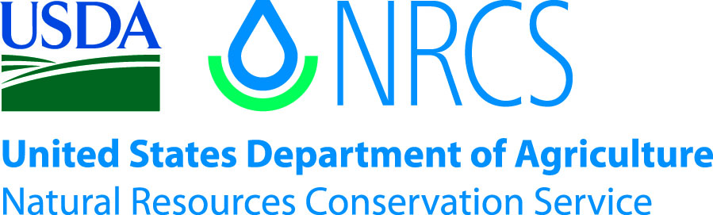

Plant Guide

# virginia wildrye

*Elymus virginicus L.*

Plant Symbol = ELVI3

*Contributed by*: USDA NRCS PMC or State PM Program

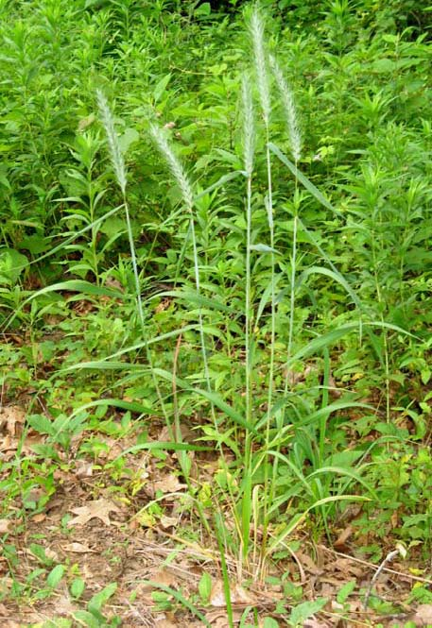R. Alan Shadow

USDA NRCS East Texas Plant Materials Center

**Alternate Names**

Wildrye

**Uses**

*Livestock:*

Virginia wildrye is palatable and nutritious to all classes of livestock. It may be grazed fall through early spring before it produces its characteristic, awned, seed head. It may also be cut for hay; however, grazing and haying should be deferred after the plant goes to seed. The seed heads are often heavily infected with ergot which causes toxicity problems in livestock (Phillips Petroleum Company, 1963). Proper management is needed to avoid selective grazing by livestock. Selective grazing weakens the stand and can lead to its elimination.

*Wildlife and Conservation*

Virginia wildrye is palatable and nutritious forage for large game animals such as deer. Birds and small mammals also forage for the seed and utilize the plant fibers for denning and nesting material (National Plant Information Network, 2009). The seed is reported to be utilized by mallard and lesser scaup ducks when found in association with wetlands, and Canada geese will graze young foliage (Hilty, 2009).

Virginia wildrye may be mixed with warm season grasses for restoration and conservation plantings, and provides an important cool season component to seed mixtures.

**Status**

Please consult the PLANTS Web site and your State Department of Natural Resources for this plant’s current status (e.g. threatened or endangered species, state noxious status, and wetland indicator values).

**Description**

*General*:

Virginia wildrye is a native, cool season, perennial, bunch grass. It is similar to Canada wildrye (*Elymus canadensis*) in appearance, but is typically shorter in height with shorter awns on the seed head. The seed heads are more erect than those of Canada wildrye which typically bow or droop (Philips Petroleum Company, 1963). There is evidence of variation in *E. virginicus and E. canadensis* due to hybridization of the two species (Grelen and Hughes, 1984). It reaches approximately three feet in height, lacks rhizomes and reproduces by seed and tillers.

Seed heads are typically 3 to 6 inches in length, erect, and have numerous, coarse awns. Each spikelet has 2 or more florets that decrease in size as they extend to the end of the inflorescence. The glumes bow outward at the base producing a “U” shape and are strongly nerved (Hatch et al., 1993). The spiklets are densely packed on the inflorescence. They are sessile, have a pair of glumes with a cluster of 2 to 4 lemmas, and their florets (Hilty, 2009). Virginia wildrye blooms in the spring from March through May, and is wind pollinated (Hilty, 2009).

Color may vary from green to silvery blue, and foliage often has a waxy appearance. The culms are tufted, strictly erect, or decumbent at the base. The ligule is a minute, truncated membrane (Gould, 1975). The alternately arranged leaves are approximately 12 inches in length and 2/3 inch in width. Virginia wildrye is typically hairless, but may have short pubescent on the leaf sheaths (Hilty, 2009).

*Distribution*:

Virginia wildrye has a very broad distribution, a testament to its adaptability. It may be found throughout the eastern 2/3rds of the United States, as far west as Arizona, and in the entire southern half of Canada. For current distribution, please consult the Plant Profile page for this species on the PLANTS Web site (<http://plants.usda.gov>).

*Habitat*:

Virginia wildrye is shade tolerant and is equally at home in open grasslands and prairies as it is in wooded sites. It is more shade tolerant than Canada wildrye, and prefers soils with more moisture and fertility (Philips Petroleum Company, 1963). It is commonly found in moist sites such as wet prairies, margins of wetlands, ditches, and riparian areas. It is also commonly found in woodlands, especially those in association with flood plains. It will adapt to disturbances and can be found in areas such as forest cut-overs (Hilty, 2009).

**Adaptation**

Virginia wildrye will tolerate a wide range of soil textures, from coarse sands to heavy clay. It prefers heavier soils with moderate fertility and a pH between 5 and 7. It has a moderate tolerance of drought and low tolerance of burning (Grelen and Hughes, 1984). It will not tolerate saline conditions. It can survive temperatures down to negative 23oF. Virginia wildrye requires at least 36 inches of rain annually, and a minimum of 130 frost free days to reach maturity and produce seed (NRCS, 2009).

**Establishment**

The seed requires no stratification or treatment, and typically produce greater than 85% germination (NRCS, 2009). For best results, prepare a clean, firm, weed free seedbed by disking, harrowing, and firming the seedbed with a cultipacker or roller prior to establishment. Rain or irrigation may also be used to settle and firm the field. If possible, allow an initial flush of weeds before planting, and treat with a non selective, broad spectrum herbicide such as glyphosate in the 2-4 leaf stage. This will help reduce early weed pressure, and maybe done multiple times before planting if severe weed competition is anticipated.

Seed should be planted in or early fall approximately ¼ to ½ inch deep in heavy soils, and up to 1 inch deep in sandy soils (NRCS, 2009). Adequate soil moisture is critical for establishment of healthy stands. Seed should be drilled at 10-15 pure live seed (PLS) pounds per acre or broadcast at 20 PLS pounds per acre, when a monoculture is desired. Mixtures should be adjusted accordingly based on the desired concentration of plants.

**Management**

New plantings should not be fertilized during their first year of establishment. Fertilization at this time promotes weed competition. Established stands maybe fertilized according to current soil test recommendations.

Warm season annual grasses can be very competitive in young plantings. However, their competitiveness is greatly reduced as temperatures cool, favoring the cool season Virginia wildrye. If they become a problem during early establishment, they may be controlled using cultivation and mowing. Mowing above the Virginia wildrye will reduce the leaf area of taller weeds, making them less competitive, and can destroy weed seed before it reaches maturity. Cultivation is useful in seed production settings to control weeds between rows. Avoid deep cultivation as it decreases soil moisture and brings new weed seed to the surface to germinate.

A wick applicator filled with a 50% glyphosate mixture is effective for tall weeds. Attach the wick applicator to an ATV or tractor and drive slowly through the planting with the wick positioned at a height to provide maximum control of target weeds, but above the Virginia wildrye plants.

Broadleaf weeds may be controlled with selective herbicides such as 2, 4-D amine. Applications of post emergent herbicides should be done while weeds are young and not under stress such as drought. Pre-emergent herbicides are useful as broad spectrum weed control in established stands, but their use may only be applicable in monotypic stands and seed production situations.

Please contact your local agricultural extension specialist or county weed specialist to learn what works best in your area and how to use it safely. Always read label and safety instructions for each control method. Trade names and control measures appear in this document only to provide specific information. USDA NRCS does not guarantee or warranty the products and control methods named, and other products may be equally effective.

**Pests and Potential Problems**

Several species of insects feed on Virginia wildrye including the leafhoppers (*Dorycephalus platyrhynchus*, *Elymana acrita*, *Elymana acuma* and (*Laevicephalus orientalis*).Leaf hoppers suck juices from the foliage and create stress on the plant. The flea beetle (*Chaetocnema pulicaria*,), leaf beetle (*Chalepus walshii*) and the caterpillars of the False Wainscot moth (*Leucania pseudoargyria*) will feed on the foliage. Stink bugs are also known to feed on Virginia wildrye. These include Brown Stink Bugs (*Euschistus servus*), green stink bug (*Chinavia hilare*, *Coenus delia*), and rough stink bug (*Brochymena quadripustulata*) (Hilty, 2009). White grub worms are also know to cause damage and should be controlled with a labeled pesticide when they are most active in late spring and early summer (NRCS, 2009).

Seed heads can become heavily infestation with ergot which causes toxicity problems in livestock (Phillips Petroleum Company, 1963). Virginia wildrye’s forage value decreases as it matures. When managed properly, it is baled at its nutritional peak, well before seed production; therefore, ergot should not be a problem.

*Elymus* species are known to hybridize readily with one another (Gould, 1975). This may create potential problems in a seed production setting with isolation requirements when more than one specie or subspecies is produced, or when natural populations exist in close proximity to production fields.

Seed must be awn free to flow through most drills and planters. Awned seed can bridge and clog planter tubes. When ordering seed make sure it is awn free, or the equipment being used is compatible with awned seed (NRCS, 2009).

**Environmental Concerns**

There are no known negative environmental concerns with this species.

**Cultivars, Improved, and Selected Materials (and area of origin)**

Kinchafoonee Germplasm was released in 2004 through the Jimmy Carter Plant Materials Center in Georgia as a cool season cover crop and for stabilization of critical areas.

Northern Missouri Germplasm was released in 1999 through the Elsberry Plant Materials Center in Elsberry, Missouri for planting in riparian areas, soil stabilization, forage, wildlife food and cover, and prairie plantings.

Cuivre River Germplasm was released in 2002 from the Elsberry Plant Materials Center for use as a companion species for forage production and erosion control. It may also be used in a mono culture or part of a seed mix for vegetative buffers, filters, wildlife forage and cover, plant diversity in wetland and riparian plantings, and a cover crop for woody plantings.

‘Omaha’ was developed by Stock Seed Company in Murdock, Nebraska for us as cool season forage and conservation plantings such buffers, filters, and restoration plantings.

**References**

Phillips Petroleum Company. 1963. Pasture and Range Plants. Bartlesville, Oklahoma.

Lady Bird Johnson Wildflower Center The University of Texas at Austin. 2009. Native Plant Information Network (http://www.wildflower.org/plants/result.php?id_p lant=ELVI3Accessed 27 July 2009). Austin, TX. 78739 USA.

Hilty, J. 2002-2009. Illinois Wildflowers. (http://www.illinoiswildflowers.info/grasses/plants /va_rye.htm . Accessed 27 July 2009). Dr. John Hilty, Illinois.

Grelen, H.E., and R.H. Hughes. 1984. Common herbaceous plants of southern forest range. Res. Paper SO-210. USDA, Forest Service, Southern Forest Exp. Stn., New Orleans, LA.

Hatch, S. L. and Pluhar, J. 1993. Texas Range Plants. Texas A&M University Press, College Station.

Gould, F.W. 1975. The Grasses of Texas. Texas A&M University Press, College Station.

USDA, NRCS. 2009. The PLANTS Database (http://plants.usda.gov, 27 July 2009). National Plant Data Center, Baton Rouge, LA 70874-4490 USA.

USDA, NRCS Plant Material Program 1997.

## Planting Guide ‘Kinchafoonee’ Virginia Wildrye Selected Class of Natural Germplasm. (http://www.plant- materials.nrcs.usda.gov/pubs/gapmcpg5458.pdf. Accessed27 July 2009). Jimmy Carter Plant Materials Center, Americus, Georgia. 31709. USA.

**Prepared By**

R. Alan Shadow, USDA NRCS East Texas Plant Materials Center

**Species Coordinator**

Published October, 2009

Edited:

For more information about this and other plants, please contact your local NRCS field office or Conservation District at <http://www.nrcs.usda.gov/> and visit the PLANTS Web site at <http://plants.usda.gov/> or the Plant Materials Program Web site <http://plant-materials.nrcs.usda.gov>.

PLANTS is not responsible for the content or availability of other Web sites.

**USDA IS AN EQUAL OPPORTUNITY PROVIDER AND EMPLOYER**