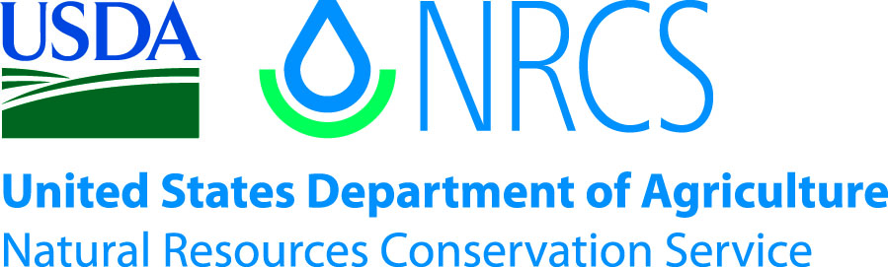

Plant Guide

# las vegas buckwheat

## Eriogonum corymbosum var. nilesii Reveal

Plant Symbol = ERCON

*Contributed by*: USDA NRCS Idaho Plant Materials Program

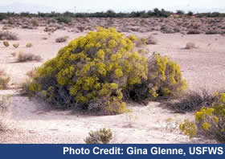

**Las Vegas buckwheat. Gina Glenn, USFWS.**

### Alternate Names

*Common Alternate Names:* Golden buckwheat, Nile’s wild buckwheat

*Scientific Alternate Names:* Las Vegas buckwheat was recently determined to be a distinct taxon in the *Eriogonum corymbosum* complex (Reveal 2004). It has historically been grouped in varieties *aureum* (Welsh et al 2008) and *glutinosum* (Mrowka 2008).

### Uses

The plants provide cover and food for small mammals, birds and insects.

### Status

Las Vegas buckwheat was designated a Candidate Species, Priority Level 6 (non-imminent threat to a subspecies) by the US Fish and Wildlife Service in 2007 due to continued loss of habitat. In 2008 it was petitioned for listing and listing was determined to be warranted but precluded due to work on higher priority listing actions (USDI 2008). It is a Bureau of Land Management Special Status Species in the state of Nevada and considered threatened by the National Park Service, Lake Mead National Recreation Area (Mrowka 2008).

Please consult the PLANTS Web site and your State Department of Natural Resources for this plant’s current status (e.g., threatened or endangered species, state noxious status, and wetland indicator values).

### Description

Buckwheat family (Polygonaceae). Las Vegas buckwheat is a woody perennial shrub up to 1.2 m (4 ft) high with an open rounded profile. The leaves are densely elliptic to oblong, 0.8 to 2.5 cm (0.3 to 1.0 in) long and 0.4 to 0.8 cm (0.16 to 0.3 in) wide and densely hairy. The inflorescence is a cyme or corymb of yellow flowers (Holmgren et al 2012). Flowering occurs in September and early October (Mrowka 2008).

*Distribution*:

In 2008 there were nine populations known from 15 sites, totaling approximately 1,145 acres in Clark and Lincoln Counties, Nevada (Mrowka 2008). Populations in Kane and Washington Counties, Utah have recently been discovered (UTDNR 2012). For current distribution, please consult the Plant Profile page for this species on the PLANTS Web site.

*Habitat*:

Las Vegas buckwheat is found in sparsely vegetated gypsum outcroppings in the Mojave Desert. It is associated with other gypsophiles (adapted to gypsum-based soils) including Las Vegas bearpoppy (*Arctomecon californica*), Parry sandpaper plant (*Petalonyx parryi*), Palmer’s phacelia (*Phacelia palmeri*), wingseed blazing star (*Mentzelia pterosperma*) and froststem suncup (*Camissonia multijuga*) (Mrowka 2008).

**Adaptation**

Las Vegas buckwheat is found on gypsum based soils, clay beds and high-boron shale soils (Mrowka 2008). Known populations occur between 200 and 850 m (650 to 2,800 ft) elevation in areas receiving an average of 110 mm (4.5 in) annual precipitation (Holmgren et al 2012).

### Management

To date, little has been done at Federal, State or County level to protect Las Vegas buckwheat (Mrowka 2008). Conservation measures are being developed to protect the sensitive habitat; however these are not viewed as sufficient to remove the threats to the species (USDI 2011).

### Pests and Potential Problems

The primary threat to Las Vegas buckwheat is reduction of habitat due to the development and urbanization in the Las Vegas, Nevada area. Other notable threats include off-road vehicle use and gypsum mining in Las Vegas buckwheat habitat (Mrowka 2008).

### Environmental Concerns

Changes to habitat and precipitation due to global climate change have been cited as a potential threat to Las Vegas buckwheat (Mrowka 2008).

### Seeds and Plant Production

There is no available information on the propagation and establishment of Las Vegas buckwheat in the strict sense. Meyer and Paulsen (2000) reported that seed of *E. corymbosum (i*n the broad sense) from low elevation, warm sites near Moab and Saint George, Utah required 4 weeks of cold/moist pretreatment at 2° C (36° F) in the dark, while seed from a higher elevation collection on the San Rafael Swell, Utah required 8 weeks of cold/moist treatment to break dormancy.

### Cultivars, Improved, and Selected Materials (and area of origin)

None

### References

Holmgren, N.H., Holmgren, P.K., Reveal, J.L and Collaborators. 2012. Intermountain Flora. Vascular Plants of the Intermountain West, U.S.A. Vol 2a. The New York Botanical Garden. 731p.

Meyer, S.E. and A. Paulsen. Chilling requirements for seed germination of 10 Utah species of perennial wild buckwheat. Native Plants Journal. 1(1): 18-24.

Mrowka, R. 2008. A petition to list eth Las Vegas buckwheat (Eriogonum corymbosum var. nilesii) as threatened or endangered under the U.S. Endangered Species Act. The Center for Biological Diversity. Las Vegas, NV.37p.

Reveal, J.L. 2004. New entities in Eriogonum (Polygonaceae: eriogonoideae). Phytologia. 86(3): 121-159.

USDI Fish and Wildlife Service. 2008. Endangered and threatened wildlife and plants; review of native species that are candidates for listing as endangered or threatened; annual notice of findings on resubmitted petitions; annual description of progress on listing actions. Federal Register. 73(238): 75176-75244.

USDI Fish and Wildlife Service. 2011. Endangered and threatened wildlife and plants; review of native species that are candidates for listing as endangered or threatened; annual notice of findings on resubmitted petitions; annual description of progress on listing actions. Federal Register. 76(207): 66370-66439.

Utah Division of Wildlife Resources. 2012. Utah Conservation Data Center. Online. http://dwrcdc.nr.utah.gov/ucdc/default.asp. Accessed Sep. 27, 2012.

Welsh, S.L., N.D. Atwood, S. Goodrich, and L.C. Higgins [eds]. 2008. A Utah flora, fourth edition, revised. Provo, Utah: Brigham Young University. 1019 pp.

**Prepared By**:

Derek Tilley, USDA NRCS Plant Materials Center, Aberdeen, ID

**Citation**

Tilley, D. 2012. Plant Guide for Las Vegas buckwheat (*Eriogonum corymbosum* var*. nilesii*). USDA-Natural Resources Conservation Service, Aberdeen, ID Plant Materials Center. 83210-0296.

Published October 2012

Edited: 27Sep2012djt; 27Sep2012ls; 23Oct2012jab

For more information about this and other plants, please contact your local NRCS field office or Conservation District at <http://www.nrcs.usda.gov/> and visit the PLANTS Web site at <http://plants.usda.gov/> or the Plant Materials Program Web site <http://plant-materials.nrcs.usda.gov>.

PLANTS is not responsible for the content or availability of other Web sites.

**USDA IS AN EQUAL OPPORTUNITY PROVIDER AND EMPLOYER**