

Plant Guide

# Clay-Loving Wild buckwheat

## Eriogonum pelinophilum Reveal

Plant Symbol = ERPE10

*Contributed by*: USDA NRCS Colorado Plant Materials Program

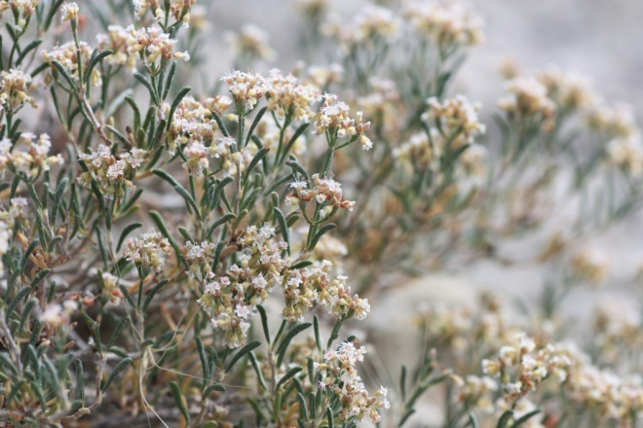

Figure1: Clay-loving wild buckwheat, *Eriogonum pelinophilum*. Photo USFWS, Alicia Langton July 2010.

### Alternate Names

### N/A

### Uses

### Clay-loving wild buckwheat, (*Eriogonum pelinophilum*) was first collected in 1958 near Hotchkiss, Colorado, in Delta County by Howard Gentry (U.S. Fish and Wildlife Service (USFWS, 1988). The species was first described by James Reveal in1973. Clay-loving wild buckwheat’s particularly long flowering period extends from May to early September with individual flowers lasting fewer than 3 days. Perhaps due to its extended flowering period or because it is the most abundant species in bloom in its habitat, clay-loving wild buckwheat flowers are visited by more than 50 species of pollinators in a season (Bowlin et al., 1992). Roughly half of these 50 species are native bees, and 18 species are native ants (USFWS, 2009). USFWS in its 5-year review of the species cited Tepedino (2011) noting that of all *Eriogonum* species studied to date, none has as many pollinators as clay-loving wild buckwheat.

### Edible buckwheat (Fagopyrum esculentum) is an important food crop originating from Eurasia and is in the same botanical family as clay-loving wild buckwheat. Although the common name alludes to it, clay-loving wild buckwheat has no association with wheat or cereal grains. There are no agricultural, economic, or other human uses of clay-loving wild buckwheat known at this time.

### Status

Clay-loving wild buckwheat was designated as endangered, with critical habitat, by the USFWS in 1984. In 2009, the USFWS completed a 5-year status review to update the status of the species. This review noted that the range of clay-loving wild buckwheat primarily stayed the same as when the recovery plan was completed in 1988 (USFWS, 2009) (some sites were destroyed while new sites were discovered) even though increases in species numbers were noted (from 10,000 known individuals to ~278,425 known individuals). The USFWS attributed these changes in population to increased survey efforts rather than species expansion (USFWS, 2009). The NatureServe conservation status rank an international effort which rank species on their “global” status, denotes clay-loving wild buckwheat as G2/S2- globally imperiled and statewide imperiled, with a high risk of extinction due to very restricted range, very few populations (often 20 or fewer), steep declines, or other factors (NatureServe, 2011).

### Description

*General*:

Buckwheat family (Polygonaceae). Clay-loving wild buckwheat is a long-lived low-growing, spreading sub-shrub, reaching up to 4 inches (10 centimeters) in height and 12 in (30 cm) across (Reveal, 2005). “Stems are spreading without persistent leaf bases up to 1/3the height of the plant; aerial flowering stems spreading to erect, slender, leaves, 1 per node” (Reveal, 2005). Leaves are dark green and appear needle-like with in-rolled margins (USFWS, 2009). Flowers are white to cream with reddish-brown midribs and brownish-red bases (USFWS, 2009), (Figure 2), petals all the same length. Fruits are achenes, light brown, 0.1 in (0.3 to 0.35 cm) and triangular in cross-section. Flowering occurs late May to early September.

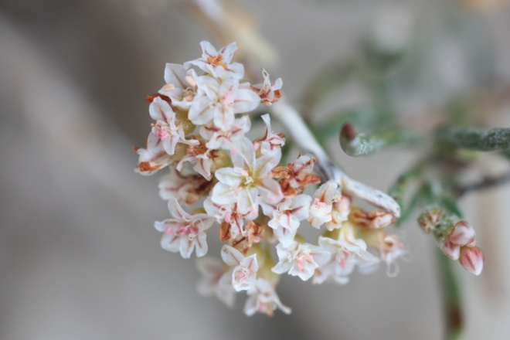

Clay-loving wild buckwheat may be distinguished from its close relatives *E. clavellatum* and *E. contortum,* according to Reveal (2005) and Spackman et al. (1997) as follows:

*E. clavellatum* is larger in stature and habit and has larger flowers up to 1.8 in (4.5 cm) with petals of two different lengths, *E. clavellatum* lacks the reddish-brown midribs and brownish-red bases and *E. clavellatum* is known to occur only in the Four Corners region (Weber, 1987). Attempts to separate the two genetically have been inconclusive.

*E. contortum* has yellow flowers and occurs farther north than *E. pelinophilum*, in Mesa and Garfield Counties in Colorado and in Grand County, Utah, (Spackman et al.,1997).

*Distribution*:

Clay-loving wild buckwheat is endemic to the rolling clay (adobe) hills and flats immediately adjacent to the communities of Delta and Montrose, of west-central Colorado. According to USFWS 5-year review (2009), citing information based on spatial data tracked by the Colorado Natural Heritage Program in 2009, the total global population of this species occurs roughly within an area that is 11.5 mi north to south and 28.5 mi east to west. Nearly 75% of the existing known populations and habitat for clay-loving buckwheat occur on private land (USFWS 2009). Please consult the USFWS website at www.fws.gov for a map of the species occurrence.

For current distribution, please consult the Plant Profile page for this species on the PLANTS Web site.

*Habitat*:

The habitat of clay-loving wild buckwheat consists of adobe clay badland hills and flats within the sparsely vegetated desert shrub community. This plant community includes the following clay-loving buckwheat plant associates: mat saltbush (*Atriplex corrugata*), black sagebrush (*Artemesia nova*), shadscale (*Atriplex confertifolia*), Gardner’s saltbush, (*Atriplex gardneri*), bud sagebrush (*Picrothamnus desertorum*), charming woodyaster, (*Xylorhiza venusta),* and Adobe Hills beardtongue (*Penstemon retrorsus*) (USFWS, 2009), (Rocky Mountain Herbarium, 2010).

**Adaptation**

Clay-loving wild buckwheat is adapted to the harsh growing conditions that include clay, alkaline, and calcareous soils of the Mancos shale formation, unique to west-central Colorado (Potter, 1985). The Mancos shale formation has been associated with high salts and selenium (USFWS, 2009), however no selenium accumulation information related to clay-loving wild buckwheat is known at this time. At elevations ranging from 5,180 to 6,350 ft., clay-loving wild buckwheat is generally found growing on the mid to lower slopes of the rolling topography of the adobe Mancos shale hills, also occurring in swales or drainages (USFWS, 2009). With an average annual total precipitation of 7-10 inches, clay-loving wild buckwheat is dependent upon the microclimates created by the small areas where snow lingers longer due to aspect, topography, and landscape position.

Figure 2: Clay-loving wild buckwheat, detailing the white to cream flowers with reddish-brown midribs and brownish-red bases Photo USFWS, Alicia Langton July 2010.

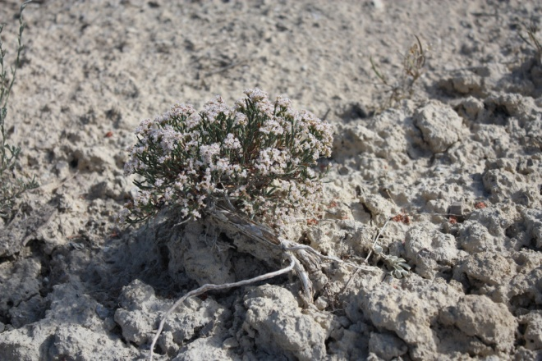

Figure 3: Clay-loving wild buckwheat harsh site conditions. Photo USFWS, Alicia Langton July 2010.

**Management**

Clay-loving wild buckwheat is a long-lived species, as demonstrated by static populations over the last 20 years, with recruitment of seedling plants being sporadic and infrequent (USFWS, 2009). Clay-loving wild buckwheat occurrences and suitable habitat continue to be threatened by growing development pressure and related expansion activities around the communities where it occurs. Additionally, 75% of the occupied habitat occurs on private lands. In Colorado, endangered plant species are not afforded protection unless a Federal nexus exists, such as canal development projects. Conservation efforts geared toward private lands would greatly benefit this species to prevent further isolation of the small existing populations most at risk from habitat fragmentation, thereby reducing the resiliency of these populations.

**Pests and Potential Problems**

Tent caterpillar impacts were noted on clay-loving buckwheat by Ferguson (2007).

### Environmental Concerns

The effects of climate change could pose continued uncertainty to the long term survival of clay-loving wild buckwheat populations. Due to the limited range of the Mancos shale formation and the long-lived nature of this species, its ability to migrate with changing climates is uncertain. Decreased or lack of flowering has been noted in association with the 1998 drought in the region, thereby causing concern that a lack of precipitation, during the growing and flowering season, could significantly impact seedling recruitment (USFWS, 2009).

### Seeds and Plant Production

Clay-loving wild buckwheat requires an insect pollinator in order to set seed, for both outcrossing and self-pollination (within a plant but not within a flower) (Bowlin et al. 1993, Tepedino et al., 2011). O’Kane in 1985 stated that “seed dispersal is usually passive, either being consumed or carried by animals, windblown, or moved by gravity or water.” “All *Eriogonum* species studied thus far have seeds that require a cold period to break dormancy (not necessarily a freeze), and some *Eriogonum* species have seeds with a 5-year shelf life (Reveal undated, cit. in O'Kane 1985).”

According to the Colorado Natural Areas Program life history study of clay-loving wild buckwheat, it appears that this species grows at highest densities away from other shrubs, such as black sagebrush *(Artemisia nova)* (CNAP, 1987). Other research in which individuals of clay-loving wild buckwheat were permanently tagged from 1990 to 2008 supports the conclusion that this species is relatively long-lived (20-30years minimum), (Lyon, 2008).

### References

Brown, T. A., A. Shrift. 1982. Selenium: Toxicity and Tolerance in Higher Plants. Biological Reviews. 1982, Vol. 57, pp. 59-84.

Bowlin, W.R., V.J. Tepedino, and T.L. Griswold. 1993. The reproductive biology of Eriogonum pelinophilum (Polygonaceae). Pages 296-302 in R. Sivinski and K. Lightfoot, editors. Southwestern rare and endangered plants. New Mexico Energy, Minerals and Natural Resources Department, Forestry and Resources Conservation Division, Miscellaneous Publication Number 2.

Cane, J.H. 2011 Personal Communication. USDA-ARS Pollinating Insect Research Lab

Utah State University, Logan, UT 84322 USA.

Chapman, S.S., G.E. Griffith, J.M. Omernik, A.B. Price, J. Freeouf, and D.L. Schrupp. 2006. Ecoregions of Colorado (color poster with map, descriptive text, summary tables, and photographs): Reston, Virginia, U.S. Geological Survey (map scale 1:1,200,000).

Center for Plant Conservation.

http://www.centerforplantconservation.org/. Accessed September 2011 at: http://www.centerforplantconservation.org/collection/CPC_ProfileImage.asp?fn=1773a.

Colorado Natural Areas Program (CNAP). 1987. Life history characteristics and habitat requirements for *Eriogonum pelinophilum* (clay-loving wild buckwheat-threatened): 1987 performance report. Unpublished report.

Ferguson, J.R. 2007. Summer 2007, Clay-loving buckwheat field surveys. Unpublished report for the Bureau of Land Management, Uncompahgre Field Office.

Flora of North America, eFlora. Accessed June 2011 at:http://www.efloras.org/florataxon.aspx?flora_id=1&taxon_id=250060457.

Lyon, P. 2008. Monitoring of *Eriogonum pelinophilum* at the Wacker Ranch Montrose, Colorado. Unpublished report prepared by the Colorado Natural Heritage Program, June 2008.

NatureServe. 2011. NatureServe. (2011). NatureServe Explorer: An online encyclopedia of life [web application]. Version 7.1. NatureServe, Arlington, Virginia. Available http://www.natureserve.org/explorer. (Accessed: September 25, 2011 ).

O'Kane, S. L. 1988. Colorado's Rare Flora. Great Basin Naturalist. 48(4):434-484.

O'Kane, S. L. Jr. 1985. Endangered Species Information System, Species Biology Workbook for *Eriogonum pelinophilum*. U.S. Fish and Wildlife Service.

Potter, L.D.; R.C. Jr. Reynolds, E.T. Louderbough, 1985. Mancos Shale and plant community relationships: field observations. Journal of Arid Environments. 9: 137-145.

Reveal, J.L. 2005. Flora of North America, www.eFloras.org: *Eriogonum*. Accessed on the internet May1, 2011.

Rocky Mountain Herbarium. www.rhm.uwyo.edu, 3/25/2010. Accessed July 2011, *E. pelinophilum* accession information on database.

Spackman, S., B. Jennings, J. Coles, C. Dawson, M. Minton, A. Kratz, and C. Spurrier. 1997. Colorado Rare Plant Field Guide. Prepared for the Bureau of Land Management, the U.S. Forest Service and the U.S. Fish and Wildlife Service by the Colorado Natural Heritage Program.

Tepedino, V.J., W.R. Bowlin, and T.L.Griswold. 2011. Diversity and Pollination Value of Insects Visiting the Flowers of a Rare Buckwheat (*Eriogonum pelinophilum*: Polygonaceae) in Disturbed and “Natural” Areas. Journal of Pollination Ecology, 4(8), 2011, pp57-67.

U.S. Fish and Wildlife Service (USFWS). 1988. Clay-loving Wild-buckwheat Recovery Plan. U.S. Fish and Wildlife Service, Denver, Colorado.

U.S. Fish and Wildlife Service (USFWS). 1984. Final rule to determine *Eriogonum pelinophilum* to be an endangered species. Federal Register 49(136): 28562-28565.

U.S. Fish and Wildlife Service (USFWS). 2009. Clay-loving Wild-buckwheat 5-year Review. U.S. Fish and Wildlife Service, Denver, Colorado.

USDA, Natural Resources Conservation Service, PLANTS Database [USDA PLANTS]. http://plants.usda.gov/. Accessed 2011.

Weber, W.A. 1987. Colorado Flora: Western Slope. Colorado Associated University Press, Boulder, Colorado. 530pp.

**Acknowledgements:**

Thank you for editorial and photo contributions from:

Anderson, David and the Botany Team with the Colorado Natural Heritage Program, CSU, Fort Collins, Co.

Denver Botanic Garden, Herbarium. Denver, Co.

Cane, Jim. USDA-ARS Pollinating Insect Research Lab Utah State University, Logan, UT

Lederer, N. University of Colorado Herbarium, Boulder, Co.

Nelson, E. Rocky Mountain Herbarium. University of Wyoming, Laramie, WY.

O’Kane, Steve L. Jr. University of Northern Iowa, Cedar Falls, IA.

**Prepared By**:

Christine Taliga, USDA NRCS Colorado State Office, Denver, Co., and Gina Glenne, USFWS, Mountain-Prairie Region, Grand Junction, Colorado.

### Citation

Taliga, Christine E., Glenne, Gina, 2011. Plant Guide for clay-loving wild buckwheat (*Eriogonum pelinophilum)*. USDA-Natural Resources Conservation Service, Colorado State Office. Denver, CO 80225-0426.

Published *September, 2011*

### Edited: 18Sep2011 cet; 22Sep2011 fws, 22Sep2011 jab, 22Sep2011cnhp, 23 Sep2011cga, 23Sep2011jsj

For more information about this and other plants, please contact your local NRCS field office or Conservation District at [http://www.nrcs.usda.gov/](http://www.nrcs.usda.gov/%20) and visit the PLANTS Web site at [http://plants.usda.gov/](http://plants.usda.gov/%20) or the Plant Materials Program Web site <http://plant-materials.nrcs.usda.gov.>

PLANTS is not responsible for the content or availability of other Web sites.

**USDA IS AN EQUAL OPPORTUNITY PROVIDER AND EMPLOYER**