|  |  |
| --- | --- |
| **Natural Resources Conservation Service** | Plant Guide |

# spike lovegrass

## Eragrostis spicata Vasey

Plant Symbol = ERSP2

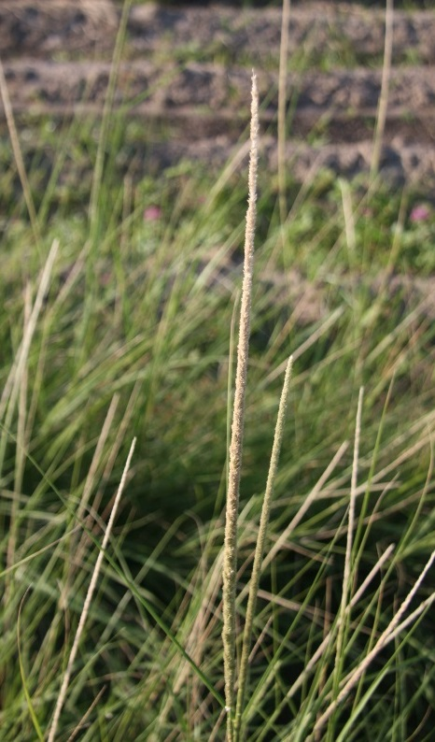

Spike lovegrass, photo by South Texas Natives

### Description

*General*: Spike lovegrass (*Eragrostis spicata* Vasey) is a caespitose, robust perennial with short rhizomes. Culms are unbranched, erect, and glabrous, growing 80-120 cm (31-47 in) tall. The leaf blades are 2-7.5 mm (0.08-0.29 in) wide, 25-40 cm (9-16 in), and are flat, rolled (when desiccated), or involute. Leaf color is grayish green and leaves are glabrous with serrate margins. Ligules are a 0.5 mm (0.2 in) fringed membrane. Inflorescence sheaths are glabrous to ciliate-pilose near the ligules. Panicles range 20-50 cm (7-20 in) in length by 5 mm (0.2 in) wide, and are spike-like, linear, and have several branches per node. The spikelets are densely imbricate. Spikelets are small, less than 1 mm (0.03 in). (Everitt et al. 2011). There are about 4,000,000 seeds per 0.45 kg (lb).

*Distribution*: Spike lovegrass is found from South Texas into Mexico, Paraguay, and Argentina. For current distribution, please consult the Plant Profile page for this species on the PLANTS Web site.

**Adaptation**

Spike lovegrass is found in moist areas in clay or clay loam soils throughout South Texas. Spike lovegrass is well adapted to saline or alkaline soil conditions common in western South Texas.

### Uses

### Spike lovegrass is recommended for wildlife plantings since it provides good cover for birds and small mammals as well as providing seed for graminivorous bird species. It can also be used in range plantings because it has the ability to recover from defoliation and reseeds itself.

### Spike lovegrass is useful for critical site revegetation and bank stabilization because of the dense vegetation near the soil surface which helps stabilize the soils. This is especially benefical for saline and alkaline sites. It is a native species that is well adapted to moist soil areas and saline soils resulting from oil and gas production activities and pipeline right-of-way construction.

### Status

Please consult the PLANTS Web site (<http://plants.usda.gov/>) and your State Department of Natural Resources for this plant’s current status (e.g., threatened or endangered species, state noxious status, and wetland indicator values).

### Planting Guidelines

Seedbed preparation should begin well in advance of planting. Planting is done in late fall or spring in South Texas. Establish a clean, weed-free seedbed by either tillage or herbicides. Prior to planting, the site should be firm and have accumulated soil moisture. Spike lovegrass is seeded using a drill or broadcast seeder. If broadcast seeded, some type of additional coverage such as culti-packing or light dragging is recommended to ensure good seed-to-soil contact.

Seed is planted 1/8 to 1/4 inch deep. It is better to plant too shallow than too deep. For calibration purposes, spike lovegrass contains approximately 4,000,000 seeds per bulk pound. A seeding rate of 0.5-1 pounds pure live seed (PLS) per acre is recommended for establishment of pure stands; when used as part of a seeding mixture the seeding rate should be adjusted according to the desired percentage of the plant on the planting site.

### Management

Areas planted to spike lovegrass should be deferred form grazing until plants become established and are allowed to set seed. Established plants should be allowed to produce seed annually.

### Pests and Potential Problems

There are no potential pests or problems with this species.

### Environmental Concerns

There are no evnirontmental concerns associated with this species.

### Two rows of tall and thin spike lovegrass plants with thin green seedheads.

Seed increase field of Ramadero Germplasm spike lovegrass, photo by South Texas Natives

### Seeds and Plant Production

Seed production can be started from transplants or direct seeded on beds or flat ground. Well maintained transplant plot can be expected to produce a marketable crop in the first production year, however the majority of a direct seeded plot will not mature during the first season. Seed is best harvested using a Woodward Flail-Vac Seed Stripper (Ag-renewal, Inc., Weatherford, Oklahoma). Following harvest trash can be removed using a Clipper seed cleaner (A. T. Farrell, Bluffton, Indiana).

Over three years, plots of about 200 plants in South Texas produced an average of 1.1 PLS pound of seed annually and averaged an extremely high percent of pure live seed (93.6%). Yields were estimated at 80 pounds of PLS per acre per year on 36” bedded rows with a plant population of 14,000 plants per acre (plants established using transplants spaced 1’).

### Cultivars, Improved, and Selected Materials (and area of origin)

Ramadero Germplasm spike lovegrass (TX) was cooperatively released by the E. “Kika” de la Garza Plant Material Center and *South Texas Natives* in 2015. It was selected for its vigor, forage production, and seed quality thoughout the intended area of use. Ramadero Germplasm is recommended for use in Rio Grande Plains (MLRA 83A, B, C and D), Coastal Sand Plain (MLRA 83 E) and Gulf Coast Prairies and Marshes of Texas (MLRA 150A and B) in critical site revegetation and for inclusion in range seeding mixes. Ramadero Germplasm is adapted to clay and clay loam soils, including saline clay soils in the Rio Grande Plains. Spike lovegrass does not naturally occur north of the Rio Grande Plains in North America, and use of the species beyond this limit of distribution of the species is unlikely to be successful.

**Literature Cited**

Everitt, J.H., D.L. Drawe, C.R. Little, and R.I. Lonard. 2011. Grasses of South Texas. Texas Tech University Press. Lubbock, TX.

### Citation

Maher S., and J. Reilley. 2015. Plant guide for spike lovegrass (*Eragrostis spicata*). USDA-Natural Resources Conservation Service, E. “Kika” de la Garza Plant Materials Center. Kingsville,TX.

Published August 2015

For more information about this and other plants, please contact your local NRCS field office or Conservation District at <http://www.nrcs.usda.gov/> and visit the PLANTS Web site at <http://plants.usda.gov/> or the   
Plant Materials Program Web site:

<http://plant-materials.nrcs.usda.gov>.

PLANTS is not responsible for the content or availability of other Web sites.

***Helping People Help the Land***

**USDA IS AN EQUAL OPPORTUNITY PROVIDER AND EMPLOYER**