|  |  |
| --- | --- |
| **Natural Resources Conservation Service** | Plant Guide |

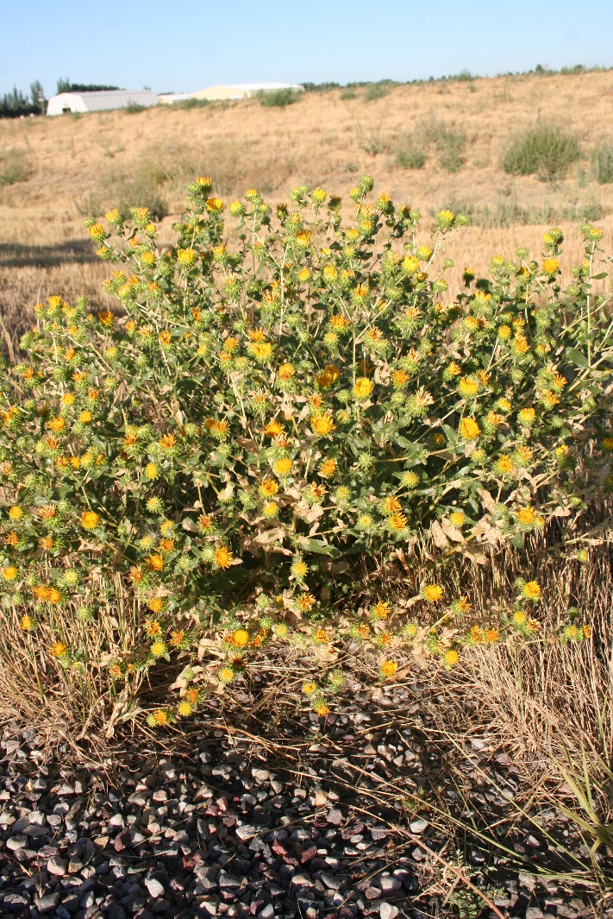

##### Figure 1. Curlycup gumweed growing in a disturbed roadside.

**CURLYCUP GUMWEED**

**Grindelia squarrosa** (Pursh) Dunal

Plant Symbol = GRSQ

*Common Names:* Tarweed; resinweed; rosinweed

*Scientific Names:* None

### Description

*General*: Composite family (Asteraceae). Curlycup gumweed is a short-lived perennial, or biennial forb averaging 1 to 3 feet high. Numerous branching stems bear alternately arranged leaves, typically 1 to 4 inches long with entire to serrate or even somewhat lobed margins. The flower heads are radiate with 25 to 40 yellow rays and a yellow center. The involucural bracts are squarrose-reflexed, or strongly rolled back, and highly resinous. The fruit is a 2.5 to 3 mm long achene bearing 2 to 3 pappus awns (Welsh et al., 2003). Flowering occurs in mid- to late-summer, typically beginning in July and continuing through August and into September. Occasional plants will be seen with flowers persisting into November.

There are currently three varieties recognized by the PLANTS database, including var. *quasiperennis*, var. *serrulata*, and var. *squarrosa*. Variety *quasiperennis* is a true short-lived perennial with largely entire leaf margins. The other two varieties, both biennials, can be separated by their leaf width to length ratio, with var. *squarrosa* having upper stem leaves 2 to 4 times longer than broad, and oblong in outline, and var. *serrulata* having upper stem leaves much narrower, 5 to 8 times longer than broad, and narrowly oblong in outline (Welsh et al., 2003).

*Distribution*: Curlycup gumweed is native throughout North America with the exception of the southeastern states. For current distribution, please consult the Plant Profile page for this species on the PLANTS Web site.

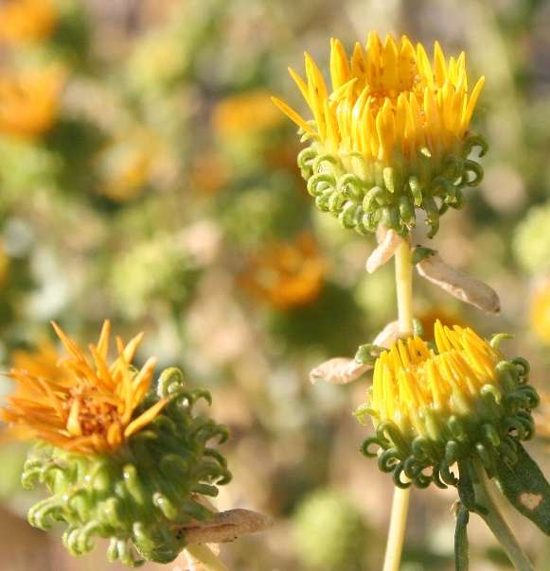

##### Figure 2. Close-up of curlycup gumweed flower head showing strongly reflexed involucural bracts.

*Habitat*: Curlycup gumweed inhabits a variety of arid plant communities including sagebrush steppe, desert grasslands, prairies and mountain shrub chaparral (Walsh, 1993). It is very commonly found in disturbed roadsides, open fields and in poorly managed pastures and rangelands.

***Adaptation***

Curlycup gumweed is adapted to disturbed sites receiving 10 to 20 inches mean annual precipitation. This species is most commonly found in rocky, gravelly soils of disturbed roadsides, but can be found in heavier silty clay loam soils to sandy loams. Curlycup gumweed is adapted to neutral to moderately saline conditions. It is very commonly found growing in sites occupied by non-native grasses such as cheatgrass (*Bromus tectorum*) and crested wheatgrass (*Agropyron cristatum*).

### Uses

*Pollinators:*

This species is highly attractive to native bees. ARS Bee Research Laboratory records indicate visitations by species from over 40 genera of native bees (Ikerd, 2016). Its drought tolerance and late-season flowering make it especially valuable for CRP and other range plantings in the arid west where late-blooming forbs are limited.

Curlycup gumweed is also readily visited by European honeybees; however, honey produced from this species has an inferior flavor and can lower the grade (Dalby, 1999). The pollen is considered more valuable than the nectar, as bees visit the plants late in the season to build pollen reserves for winter (Dalby, 1999).

*Wildlife:*

Curlycup gumweed has been observed being consumed by sage-grouse. Twenty-eight percent of monitored sage-grouse chicks between 5 and 8 weeks of age were reported eating curlycup gumweed in central Montana.  Curlycup gumweed made up 3 percent by volume of crop contents.  It was used by 39 percent of 9 to 12 week old chicks and made up 4 percent of crop contents.  It was not used by chicks younger than 5 weeks old (Peterson, 1970).

*Livestock:*

Curlycup gumweed offers little forage value and is largely unpalatable to cattle, sheep, and horses, though sheep will occasionally crop flower heads in the absence of other forage (Johnson and Nichols, 1970). Tannins, volatile oils, resins, bitter alkaloids, and glucosides give curlycup gumweed an unpleasant taste (Bare, 1979). Cattle, sheep, and goats will occasionally graze Curlycup gumweed in its rosette stage of growth.

### Ethnobotany

The resin of curlycup gumweed contains many medicinally beneficial compounds. Native Americans used this species for a variety of ailments. A decoction of root was used for liver trouble. (McClintock, 1909), and a paste made from flowering tops was applied to skin diseases, scabs and sores (Hart, 1992).

### Status

*Threatened or Endangered*: No.

*Wetland Indicator:* Curlycup gumweed is considered to be a Facultative Upland (FACU) species (usually occurs in non-wetlands (estimated probability 67%-99%), but occasionally found in wetlands (estimated probability 1%-33%) or Obligate Upland (UPL) species (occurs in wetlands in another region, but occur almost always (estimated probability >99%) under natural conditions in non-wetlands in the region specified).

*Weedy or Invasive:*

Although this species is native to North America, it can have weedy or invasive characteristics under improper management (Stubbendieck et al, 1994; Whitson et al., 1996). It has become a problematic weed in Eastern Europe (Sirbu and Oprea, 2008). Please consult with your local NRCS Field Office, Cooperative Extension Service office, state natural resource, or state agriculture department regarding its status and use.

Please consult the PLANTS Web site (<http://plants.usda.gov/>) and your state’s Department of Natural Resources for this plant’s current status (e.g., threatened or endangered species, state noxious status, and wetland indicator values).

### Planting Guidelines

### Tests conducted at Aberdeen Plant Materials Center indicate there are approximately 400,000 seeds/lb and 39 lbs/bushel. Based on a seeding rate of 50 pure live seeds (PLS) per foot, the full stand seeding rate is 5 lbs/ac. Seeding rate should be adjusted to match the desired percentage within a seed mixture.

McDonough (1975) showed that curlycup gumweed exhibited seed germination polymorphism. Disc achenes (those from the center of the flower) germinated more rapidly and attained higher final germination percentages than did ray achenes (those from the outer, petal-like flowers). It is believed that this allows germination and emergence to occur during different seasons, and subsequently affects the time required for completion of the growth cycle.

### Management

Due to its low moisture requirements and limited palatability, curlycup gumweed increases under drought conditions in irrigated pasture as well as under poor grazing management practices, and is often associated with pastures and range that have been over grazed. Curlycup gumweed should be used as a minor component of pollinator and restoration seed mixtures. Management strategies should be based on the key species in the established plant community. Grazing should be deferred on seeded lands for at least two growing seasons to allow for full stand establishment (Ogle et al., 2011).

### Pests and Potential Problems

Curlycup gumweed has been shown to have the capacity to serve as a host plant of the Colorado red node virus of bean (Thomas, 1949). It may also have the ability to accumulate selenium from the soil and become toxic to livestock (SDSU, 2016)

### Environmental Concerns

### Curlycup gumweed is native to western North America. It will spread under favorable conditions but does not pose any environmental concern to native plant communities under proper management. Due to its ability to readily occupy disturbed sites, it has been associated with other rangeland weeds (Whitson et al., 1996).

### Control

Early season treatments (June) with broadleaf selective herbicides such as metsulfuron, 2,4-D, or dicamba produced better than 95% control of curlycup gumweed, while later treatments (August) yielded slightly lower results (Ferrell and Whitson, 1987).

Contact your local agricultural extension specialist or county weed specialist to learn what works best in your area and how to use it safely. Always read label and safety instructions for each control method. Trade names and control measures appear in this document only to provide specific information. USDA NRCS does not guarantee or warranty the products and control methods named, and other products may be equally effective.

### Seeds and Plant Production

Small scale production fields and wildland collections can be made by beating the seeds off the plant into a bin or bag, or by clipping the flower heads. Seed is cleaned by running the collected material through a hammer mill followed by sieving and air-screening. Seed often contains small grubs. Placing the seed in a freezer for 24 hours may help eliminate seed eating insects.

Nuzzo (1978) used a 10 week moist stratification for propagating curlycup gumweed. She reported first germination occurred after 3 days and peak germination occurred after 14 days. Plants were ready to transplant into the field after 10 weeks.

Two similar species, *Grindelia camporum* and *G. stricta*, are grown for seed production in California. Both have very sticky vegetation like curlycup gumweed. Fields are direct combined; however the gum must be scraped off of the combine and machine parts every so often to keep it working effectively. The seeds separate from the seed head quite readily. Deer are very fond of the young vegetation and may pose a problem in production settings (Emily Allen, Hedgerow Farms Personal communication 2016).

### Cultivars, Improved, and Selected Materials (and area of origin)

### Limited quantities of wildland collected seed may be available from commercial sources. There are currently no commercial releases of curlycup gumweed; however multiple accessions are currently under investigation at Aberdeen Plant Materials Center for potential release. Seed sources should be selected based on the local climate, resistance to local pests, and intended use. Consult with your local land grant university, local extension or local USDA NRCS office for recommendations for use in your area.

**Literature Cited**

Allen, E. 2016. Hedgerow Farms, Winter CA. Personal Communication.

Bare, J.E. 1979. Wildflowers and weeds of Kansas. Lawrence, KS: The Regents Press of Kansas. 509p.

Dalby, R. 1999. Minor bee plants in a major key: gum weed, common mallow, and alfileria. American Bee Journal. 139(11): 855-856.

Ferrell, M.A.; Whitson, T.D. 1987. Evaluation of curlycup gumweed control with spring vs. fall herbicide applications. Proceedings of the western society of weed science. 40: 72-73.

Hart, Jeff, 1992, Montana Native Plants and Early Peoples, Helena. Montana Historical Society Press, page 32

Ikerd, H. 2016. USDA-ARS Bee Research Laboratory, Logan, Utah. Insect Visitation Database Manager. Personal Communication.

Johnson, James R.; Nichols, James T. 1970. Plants of South Dakota grasslands: A photographic study. Bull. 566. Brookings, SD: South Dakota State University, Agricultural Experiment Station. 163 p.

McClintock, Walter, 1909, Medizinal- Und Nutzpflanzen Der Schwarzfuss Indianer, Zeitschriff fur Ethnologie 41:273-9.

McDonough, W.T. 1975. Germination polymorphism in *Grindelia squarrosa*. Northwest Science. 49(4): 190-200.

Peterson, J.G. 1970. The food habits and summer distribution of juvenile sage grouse in central Montana. Journal of Wildlife Management. 34(1): 147-155.

Nuzzo, V. 1978. Propagation and planting of prairie forbs and grasses in southern Wisconsin. Dane County Highway Department. Madison, WI. In: Glenn-Lewin, D.C. and R.Q. Landers. Fifth Midwest Prairie Conference Proceedings: Iowa State University. Ames, IA. August 22-24, 1976.

Nyamusamba, R. 2016. Controlling curlycup gumweed (*Grindelia squarrosa*). South Dakota State University Extension. 2016. <http://igrow.org/livestock/beef/controlling-curlycup-gumweed-grindelia-squarrosa/>

Ogle, D., St. John, L. Stannard, M. and L. Holzworth. 2011. Technical Note 24: Conservation plant species for the Intermountain West. USDA-NRCS, Boise, ID-Salt Lake City, UT-Spokane, WA. ID-TN 24. 57p.

Peterson, J.G. 1970. The food habits and summer distribution of juvenile sage grouse in central Montana. Journal of Wildlife Management. 34(1): 147-155.

Sîrbu, C.; Oprea, A. 2008. Two alien species in the spreading process in Romania: *Reynoutria* × *bohemica* Chrtek & Chrtková and *Grindelia squarrosa* (Pursh) Dunal. Cercetari agronomice în moldova. 41 (2): 41-50.

Stubbendieck, J., G.Y. Friisoe, and M.R. Bolick. 1994. Weeds of Nebraska and the Great Plains. Nebraska Department of Agriculture, Bureau of Plant Industry. Lincoln, Nebraska.

Thomas, W.D. 1949. Studies on the host range of the Colorado red-node virus. Journal of the Colorado-Wyoming Academy of Science. 4 (1): 40 p.

Walsh, R.A. 1993. *Grindelia squarrosa*. In: Fire Effects Information System, [Online]. USDA, Forest Service, Rocky Mountain Research Station, Fire Sciences Laboratory.

Welsh, S.L., Atwood, N.D., Goodrich, S., and L.C. Higgins. 2003. A Utah Flora. Third Edition, revised. Brigham Young University, Provo, UT.

Whitson, T.D. (ed.), Burrill, L.C., Dewey, S.A., Cudney, D.W., Nelson, B.E., Lee, R.D. and R. Parker. 1996. Weeds of the West. Western Society of Weed Science in cooperation with Cooperative Extension Services, University of Wyoming. Laramie, Wyoming.

### Citation

Tilley, D. and T. Pickett. 2016. Plant Guide for curlycup gumweed (*Grindelia squarrosa)*. USDA-Natural Resources Conservation Service, Aberdeen Plant Materials Center. Aberdeen, ID. 83210.

Published: December 2016

[Edited:](#edited" \o "[e.g., 08Sep2009 rg, 08Sep2009 jfh; 17Sep2009 mws]  NOTE:  Please remove the brackets if no editing data exists (new document).1) The author is the person(s) who did the majority of the work and should not exceed 2 people. Names should not be added to updated PGs unless significant rewrites are done. If a substantial rewrite is done the citation should be adjusted as follows:Original authors name, title, [add ed. (rev) Editor name. new pub date], remainder of citation remains the same.Example:  Pavek, P.L.S. 2012. Plant guide for pea (Pisum sativum L.). ed. (rev) E.R. Garner. 2014. USDA-Natural Resources Conservation Service, Pullman, WA.2) If minor updates or revisions are made it is only in the edited by section. Retain the most recent 5-10 edits.3) Names should not be removed regardless of death or retirement.)

For more information about this and other plants, please contact your local NRCS field office or Conservation District at <http://www.nrcs.usda.gov/> and visit the PLANTS Web site at <http://plants.usda.gov/> or the   
Plant Materials Program Web site:

<http://plant-materials.nrcs.usda.gov>.

PLANTS is not responsible for the content or availability of other Web sites.

The U.S. Department of Agriculture (USDA) prohibits discrimination against its customers, employees, and applicants for employment on the bases of race, color, national origin, age, disability, sex, gender identity, religion, reprisal, and where applicable, political beliefs, marital status, familial or parental status, sexual orientation, or all or part of an individual's income is derived from any public assistance program, or protected genetic information in employment or in any program or activity conducted or funded by the Department. (Not all prohibited bases will apply to all programs and/or employment activities.)

If you wish to file an employment complaint, you must contact your agency's [EEO Counselor](http://www.ascr.usda.gov/doc/EEO_Counselor_List.pdf) (PDF) within 45 days of the date of the alleged discriminatory act, event, or in the case of a personnel action. Additional information can be found online at <http://www.ascr.usda.gov/complaint_filing_file.html>.

If you wish to file a Civil Rights program complaint of discrimination, complete the [USDA Program Discrimination Complaint Form](http://www.ocio.usda.gov/sites/default/files/docs/2012/Complain_combined_6_8_12.pdf) (PDF), found online at <http://www.ascr.usda.gov/complaint_filing_cust.html>, or at any USDA office, or call (866) 632-9992 to request the form. You may also write a letter containing all of the information requested in the form. Send your completed complaint form or letter to us by mail at U.S. Department of Agriculture, Director, Office of Adjudication, 1400 Independence Avenue, S.W., Washington, D.C. 20250-9410, by fax (202) 690-7442 or email at [program.intake@usda.gov](mailto:program.intake@usda.gov).

Individuals who are deaf, hard of hearing or have speech disabilities and you wish to file either an EEO or program complaint please contact USDA through the Federal Relay Service at (800) 877-8339 or (800) 845-6136 (in Spanish).

Persons with disabilities who wish to file a program complaint, please see information above on how to contact us by mail directly or by email. If you require alternative means of communication for program information (e.g., Braille, large print, audiotape, etc.) please contact USDA's TARGET Center at (202) 720-2600 (voice and TDD).

For any other information dealing with Supplemental Nutrition Assistance Program (SNAP) issues, persons should either contact the USDA SNAP Hotline Number at (800) 221-5689, which is also in Spanish or call the [State Information/Hotline Numbers](http://www.fns.usda.gov/snap/contact_info/hotlines.htm).

For any other information not pertaining to civil rights, please refer to the listing of the [USDA Agencies and Offices](http://www.usda.gov/wps/portal/usda/usdahome?navtype=MA&navid=AGENCIES_OFFICES_C) for specific agency information.

***Helping People Help the Land***

**USDA IS AN EQUAL OPPORTUNITY PROVIDER AND EMPLOYER**