|  |
| --- |
| Utah Sweetvetch |
| *Hedysarum boreale* Nutt. |
| Plant Symbol = HEBO |

Contributed by: Upper Colorado Environmental Plant Center

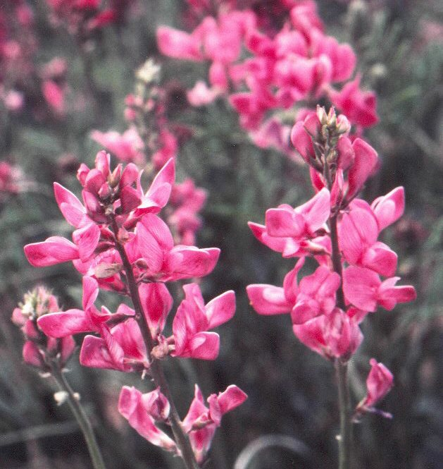

UCEPC, Meeker, Colorado

Alternate Names

Northern sweetvetch, chain-pod, northern sweet broom

Uses

*Grazing/Rangeland/Wildlife:* Utah sweetvetch can beused as a complimentary species in rangeland seedings. It is considered succulent and its foliage is highly nutritional and palatable to livestock and big game, including bison, deer, elk, and moose. It remains succulent throughout the growing season and some basal leaves can remain green through the winter. Utah Sweetvetch also provides important habitat attributes for sage grouse. It has been rated as medium for cover value and excellent for food value. The colorful flowers of Utah sweetvetch are utilized by honeybees, which are essential for setting seed.

*Erosion Control:* Utah sweetvetch is a good soil stabilizer. It provides good roadside stabilization as well as beautification.

*Reclamation****:***Utah sweetvetch is a legume capable of fixing nitrogen from the atmosphere (Nitrogen fixation is a process whereby inorganic nitrogen-N2 found in the atmosphere is converted into organic compounds usable by the plant with the aid of Rhizobia bacteria). Eventually, this nitrogen is released into the soil, thereby, improving soil quality. There are a limited number of native legumes to use in land reclamation and range improvement. Utah sweetvetch can be used to help fulfill this need.

*Ornamental Landscaping:* Utah sweetvetch can be used for beautification and diversity in areas of low maintenance and low precipitation. It is especially suitable for xeriscaping and roadside beautification.

*Ethnobotany*: The roots of Utah sweetvetch and other sweetvetches have been documented to be used as food by northern tribes, and also as a substitute for licorice.

Status

Please consult the PLANTS Web site and your State Department of Natural Resources for this plant’s current status (e.g. threatened or endangered species, state noxious status, and wetland indicator values).

Description

*General*: Pea Family (Fabaceae). Utah sweetvetch is a native perennial, cool season, herbaceous legume with deep taproots and several lateral roots, sometimes rhizomatous. Its deep taproots allow the plant to extract deep soil moisture and nutrients resulting in significant drought resistance and winter hardiness. The main stems arise from a woody crown and may grow 1 to 2 feet tall. The leaves are compound (two or more leaflets) and hairless. Flowers can be pink, purple, or white arranged in a loose raceme. Seeds develop in a long constricted pod, with several sections. Each section contains one brown kidney-shaped seed.

*Distribution*: Utah sweetvetch is common and widely distributed in the Intermountain West, Montana, south to Colorado and Utah. For current distribution, please consult the Plant Profile page for this species on the PLANTS Web site.

*Habitat*: Utah sweetvetch can be found in the mountain brush, ponderosa pine, pinyon-juniper and big sage brush vegetative zones.

Adaptation

Utah sweetvetch can grow on clayey or sandy soils, however, is more adaptable to well-drained loamy soils. It is most often found on moderately saline or alkaline soils, but will grow on moderately acidic to neutral soils. Utah sweetvetch is usually found at elevations between 4000 to 8000 feet, in precipitations zones receiving 10 to 18 inches of moisture annually. It grows best with 15 inches or more of precipitation and minimum competition.

Establishment

Utah sweetvetch can be grown from seed. Planting should be done in early spring or late fall. Fall planting is preferable to take advantage of natural weather conditions during winter to get proper germination. Seed scarification will ensure water up-take by the seeds and provide better germination. Drill seed at about ¼ to ½ inch deep. Inoculation with the proper rhizobium will enhance nitrogen fixation. Germination occurs within 6 to 30 days. It is recommended that Utah sweetvetch be either seeded with less competitive species when used in mixtures or seeded separately in alternating rows.

Management

Reduce or withhold stocking during establishment and avoid overuse after establishment to maintain a healthy stand. Utah sweetvetch is moderately to fairly tolerant of grazing.

Pests and Potential Problems

Utah sweetvetch is subject to root-rots, seed pod insects and some rust. Chemical insect control may be necessary in seed production fields to prevent infestation of bruchid weevil larvae in developing seed. Rabbits, grasshoppers, and crickets can also become problems by reducing plant stand.

Environmental Concerns

Some plant sources of Utah sweetvetch have been reported to spread rhizomatously. However, Utah sweetvetch, as a native plant, has moderate competiveness.

**Seed Production**

*Spacing:* For seed production, 10 pure live seeds per linear foot of row, or 3 to 4 pure live seeds planted in hills 2 to 4 feet apart is recommended.

*Fertilization:* About 30 pounds of available phosphate per acre every other year might be needed, depending on soil test.

*Irrigation*: Irrigate to get plants established, and thereafter as needed depending upon soil moisture. Fifteen to eighteen inches of precipitation and irrigation is recommended. Avoid sprinkler irrigation during flowering and pollination. A minimum of two irrigations is recommended prior to flowering and during seed fill.

*Weed Control:* Mechanical or chemical control is needed to keep fields as weed free as possible.

*Pollination:*  Bees and bumblebees are needed for pollination*.*

*Harvesting:* Seeds can be harvested with a combine.

*Yields*: No seed is produced the first season. However, 10 to 35 percent can be expected the second year and full production on the third year. Properly managed fields can produce up to 250 pounds of cleaned seed per acre. A production field can be expected to remain in production for eight years or more. Optimum seed yields occur every other year.

*Seeds per Pound*: Seed counts are variable ranging from 34,000 to 100,000 depending on seed source.

*Seed After-ripening:*  Maximum germination is not reached for one to two months following seed harvest.

*Seed Longevity:* Seeds can be viable for six years or more, when stored in a cool dry place.

Cultivars, Improved, and Selected Materials (and area of origin)

‘Timp’ Utah Sweetvetch (*Hedysarum boreale* Nutt.) is a seed-propagated cultivar. The genetic material originated from two sources: (1) a site at the base of the Wasatch Mountains and east of Orem County in Utah, and (2) a single-plant selection made by Dr. Robin Cuany. ‘Timp’ was selected based on its seedling vigor, site adaptability, persistence, seed production, dinitrogen fixation, and stability. It was released in 1994 by Upper Colorado Environmental Plant Center, Utah Division of Wildlife Resources, Colorado State University Agricultural Experiment Station, Utah State University Agricultural Experiment Station, and USDA-Soil Conservation Service.

‘Timp’ Utah sweetvetch is adapted to a wide range of soil types, however, performs better in well-drained loamy soils. It has proven acceptable performance where the annual precipitation ranges from 12 to 18 inches.

‘Timp’ certified seed is available commercially and breeder seed is maintained at Upper Colorado Environmental Plant Center.

Contact your local Natural Resources Conservation Service office for more information. Look in the phone book under”United States Government”. The Natural Resources Conservation Service will be listed under the subheading “Department of Agriculture.”

References

Anderson B. A and A. H. Holmgren. 1985. *Mountain Plants of Northeastern Utah.*  Utah State University Extension Services Logan. Circular 319

Harrington, H. D. 1979. *Manual of the plants of Colorado.* 2nd ED. Swallow Press, Inc., Chicago, IL Chicago, IL. 666 pp.

Institute for Land Rehabilitation. 1979. *Selection, Propagation, & Field Establishment of Native Plant Species on Disturbed Arid Lands.* Utah Agricultural Experiment Station. Bull. 500.

Kingery J., A. Cotter, and K. Moseley. 2003. *Idaho Roadside Revegetation Handbook.* Department of Rangeland Ecology and Management University of Idaho.

Larson G. E. and J.R. Johnson. 1999. *Plants of the Black Hills and Bear Lodge Mountains.* South Dakota State University College of Agricultural & Biological Sciences, South Dakota Agricultural Experiment Station. 608 pp

Metcalf S., C. Jones, and L. Holzworth. 2006. *Symbiotic Nitrogen Fixation and Establishment of Six Montana Native Legume Species.* USDA-NRCS Plant Materials Technical Note No. MT-54.

Monsen S.B. 2005. *Restoration Manual for Colorado Sagebrush and Associated Shrubland Communities*. Colorado Division of Wildlife Department of Natural Resources.

Plummer, A.P., D.R. Christensen, and S.B. Monsen. 1968. *Restoring Big Game Range in Utah.* Utah Division of Fish and Game. Publication No. 68-3.

Redente E.F. 1982. *Sweetvetch Seed Germination.* Journal of Range Management 35(4).

Stevens R., K. R. Jorgensen, S.A. Young, and S.B. Monsen. 1996.  *Forb and Shrub Seed Production Guide for Utah.*  Utah State University Extension. AG 501

Upper Colorado Environmental Plant Center. 1994. *Notice of Naming and Release of ‘Timp’ Utah Sweetvetch (Hedysarum boreale Nutt.) for Soil Improvement and Early Spring Forage for both Wildlife and Livestock.*

USDA-NRCS, 2006. The PLANTS Database(<http://plants.usda.gov>) National Plant Data Center, Baton Rouge, LA 70874-4490 USA.

Wasser, C. H. 1982. *Ecology and Culture of Selected Species Useful in Revegetating Disturbed Lands in the West.*  U.S. Dept. of the Interior, Fish and Wildlife Service. FWS/OBS-82/56.

Prepared By & Species Coordinator

*Manuel Rosales,* USDA NRCS Upper Colorado Environmental Plant Center, Meeker, Colorado

Edited: 070814 jsp

For more information about this and other plants, please contact your local NRCS field office or Conservation District, and visit the PLANTS Web site<<http://plants.usda.gov>> or the Plant Materials Program Web site <<http://Plant-Materials.nrcs.usda.gov>>

*The U.S. Department of Agriculture (USDA) prohibits discrimination in all its programs and activities on the basis of race, color, national origin, sex, religion, age, disability, political beliefs, sexual orientation, and marital or family status. (Not all prohibited bases apply to all programs.) Persons with disabilities who require alternative means for communication of program information (Braille, large print, audiotape, etc.) should contact USDA's* [*TARGET Center*](http://www.usda.gov/oo/target.htm) *at 202-720-2600 (voice and TDD).*

*To file a complaint of discrimination write USDA, Director, Office of Civil Rights, Room 326-W, Whitten Building, 14th and Independence Avenue, SW, Washington, DC 20250-9410 or call 202-720-5964 (voice or TDD). USDA is an equal opportunity provider and employer.*

*Read about* [*Civil Rights at the Natural Resources Conservation Service*](http://www.nrcs.usda.gov/about/civilrights/).