

Plant Guide

# oneflower helianthella

## Helianthella uniflora (Nutt.) Torr. & A. Gray

Plant Symbol = HEUN

*Contributed by*: USDA NRCS Idaho Plant Materials Program

### oneflower sunflower

### Oneflower helianthella. Teresa Prendusi. USDA-FS.

### Alternate Names

*Common Alternate Names*:

Onehead sunflower, Little sunflower

### Uses

*Range:*

Oneflower helianthella is a valuable rangeland forb. The leaves, flowers and tender portions of the stems are eaten by all classes of grazing animals. Palatability of oneflower helianthella is rated as fair to very good for sheep and fair for cattle (USDA 1937). It is grazed primarily in summer when the vegetative tissues are soft, and less so during fall. The sturdy taproot allows it to withstand trampling under heavy grazing.

*Wildlife:*

Oneflower helianthella can be used to add diversity and beauty to rangeland seedings. The showy flowers are a pollen source for a variety of bees including the native mason bee, *Osmia californica* (Williams 2003). The plants are browsed by deer and the seed are eaten by birds and small mammals.

### Status

Please consult the PLANTS Web site and your State Department of Natural Resources for this plant’s current status (e.g., threatened or endangered species, state noxious status, and wetland indicator values).

### Description

*General*: Composite family (Asteraceae). Oneflower helianthella is a perennial forb with a branching root crown arising from a stout taproot. The stems are 60 to 100 cm (2 to 3 ft) tall ending in solitary yellow flowers. The basal leaves are 3 to 15 cm (1 to 6 in) long and 0.6 to 6 cm (0.25 to 2.5 in) wide, lanceolate to elliptic with entire margins. The flower heads are erect with a 1.5 to 3 cm (0.6 to 1.0 in) disk. Each flower head bears 13 to 17 yellow 2 to 4 cm (0.75 to 1.5 in) long rays. The fruit is a large, flattened 6 mm (0.25 in) long achene with a pair of scaly bristles (Welsh et al 2003).

*Ethnobotany*

Oneflower helianthella was used by the Paiute Tribe to make a hot poultice of mashed root to treat swellings and sprains (Train et al 1941). An infusion of root was also used by the Shoshoni as a wash or compress for headaches (Train et al 1941).

*Distribution*:

Oneflower helianthella occurs in most western states from Montana south to New Mexico and west to British Columbia, Washington and Oregon. It does not occur in California or Arizona. For current distribution, please consult the Plant Profile page for this species on the PLANTS Web site.

*Habitat*: Oneflower helianthella occurs on open exposures on hillsides at low to mid elevations from 1,200 to 3,200 m (3,900 to 10,500 ft) (Welsh et al 2003). It can be found in sagebrush, pinyon-juniper, mountain brush, ponderosa pine, aspen, and spruce-fir communities (Welsh et al 2003). It is commonly associated with arrowleaf balsamroot, Idaho fescue, mule’s ears and snowberry (USDA 1937). Oneflower helianthella rarely occurs in pure stands but is often a minor component in the mixed forb communities (USDA 1937).

**Adaptation**

Oneflower helianthella is adapted to coarse, shallow well drained soils in areas receiving (10 to 35 in) annual precipitation (Walker and Shaw 2005). It is not tolerant of salinity, is moderately tolerant of shade, and has a pH range of 7.0 to 8.0 (USDA 2012).

### Establishment

Oneflower helianthella can be drilled or broadcast into rangeland seedings (Walker and Shaw 2005). For optimum establishment, seed should be seeded dormant in late fall to a depth of 0.3 to 0.6 cm (1/8 to 1/4 in) in a firm, weed-free seed bed. The recommended full stand seeding rate for oneflower helianthella is 26 lbs/acre; for a seed mixture adjust the seed rate accordingly (Ogle et al 2011).

### Management

### Oneflower helianthella should be used as a minor component of seed mixtures. Management strategies should be based on the key species in the established plant community. Grazing should be deferred on seeded lands for at least two growing seasons to allow for full stand establishment (Ogle and others, 2011; Stevens and Monsen, 2004). Once established, oneflower helianthella is relatively competitive against weeds.

### Pests and Potential Problems

There are no known potential problems or pests associated with oneflower helianthella.

### Environmental Concerns

### Oneflower helianthella is native to western North America. It can spread under favorable conditions but does not pose any environmental concern to native plant communities.

### Seeds and Plant Production

Wildland seed is harvested by hand or with racquets into paper sacks or hoppers. The seed can be removed from the flower heads by light threshing or with a hammer mill. Air screens can be used to separate seed from chaff. There are approximately 41,000 seeds/lb (USDA 2012).

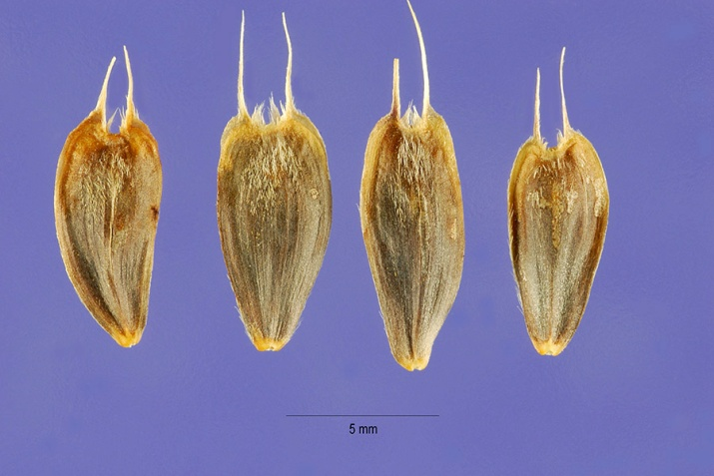

**Oneflower helianthella achenes. Steve Hurst. USDA-NRCS PLANTS Database.**

Seed pretreatment recommendations for oneflower helianthella vary widely and may reflect differences in ecotypes. Link (1993) indicated that no pretreatment is necessary for germination; however Skinner (2007) achieved 45% germination with no treatment and 80% emergence with a 45 day cold/moist stratification. Similarly, Bartow (2008) reported increasing germination rates with increased cold/moist stratification durations with optimum germination (98%) resulting from a 90 day cold/moist treatment.

### Cultivars, Improved, and Selected Materials (and area of origin)

There are no released varieties or cultivars of oneflower helianthella. Seed is available in limited quantities from commercial sources. Seed is also available through contract harvesting (Walker and Shaw 2005).

### References

Bartow, Amy 2008. Propagation protocol for production of *Helianthella uniflora* (Nutt.) Torr. & A. Gray seeds; USDA NRCS - Corvallis Plant Materials Center, Corvallis, . In: Native Plant Network. URL: http://www.nativeplantnetwork.org (accessed 26 September 2012). Moscow (ID): University of Idaho, College of Natural Resources, Forest Research Nursery.

Link, Ellen (ed.). 1993. Native Plant Propagation Techniques for National Parks Interim Guide. USDA SCS Rose Lake Plant Materials Center and USDI National Park Service. East Lansing, Michigan. 240 pp.

Ogle, D., St. John, L., Stannard, M., and L. Holzworth. 2011. Technical Note 24: Conservation plant species for the Intermountain West. USDA-NRCS, Boise, ID-Salt Lake City, UT-Spokane, WA. ID-TN 24. 57p.

Skinner, David M. 2007. Propagation protocol for production of container Helianthella uniflora (Nutt.) Torr. & Gray douglasii (Torr. & Gray) W.A. Weber plants (10 cu. in.); USDA NRCS - Pullman Plant Materials Center, Pullman, Washington. In: Native Plant Network. URL: http://www.nativeplantnetwork.org (accessed 26 September 2012). Moscow (ID): University of Idaho, College of Natural Resources, Forest Research Nursery.

Stevens R., and S.B. Monsen. 2004. Forbs for seeding range and wildlife habitats. In: S.B. Monsen, R. Stevens, and N.L. Shaw [compilers]. Restoring western ranges and wildlands. Fort Collins, CO: USDA Forest Service, Rocky Mountain Research Station. General Technical Report RMRS-GTR-136-vol-2. p. 425-491.

Train, Percy, James R. Henrichs and W. Andrew Archer 1941 Medicinal Uses of Plants by Indian Tribes of Nevada. Washington DC. U.S. Department of Agriculture.

[USDA FS] USDA Forest Service. 1937. Range Plant Handbook. United States Government Printing Office. Washington DC.

[USDA NRCS] USDA Natural Resources Conservation Service. 2012. The PLANTS Database. URL: http://plants.usda.gov (accessed Sep. 27, 2012). Baton Rouge (LA): National Plant Data Center.

Walker, S.C. and N.L. Shaw. 2005. Current and potential use of broadleaf herbs for reestablishing native communities. In: Shaw, N.L., Pellant, M., Monsen, S.B., comps. 2005. Sagegrouse habitat restoration symposium proceedings; 2001 June 4-7; Boise, ID. Proceedings RMRS-P-38. Fort Collins CO: USDA-FS, Rocky Mountain Research Station.

Welsh, S.L., N.D. Atwood, S. Goodrich, and L.C. Higgins. 2003. A Utah Flora. Third Edition, revised. Brigham Young University, Provo, UT.

Williams, N.M. 2003. Use of novel pollen species by specialist and generalist solitary bees (Hymenoptera: Megachilidae). Oecologia. 134: 228-237.

**Prepared By**:

Derek Tilley, USDA NRCS Plant Materials Center, Aberdeen, ID

### Citation

Tilley, D. 2012. Plant Guide for oneflower helianthella (*Helianthella uniflora*). USDA-Natural Resources Conservation Service, Aberdeen, ID Plant Materials Center. 83210-0296.

Published November 2012

Edited: 26Sep2012djt; 26Sep2012ls;23Oct2012jab

For more information about this and other plants, please contact your local NRCS field office or Conservation District at <http://www.nrcs.usda.gov/> and visit the PLANTS Web site at <http://plants.usda.gov/> or the Plant Materials Program Web site <http://plant-materials.nrcs.usda.gov>.

PLANTS is not responsible for the content or availability of other Web sites.

**USDA IS AN EQUAL OPPORTUNITY PROVIDER AND EMPLOYER**