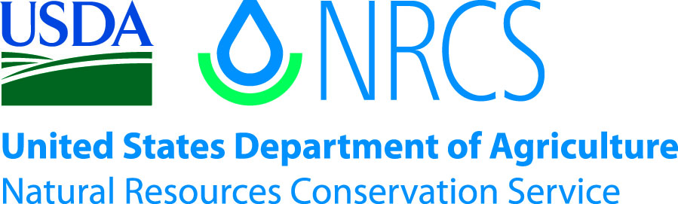

Plant Guide

# Water Howellia

## Howellia aquatilis A. Gray

### Plant Symbol = HOAQ

*Contributed by*: USDA NRCS Idaho Plant Materials Program

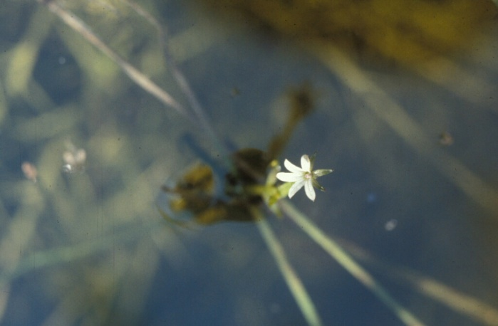 Figure . Water howellia. Photo by Dieter Wilken.

#### **Alternate Names**

This species has no known alternate names.

#### **Uses**

Water howellia forms a minor component of the aquatic flora in a limited number of wetlands, ponds and sloughs in the Pacific Northwest. It likely provides habitat for aquatic animals in the locations where it is found. It is also occasionally eaten by large animals.

#### **Status**

Water howellia was federally listed by the USDI Fish and Wildlife Service (USDI Fish and Wildlife Service) as threatened in 1994 (USFWS, 1994) and is also considered threatened in the states of Idaho, Oregon, Washington and Montana (Montana Natural Heritage Program, 2009; Oregon Department of Agriculture, 2009; State of Idaho, 2009; Washington State, 2009). In Washington State, howellia carries a rank of S2S3, and in Montana it is ranked G3, S2, while it is ranked S1 in Oregon. Howellia is not listed by the state of California; however it has a Heritage rank of G3/S1.2 and a California Native Plant Society rank of 2.2 (CA Department of Fish and Game, 2009) and is considered critically imperiled in that state by Natureserve (2009). Natureserve additionally lists water howellia as critically imperiled in Oregon and Idaho and imperiled in Montana and Washington (Natureserve, 2009).

Consult the PLANTS Web site and your State Department of Natural Resources for this plant’s current status (e.g., threatened or endangered species, state noxious status, and wetland indicator values).

#### **Description**

*General*:

Bellflower family (Campanulaceae). Water howellia is a winter-annual emergent aquatic herb. The stems are submerged or floating on the surface and rooted into the pond bottom. Stems are extensively branching reaching 24 to 36 inches in length and bear narrow leaves from 0.4 to 2 inches long. The plants produce two types of flowers. Small, inconspicuous cleistogamous (non-opening and self-pollinating) flowers are born beneath the water’s surface, and showy larger whitish to pale lavender flowers (0.08 to 0.11 inches) are born on emergent stems. The fruit is an inferior (below the petals) capsule approximately 0.8 inches in length which contains up to 5 brown seeds.

*Distribution*:

Although water howellia at one time occurred over a large range throughout the northwestern United States, it is currently found in a limited number of locations in California, Oregon (possibly extirpated), Washington, Idaho and Montana (USFWS, 2009). Water howellia is currently known from a total of six geographic regions: one in Idaho (Latah County), one in Montana (Lake and Missoula counties), one in California (Mendocino County) and three in Washington (Spokane, Clark and Pierce counties). For current distribution, consult the Plant Profile page for this species on the PLANTS Web site.

*Habitat*:

Water howellia can be found in ephemeral glacial ponds and former river oxbows that fill with spring moisture and dry down throughout the growing season. The upland flora surrounding water howellia habitat is typically comprised of deciduous and evergreen trees and shrubs including Bebb willow, Drummond’s willow, black cottonwood, quaking aspen, thinleaf alder, Engelmann spruce, Douglas fir, and lodgepole pine.

The ponds themselves contain herbaceous plants such as water parsnip, water plantain, and inflated sedge. The ponds are often inhabited by the introduced reed canarygrass (Lichthardt and Gray, 2003).

#### **Adaptation**

Due to low genetic variability, water howellia is limited to very specific habitats within its range (USFWS 1994).

#### **Establishment**

Howellia is limited by specific requirements for seed germination. Seed germinates in the fall when a pond has dried and the bottom is exposed to the air, thus reestablishment is dependent upon proper moisture conditions, and populations are vulnerable to abnormally wet or dry periods. Regeneration of populations require summer flowering, dry-down of the occupied portion of the pond, slight refilling in the fall and full filling the following spring (Reeves and Woessner, 2004).

#### **Management**

Water howellia habitat is threatened by logging, commercial and residential development, grazing and encroachment from invasive species such as reed canarygrass and purple loosestrife (USDI Fish and Wildlife Service, 1994). Recommended management strategies include controlling invasive species and limiting disturbances (logging, development) that might affect the hydrologic requirements of the species.

#### **Pests and Potential Problems**

Reed canarygrass and other invasive species threaten water howellia and its habitat by their ability to rapidly form dense monocultures and out-compete native species for available resources.

#### **Environmental Concerns**

This species is vulnerable to extirpation due to large variation in annual numbers, limited available habitat and low genetic variability (USFWS, 1994).

#### **References**

California Department of Fish and Game. 2009. Special Vascular Plants, Bryophytes, and Lichens List. Natural Diversity Database. Quarterly publication. 71 pp.

Lichthardt, J., and K. Gray. 2003. Monitoring of *Howellia aquatilis* (water howellia) and its habitat at the Harvard-Palouse River flood plain site, Idaho: fourth-year results. Idaho Department of Fish and Game. Boise, ID.

Montana Natural Heritage Program. 2009. Plant species of concern. [Online]. Available at http://mtnhp.org/SpeciesOfConcern/?AorPp (accessed 22 Dec 2009). Helena, MT.

NatureServe. 2009. NatureServe Explorer: An online encyclopedia of life [web application]. Version 7.1. NatureServe, Arlington, Virginia. Available http://www.natureserve.org/explorer. (Accessed: 25 Dec 2009).

Oregon Department of Agriculture. 2009. Oregon listed plants. [Online]. Available at http://oregon.gov/ODA/PLANT/CONSERVATION/statelist.shtml (accessed 20 Dec 2009). Portland, OR.

State of Idaho. 2009. Federal threatened and endangered species in Idaho. [Online]. Available at www.species.idaho.gov (accessed 23 Dec 2009) Idaho Governor’s office of conservation. Boise, ID.

##### USDI Fish and Wildlife Service. 1994. Endangered and threatened wildlife and plants; the plant, water howellia (*Howellia aquatilis*), determined to be a threatened species. Federal Register. 59 (134): 35860-35864.

##### Washington State. 2009. List of Plants Tracked by the Washington Natural Heritage Program. [Online]. Available at http://www1.dnr.wa.gov/nhp/refdesk/lists/plantrnk.html (accessed 19 Dec 2009). Washington State Department of Natural Resources. Seattle, WA.

#### **Prepared By**

*Derek Tilley*; Range Scientist, USDA NRCS Plant Materials Center, Aberdeen, Idaho.

*Dan Ogle;* Plant Materials Specialist, USDA NRCS, Boise, Idaho.

*Loren St. John*; Team Leader, USDA NRCS Plant Materials Center, Aberdeen, Idaho.

#### **Citation**

Tilley, D., D. Ogle, and L. St. John. 2009. Plant guide for water howellia (*Howellia aquatilis*). USDA-Natural Resources Conservation Service, Idaho Plant Materials Center. Aberdeen, ID. 83210.

Published February, 2010

Edited: 23Dec2009djt; 04Jan10dgo; 04Jan10lsj

For more information about this and other plants, please contact your local NRCS field office or Conservation District at <http://www.nrcs.usda.gov/> and visit the PLANTS Web site at <http://plants.usda.gov/> or the Plant Materials Program Web site <http://plant-materials.nrcs.usda.gov>.

PLANTS is not responsible for the content or availability of other Web sites.

**USDA IS AN EQUAL OPPORTUNITY PROVIDER AND EMPLOYER**