

Plant Guide

# Gray’s biscuitroot

## Lomatium grayi (J.M. Coult. & Rose.) J.M. Coult. & Rose

### Plant Symbol = LOGR

#### Contributed by: USDA NRCS Idaho Plant Materials Program, and USDA-FS Rocky Mountain Research Station

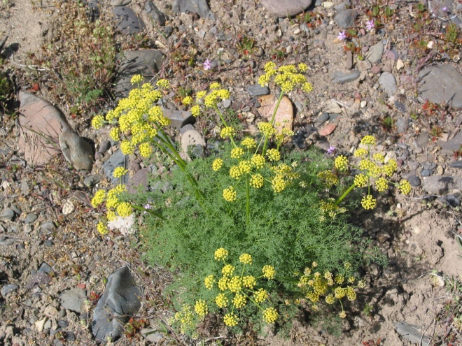

**Gray’s biscuitroot (*Lomatium grayi*). Photo by Clint Shock, Oregon State University Extension**

#### **Alternate Names**

Gray’s desert parsley

Milfoil lomatium

Mountain desert parsley

Narrow-leaf lomatium

Pungent desert parsley

#### **Uses**

*Wildlife*

Gray’s biscuitroot is grazed by deer, sheep, mice, rats, and rabbits (COSEWIC, 2008). Ogle and Brazee (2009) rate it as desirable spring and summer forage for cattle, sheep, horses, elk, deer and antelope.

Gray’s biscuitroot is one of the first species to green up and flower after snowmelt. This characteristic makes this an important species for early spring pollinators and other insects. Known pollinators include solitary bees and flies.

This species has been identified as an important plant species in sage-grouse habitat because of its early

growth habit and the associated insects that provide a critical food source for sage-grouse chicks.

Gray’s biscuitroot is a host plant for the rare Indra swallowtail butterfly (*Papilio indra*) and is one of two plants used as a host by the Anise Swallowtail (*Papilio zelicaon*) (Thompson 1989).

*Ethnobotanic*

#### The tender young stems and roots of Gray’s biscuitroot were eaten by the Paiute Indians (Mahar, 1953).

#### Medicinal

#### Though not proven in clinical trials, this species may possess antiviral and antibacterial properties based on its relationship to fernleaf biscuitroot (L. dissectum) (COSEWIC, 2008).

#### **Status**

Consult the PLANTS Web site and your State Department of Natural Resources for this plant’s current status (e.g., threatened or endangered species, state noxious status, and wetland indicator values).

#### **Description**

*General*: Carrot family (Apiaceae). Gray’s biscuitroot is a large, perennial, aromatic herb with a branched caudex arising from a deep taproot. Mature plants can reach up to 60 cm (24 in) tall. The leaves are finely divided and parsley like. Each plant bears up to 20 naked stems (scapes) which end in an umbel with several hundred male or hermaphroditic flowers (Thompson, 1984). The petals and stamens are yellow, but quickly dry to a whitish color after anthesis (Welsh et al., 2003). This species also has a distinctive pungent odor.

The seeds are approximately 12 mm (0.5 in) long with broad lateral wings. The lateral wings are approximately 2 mm (0.08 in) wide and comprise up to 2/3 the width of the fruit body (Welsh et al., 2003). There are approximately 86,000 seeds/kg (39,000 seeds/lb) (Barner, 2008).

Plants leaf out in early spring, flower quickly, set seed, and then enter summer dormancy. Umbels can contain male or hermaphroditic flowers (Thompson, 1987). Individual plants often do not flower in consecutive years (Thompson and Moody, 1985), and there can be considerable variation in the number of flowers produced from one population to the next (Thompson, 1987).

The plants live to approximately 7 years of age (COSEWIC, 2008), with growth only occurring in the spring when moisture is available. Seeds mature in July.

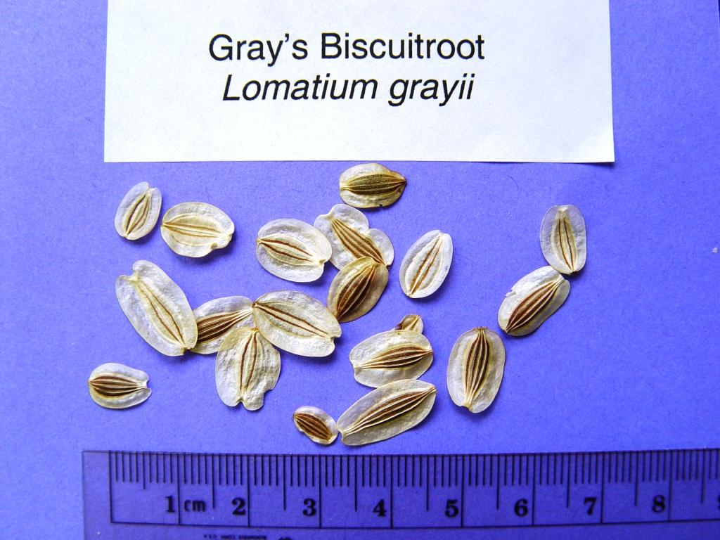

**Gray’s biscuitroot seed. Photo by Matthew Fisk, USDA-FS, Rocky Mountain Research Station**

*Distribution*:

Gray’s biscuitroot occurs in Northwest North America, primarily from the Cascade and Sierra Nevada to the Rocky Mountains in Washington, Idaho, Oregon, Wyoming, Nevada, Utah, Colorado and New Mexico. There are two populations in British Columbia, Canada where it is considered a threatened species (COSEWIC, 2008).

For current distribution in North America, consult the Plant Profile page for this species on the PLANTS website.

*Habitat*:

Gray’s biscuitroot grows on rocky outcrops, shallow pockets of soil in rocks and in open habitat in sagebrush, mountain shrub, pinyon-juniper, ponderosa pine, and Douglas fir communities.

#### **Adaptation**

This species is adapted to well drained, rocky shallow soils at elevations from sea level to 2750 m (0 to 9,000 ft) (COSEWIC, 2008; Welsh et al., 2003). Gray’s biscuitroot is generally found in areas receiving 20 to 50 cm (8 to 20 in) mean annual precipitation.

#### **Establishment**

Seed can be broadcast or drilled to 3 to 6 mm (1/8 to 1/4 in) depth into a well prepared, weed-free seed bed. This species should be seeded in late fall as a dormant planting to allow natural stratification. A pure stand seeding rate of approximately 23 lbs/ac provides 25 to 30 seeds/ft². Seeding rates should be adjusted to the desired percentage for use in a mixture.

#### **Management**

Once established, Gray’s biscuitroot is very competitive against weeds due to its long taproot; however additional measures to control weeds are necessary for seed production.

#### **Pests and Potential Problems**

Gray’s biscuitroot has been known to be attacked by the larvae of 2 weevils (*Apion oedorhychum* and *Smicronyx* sp.) and one moth (*Greya subalba* ) (Ellison and Thompson, 1987). These insect pests are known to kill the seed and reduce seed viability.

Herbivory by mammals limits species occurrence and spread in Canadian populations (COSEWIC, 2008).

#### **Environmental Concerns**

There are no known environmental concerns regarding Gray’s biscuitroot.

#### **Plant Production**

Seed matures in July to August. Wildland seed is easily hand collected. The seed disarticulates readily from the stems, and very clean, small collections can be made by shaking ripened inflorescences over a bag or tarp. Minor screening to remove sticks provides excellent purity.

Seed of Gray’s biscuitroot requires a 3-month moist chilling to relieve dormancy (Shock, 2011). Scholten et al. (2009) observed that greatest embryo elongation in the closely releated fernleaf biscuitroot (*L. dissectum*) occurred at temperatures of 3.4 to 5.5° C (38 to 42° F). The best germination percentages occurred at 3.4 C (38° F) with approximately 16 weeks of cold/moist stratification. Gray’s biscuitroot has exhibited more vigorous, rapid growing seedlings than fernleaf biscuitroot and nineleaf biscuitroot (*L.* *triternatum*).

**Large Scale Seed Production**

Shock et al. (2010a) showed a significant positive response to irrigation with 10 and 20 cm (4 and 8 in) additional water at Ontario, Oregon. Ontario has a mean annual precipitation of 24 cm (9.5 in) (U.S. Climate Data, 2010), bringing the total received water to approximately 46 cm (18 in) for optimum seed production. Peak seed yields of over 1590 kg/ha (1,400 lb/ac) resulted from 20 cm (8 in) of supplemental irrigation.

Seed production fields should be seeded at 25 to 30 PLS/ft. Rows planted on 75 cm (30 in) centers allow for between row cultivation and weed control. When using weed barrier fabric, plant seeds into 8 cm (3 in) holes at 30 to 45 cm (12 to 18 in) spacing.

Because Gray’s biscuitroot enters dormancy in early summer, foliar herbicide applications of glyphosate to surrounding weeds are possible after senescence. Always read and follow label and safety instructions for each control method. USDA-NRCS does not guarantee or warranty any products or control methods named, and other products may be equally effective.

Two separate studies at Ontario, Oregon produced seed in third and fourth growing season (Shock et al., 2010a and b). Additional techniques are being investigated regarding the feasibility of growing Gray’s biscuitroot densely in rooting beds prior to field establishment. This method would allow a grower to sacrifice a much smaller area in the first 1 to 2 years of plant development while the plants are not producing seed. Trials indicate that taproots transplanted in autumn establish well (Jensen and Anderson, 2010).

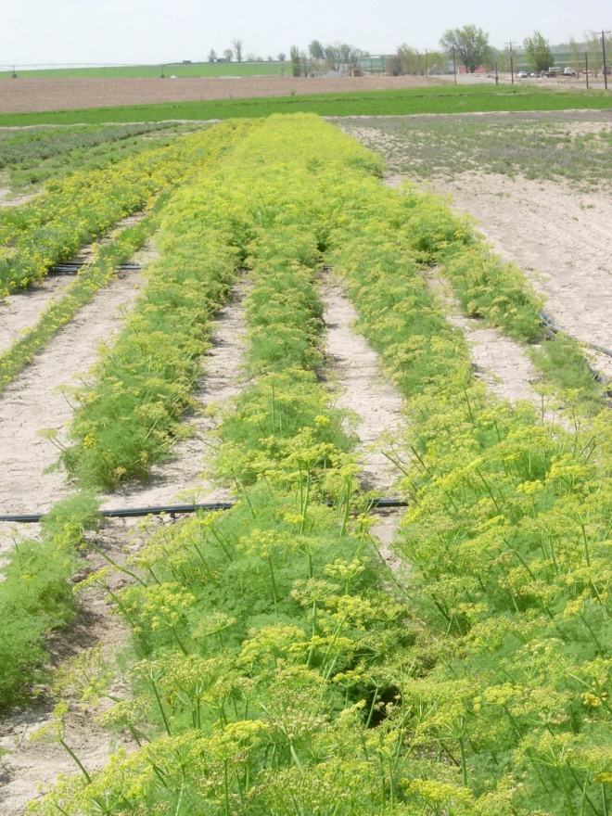

**Gray’s biscuitroot irrigation trial at Ontario, Oregon, Clint Shock, Oregon State University Extension**

Seed can be harvested in production fields via a vacuum type or flail vac harvester (Bair and Tilley, 2010). Seed can be cleaned using an air screen cleaner. Purities approximating 100% are achievable with minimal effort.

**Cultivars, Improved and Selected Materials (and area of origin)**

Common wildland collected seed is available from commercial sources. There are currently no commercial releases of Gray’s biscuitroot. Commercial growers are producing pooled Source Identified seed representative of Omernik Ecoregion 12 (Snake River Plain) and 80 (Northern Basin and Range).

#### **References**

Bair, C. and D. Tilley. 2010. The jet harvester: a shop built tool for harvesting forb and shrub seed. USDA-NRCS Technical Note 55. Boise, Idaho.

Barner, J. 2008. Propagation protocol for production of *Lomatium grayi* seeds; USDA-FS-R6 Bend Seed Extractory, Bend, Oregon. In: Native Plant Network. URL: http://www.nativeplantnetwork.org (accessed 21 Dec 2010). Moscow (ID): University of Idaho, College of Natural Resources, Forest Research Nursery.

COSEWIC. 2008. COSEWIC assessment and status report of the Gray’s desert parsley (*Lomatium* *grayi*) in Canada. Committee on the Status of Endangered Wildlife in Canada. Ottawa. vi+27pp.

Ellison, R.L. and J.N. Thompson. 1987. Variation in seed and seedling size: the effects of seed herbivores on *Lomatium grayi* (Umbelliferae). Oikos. 49(3): 269-280.

Jensen, S. and M. Anderson. 2010. The quest for natives: cultural practices, species screening and private growers. In: Great Basin native plant selection and increase project, FY2009 progress report. USDA-FS-RMRS. Boise, Idaho.

Mahar, James Michael. 1953. Ethnobotany of the Oregon Paiutes of the Warm Springs Indian Reservation. Unpublished thesis. Reed College. Portland, Oregon.

Ogle, D., and B. Brazee. 2009. Estimating initial stocking rates. USDA-NRCS Technical Note 3. Boise, Idaho.

Scholten, M., Donahue, J., Shaw, N., and M. Serpe. 2009. Environmental regulation of dormancy loss in seeds of *Lomatium dissectum* (Apiaceae). Annals of Botany. 103 (7): 1091-1101.

Shock, C.C., Feibert, E., Saunders, L., and N. Shaw. 2010. Native wildflower seed production with limited subsurface drip irrigation. Oregon State University Agricultural Experiment Station, 2009 Annual Report: 193-209.

Shock, C.C., Ishida, J., Feibert, E., and N. Shaw. 2010. Native perennial forb tolerance to repeated annual applications of postemergence herbicides. Oregon State University Agricultural Experiment Station, 2009 Annual Report: 213-217.

Shock, C.C. 2011. Station native wildflower seed production trials. Oregon State University Extension. Malheur Experiment Station. Online. Available at: http://www.cropinfo.net/crops/WildflowerSeedProd.html. Accessed 5 February, 2011.

Thompson, J.N. 1987. The ontogeny of flowering and sex expression in divergent populations of *Lomatium grayi*. Oecologia 72: 605-611.

Thompson, J.N. 1989. Genetics of butterly-hostplant associations. Trends in Ecology and Evolution. 4(2): 34-35.

Thompson, J.N. and M.E. Moody (1985). Assessing probability of interaction in size-structured populations: *Depressaria* attack on *Lomatium*. Ecology 66: 1597-1607.

U.S. Climate Data. 2010. URL: http://www.usclimatedata.com (accessed 6 December 2010). Summerweb. Belgium, Europe.

USDA, NRCS. 2010. The PLANTS Database (http://plants.usda.gov, 7 December 2010). National Plant Data Center, Baton Rouge, LA 70874-4490 USA.

Welsh, S.L., N.D. Atwood, S. Goodrich, and L.C. Higgins. 2003. A Utah flora. Third edition, revised. Brigham Young University, Provo, UT.

#### **Prepared By**

*Derek Tilley*; USDA NRCS Plant Materials Center, Aberdeen, Idaho.

*Loren St. John*, USDA NRCS Plant Materials Center, Aberdeen, Idaho.

*Dan Ogle*, USDA NRCS, Boise, Idaho.

*Nancy Shaw*. USDA-FS. Rocky Mountain Research Station. Boise, Idaho.

#### **Citation**

Tilley, D., St. John, L. Ogle, D., and N. Shaw. 2011. Plant guide for Gray’s biscuitroot (*Lomatium grayi*). USDA-Natural Resources Conservation Service, Idaho Plant Materials Center. Aberdeen, ID.

Published Feb, 2011

Edited: 07Feb2011dt; 07Feb2011ls; 17feb2011dgo; 21Feb2011ns

For more information about this and other plants, please contact your local NRCS field office or Conservation District at http://www.nrcs.usda.gov/ and visit the PLANTS Web site at http://plants.usda.gov/ or the Plant Materials Program Web site http://plant-materials.nrcs.usda.gov.

PLANTS is not responsible for the content or availability of other Web sites.

**USDA IS AN EQUAL OPPORTUNITY PROVIDER AND EMPLOYER**