|  |
| --- |
| PERENNIAL RYEGRASS |
| *Lolium perenne* L. ssp. *perenne* |
| Plant Symbol = LOPEP |

Contributed by: USDA NRCS Idaho State Office

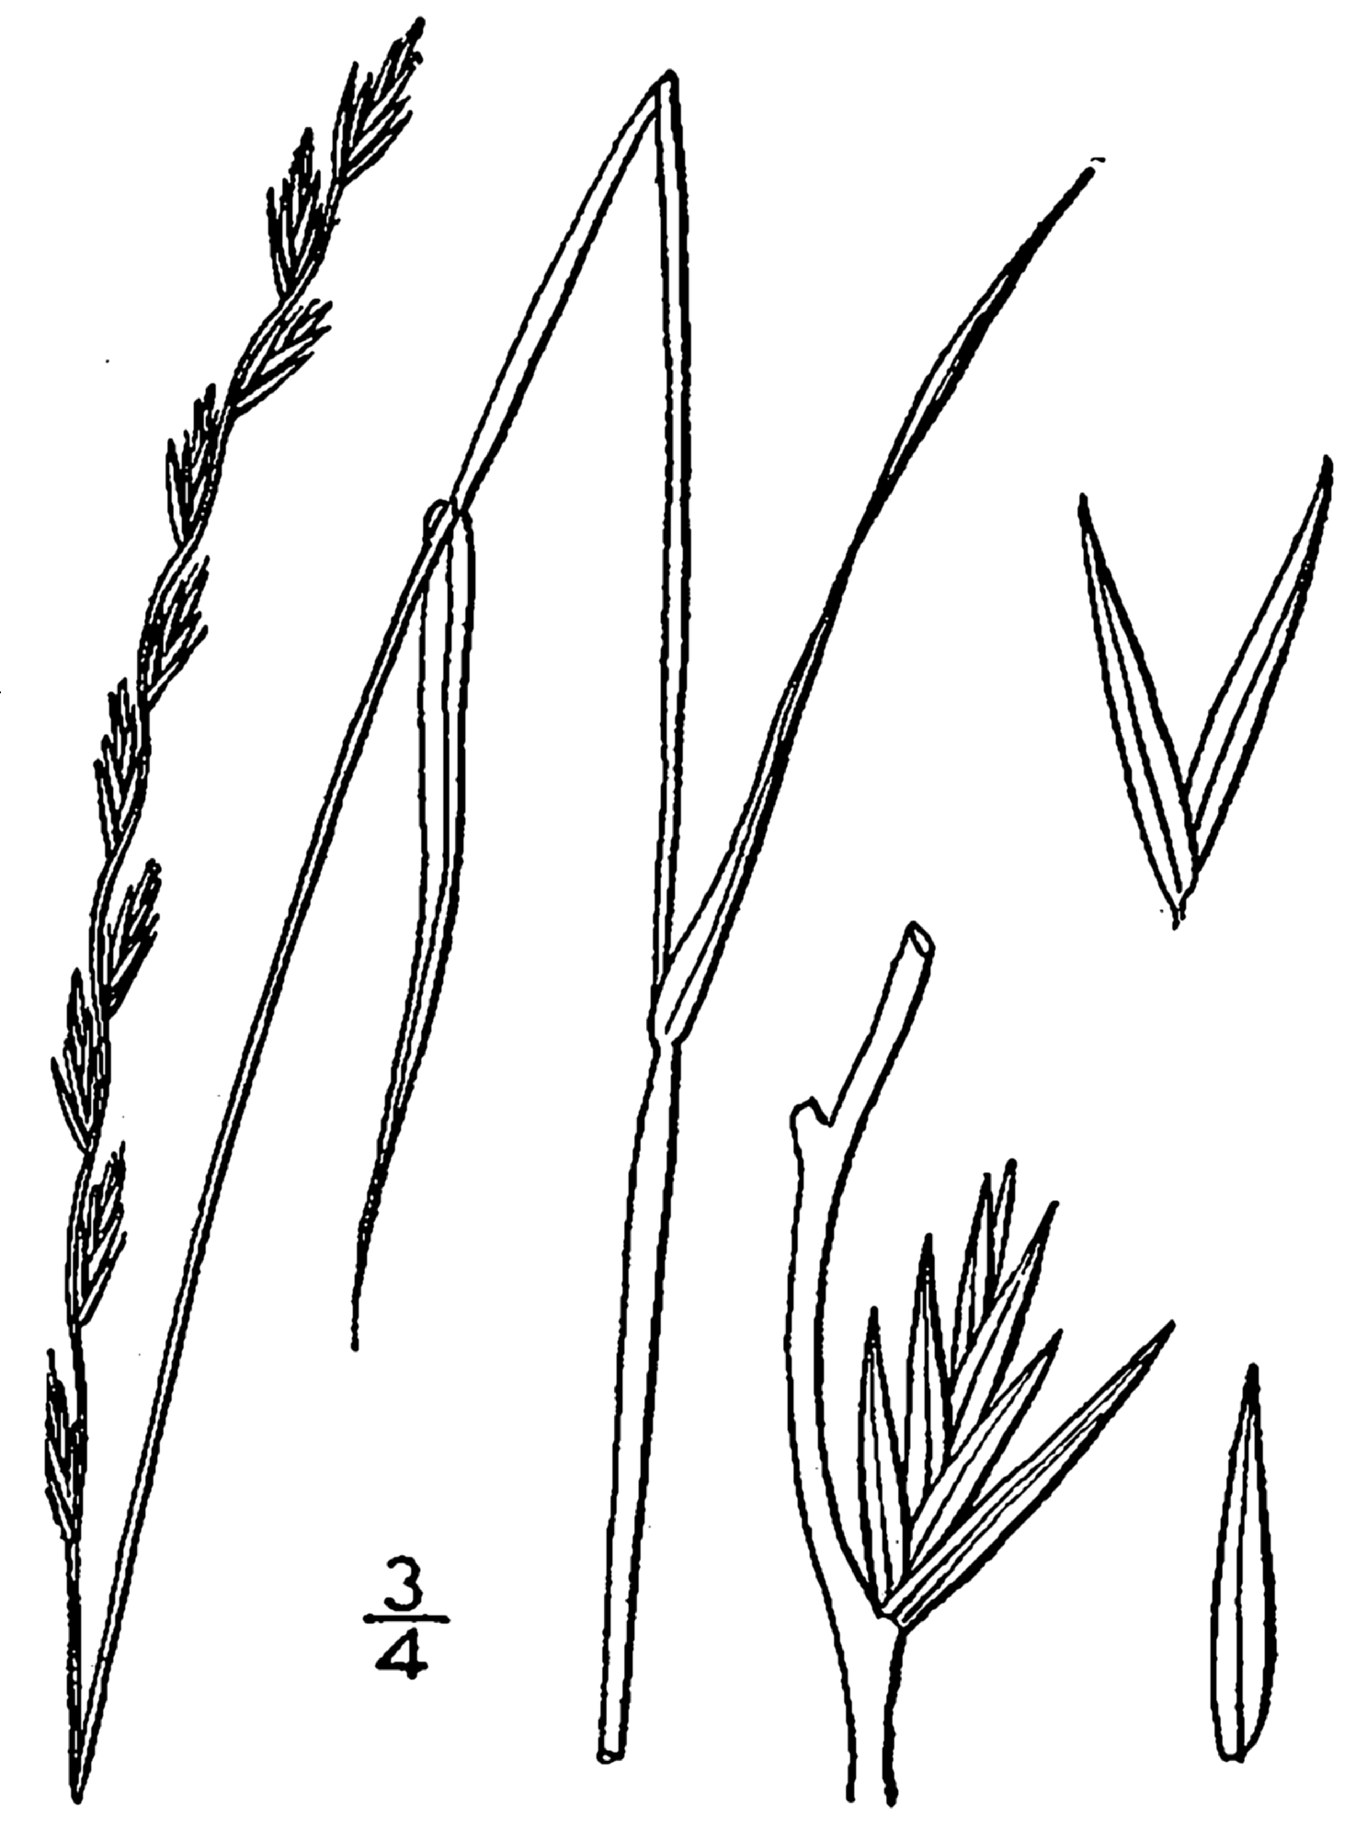

Britton & Brown. 1913. Flora of the North States and Canada

Alternate Names

None

Uses

A few farmers and ranchers are beginning to plant perennial ryegrass, *Lolium perenne* ssp*. perenne*, on irrigated pasture in the Intermountain West. This paper is intended to provide some technical guidance in the establishment and management of this species for the Intermountain West.

Perennial ryegrass is a valuable forage and soil stabilization plant. This species is one of the predominant forage grasses in Europe. It has been used in the United States for forage and turfgrass applications since the late 1700s. Generally the tetraploid varieties are used for forage and diploid varieties are used for turfgrass (lawn) and conservation plantings. Users should double check the intended use of available releases before buying seed to ensure they are getting the type desired. Italian ryegrass, the annual *L. perenne* ssp. *multiflorum*, is primarily used for quick cover in erosion control plantings.

Why plant perennial ryegrass? There are several very good reasons to consider perennial ryegrass when planning an irrigated pasture planting. Perennial ryegrass establishes easier and more quickly than most of our proven long-lived pasture grass varieties. Under ideal conditions, perennial ryegrass is ready to graze within 60 days of planting. When managed correctly, it can be very productive. Perennial ryegrass can also be inter-seeded in existing weak stands of grass with fairly good results (avoid inter-seeding healthy, productive stands). It can be broadcast seeded followed by harrowing, packing or livestock trampling with fairly good establishment results. Perennial ryegrass is very nutritious having similar or higher energy and protein levels than most proven pasture grass alternatives. This is a very important consideration when grass fattening beef cattle or for maintaining high milk production with dairy cows. It is also considered to be a very palatable feed. Preliminary forage quality results from a Montana study indicated good potential for high production of both protein and total digestible nutrients (TDN) per acre, depending on level of inputs and harvest management.

Because we do not have long term information on the survivability of perennial ryegrasses, we recommend the following to farmers and ranchers interested in planting perennial ryegrass.

* Use perennial ryegrass only in pastures that will be intensively managed.
* Plant only in areas with a good supply of irrigation water.
* Provide high levels of fertilizer with frequent applications. Perennial ryegrass production increases with split applications of nitrogen. It is recommended that 45 pounds per acre of nitrogen follow each grazing cycle. If only one application is economically feasible, then apply 150 pounds of nitrogen per acre in the spring.
* When planted with white clover, apply fertilizer in two applications, early spring and early autumn. When planted without clover, 3- 5 applications may be necessary.
* Use varieties bred in Holland to provide earlier dormancy and better winter hardiness.
* In cold winter areas, perennial ryegrass has excellent first season yields and quality; however, plants may be subject to winter-kill and may require reseeding and should generally be viewed as annual or short-lived forage crops that may require renovation each year.

Status

Consult the PLANTS Web site and your State Department of Natural Resources for this plant’s current status (e.g. threatened or endangered species, state noxious status, and wetland indicator values).

Description

*General*: Perennial ryegrass grows from 1 to 2 feet tall with a bunchy form. It has medium longevity in mild climates. In northern Intermountain and Rocky Mountain states it tends to be short-lived, often no more than one growing season. Some turfgrass varieties are longer lived. There are numerous long, narrow, stiff leaves near the base of the plant where most of the forage is concentrated. The under surfaces of leaves are bright, glossy, and smooth. Inflorescence stems are nearly naked. Seedheads are spikes with spikelets growing edgewise (at right angles) to the reproductive stem. Perennial ryegrass seeds do not have awns (bristles), whereas annual ryegrass seeds have awns. Other morphological characters of the two species are similar. There are approximately 247,000 seeds per pound.

Annual and Italian ryegrass are similar to perennial ryegrass except they are annual or biennial, depending on climate and/or length of growing season. Italian ryegrass may grow a little taller than perennial ryegrass: from 2 to 3 feet tall. The seed of this sub-species have awns.

*Distribution*: For current distribution, consult the Plant Profile page for this species on the PLANTS Web site.

Adaptation

Perennial ryegrass has a wide range of adaptability to soils, but thrives best on dark rich soils. It will withstand fairly wet soils with reasonably good surface drainage. It will not tolerate standing water for extended periods of time. It grows on soils that have a pH between 5 and 8 with best yields on soils with pH between 6 (slightly acidic) to 7 (neutral).

Perennial ryegrass should be restricted to regions having mild climates with moderate temperature and higher moisture or irrigated regions of the Intermountain and Rocky Mountain West. It does not withstand hot, dry weather or severe winters. To produce high yields, perennial ryegrass requires 30 to 50 inches of rainfall or equivalent supplemental full irrigation annually.

Establishment

A firm, weed-free seedbed gives the best results. Spring seedings should occur in March to early May. Perennial ryegrass may also be seeded in mid-August to early September under irrigated conditions. Timing for fall seedings should ensure that at least 6 weeks are allowed for establishment prior to killing frosts. Seeding rates will vary with local conditions and purpose of planting. Generally, a rate of 15 pounds per acre is used if perennial ryegrass is seeded alone. Double this rate if seed is broadcast planted. Perennial ryegrass is also recommended for grass-legume mixtures, but due to a strong animal preference toward perennial ryegrass over other pasture grasses, it should not be planted with other grasses for grazing. Reduce the full rate to the percentage of mixture desired when planting with legumes. Because perennial ryegrass has very strong seedling vigor, it should be planted at 7 to 8 pounds per acre in alternate row plantings with alfalfa and other legumes. When planting in the same row, do not exceed 4 pounds per acre of perennial ryegrass in the seed mixture with alfalfa and other legumes.

When planting with a drill, the ideal seeding depth is ¼ inch or less. Do not exceed ½ inch seeding depth. Results from a Utah study indicate that broadcast seeding followed with a roller packer results in very good stands.

Well established stands may remain productive for 3 to 4 years if not adversely affected by cold winters. However, in most cases producers over-seed fields with up to 5 pounds of perennial ryegrass seed per acre each year in late fall or early spring to maintain fully productive stands.

Management

Perennial ryegrass is generally cut for hay when seed is in the soft-dough stage. Perennial ryegrass responds well to good management, such as intensive rotational grazing and fertilizer applications.

Perennial ryegrass performs best when used in intensively managed pasture. It requires very accurate irrigation water management and fertilizer management. If either irrigation or fertilility requirements are not met, it will immediately cease growth.

Perennial ryegrass forage production can be improved with split applications of nitrogen. It is recommended that fertilizer recommendations be based on soil tests. However, rates approximating 45 pounds per acre of nitrogen following each grazing cycle has resulted in excellent overall production. If only one application is economically feasible, then apply 150 pounds of nitrogen per acre in the spring.

Perennial ryegrass is most productive and nutritious when livestock are turned into well established pastures with six to eight inches of growth and quickly grazed to three inches. Livestock should then be removed to allow plants to regrow. Regrowth periods vary from about 14 to 28 days depending on the local climate and time of year. The peak growth period is from mid May through June. In the Intermountain West, during July and August, when temperatures exceed 80º F, perennial ryegrass production normally declines due to high temperatures, water stress and long day lengths. With proper fertilization and irrigation water management, perennial ryegrass will maintain fair growth during the heat of the summer. A second peak growth period can be expected when temperatures cool in the fall. Perennial ryegrass can be allowed to attain twelve inches of growth, but should not be allowed to go to seed because the plants will not re-grow readily or maintain high nutrition and palatability.

The disadvantage of perennial ryegrass in the Intermountain West and Rocky Mountains is that it is not as winter hardy as other proven irrigated pasture grasses (orchardgrass, meadow brome, intermediate wheatgrass, pubescent wheatgrass and tall fescue). Winter hardiness data regarding perennial ryegrass is limited, thus recommendations of released varieties to farmers and ranchers are difficult. New Zealand varieties of perennial ryegrass tend to produce more than meadow brome, intermediate wheatgrass, pubescent wheatgrass and mountain brome the first growing season. However, in the Intermountain and Rocky Mountain regions, stands are commonly lost during the winter. In a trial near Shelley in eastern Idaho, the Mara variety persisted for more than 5 years, but it did not producing as much as other irrigated pasture grass species. Winter hardiness is thought to be associated with lack of dormancy in the fall and stands have also been lost during dry periods when adequate irrigation water was not available during growth.

Pests and Potential Problems

Perennial ryegrass contains a fungal endophyte, *Acremonium lolii,* which is linked to the occurrence of a neurological disorder in livestock known as ryegrass staggers. There have been reports of ryegrass staggers in western Oregon and California, but not in the Intermountain or Rocky Mountain West.

Cultivars, Improved, and Selected Materials (and area of origin)

Most forage type perennial ryegrass varieties were developed for short-rotation pasture and green-chop. There are many releases on the market that were bred in either New Zealand or Holland where most of the research for highly productive and nutritious varieties has taken place. Perennial ryegrasses are divided into diploid and tetraploid varieties. The tetraploid varieties tend to be more upright and somewhat better forage producers. The diploid varieties tend to be more persistent under grazing conditions. The New Zealand varieties generally tend to grow earlier in the spring and later into the fall. A plot of Zero Nui (a New Zealand variety) in the Pocatello, Idaho area and pastures near Preston, Idaho winter killed. The Holland varieties generally go dormant earlier in the fall. Pastures and plots of Holland varieties survived well at Pocatello and Preston.

Due to the large number of cultivars currently on the market, it is recommended that you consult a seed supplier in your area for up-to-date cultivars and blends. When requesting seed, ensure that you request a forage type perennial ryegrass if forage production is your goal.

Perennial ryegrass cross-pollinates freely with annual and Italian ryegrass, so many hybrid types of ryegrass have developed. It is difficult to maintain perennial ryegrass genetic purity; consequently, Italian ryegrass is marketed as common ryegrass or domestic ryegrass, and it is often a mixture of annual and perennial species. There is no certification of this seed since pure varieties of Italian ryegrass are almost non-existent.

There are many varieties of perennial ryegrass available for turf application. Newer turf-type varieties are often intentionally infected with an endophytic fungus to improve stress-tolerance.

References

Asay, Kay. 1996. *Personal Communication*. ARS, Utah studies.

Cash, Dennis and Howard Bowman. 1995. *Be Cautious With New High Yielding Forage Grasses*. Western Beef Producer. page 8.

Engle, Scott and Dan Ogle. October 1996. *Perennial Ryegrass for Irrigated Pasture in Southern Idaho and Northern Utah*. USDA – NRCS, Boise, ID. 4 p.

Gould, F.W. and R. B. Shaw. 1983. *Grass Systematics*. 2d ed. Texas A&M Press, College Station. 397pp.

Jensen, Kevin, Howard Horton, Ron Reed and Ralph Whitesides. 2001. *Intermountain Planting Guide*. USDA, ARS and Utah State University. Pages 58- 59.

Kaye, John. 1995. Modern Forage Systems, Inc. booklet. 12 p.

Ogle, D., L. St. John, M. Stannard, L. Holzworth. 2008. *Grass, Grass-Like, Forb, Legume and Woody Species for the Intermountain West.* Natural Resources Conservation Service. Boise, Idaho. Idaho Technical Note No. 24. 43p.

Peterson, J.S. 2002. *Perennial Ryegrass Plant Fact Sheet*. USDA, NRCS, National Plant Data Center, Baton Rouge, LA. 2p.

Shewmaker, G. E. 2005. *Idaho Forage Handbook.* Third Addition. University of Idaho Bulletin 547. 99p.

Prepared By

Dan Ogle, USDA NRCS Idaho State Office, Boise, Idaho

Scott Engle, USDA NRCS Pocatello Field Service Center, Pocatello, Idaho

Glenn Shewmaker, University of Idaho, Twin Falls, Idaho

Species Coordinator

Dan Ogle, USDA NRCS Idaho State Office, Boise, Idaho

Edited: 042908 jsp; 043008 dgo; 080702 jsp

For more information about this and other plants, please contact your local NRCS field office or Conservation District, and visit the PLANTS Web site<<http://plants.usda.gov>> or the Plant Materials Program Web site <<http://Plant-Materials.nrcs.usda.gov>>

*The U.S. Department of Agriculture (USDA) prohibits discrimination in all its programs and activities on the basis of race, color, national origin, sex, religion, age, disability, political beliefs, sexual orientation, and marital or family status. (Not all prohibited bases apply to all programs.) Persons with disabilities who require alternative means for communication of program information (Braille, large print, audiotape, etc.) should contact USDA's* [*TARGET Center*](http://www.usda.gov/oo/target.htm) *at 202-720-2600 (voice and TDD).*

*To file a complaint of discrimination write USDA, Director, Office of Civil Rights, Room 326-W, Whitten Building, 14th and Independence Avenue, SW, Washington, DC 20250-9410 or call 202-720-5964 (voice or TDD). USDA is an equal opportunity provider and employer.*

*Read about* [*Civil Rights at the Natural Resources Convervation Service*](http://www.nrcs.usda.gov/about/civilrights/)*.*