|  |  |
| --- | --- |
| **Natural Resources Conservation Service** | Plant Guide |

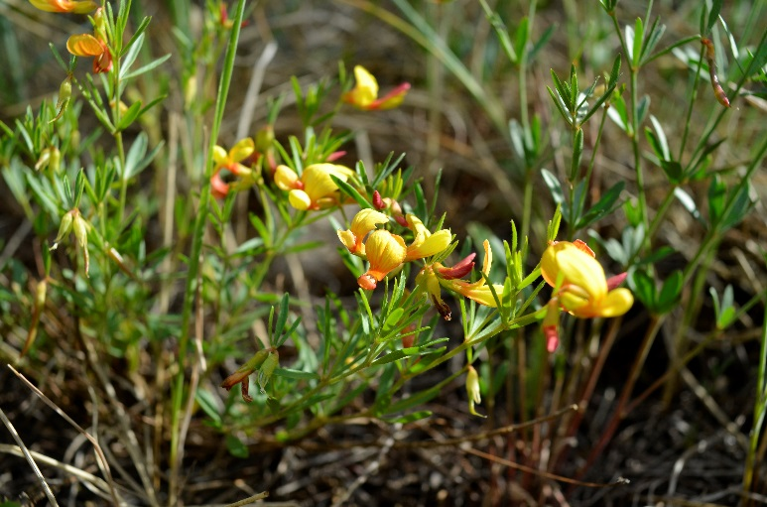

Utah Trefoil

*Lotus utahensis Ottley*

Plant Symbol = LOUT3

*Common Names:*

Utah lotus, Utah bird’s-foot trefoil, Utah birdsfoot trefoil

*Scientific Names:*

*Lotus utahensis* Ottley

### Description

*General*: Utah trefoil is described as a perennial leguminous species with erect-ascending stems from a shallow tap root. Plants senesce each winter with all above-ground growth dying back to the root crowns. Plants reach full bloom in mid to late June to early July with seed pods reaching full maturity in mid-July when the pods naturally split (Stettler, 2016a). It has many primary stems that have an upright growth pattern with dense green foliage and pale yellow to dark yellow flowers, usually in groups of five (Stettler, 2016a). Leaves are sessile, palmate, with 3 to 5 leaflets averaging 2 to 28 mm long, 1.5 to 7 mm wide, and spatula shaped to oblanceolate or oblong, obtuse to acute. The flowers are 12 to 16 mm long, yellow, suffused with red; calyx 4.5 to 8.7 mm long, with a 3.3-4.5 mm long tube. The fruit is a narrowly oblong pod, 22 to 35 mm long, 2.5 to 3.5 mm wide, minutely strigulose to glabrate (Welsh et al., 2003).

*Distribution*: Utah trefoil occurs in southern Utah, Nevada and parts of Arizona (Welsh et al., 2003). It is plentiful in the southern Great Basin and the Mojave Basin and Range (Stettler, 2016a), where it is found on the plateaus of Utah in Beaver, Garfield, Iron, Kane, Millard, Piute, Sevier, Utah, Washington, and Wayne counties. It is also found on the Kaibab Plateau in northwestern Arizona, in the mountains of central Arizona, and into Lincoln County, Nevada. For current distribution, please consult the Plant Profile page for this species on the PLANTS Web site.

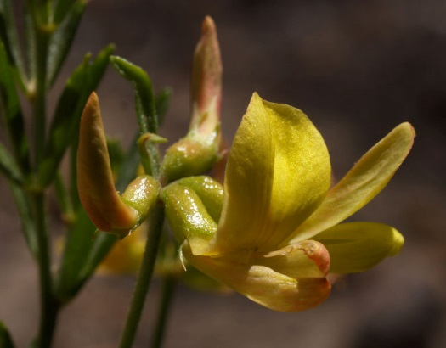

Closeup of Utah trefoil flower. Photo by Lee Dittmann, used with permission.

*Habitat*: Utah trefoil is found in semi-arid areas of the Intermountain West among sagebrush, pinyon-juniper, mountain brush, aspen, and spruce-fir communities at 1470 to 2850 m. (4800-9350 ft.) (Cronquist et al., 1989; Welsh et al., 2003).

**Adaptation**

Utah trefoil is commonly found growing in open, dry, stony or sandy soils in sites receiving 30-50 cm (12-20 in.) of annual precipitation. Early trials of 14 accessions of Utah trefoil suggest that plants will be adapted to a wide range of environmental conditions at restoration sites, which may improve seeding success. The average elevation of the 14 collection sites was 2261 m. (7418ft.) (Stettler, 2016a).

### Uses

*Restoration*: Utah trefoil may have potential for rangeland restoration and rehabilitation in the Intermountain West (Stettler, 2016a). As a native legume, Utah trefoil would add a nitrogen-fixing component to rangeland plant mixtures.

*Wildlife/forage*: Regrowth in trial plots of Utah trefoil was heavily grazed by rabbits and/or mule deer, showing that this species is useful for feed even despite its relatively high levels of tannins (Stettler, 2016a). Species of the genus *Lotus* L. have been recognized as important to agriculture due to their high digestibility and crude protein content (Escaray et al., 2012). Their condensed tannin content, which is important for forage quality because it reduces the risk of bloat, improves nutrient absorption, reduces protein degradation in the rumen (Undersander et al., 1993; Smith and Kelmen, 1997), and controls intestinal parasites (Novobilsky et al., 2011).

*Pollinator*: Utah trefoil should be considered for use in Intermountain West pollinator plantings and CRP. Native bees of the genera *Anthidium*, *Bombus*, and *Megachile* have been most frequently observed in association with this species of trefoil (Ikerd, 2016).

### Status

*[Weedy or Invasive:](#status3" \o "Include statement, if necessary, shown below.  Also include states where the species is listed, if applicable.)* This native forb/legume has not been shown to become problematic within its native range. Please consult with your local NRCS Field Office, Cooperative Extension Service office, state natural resource, or state agriculture department regarding its status and use. Please consult the PLANTS Web site (<http://plants.usda.gov/>) and your state’s Department of Natural Resources for this plant’s current status (e.g., threatened or endangered species, state noxious status, and wetland indicator values).

### Planting Guidelines

Utah trefoil seed used in preliminary field trials were acid scarified for 10-20 minutes, followed by inoculation with a peat-based *Rhizobium*. Until specific propagation methods are developed for Utah trefoil, one might use the seeding recommendations made for birdsfoot trefoil seed production as a guide (Stettler, 2016b).

### Management

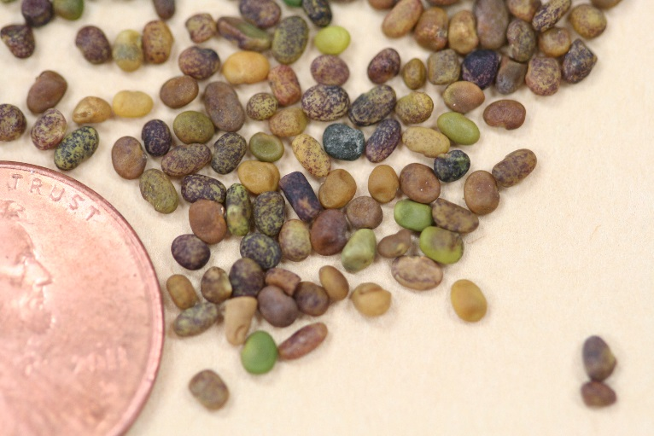

Utah trefoil seed. There are approximately 122,000 seeds/lb. Photo by Derek Tilley.

Utah trefoil should be used as a minor component of restoration seed mixtures. Management strategies should be based on the key species in the established plant community. Grazing should be deferred on seeded lands for at least two growing seasons to allow for full stand establishment.

### Pests and Potential Problems

There are no known pests or potential problems associated with Utah trefoil.

### Environmental Concerns

Utah trefoil is a natural component of many native plant communities in North America. There are no known environmental concerns regarding Utah trefoil.

### Seeds and Plant Production

There are approximately 122,580 seeds/lb of Utah trefoil and a bushel weight of approximately 60.5 lb/bu. The full stand seeding rate is 9 lbs PLS/ac, based on a target rate of 25 to 30 PLS/ft. Although currently there is no commercially available seed, certain collections have shown promise for agronomic seed production because they produce pods on tall upright stems, which should allow seed to be mechanically harvested (Stettler, 2016a).

**Cultivars, Improved, and Selected Materials (and area of origin)** At present there have not been any cultivars selected or improved, but early trials conducted by the ARS Forage and Range Research Laboratory in Logan, UT have shown promise for future production of selected cultivars (Stettler, 2016a). Cultivars may be selected based on the local climate, resistance to pests, seedling establishment, seed production, and intended use. Consult with your local land-grant university, local extension office, or local USDA-NRCS office for recommendations on adapted sources for use in your area**.**

**Literature Cited**

Cronquist, A., A. Holmgren, N. Holmgren, J. Reveal, P. Holmgren. 1989. Intermountain Flora: Vascular Plants of the Intermountain West USA. Vol. 3b Fabales. The New York Botanical Garden. Bronx, NY. 279p.

Escaray, F. J., A.B. Menendez, A. Gàrriz, F. L. Pieckenstain, M. J. Estrella, L. N. Castagno, P. Carrasco, J. Sanjuàn, O. A. Ruiz. 2012. Ecological and agronomic importance of the plant genus *Lotus.* Its application in grassland sustainability and the amelioration of constrained and contaminated soils. Plant Science 182:121-133.

Ikerd, H. 2016. Personal communication. USDA-ARS Bee Biology and Systematics Laboratory. Logan, UT.

Novobilisky, A., I. Mueller-Harvey, S. M. Thamsborg. 2011. Condensed tannins act against cattle nematodes. Veterinary Parasitology 182:213-220.

Smith, K. F., W. M. Kelman. 1997. Predicting condensed tannin concentrations in *Lotus uliginosus* Schkuhr using near-infrared reflectance spectroscopy. Journal of the Science of Food and Agriculture 75:263-267.

Stettler, J. 2016a. Utah Lotus: North American legume for possible uses in rangeland revegetation in the southern Great Basin of the western United States. Unpublished M.S. thesis. Utah State University. Logan Utah.

Stettler, J. 2016b. Personal communication. PhD candidate. Brigham Young University. Provo, UT.

Undersander, D., L. Greub, R. Leep, P. Beuselinck, J. Wedberg, D. Smith, K. Kelling, J. Doll, D. Cosgrove, C. Grau, S. Peterson, M. Wipfli, J. English. 1993. Birdsfoot trefoil for grazing and harvested forage. University Extension, Iowa State University, Ames, IA.

Welsh, S., N. Atwood, S. Goodrich, L. Higgins. 2003. A Utah Flora. Brigham Young University. Provo, UT. 912p.

### Citation

Pickett, T., and D. Tilley. 2016. Plant Guide for Utah trefoil (*Lotus utahensis)*. USDA-Natural Resources Conservation Service, Aberdeen Plant Materials Center. Aberdeen, ID 83210.

Published: November 2016

[Edited:](#edited" \o "[e.g., 08Sep2009 rg, 08Sep2009 jfh; 17Sep2009 mws]  NOTE:  Please remove the brackets if no editing data exists (new document).1) The author is the person(s) who did the majority of the work and should not exceed 2 people. Names should not be added to updated PGs unless significant rewrites are done. If a substantial rewrite is done the citation should be adjusted as follows:Original authors name, title, [add ed. (rev) Editor name. new pub date], remainder of citation remains the same.Example:  Pavek, P.L.S. 2012. Plant guide for pea (Pisum sativum L.). ed. (rev) E.R. Garner. 2014. USDA-Natural Resources Conservation Service, Pullman, WA.2) If minor updates or revisions are made it is only in the edited by section. Retain the most recent 5-10 edits.3) Names should not be removed regardless of death or retirement.)

For more information about this and other plants, please contact your local NRCS field office or Conservation District at <http://www.nrcs.usda.gov/> and visit the PLANTS Web site at <http://plants.usda.gov/> or the   
Plant Materials Program Web site:

<http://plant-materials.nrcs.usda.gov>.

PLANTS is not responsible for the content or availability of other Web sites.

The U.S. Department of Agriculture (USDA) prohibits discrimination against its customers, employees, and applicants for employment on the bases of race, color, national origin, age, disability, sex, gender identity, religion, reprisal, and where applicable, political beliefs, marital status, familial or parental status, sexual orientation, or all or part of an individual's income is derived from any public assistance program, or protected genetic information in employment or in any program or activity conducted or funded by the Department. (Not all prohibited bases will apply to all programs and/or employment activities.)

If you wish to file an employment complaint, you must contact your agency's [EEO Counselor](http://www.ascr.usda.gov/doc/EEO_Counselor_List.pdf) (PDF) within 45 days of the date of the alleged discriminatory act, event, or in the case of a personnel action. Additional information can be found online at <http://www.ascr.usda.gov/complaint_filing_file.html>.

If you wish to file a Civil Rights program complaint of discrimination, complete the [USDA Program Discrimination Complaint Form](http://www.ocio.usda.gov/sites/default/files/docs/2012/Complain_combined_6_8_12.pdf) (PDF), found online at <http://www.ascr.usda.gov/complaint_filing_cust.html>, or at any USDA office, or call (866) 632-9992 to request the form. You may also write a letter containing all of the information requested in the form. Send your completed complaint form or letter to us by mail at U.S. Department of Agriculture, Director, Office of Adjudication, 1400 Independence Avenue, S.W., Washington, D.C. 20250-9410, by fax (202) 690-7442 or email at [program.intake@usda.gov](mailto:program.intake@usda.gov).

Individuals who are deaf, hard of hearing or have speech disabilities and you wish to file either an EEO or program complaint please contact USDA through the Federal Relay Service at (800) 877-8339 or (800) 845-6136 (in Spanish).

Persons with disabilities who wish to file a program complaint, please see information above on how to contact us by mail directly or by email. If you require alternative means of communication for program information (e.g., Braille, large print, audiotape, etc.) please contact USDA's TARGET Center at (202) 720-2600 (voice and TDD).

For any other information dealing with Supplemental Nutrition Assistance Program (SNAP) issues, persons should either contact the USDA SNAP Hotline Number at (800) 221-5689, which is also in Spanish or call the [State Information/Hotline Numbers](http://www.fns.usda.gov/snap/contact_info/hotlines.htm).

For any other information not pertaining to civil rights, please refer to the listing of the [USDA Agencies and Offices](http://www.usda.gov/wps/portal/usda/usdahome?navtype=MA&navid=AGENCIES_OFFICES_C) for specific agency information.

***Helping People Help the Land***

**USDA IS AN EQUAL OPPORTUNITY PROVIDER AND EMPLOYER**