

Plant Guide

# Bigelow's tansyaster

## Machaeranthera bigelovii

## (A. Gray) Greene

var. *bigelovii*

Plant Symbol = MABIB

*Contributed by*: USDA NRCS Colorado Plant Materials Program

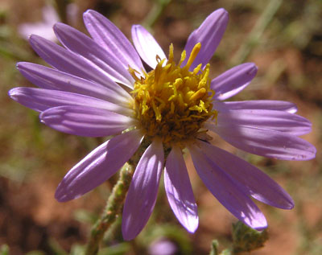

Figure 1: Bigelow’s tansyaster, Machaeranthera bigelovii var. bigelovii Photo ©Al Schneider, www.swcoloradowildflowers.com, used with permission.

### Alternate Names

*Common Alternate Names:* Tansy aster, Bigelow’s aster, sticky aster, purple aster

*Scientific Alternate Names: Aster bigelovii, Machaeranthera mucronata, Dieteria bigelovii var. bigelovii*

### Uses

*Restoration/reclamation*:

Bigelow’s tansyaster is used as a forb component for restoration and wildlife enhancement projects. Once established it exhibits extreme drought tolerance. As an early seral species, it competes with undesirable non-native species such as cheatgrass (*Bromus tectorum*) and knapweed species (*Centaurea* spp.). Its tall stature and showy flowers provide structural diversity in a mix for wildlife. As an early colonizer for disturbed sites, it may be used for erosion protection for restoration projects post-wildfire, and reclamation projects. It can be planted to enhance species diversity in rangeland; however, it is not noted as having value as forage for livestock (Ogle et al 2011).

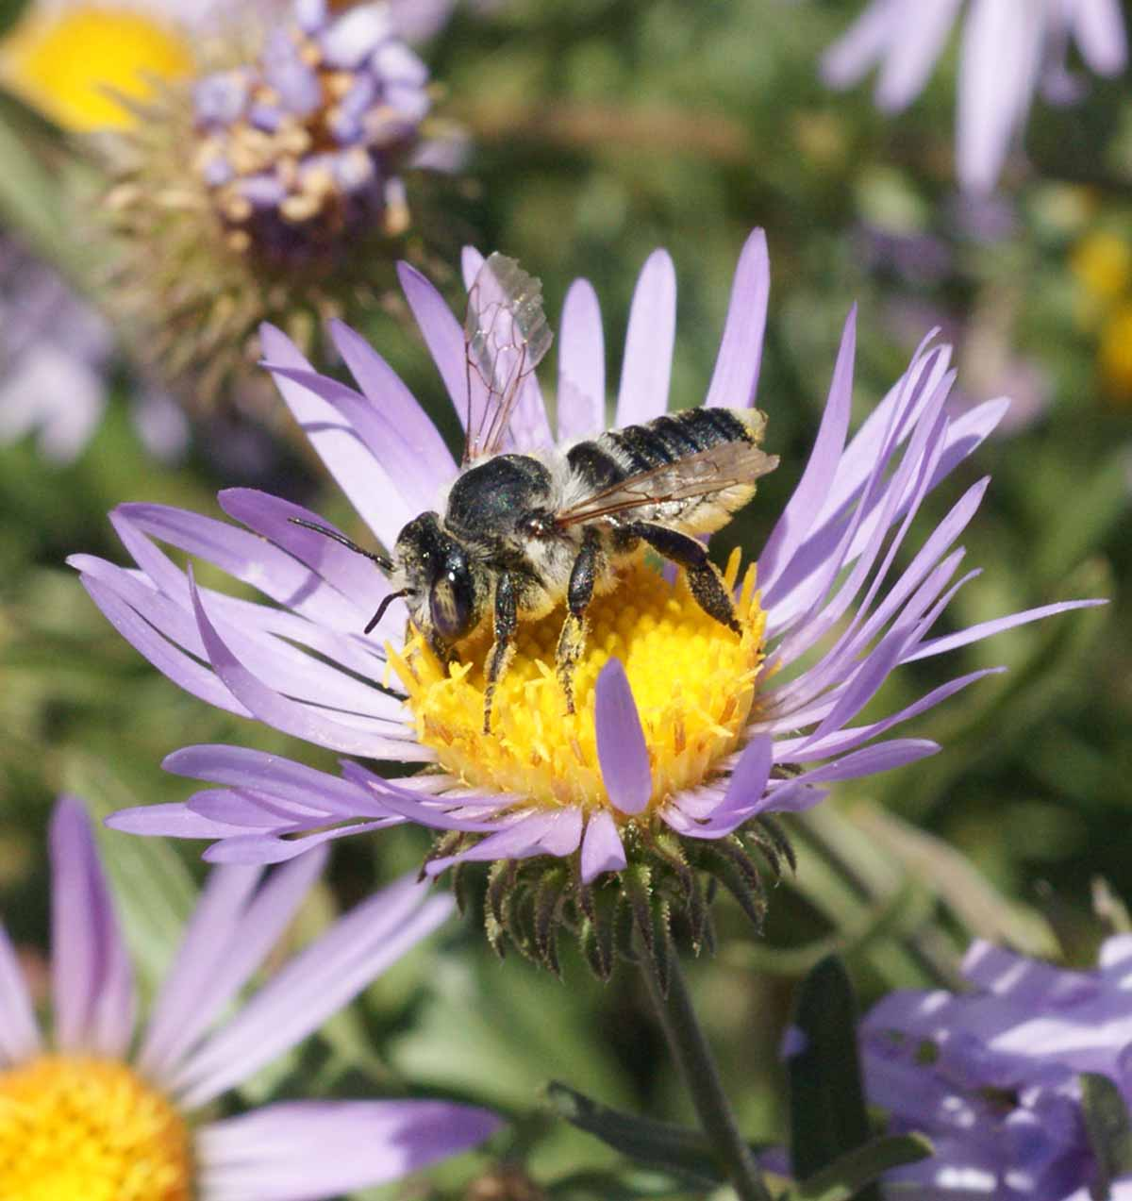

Figure 2: Leaf-cutter bee (Megachile ssp.) visiting Bigelow’s tansyaster. Photo by Diane Wilson, Applewood Seed Company, used with permission.

*Pollinator*

A variety of generalist bees, such as honey and leaf-cutter bees, which are active late in the summer or early autumn, utilize the prolific blooms of Bigelow’s tansyaster (Cane, 2012).

### Status

Please consult the PLANTS Web site and your State Department of Natural Resources for this plant’s current status (e.g., threatened or endangered species, state noxious status, and wetland indicator values).

### Description

*General*: Aster Family (Asteraceae). This genus has been recently circumscribed to *Dieteria*, to better incorporate the current understanding of the complex evolutionary history (Cronquist et al 1984;Turner 1987; Hartman 1990; Morgan 2009; Morgan and Hartman 2003; Stevens 2001; and Weber and Wittmann, 2001). Bigelow’s tansyaster is a native biennial to short-lived perennial with deep violet to blue-white colored flowers. Plants are 1 to 3 feet tall (15cm to 90cm) and arise from a taproot. Cauline (stem) leaves are 0.4 to 3 inches long (1cm to 7.5cm) and 0.30 in. (1.5mm to 8mm) or less in

### Bigelow's tansyaster showing the green phylliaries

width, lance- to oblanceolate-shaped with sharply toothed margins. Flower heads are subtended by overlapping rows of bracts (phylliaries) with curved tips which are green for at least half of the length of the phylliary. The flower stalks, (peduncle) and bracts are covered with sticky glandular hairs (trichomes). The pappus attached to the achene is off-white and there are 1,283,000 seeds per pound (Wilson 2012). Blooms from July to October.

Bigelow’s tansyaster (*Machaeranthera bigelovii*) and hoary tansyaster (*Machaeranthera canescens*) are challenging to distinguish due to overlapping habitats and hybridization and the many varieties of *M. canescens*. Weber and Wittmann (2001) distinguish between the two species as follows:

*M. bigelovii*: Presence of glandular trichomes on both the peduncles and phylliaries. Phylliaries with green tips equaling or exceeding the colorless base (Figure 4).

*M. canescens*: Well-developed glandular trichomes absent from peduncles. Phylliaries with a relatively short green apex (Figure 5), (Schneider 2004).

**Ethnobotany**

*Machaeranthera* ssp. have been utilized by Native American Tribes for a variety of purposes from a stimulant to gastrointestinal aid to respiratory aid. The flowers used to make necklaces (Native American Ethnobotany, 2012). Plants were used by Navajo Indians for nose and throat troubles (Moerman, 1998).

*Distribution:*

According to Morgan and Hartman (2003), of the three recognized varieties of *Dieteria bigelovii* only *Dieteria*

*bigelovii* var. *bigelovii*, (Bigelow’s tansyaster), occurs in

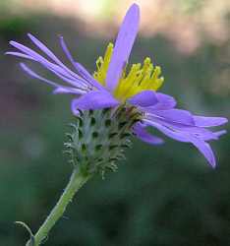

Figure 5: Hoary tansyaster (Machaeranthera canescens)

Figure 4: Bigelow’s tansyaster (Machaeranthera bigelovii) detailing the differences between the coloration on the bracts to distinguish from hoary tansyaster, also note the sand particles on the glandular hairs. Photo ©Al Schneider, www.swcoloradowildflowers.com, used with permission.

showing the lack of glandular hairs on the peduncle and the

phylliary with relatively short green apex. Photo ©Al Schneider, www.swcoloradowildflowers.com, used with permission.

the Southern Rocky Mountain region of Wyoming, Colorado and New Mexico (Welsh 2003). While Bigelow’s tansyaster is very similar to the hoary tansyaster, it is much more restricted to habitat and range (Schultz 1987, Welsh 2003, Turner 1987).

*Habitat*:

Bigelow’s tansyaster is common in plant communities such as meadows, open areas, subalpine coniferous forests, oak woodlands, grasslands, creosote bush or sagebrush scrublands, often found along streams and roadsides (Hartman 2012). In the fall months, vast flower displays of Bigelow’s tansyaster may be observed in foothill fields and along roadsides.

**Adaptation**

Bigelow’s tansyaster is adapted to fine to coarse textured soils with a pH of 6.0 to 8.5 (USDA Plants Database; Tilley et al, 2010). Bigelow’s tansyaster requires full exposure to sunlight, and a minimum 6 inch rooting depth. The species is commonly found in areas receiving 6 to 18 in. (15cm to 45cm) of annual precipitation at 7,500 to 11,500 feet (2300m to 3200m) in elevation.

**Establishment**

“Loring (2012) observed 80% to 90% typical germination from fresh seed at 15 ° C for 21 days,” Hall (2012) noted 93% and 98% seed viability from Tetrazolium tests.

For conservation and restoration projects seed should be drilled or broadcast seeded in late fall into a firm, weed-free seed bed at a depth of 0 to 6 mm (0 to 0.25 in.) To establish a solid stand for seed production, target delivery of 20 to 30 pure live seeds (PLS) per square foot, seed at a rate of 2 lbs (0.9 kg) PLS per acre. If seeding as part of a mix, adjust seeding rate to the desired percentage of the mixture. Broadcast seedings should be followed with a culti-packer to ensure good seed to soil contact. For establishment of fields for seed production, use irrigation for the first two weeks to establish plants from seed, conduct seeding in spring, with monsoonal moisture in summer, or in fall (Swift, 2012).

Seed should be mixed with a carrier such as rice hulls to assist seed flow through seeding equipment. When calculating rice hull amounts based on seed bushel weights, it is important to determine the condition of the seed. Hoary tansyaster seed which has not had the pappus removed has a bushel weight of approximately 3 lb/bushel (Tilley, et al 2010).

**Management**

When planted in a wildlife habitat or reclamation seeding, use Bigelow’s tansyaster as a quick establishing species that provides competition to nonnative weedy species. As longer-lived perennials become established, Bigelow’s tansyaster will become a minor component in the established plant community; therefore, management should be based on other key species. Defer grazing on seeded lands for at least two growing seasons to allow for full stand establishment.

**Pests and Potential Problems**

Moth caterpillars from the genus *Cucillia* were observed on observational plots of *M. canescens* at Aberdeen, Idaho. These were seen eating flower heads, but did not appear to do extensive damage to the plots or decrease seed production significantly (Tilley et al, 2010). Caterpillars were also observed eating flower heads on production plots of *M. bigelovii,* in the San Luis Valley of Colorado, however, the species of caterpillar was not identified (Swift, 2012).

**Seed and Plant Production**

Seed production fields of Bigelow’s tansyaster can be planted into weed barrier fabric at 23 to 46 cm (9 to 18 in.) spacing (Tilley et al 2010). Seed should be planted in late fall into slightly roughened soil and then lightly packed. For seed production and under irrigation, seed may be planted in the spring with row spacing for between row cultivation. After establishment no additional moisture is required and plants are extremely drought tolerant (Swift, 2012). When using irrigation, Swift 2012, noted the presence of caterpillar infestations on the flowers observing them to be absent when irrigation is not utilized.

Seed can be harvested by hand, direct combined, or by using a vacuum harvester (Bair and Tilley, 2010) beginning mid- to late October. Vacuum harvesters allow multiple, non-destructive harvests to take place as seed matures. Seed can be cleaned by sifting collected materials over ½ inch hardware cloth to separate seed from stems and flower heads. Using this method, it is possible to collect seed of high enough quality that additional processing may not be necessary. Seed processed in this manner will have an intact pappus and fair to moderate purity; however, when mixed with a carrier such as rice hulls, the seed flows well through grain and no-till drills and other seeding equipment. Seed harvests of experimental plots of *M. canescens*, yielded approximately 200 lbs of clean seed per acre (Tilley et al, 2010).

Weed control efforts should begin prior to planting. Planting into a weed-free seed bed, or using weed barrier fabric greatly reduces management inputs. Weeds can be controlled using pre-emergent herbicides and by hand rouging. Weedy grasses can be controlled with selective herbicides (Tilley et al, 2010).

Always read and follow label and safety instructions for each control method. USDA-NRCS does not guarantee or warranty any products or control methods named, and other products may be equally effective.

As with *M. canescens*, Bigelow’s tansyaster is a difficult species to clean. Seed is small with a flexible pappus that is not easily removed. Tilley et al 2010, describe “hammer-milling removes some of the pappus, but mostly results in creating a mat of pappus hairs, seed, and inert matter. The USDA Forest Service at the Bend, OR Seed Extractory uses a Westrup Model LA-H laboratory brush machine with a #40 mantel at a speed of 3 to dislodge seed from the flower heads and remove the pappus. The gate is left completely open to allow the seed to move quickly through the machine and avoid damaging the achenes.” This is followed by air-screening (Barner, 2009).

**Cultivars, Improved, and Selected Materials (and area of origin)**

### Common wild land collected seed is available from commercial sources. There are currently no commercial releases of Bigelow’s tansyaster.

**Prepared By**:

*Christine Taliga*; Plant Materials Specialist, USDA NRCS Denver, Colorado.

### Citation

Taliga, Christine E. 2012. Plant Guide for Bigelow’s tansyaster (*Machaeranthera bigelovii)*. USDA-Natural Resources Conservation Service, Colorado State Office. Denver, CO 80225-0426.

Published *September, 2012*

Edited: 20Sep2012jab, 21Sep2012cga

### References

Bair, C. and D. Tilley. 2010. The Jet Harvester: A New Tool for Harvesting Native Forb and Shrub Seed. USDA-NRCS. Technical Note 55. Boise, ID.

Barner, J. 2009. Propagation protocol for production of *Machaeranthera canescens* (Pursh) A. Gray Seeds; USDA FS-R6 Bend Seed Extractory, Bend, OR. In: Native Plant Network. [Online] at:

http://www.nativeplant network.org (accessed 26 July 2010). Moscow (ID): University of Idaho, College of Natural Resources, Forest Research Nursery.

Butler, Jennifer; Frieswyk, Christin. 2001. Propagation protocol for production of Machaeranthera seeds; USDI NPS - Rocky Mountain National Park, Estes Park, Colorado. In: Native Plant Network. [Online] at: http://www.nativeplantnetwork.org (Accessed 20 September 2012). Moscow (ID): University of Idaho, College of Natural Resources, Forest Research Nursery.

Cane, J. 2012. Personal communication. Logan (UT). USDA-Agricultural Research Service, Bee Systematics and Biology Laboratory.

Cronquist, A. J., A. H. Holmgren, N. H. Holmgren, J. L. Reveal & P. K. Holmgren. 1984. Vascular Plants of the Intermountain West, U.S.A. 4: 1–573. In A. J.

Hall, Denny. 2012. Personal communication. Powell, (WY) University of Wyoming, Seed Analysis Laboratory.

Hartman, R. L. 1990. A Conspectus of Machaeranthera (Asteraceae: Astereae)Phytologia 68(6):439-465.

Hartman, R.L. (2008 onwards). University of Wyoming. Rocky Mountain Herbarium Database. *Dieteria bigelovii*, accessed: 9/4/2012.

Loring, Mary, 2012. Personal communication. Wheat Ridge, CO. Precision Seed Testing.

Moerman, D.E. 1998. Native American Ethnobotany. Timber Press. 927 p.

Morgan, D.R., R. Korn, S. Mugelston. 2009. Insights Into Reticulate Evolution In Machaerantheae (Asteraceae: Asterea): 5S Ribosomal RNA Spacer Variation Estimating Support for Congruence and Constructing Reticulate Phylogenies. American Journal of Botany 96(5): 920–932.

Morgan, D.R., and R.L. Hartman. 2003. A synopsis of *Machaeranthera* (Asteraceae: Astereae), with recognition of segregate genera. Sida 20:1837–1416.

Morgan, D.R.  2003.  *Dieteria*.  In: eFloras (2008). Published [Online] at: http://www.efloras.org (accessed 9 September 2012). Missouri Botanical Garden, St. Louis, MO & Harvard University Herbaria, Cambridge, MA.

Native American Ethnobotany Database. University of Michigan, Dearborn. [Online] at: http://herb.umd.umich.edu/ (Accessed September 3, 2012).

Ogle, D., St. John, L., Stannard, M. and L. Holzworth. 2011. Technical Note 24: Conservation plant species for the Intermountain West. USDA-NRCS, Boise, ID-Salt Lake City, UT-Spokane, WA. ID-TN 24. 57p.

Schneider, Al. (2004 onwards). Southwest Colorado Wildflowers. [Online] at: www.swcoloradowildflowers.com, (Accessed 20 September 2012).

Schultz, L.M., E.E. Neely, J.S. Tuhy. 1987. Flora of the Orange Cliffs of Utah. Great Basin Naturalist. Vol. 47 No.2.

Stevens, P. F. (2001 onwards). Angiosperm Phylogeny Website. Version 12, July 2012, [Online] at: http://www.mobot.org/MOBOT/research/APweb/,(Accessed 20 September 2012).

Swift, Dean. Dean Swift Seed Company. http://deanswiftseed.com/

Tilley, D., D. Ogle, and L. St. John. 2010. Plant guide for hoary tansyaster (Machaeranthera canescens). USDA-Natural Resources Conservation Service, Idaho Plant Materials Center. Aberdeen, ID. 83210.

Turner, B.L. 1987. A Taxonomic Study of Machaeranthera Sections Machaeranthera and Hesperastrum Asteraceae. Phytologia: Vol. 62, No. 3, p 207- 266.

USDA, NRCS. 2012. The PLANTS Database (http://plants.usda.gov, 21 September 2012). National Plant Data Team, Greensboro, NC 27401-4901 USA.

Weber, W.A. and R. C. Wittmann, 2001. Colorado Flora: Western Slope and Eastern Slope. Colorado Associated University Press, Boulder, Colorado. 530pp.

Welsh, S.L., N.D. Atwood, S. Goodrich, and L.C. Higgins. 2003. A Utah Flora. Third Edition, revised. Brigham Young University, Provo, UT.

Wilson, Diane. 2012. Personal communication. Arvada, CO. Applewood Seed Company.

For more information about this and other plants, please contact your local NRCS field office or Conservation District at <http://www.nrcs.usda.gov/> and visit the PLANTS Web site at <http://plants.usda.gov/> or the Plant Materials Program Web site <http://plant-materials.nrcs.usda.gov>.

PLANTS is not responsible for the content or availability of other Web sites.

**USDA IS AN EQUAL OPPORTUNITY PROVIDER AND EMPLOYER**