|  |  |
| --- | --- |
| **Natural Resources Conservation Service** | Plant Guide |

# hoary tansyaster

## Machaeranthera canescens (Pursh) A. Gray

Plant Symbol = MACA2

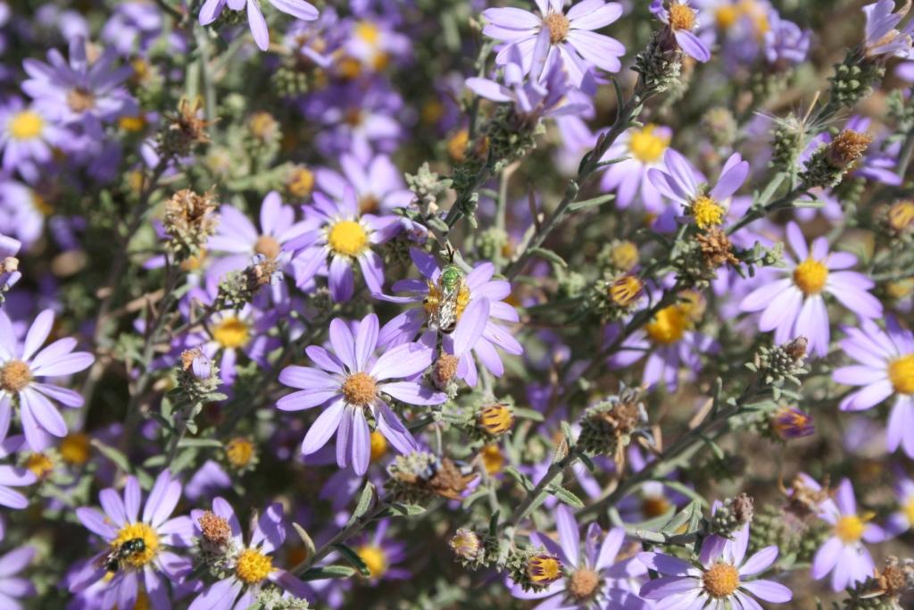

Hoary tansyaster flowers. Photo by Derek Tilley

### Alternate Names

*Common Names:* Purple aster

*Scientific Names: Dieteria canescens*

### Description

*General*: Sunflower family (Asteraceae). Hoary tansyaster is a short-lived perennial forb with pale to dark purple flowers. Plants are 15 to 75 cm (6 to 30 in) tall with diffuse branching. Leaves are about 5 cm (2 in) long and 6 mm (0.25 in) wide, oblong or lance shaped with entire to sharply toothed margin. Flower heads have many subtending bracts that reflex away from the flower at the tip (Welsh et al., 2003). Flower heads and vegetation are very sticky and heavily scented. Bracts are white and membranous at the bottom and green at the tip. The pappus of the achene is dirty white and hair-like. There are approximately 1.3 million seeds/lb based on seed counts conducted by Aberdeen Plant Materials Center (Tilley and St. John, 2010).

*Distribution*: Hoary tansyaster occurs throughout western North America from British Columbia to Saskatoon, south to California, Arizona and Colorado. For current distribution, please consult the Plant Profile page for this species on the PLANTS Web site.

*Habitat*: Hoary tansyaster is common in plant communities from shadscale desert and Wyoming big sage sagebrush shrub communities on the valley floors to mountain big sagebrush, aspen and limber pine communities moving up-slope to higher elevations. Plants can be readily found flowering in late summer in numerous habitats, but primarily in valley bottoms and other dry areas. Hoary tansyaster is very common in low seral degraded and disturbed sites and has been considered by some as a weedy species in meadows and rangelands (Whitson et al., 1996).

**Adaptation**

Hoary tansyaster is adapted to medium to coarse textured, well drained soils with a pH of 6.0 to 8.4 (Borden and Black, 2005; Tilley and St. John, 2010). Hoary tansyaster requires full exposure to sunlight, and a minimum 10 inch rooting depth. The species is commonly found in areas receiving 20 to 150 cm (8 to 60 in.) of annual precipitation.

### Uses

*Restoration/reclamation*:

Hoary tansyaster is an early colonizer of rangelands and disturbed sites. It is commonly found on roadsides and gravel pits competing with invasive plants such as cheatgrass (*Bromus tectorum*) and knapweed species (*Centaurea* spp). It can be planted to enhance species diversity in rangeland seedings throughout the western United States.

*Ethnobotanical*

Plants were used by Navajo Indians to treat nose and throat troubles (Moerman, 1998).

*Wildlife*:

Hoary tansyaster can be used as part of a native forb component in rangeland and wildland seedings to increase biodiversity, improve wildlife habitat, and provide food for numerous birds and mammals. Hoary tansyaster is readily visited by pollinators and other insect species. It is considered an important species for sage grouse during brood rearing because of its insect associations. Insect surveys on hoary tansyaster plots at the Aberdeen Idaho Plant Materials Center showed visitation by sweat bees (*Halictus* spp.), green sweat bees (*Agapostemon* spp.), European honey bees (*Apis mellifera*), bee flies (*Bombilidae*) and cabbage white butterflies (*Pieris* spp.).

### Figure 2. A green sweat bee (Agapostemon spp.) visiting hoary tansyaster. Photo by Derek Tilley

A green sweat bee (*Agapostemon* sp.) visiting hoary tansyaster. Photo by Derek Tilley

### Status

### Please consult the PLANTS Web site (<http://plants.usda.gov/>) and your State Department of Natural Resources for this plant’s current status (e.g., threatened or endangered species, state noxious status, and wetland indicator values).

### Planting Guidelines

Parkinson and DeBolt (2005) observed 77% germination of seed that had been pre-chilled in dampened blotter paper at 4° C for 35 days. Seed field establishment at the Aberdeen PMC indicates that pre-chilling may not be necessary for germination.

A common garden study comparing 9 populations of hoary tansyaster from Idaho and Utah had establishment percentages ranging from 41 to 87% (Tilley and St. John, 2010) from seed that was field-planted in November and allowed to undergo natural stratification.

Seed should be drilled or broadcast seeded in late fall into a firm, weed-free seed bed at a depth of 0 to 6 mm (0 to 0.25 in). For a pure stand, target delivery of 20 to 30 pure live seeds (PLS) per square foot, seed at a rate of 2 lbs (0.9 kg) PLS per acre. If seeding as part of a mix, adjust seeding rate to the desired percentage of the mixture. Broadcast seedings should be followed with a cultipacker to ensure good seed to soil contact.

Seed should be mixed with a dilutent such as rice hulls to assist seed flow through seeding equipment. When calculating rice hull amounts based on seed bushel weights, it is important to determine the condition of the seed. Hoary tansyaster seed which has not had the pappus removed has a bushel weight of approximately 3 lb/bushel. Seed that has been processed to remove the pappus weighs approximately 20 to 24 lb/bushel.

### Management

When planted in a native reclamation seed mix, it will be a minor component of the establishing plant community; therefore management should be based on other key species in the mixture.

### Pests and Potential Problems

Moth caterpillars from the genus *Cucillia* were observed on observational plots at Aberdeen, Idaho. These were seen eating flower heads, but did not appear to do extensive damage to the plots or decrease seed production significantly (Tilley and St. John, 2010).

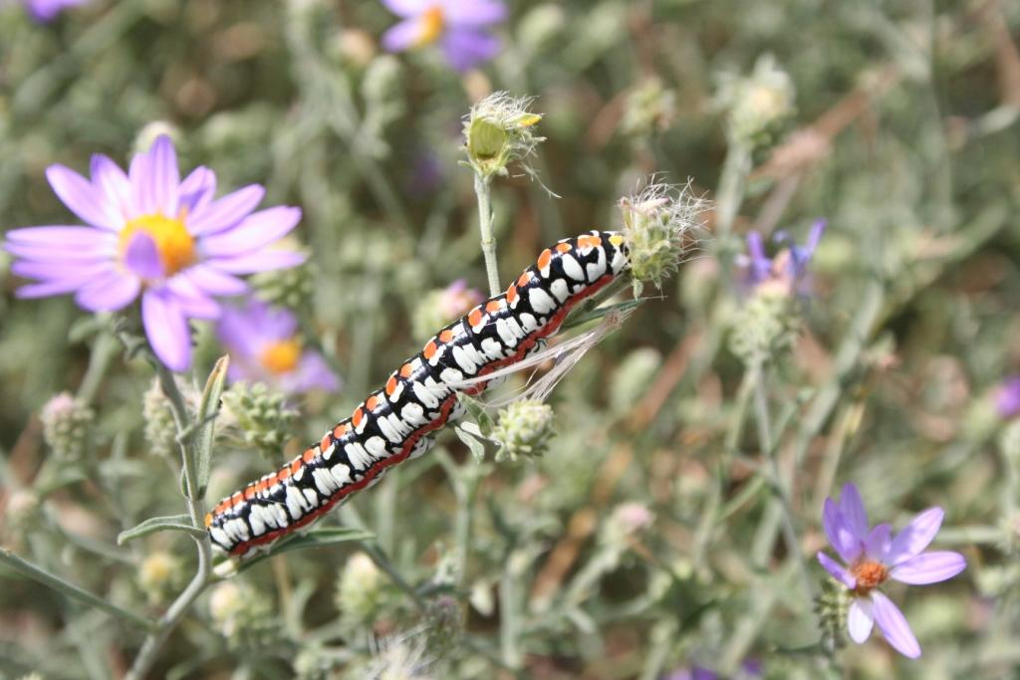

A *Cucillia* moth caterpillar feeding on hoary tansyaster flower heads. Photo by Derek Tilley

### Environmental Concerns

There are no known environmental concerns associated with hoary tansyaster.

### Seeds and Plant Production

Seed production fields of hoary tansyaster can be hand-planted into weed barrier fabric at 9 to 18 inch plant spacing or mechanically seeded into larger field plantings at 30 to 36 inch row spacing at 0.35 lb PLS/ac.

Planting timing is important with hoary tansyaster. We have found that late summer (August) seedings result in reduced annual weed competition. Fields planted in spring or early summer did not produce a crop during the first year but did produce the following year and died that winter. Fields planted in the fall produced crops the following 2 years.

Plants grown in weed barrier fabric at Aberdeen, Idaho (an 8- 12 inch mean annual rainfall zone) required no supplemental irrigation. Drill seeded fields received 10 cm (4 in) supplemental irrigation in late April and again in mid-May. Flowering begins in late summer and continues for several weeks into the autumn.

Seed can be harvested by hand, flail-vac, direct combined, or by using a vacuum harvester (Bair and Tilley 2010). Vacuum harvesters allow multiple, non-destructive harvests as seed matures.

Harvested material is spread out on a clean concrete floor to air dry. Multiple box fans are aimed at the seed to increase air-flow over the seed. The material is sifted and turned with hay forks twice daily to facilitate drying and to remove larger pieces of residue from the harvest.

Once dried, seed is first sent through a laboratory brush machine with a number 7 mantle and brush rotation speed of 3 to break up flower heads and remove the pappus. The gate is closed to allow the brushed seed to fall through to the catch pan below. The brushed material is then cleaned using a multi-deck air screen cleaner with 6x30 and 6x32 screens. The air is set at a low setting (1 to 2) to remove dust, pappus and unfilled seed. Flail Vac and combine harvested material contains a large amount of inert matter and needs to be run through the air screen process 6 to 10 times for adequate cleaning. Following air screening, we use an indent cleaner with 1.8 mm indents to remove small weed seeds such as witchgrass (*Panicum capillare* L.) and redroot pigweed (*Amaranthus retroflexus* L.). This process results in seed that can partially flow through seed drills. Rice hulls as a carrier can be mixed with the seed to improve seed flow through seeding equipment.

This method yields approximately 60 to 90% purity and 60 to 90% viability. Hand harvested and vacuum harvested seed is much easier to process, and higher purities (80 to 90%) are easily obtained due to the reduced amount of inert matter collected. Sowthistle (*Sonchus* sp.) and prickly lettuce (*Lactuca* *serriola* L.) seed are similar in shape and weight to hoary tansyaster. These are very difficult to remove during seed cleaning and are best handled in the field with hand rogueing or spot herbicide treatments.

Hand harvest of experimental plots yielded approximately 100 lbs of clean seed per acre (assuming 50% PLS). Mechanical harvest yields range between 2 and 7 lbs pure live seed (PLS)/ac. Increasing the number of harvests beyond 2 in a single year may slightly increase the total yield. As more experience with harvest and seed processing occurs, clean seed yields may be increased incrementally.

Weed control efforts should begin prior to planting. Planting into a weed-free seed bed, or using weed barrier fabric greatly reduces management inputs. Weeds can be controlled using pre-emergent herbicides and by hand rouging. Weedy grasses can be controlled with selective herbicides.

### Cultivars, Improved, and Selected Materials (and area of origin)

Amethyst Germplasm hoary tansyaster was released in 2014 by the Aberdeen Plant Materials Center for wildlife habitat and pollinator plantings in the Intermountain West. The original source population of Amethyst Germplasm hoary tansyaster is located near the St. Anthony Sand Dunes in Fremont County, Idaho at 1,524 m (5,000 ft) elevation. It is anticipated that Amethyst Germplasm hoary tansyaster is suited for conservation plantings in MLRA B11, Snake River Plains and B13 Eastern Idaho Plateaus (USDA 2006). It is also likely adapted for use in arid locations throughout the Intermountain West, but has not been tested to that extent.

Wildland collected seed may also be available commercially.

Cultivars should be selected based on the local climate, resistance to local pests, and intended use. Consult with your local land grant university, local extension or local USDA NRCS office for recommendations on adapted cultivars for use in your area**.**

**Literature Cited**

Bair, C. and D. Tilley. 2010. The Jet Harvester: A New Tool for Harvesting Native Forb and ShrubSeed. USDA-NRCS. Technical Note 55. Boise, ID.

Barner, J. 2009. Propagation protocol for production of *Machaeranthera canescens* (Pursh) A. Gray Seeds; USDA FS-R6 Bend Seed Extractory, Bend, OR. In: Native Plant Network. URL: http://www.nativeplant network.org (accessed 26 July 2010). Moscow (ID): University of Idaho, College of Natural Resources, Forest Research Nursery.

Moerman, D.E. 1998. Native American Ethnobotany. Timber Press. 927 p.

Parkinson, H., and A. DeBolt. 2005. Propagation protocol for production of container *Machaerantehra canescens* (Pursh) A. Gray plants; USDA Forest Service, RMRS, Boise, ID. In: Native Plant Network. URL: http://www.nativeplantnetwork.org (accessed 9 Feb 2007). Moscow (ID): University of Idaho, College of Natural Resources, Forest Research Nursery.

Tilley, D. and L. St. John. 2010. Hoary tansyaster initial evaluation planting: progress report 2010. USDA-NRCS. Aberdeen, ID.

Welsh, S.L., N.D. Atwood, S. Goodrich, and L.C. Higgins. 2003. A Utah Flora. Third Edition, revised. Brigham Young University, Provo, UT.

### Citation

Tilley, D., D. Ogle, and L. St. John. 2014. Plant guide for hoary tansyaster (*Machaeranthera canescens*). USDA-Natural Resources Conservation Service, Idaho Plant Materials Center. Aberdeen, ID. 83210.

November, 2010

[Edited:](#edited" \o "[e.g., 08Sep2009 rg, 08Sep2009 jfh; 17Sep2009 mws]  NOTE:  Please remove the brackets if no editing data exists (new document).1) The author is the person(s) who did the majority of the work and should not exceed 2 people. Names should not be added to updated PGs unless significant rewrites are done. If a substantial rewrite is done the citation should be adjusted as follows:Original authors name, title, [add ed. (rev) Editor name. new pub date], remainder of citation remains the same.Example:  Pavek, P.L.S. 2012. Plant guide for pea (Pisum sativum L.). ed. (rev) E.R. Garner. 2014. USDA-Natural Resources Conservation Service, Pullman, WA.2) If minor updates or revisions are made it is only in the edited by section. Retain the most recent 5-10 edits.3) Names should not be removed regardless of death or retirement.) 05Sep2014 djt

For more information about this and other plants, please contact your local NRCS field office or Conservation District at <http://www.nrcs.usda.gov/> and visit the PLANTS Web site at <http://plants.usda.gov/> or the   
Plant Materials Program Web site:

<http://plant-materials.nrcs.usda.gov>.

PLANTS is not responsible for the content or availability of other Web sites.

***Helping People Help the Land***

**USDA IS AN EQUAL OPPORTUNITY PROVIDER AND EMPLOYER**