

Plant Guide

Yellow sweetclover &

white sweetclover

*Melilotus officinalis* (L.) Lam.

& M. alba Medik

Plant Symbol = MEOF, MEAL2

Contributed by: Idaho NRCS State Office and Aberdeen, ID Plant Materials Center

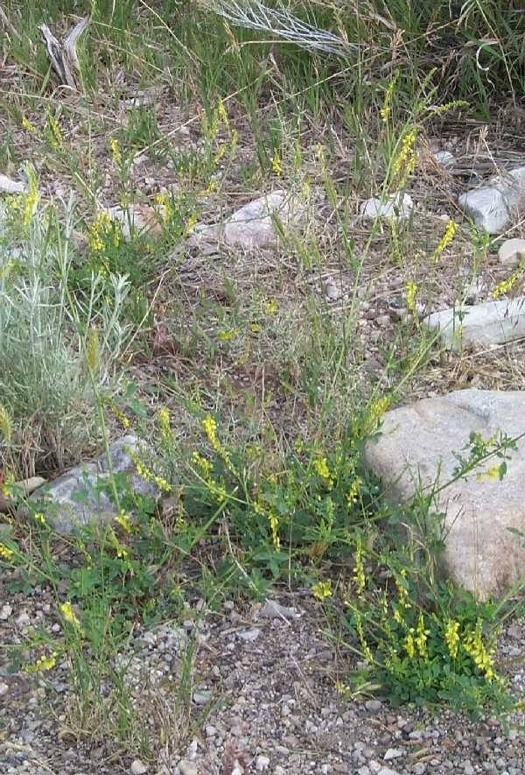**Yellow sweetclover. J.S. Peterson.** [**USDA NRCS NPDC**](http://npdc.usda.gov)

Alternate Names

Ribbed millet; Field millet; Cornilla real; Official melilot

Uses

*Wildlife*

Sweetclover provides food and cover to a variety of birds and mammals. The stems and leaves can make up a large portion of the diet of elk, deer and antelope. Mule deer diets can be comprised of over 70 percent sweetclover in summer and early fall (Sullivan, 1992). Elk prefer the forage in summer and fall while mule deer and antelope use it for forage throughout the year (Kufeld et al. 1973); however, the plants become coarse, stemmy and less palatable late in the season.

Sweetclover is utilized by birds as cover and food. Sharp-tail grouse, greater prairie-chicken, gray partridge, ring-necked pheasants and many quail species eat the seed (Wasser et al., 1986). It has been recommended to improve sage grouse habitat (Beck and Mitchel, 1997) and for use in reducing post-burn soil erosion in green strips (Braun, 2006). It provides good nesting materials for ducks and good habitat for pheasants, grouse and other upland birds as well as bitterns and passerine species. Small mammals eat the seed and use the plants for cover and nesting.

*Pollinators*

Sweetclover flowers are attractive to bees and butterflies (Ogle et al., 2007). The scientific name *Melilotus* comes from the Latin Mel (honey) and *Lotus*, another genus within the Legume family. It is a popular species for honey production (Baldridge and Lohmiller, 1990). Honey yields of up to 200 pounds per colony have been obtained (USDA, 1937). Seed production improves with supplemental pollinators. Seed production fields utilizing natural pollinators yield between 50 and 100 pounds of seed per acre, while fields using one to two colonies of honey bees yield up to 700 pounds of seed per acre (Baldridge and Lohmiller, 1990).

*Livestock*

Sweetclover can be used for hay, silage or pasture. It is; however, less palatable than many other legumes because of its bitter taste caused by the chemical coumarin in the plant tissues. Cattle graze it sparingly at first but increase intake as they become used to the bitter taste. It is somewhat more palatable in spring and early summer than later in the season when stems become woody. It has fair to good palatability for cattle, sheep and horses. Sweetclover has been used to improve forage production for livestock on low forage value sites.

Sweetclover hay yields are good, but it can be difficult to harvest (Baldridge and Lohmiller, 1990). Forage and hay yields range from approximately 2,000 to 6,000 pounds per acre depending on variety and location (Meyer, 2005). Hay must be cut in the bud to 10% bloom stage. Waiting until full flowering results in stemmy, lower-quality hay.

The National Academy of Sciences (1971) gives the following nutritional values for sweetclover:

crude protein 15%; digestible protein 10.2% (cattle), 10.8% (goats), 10.5% (horses), 10.4% (rabbits), and 10.6% (sheep).

Bloat caused by sweetclover is less of a problem than with alfalfa and clover species. The chance of bloat can be reduced by providing other dry feed in addition to sweetclover and by providing adequate water and salt (Meyer, 2005).

*Reclamation*

Rapid growth and easy establishment make sweetclover a popular choice for reclamation seedings. Additionally it works well in seed mixtures for road cuts, post-fire, mine spoils and other disturbed sites (Thornburg 1982). Sweetclover, like other legumes, increases nitrogen in poor soils. The large taproot increases aeration and water absorption by opening the subsoil (Baldridge and Lohmiller, 1990).

*Medical*

Sweetclover contains coumarin which breaks down when the plant is spoiled or damaged to dicoumarin (Schipper, 1999). This compound is used as a blood thinner and anticoagulant in rat and mouse poisons and also for treating human ailments. (Smith and Gorz, 1965). Coumarin is the cause of sweetclover bleeding disease which affects cattle after prolonged grazing on moldy or damaged sweetclover hay. For more information, refer to the “Pests and Potential Problems” section of this guide.

*Green manure*

Prior to World War II, sweetclover was an important green manure crop. Its ability to grow rapidly and fix nitrogen made it an ideal green manure. Interest in sweetclover for green manure dwindled rapidly after World War II when commercial fertilizers became readily available. When used for green manure, plowing under sweetclover residue increases soil nitrogen content when compared to just harvesting top growth for forage.

Description

*General*: Legume Family (Fabaceae). Yellow and white sweetclover have historically been separated by taxonomists. According to Isley (1998) in addition to flower color, the two species can be separated by flower size (white are 4-5 mm long, while yellow are 5-7 mm long) and the ridge patterns on the fruit (white are reticulate, while yellow are cross-striate). New evidence however suggests that synonomizing the two species under *M. officinalis* may be warranted.

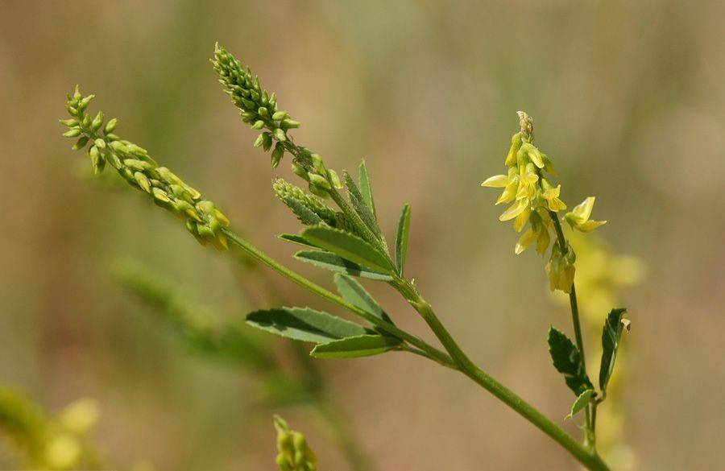

**Sweetclover flower. Patrick J. Alexander**

Broadly speaking, sweetclover is an annual to biennial forb reaching 5 feet (1.5 m) in height. Leaves are trifoliate (3 leaflets) with short stems. Each leaflet is 8-38 mm long and 3-16 mm wide with teeth along the entire margin, unlike alfalfa which only has teeth on the distal half of the leaflet. Leaves can be hairy or not, but are most commonly smooth. Flower stalks bear 20 to 65 flowers.

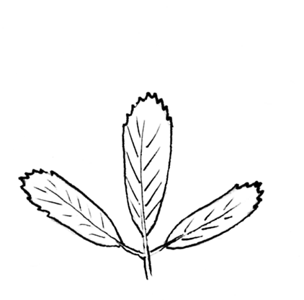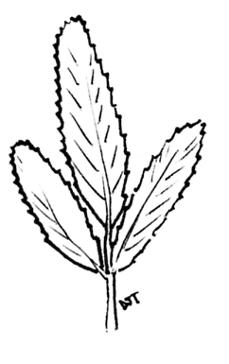

**Alfalfa leaf (left) and sweetclover leaf (right). Derek J. Tilley**

Yellow sweetclover is reported to be shorter growing, more widely branching, finer stemmed, more drought tolerant and easier to establish than white sweetclover (Meyer, 2005).

Like other plants in the legume family, sweetclover forms root nodules when infected with the correct rhizobium bacteria, creating higher levels of soil nitrogen.

Seeds are small and similar in appearance to alfalfa seed. There are an average of 260,000 seeds/lb. Sweetclover seed requires scarification before germination. Natural scarification occurs via freeze-thaw cycles, fire, or passage through an animal’s digestive track. Seed can remain viable for 40 or more years.

*Distribution*:

Sweetclover was introduced to North America from Europe in the 1700’s (Meyer, 2005). The species is now widespread throughout North America in a broad array of habitats and plant communities.

For current distribution, consult the Plant Profile page for this species on the PLANTS Web site.

*Habitat*:

Sweetclover plants inhabit roadsides, riparian zones and other communities from low to middle elevations. It is common in mountain shrub communities, cottonwood bottomlands, Rocky Mountain juniper habitats and on bluebunch wheatgrass – big sagebrush ecological sites from sea level to 8,500 ft.

Status

Consult the PLANTS Web site and your State Department of Natural Resources for this plant’s current status (e.g. threatened or endangered species, state noxious status, and wetland indicator values).

**Weediness**

Sweetclover was considered a weed in North America until the early 1900’s when its value as a range and pasture plant was realized (Baldridge and Lohmiller, 1990). Since then it has been used extensively for rangeland seedings, soil stabilization, and reclamation projects as well as for pasture.

Its ability to establish in disturbed areas and to spread from seedings has caused it to again be viewed as a weedy species by many land managers. Under optimum conditions sweetclover can invade into adjacent native plant communities and compete with desirable native species.

Adaptation

Sweetclover is the most drought tolerant of the commercially available legumes (Ogle et al., 2008b). It has been used effectively in areas receiving as little as nine inches mean annual precipitation, though it does best in 12 to 20 inch precipitation zones (Thornburg 1982).

Sweetclover commonly establishes from seed during years with abundant spring rains and remains in the plant community for at least two growing seasons. Then during periods of drought it may be totally lacking in the plant community, until again a good moisture years occurs and it becomes abundant once again.

Sweetclover seedlings can tolerate 10 to 14 days of early spring flooding (Baldridge and Lohmiller, 1990).

Yellow and white sweetclover are adapted to all soil textures, but they perform best on medium textured sandy to clayey soils (Baldridge and Lohmiller, 1990). Sweetclover will not tolerate acidic soils; a pH of 5.5 is the plant’s lowest limit. It can however withstand slight to moderate saline conditions as high as 10 mmhos/cm² (Ogle et al., 2008a).

Sweetclover is highly tolerant of frost and cold temperatures. The plants have evolved contractile roots, which pull the plant crown down into the soil in the fall, allowing the plant to survive cold winter temperatures.

Sweetclover is not shade tolerant. It will invade sunny open disturbed areas, but does not move into areas with an established perennial canopy.

Establishment

Seed should be planted in a firm, weed-free seedbed at a depth of 1/8 to 1/2 inch. Ground can be prepared with tillage equipment and then packed to firm the seedbed. Seed can be planted up to 2 inches deep but will take much longer to germinate than shallower planted seed. Seed must be chemically or mechanically scarified prior to seeding or planted in the fall to stratify naturally. Most seed bought commercially is pre scarified (Baldridge and Lohmiller, 1990). Seed should be inoculated with the proper rhizobium bacteria for nitrogen fixation. When properly inoculated, sweetclover will not need supplemental nitrogen. Add phosphorus and potassium as indicated by soil tests.

Sweetclover is not generally recommended for pure stands unless it is being used as a green manure crop. Under this condition plant at a rate of 4 lb/ac.

If using sweetclover as part of a seeding mixture for conservation cover, dryland pasture or range plantings, the percentage of the seeding mixture should not exceed 10 percent of the mixture. This is due to its competitive nature with other establishing species. Plant at a rate of 0.10 to 0.25 lb/ac (Ogle et al., 2008b).

Under irrigated pasture conditions, use approximately 1 lb/ac of sweetclover in grass mixtures.

Sweetclover seed is easy to clean and to store. Any seed purchased should exceed 95% purity and 85% germination.

Plant prior to spring or summer rains depending on location. Range seedings should be completed in the late fall or winter to allow for natural stratification of the seed. Sweetclover can be planted at any time under irrigated conditions (must use scarified seed) but should be planted at least 6 weeks prior to hard frosts (Wasser et al., 1986). Drill or broadcast with an alfalfa- type drill or with a grain drill equipped with a legume seed box. Sweetclover can also be planted using a grain drill if seed is mixed with an inert carrier such as rice hulls. For this application the grain drill should be set to seed one bushel of barley per acre. For large rangeland seedings or on rough terrain, sweetclover can be broadcast aerially.

Management

Establishing stands should not be grazed during the year of establishment. Begin grazing the second year when new growth is 6 to 8 inches tall. Stocking rates may need to be increased from normal rates in order to keep plants from becoming stemmy and less palatable. If plants become coarse and stemmy, mowing to a stubble height of 10 to 12 inches may be necessary to achieve regrowth (Meyer, 2005).

Plants should not be heavily grazed or closely mowed in the fall as growth will be hindered the following year. Poor fall management results in loss of plants through winter-kill, and provides less forage the following year. Hay must be cut at least 10 to 12 inches in height for good regrowth to occur since regrowth comes from stem buds (Baldridge and Lohmiller, 1990).

Burning sweetclover stands can damage tissues and kill existing plants; however, burning typically aids in establishing better stands by creating openings for plants to spread and by scarifying seed in the seed bed.

There are no herbicides labeled for application on establishing seedlings or on established sweetclover fields (Meyer, 2005).

Sweetclover can be an effective hay or silage if managed properly. It has not been widely used due to its coarse stems which take longer to dry than the leaves, resulting in leaf loss during baling. Swathers with conditioning equipment decrease curing time and resulting hay is comparable in feed value to alfalfa (Meyer, 2005). Harvest for hay at the bud to 10% bloom stage. Harvesting in late bloom stage decreases forage yield and reduces digestibility and overall forage quality (Meyer, 2005).

Because of the danger of sweetclover bleeding disease, sweetclover should be baled drier than other grass or legume hay to reduce risk of molding. For small bales dry to at least 12% moisture, larger bales should be dried to 13 to 14% moisture (Meyer, 2005).

Sweetclover silage should be about 65% moisture content when stored in silos and green chop bunks or piles. When stored as haylage or low-moisture silage it should have a moisture content of 55 to 65%. All silage should be cut at the proper growth stage, fine chopped and filled rapidly to aid packing. Silage should be covered to exclude outside air to prevent mold. Any moldy surfaces should be removed prior to feeding (Meyer, 2005).

Pests and Potential Problems

Sweetclover plants contain coumarin, which is the cause of sweetclover bleeding disease. Coumarin breaks down to dicoumarin when a plant becomes damaged or moldy. Dicoumarol is an anticoagulant which causes hemorrhaging in cattle and can be fatal. Animals will have difficulty clotting, and may bleed to death from small external or internal injuries. Do not feed sweetclover to livestock for at least three weeks prior to castrating or dehorning and 30 days prior to calving. Sheep and horses are less prone to sweetclover bleeding disease due to their more selective eating habits (Schipper, 1999).

The best way to avoid sweetclover bleeding disease is to use certified seed of low-coumarin varieties such as Norgold or Polara. Problems can be avoided if hay is properly dried and cured, or by supplementing moldy hay with other better quality feed. It takes several weeks of eating moldy sweetclover hay to cause bleeding disease.

Bloat is less common from sweetclover than with alfalfa or clover, but can occur.

Sweetclover weevil (*Sitona cylindricollis*) reduces sweetclover stands. Brown root rot, common leaf spot and gray stem canker can also pose problems. ‘Yukon’ is reported to be resistant to brown rot and gray stem canker. Control common leaf spot by cutting before defoliation becomes severe. Gray stem canker can be controlled with a good crop rotation and by cutting fields cleanly (Smith and Gorz, 1965).

In areas of the southwest, Arizona fescue (*Festuca arizonica*) and mountain muhly (*Muhlenbergia montana*) contain allelopathic chemicals that reduce germination of sweetclover and inhibit radicle growth (Reitveld, 1977).

Environmental Concerns

Sweetclover volunteers and spreads easily. It is considered a weed in some areas.

Seed Production

Plant sweetclover seed at 2.1 to 2.5 lbs/ac in 24 inch rows and at 1.5 to 2.0 pounds per acre in 36 inch rows for seed production fields (Ogle et al., 2008b). To facilitate seed production and between row weed control, it is desirable to plant sweetclover in spaced rows instead of solid stands. Most plants germinate from March to April but can germinate anytime water is available. Sweetclover rarely flowers during the first growing season. First year shoots will die back with freezing temperatures, and second year growth initiates from the subterranean crown. Flowering occurs in May to June with seed set in June through July. Sweetclover will produce only one seed crop.

Honey bees are essential for seed production. Seed production fields utilizing natural pollinators on average yield between 50 and 100 pounds of seed per acre, while fields using colonies of honey bees yield up to 700 pounds per acre (Baldridge and Lohmiller, 1990).

Seed is ready to harvest when pods turn brown, dark gray or white. Fields should be swathed when 30 to 60 percent of the pods are brown to black, and immature seed should be allowed to cure in the swath (Meyer, 2005). Swathed rows can be picked up with a combine, but care should be taken not to leave rows on the ground too long or seed can be lost from shattering. Swath and combine in early morning when plants are damp. This will improve feeding through the machines and reduce seed shatter. Use slow cylinder speeds for maximum seed yields (Baldridge and Lohmiller, 1990).

Control

Moderately good sweetclover control can be achieved with a number of broadleaf herbicides. Sweetclover plants are more difficult to kill in the second year of growth.

Once established it is very difficult to completely control sweetclover. Chemical herbicides such as 2,4-D will kill existing plants, but new stands will establish from seed deposited in the soil. Seeds may remain dormant in the seedbed for many years, and new stands can establish years after control.

A regimen of concentrated grazing during the late summer and fall can reduce root reserves in established plants. This in turn will cause plant mortality the following year, lowering plant densities to an acceptable level (Meyer, 2005).

Contact your local agricultural extension specialist or county weed specialist to determine the best control methods in your area and how to use them safely. Always read label and safety instructions for each control method. Trade names and control measures appearing in this document are only to provide specific information. USDA NRCS does not guarantee or warranty the products and control methods named, and other products may be equally effective.

Cultivars, Improved, and Selected Materials (and area of origin)

There are several released cultivars of sweetclover. Most of these have not, however, performed any better than common seed sources. Currently the majority of marketed seed comes from uncertified lots (Stevens and Monsen, 2004). Goldtop, Madrid, Norgold and Yukon are the yellow sweetclover releases; while Evergreen and Polara are releases of white sweetclover (Meyer, 2005).

‘Evergreen’ is a late maturing white sweetclover released by the Ohio Agricultural Experiment Station in 1935. It is known for its difficulty in producing high seed yields.

‘Goldtop’ was released in 1956 by the Wisconsin Agricultural Experiment Station. It has excellent seedling vigor and produces higher yields, better forage and larger seeds than Madrid. Seed matures two weeks later than Madrid.

‘Madrid’ was introduced from Spain to North America in 1910 by the USDA Division of Plant Introduction. This variety has good seedling vigor, frost resistance and seed production.

‘Norgold’ is a low-coumarin variety released by Agriculture Canada in 1981. Norgold has lower spring vigor than other yellow sweetclover releases and yields less forage.

‘Polara’ is a low-coumarin variety of white sweetclover from Agriculture Canada. It was released in 1970.

‘Yukon’ was released in 1970 from Agriculture Canada from selections made from Madrid. Yukon produces equal to or higher yields than Madrid and is more winter hardy.

References

Baldridge, D.E. and R.G. Lohmiller, eds. 1990. Montana interagency plant materials handbook. Montana State University, Bozeman, MT. 337p.

Beck, J. L. and D. Mitchell. 1997. Brief guidelines for maintaining and ehnanching sage grouse habitat on private lands in Utah. Utah Division of Wildlife Resources. 6p.

Braun, C.E. 2006.A blueprint for sage grouse conservation and recovery. Grouse Inc. Tucson, AZ. 21p.

Isley, D. 1998. Native and Naturalized Leguminosae (Fabaceae) of the United States. Monte L. Bean Life Science Museum. Brigham Young University. Provo, UT. 1007p.

Kufeld, R.C. 1973. Foods eaten by the Rocky Mountain elk. J. Range Management. 26:106-113.

Meyer, D. 2005. Sweetclover production and management. North Dakota State University Extension Service. [www.ag.ndsu.edu/pubs/plantsci/hay/r862w.htm](http://www.ag.ndsu.edu/pubs/plantsci/hay/r862w.htm). Accessed 16 October 2008.

National Academy of Sciences. 1971. Atlas of nutritional data on United States and Canadian feeds. Washington DC: NAS. 772p.

Ogle, D.G., Cane, J., Fink, F., St. John, L., Stannard, M. and T. Dring. 2007. Plants for pollinators in the Intermountain West. Natural Resources Conservation Service. Boise, Idaho. Idaho Technical Note No. 2. 22p.

Ogle, D., M. Majerus, L. St. John. 2008. Plants for

saline to sodic soil conditions Natural Resources Conservation Service. Boise, Idaho. Idaho Technical Note No. 9. 12p.

Ogle, D., L. St. John, M. Stannard, and L. Holzworth. 2008. Grass, grass-like, forb, legume and woody species for the Intermountain West. Natural Resources Conservation Service. Boise, Idaho. Idaho Technical Note No. 24. 43p.

Reitveld, W.J. 1977. Phytotoxic effects of bunchgrass residues on germination and initial root growth of yellow sweetclover. Journal of Range Management. 30(1):39-43.

Schipper, I.A. 1999. Sweet clover poisoning. In: Beef Cattle Handbook. North Dakota State University. BCH-3415. 2p.

Smith, W.K and H.J. Gorz. 1965. Sweetclover improvement. Advances in Agronomy. 17: 163-231.

Stevens, R. and S.B. Monsen. 2004. Forbs for seeding range and wildlife habitats. In: S.B. Monsen, R. Stevens, and N.L. Shaw [compilers]. Restoring western ranges and wildlands. Fort Collins, CO: USDA Forest Service, Rocky Mountain Research Station. General Technical Report RMRS-GTR-136- vol-2. p. 425-466.

Sullivan, J. 1992. Melilotus officianalis. In: Fire Effects Information System, [Online]. USDA, Forest Service, Rocky Mountain Research Station, Fire Sciences Laboratory. www.fs.fed.us/database/feis/.

Accessed 10/15/08.

Thornburg, A. A. 1982. Plant Materials for use on Surface-mined Lands in Arid and Semiarid Regions. USDA-NRCS. SCS-TP-157. 88p.

USDA Forest Service. 1937. Range Plant Handbook. U.S Government Printing Office, Washington D.C.

Wasser, C.H., Dittberner, P.L. and W.A. Mitchell. 1986. Yellow Sweetclover (Melilotus officinalis): Section 7.3.4, US Army Corps of Engineers Wildlife Resources Management Manual. US Army Engineer Waterways Experiment Station, Vicksburg, MS. 17p.

Prepared By

Derek Tilley, USDA NRCS Plant Materials Center, Aberdeen, ID

Dan Ogle, USDA NRCS Idaho State Office, Boise, ID

Loren St. John, USDA NRCS Plant Materials Center, Aberdeen, ID

Species Coordinator

Dan Ogle, USDA NRCS Idaho State Office, Boise, ID

Published October, 2008

Edited: 22Oct08djt; 20Oct08lsj; 22Oct08dgo

### Citation

Ogle, D., St, John, L., Tilley, D. 2008. Plant Guide for yellow sweetclover (*Melilotus officinalis* (L.) Lam. And white sweetclover (*M. alba* Medik. USDA-Natural Resources Conservation Service, Idaho Plant Materials Center, Aberdeen, ID. 83210

For more information about this and other plants, please contact your local NRCS field office or Conservation District at <http://www.nrcs.usda.gov/> and visit the PLANTS Web site at <http://plants.usda.gov/> or the Plant Materials Program Web site <http://plant-materials.nrcs.usda.gov>.

PLANTS is not responsible for the content or availability of other Web sites.

**USDA IS AN EQUAL OPPORTUNITY PROVIDER AND EMPLOYER**