|  |  |
| --- | --- |
| **Natural Resources Conservation Service** | Plant Guide |

# yellow-flowered alfalfa

## Medicago sativa subsp. falcata (L.) Arcang.

Plant Symbol = MESAF

Yellow-flowered alfalfa seed production field at Bismarck North Dakota Plant Materials Center.

Yellow-flowered alfalfa seed production field at Bismarck North Dakota Plant Materials Center.

### Alternate Names

*Common Names:* yellow alfalfa, falcata alfalfa, falcata

*Scientific Names:* syn. *M. falcata* L.

### Description

*General*: Yellow-flowered alfalfa is a non-native, perennial, forage legume. It has trifoliate leaves, multiple stems, and a thick, somewhat woody crown. Like purple-flowered alfalfa, its roots host nitrogen-fixing bacteria. Unlike purple-flowered alfalfa, however, its roots are more branching and fibrous than the tap root of purple-flowered alfalfa.

*Distribution*: For current distribution, please consult the Plant Profile page for this species on the PLANTS Web site.

*Habitat*: Yellow-flowered alfalfa may be cultivated in monoculture or interseeded with shrubs or grasses and/or with purple-flowered alfalfa. In parts of South Dakota it has become naturalized.

***Adaptation***

Yellow-flowered alfalfa is best adapted to medium textured soil with a pH between 6 and 8. It does well in areas with low precipitation and cold winters.

### Uses

Yellow-flowered alfalfa is used for dry hay, greenchop, silage, and grazing and has a potential as a summer stockpiled forage. It is a source of nectar and pollen for insects and provides habitat for birds and mammals.

### Ethnobotany

Native to Siberia, it was introduced to the Dakotas by a travelling scientist around 1915. The travelling scientist had noted the plant’s success on the Siberian plains near the Arctic Circle.

### Status

Yellow-flowered alfalfa is an obligate upland (UPL) species.

This plant has not been observed to become weedy. Please consult with your local NRCS Field Office, Cooperative Extension Service office, state natural resource, or state agriculture department regarding its status and use.

Please consult the PLANTS Web site (<http://plants.usda.gov/>) and your State Department of Natural Resources for this plant’s current status (e.g., threatened or endangered species, state noxious status, and wetland indicator values).

### Planting Guidelines

Preparations for yellow-flowered alfalfa include controlling perennial weeds and adjusting soil pH to near neutral. It may be grown from shallow-planted seed in spring or late-summer.

### Management

Since yellow-flowered alfalfa exhibits an indeterminate flowering habit, it may be managed for forage production with fewer cuttings per year or may be harvested later in the flowering cycle with less decline in quality than purple-flowered alfalfa.

### Purple-flowered alfalfa (left) and yellow-flowered alfalfa (right) showing difference in potato leaf hopper resistance in E. Lansing, Michigan.

*Purple-flowered alfalfa (left) and yellow-flowered alfalfa (right) showing difference in potato leaf hopper resistance in E. Lansing, Michigan.*

### Pests and Potential Problems

The observed effects of insects (e.g. alfalfa weevil and potato leaf hopper) and diseases (e.g. root rots) have not been as deleterious on yellow-flowered alfalfa as on purple-flowered alfalfa.

### Environmental Concerns

There are no known environmental concerns associated with yellow-flowered alfalfa.

### Control

Please contact your local agricultural extension specialist or county weed specialist to learn what works best in your area and how to use it safely. Always read label and safety instructions for each control method. Trade names and control measures appear in this document only for illustrative purposes. USDA-NRCS does not guarantee or warranty the products and control methods named, and other products may be equally effective.

### Seeds and Plant Production

Spatial isolation from purple-flowered alfalfa is required to maintain seed purity. Leaf-cutter bees may be imported to increase pollination and seed set. Dessicants and pod dehiscence reducing agents may be used as harvest aides.

### Cultivars, Improved, and Selected Materials (and area of origin)

Cultivars should be selected based on the local climate, resistance to local pests, and intended use. Consult with your local land grant university, local extension, or local USDA-NRCS office for recommendations on adapted cultivars for use in your area**.** Three yellow-flowered alfalfa cultivars are known: ‘Anik’ developed by Agriculture Canada Northern Research Group, ‘AC Yellowhead’ developed at the Semiarid Prairie Agriculture Research Centre, Agriculture and Agri-Food Canada, and ‘Don’ developed by the USDA-ARS Forage and Range Research Laboratory in Logan, UT. (The name *Don* was chosen to reflect its origin in Don Province of Southeast Russia.) ‘Sholty’ was jointly released in 2015 by the South Dakota Agricultural Experiment Station, South Dakota State University, Brookings, SD; the Michigan Agricultural Experiment Station, Michigan State University, E. Lansing, MI; the USDA-NRCS Bismarck Plant Materials Center, Bismarck, ND; and the USDA-NRCS Rose Lake Plant Materials Center, E. Lansing, MI and should be adapted to the service areas which these institutions represent.

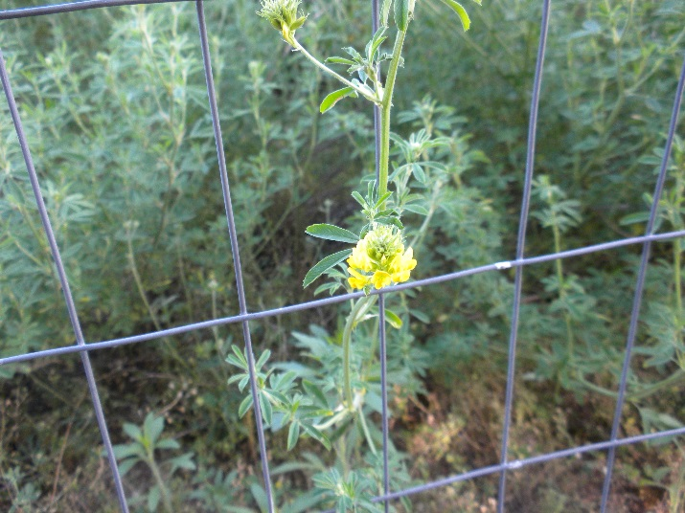

*Sholty alfalfa behind deer exclusion fence at Rose Lake Plant Materials Center.*

**References**

Bliss, R.M. 2003. Interseeding alfalfa on the northern plains: Flowering alfalfa breaks barriers. Agricultural Research. USDA-ARS. Oct. 2003: Pp. 8-10.

Boe, A., R. Bortnem, K.F. Higgins, A. Kruse, K.D. Kephart, and S. Selman. 1998. Breeding yellow-flowered alfalfa for combined wildlife habitat and forage purposes, pp. 12, *In* SDAES, (ed.). South Dakota State University, Brookings, SD

Bortnem, R., A. Boe, and A. Kruse. 1994. Forage quality of yellow-flowered and hay-type alfalfas *In* 34th North American Alfalfa Improvement Conference Proceedings, University of Guelph, Guelph, ON

Dietz, T.S. 2011. Evaluation of Medicago sativa spp. falcata for sustainable forage production in Michigan. Ph.D. Thesis. Michigan State Univ., E. Lansing, MI

McLeod, J.G., R. Muri, P.G. Jefferson, S. Bittman, and D. McCarthey. 2009. Yellowhead alfalfa. Can. J. Plant Sci. 89:653-655.

Pankiw, P. and B. Siemens. 1975. Anik alfalfa. Can. J. Plant Sci. 56:203-205.

Peel, M.D., K.H. Asay, B.L. Waldron, K.B. Jensen, J.G. Robins, and I.W. Mott. 2009. ‘Don’, a diploid falcata alfalfa for western U.S. Rangelands. Journal of Plant Registrations. 3:115-118.

Quiros, C.F., and G.R. Bauchan. 1988. The genus *Medicago* and the origin of the *Medicago sativa* complex, *In* A. A. Hanson, et al., eds. Alfalfa and Alfalfa Improvement, Vol. 29. ASA CSA SSSA, Madison, WI

### Prepared by

### Durling, J.C., USDA-NRCS Rose Lake Plant Materials Center; T.S. Dietz, Monsanto and formerly Crop & Soil Sciences Department, Michigan State University; W.L. Duckwitz and N.K. Jensen, USDA-NRCS Bismarck Plant Materials Center; and K.A. Cassida, Department of Plant, Soil, & Microbial Sciences, Michigan State University

### Citation

USDA-NRCS Plant Materials Program. 2015. Plant guide for yellow-flowered alfalfa [*Medicago sativa* subsp. *falcata* (L.) *Arcang.*].

For more information about this and other plants, please contact your local NRCS field office or Conservation District at <http://www.nrcs.usda.gov/> and visit the PLANTS Web site at <http://plants.usda.gov/> or the   
Plant Materials Program Web site:

<http://plant-materials.nrcs.usda.gov>.

PLANTS is not responsible for the content or availability of other Web sites.

***Helping People Help the Land***

**USDA IS AN EQUAL OPPORTUNITY PROVIDER AND EMPLOYER**