|  |
| --- |
| beaked panicgrass |
| *Panicum anceps* Michx. |
| Plant Symbol = PAAN |

*Contributed by: USDA, NRCS, Louisiana State Office, National Plant Data Center, & the Grazing Land Conservation Initiative-South Central Region*

## Alternative Names

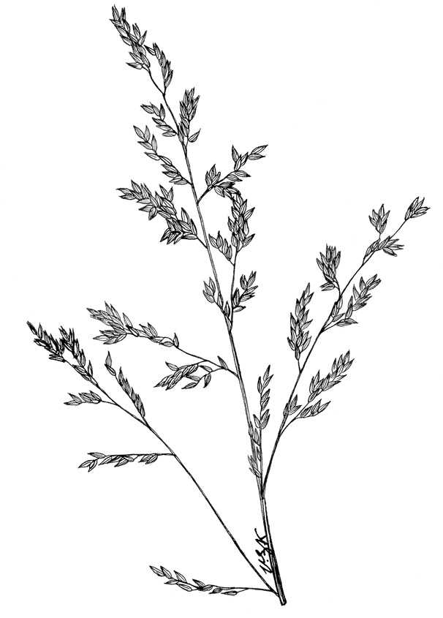

Grass Images

@ Texas A&M University

Beaked panicum and spreading panicum. Synonyms of the scientific name of beaked panicgrass are *Panicum anceps* var. *rhizomatum* and *Panicum rhizomatum.* The seed resembles the slightly curved beak of a bird, hence the common name, beaked panicgrass.

## Uses

*Livestock:* Cattle and horses readily graze beaked panicgrass from early spring to late fall. Grazing should be deferred through the summer because it will improve plant vigor and density. Overgrazing will reduce the amount of this plant and allow lesser value plants to invade. If cattle and horses graze

Beaked panicgrass in the winter, then protein and energy supplements are necessary.

*Wildlife*:Deer graze on beaked panicgrass. The seeds are eaten by most upland birds and by some waterfowl.

*Erosion:* Beaked panicgrass is used for the revegetation of surfaces such as mined land, logging sites, timber roads, and other disturbed areas.

*Conservation Practices*: Beaked panicgrass, because of its growth habit, potentially has application when established with certain conservation practices; however, conservation practice standards vary by state. For localized information, consult your local NRCS Field Office.

## Status

Consult the PLANTS Web site and your State Department of Natural Resources for this plant’s current status, such as, state noxious status and wetland indicator values.

## Description

*General*: Grass Family (Poaceae). Beaked panicgrass is a native, rhizomatous perennial. The culms are glabrous, erect and up to 4 feet tall. The blades are elongated, flat, glabrous to pubescent, and range in widths of ¼ to ½ inch wide. The ligules are membranous, irregular shaped and about 1∕16 inch long. The inflorescences are open panicles, 6 to 15 inches long, ascending and usually bearing appressed, short branchlets. Spikelets are unequally positioned on the pedicle and range in lengths of ⅛ to ¼ inch wide. The first glume is 1/4 to ½ the length of the spikelets. It is sharply angled, 3 to 5 nerved, and encompasses nearly the entire base of the spikelet. The second glume is as long as the spikelet and with 5 to 7 nerves. The second glume is curved like a bird’s beak. The thin, dry sterile palea is ⅛ inch long. The fertile palea and lemma are angled, straw-colored, slightly pubescent with stiff hairs at the apexes and is up to ⅛ inch long. The caryopsis is oval-shaped and purple in color.

*Distribution*: Beaked panicgrass can tolerate a wide range of habitats, from well-drained sandy soil to waterlogged sites. It is native to Louisiana and is found from New Jersey to Kansas, south to Florida and over to Texas. For current distribution, consult the Plant Profile page for this species on the PLANTS Web site.

## Establishment

*Adaptation*: Beaked panicgrass grows on moist to wet soils along margins of fresh marshes, swamps, and bottomlands that overflow occasionally. It grows best under 30 to 35 percent shade.

Beaked panicgrass reproduces by seeds, tillers, and rhizomes. It flowers only once a year in the fall and produces an abundant amount of seed. However, not much research has been done on germination. Beaked panicgrass is most commonly established by rhizomes, which will form pure stands of large clumps.

The seeds should be planted in the fall or early winter. The rhizomes could be planted from December to April; however, if planting after April, then plenty of water should be provided.

Plants should be placed at 3 foot-centers. Growth begins in February and beaked panicgrass remains green all year round.

It is not recommended to mix beaked panicgrass seeds with cool season grass seeds. In parts of the United States where cool season grasses dominate, the warm season grasses can be taken over because they develop slower than the cool season grasses. It is also recommended that seed not be moved more than 300 miles north, 100 miles east or west, or 200 miles south of its point of origin.

## Management

Beaked panicgrass maintains its production and contributes only small quantities of forage. However, check with the local extension service for recommended herbicides if it becomes weedy. Beaked panicgrass has no known pests or problems.

## Cultivars, Improved and Selected Materials (and area of origin)

Contact your local NRCS Field Office. Common seed and container plants are readily available from a number of growers, wholesalers, and retailers of native seed.

## References

Hitchcock, A.S. 1950. *Manual of the grasses of the United States*. USDA Miscellaneous Publication No 200. Agricultural Research Administration, Washington, D.C. Pp. 702.

Texas A&M University 1997. *Grass images: Panicum anceps*. <http://www.csdl.tamu.edu/FLORA/taesgrass/4634500e.jpg>. Bioinformatics Working Group, College Station, Texas.

USDA, NRCS 2000. *The PLANTS database*. <http://plants.usda.gov>. 001106. National Plant Data Center, Baton Rouge, Louisiana.

## Prepared By

# *Selena Dawn Newman*

USDA, NRCS, Louisiana State Office

# *Maraya Gates*

Formerly USDA, NRCS, National Plant Data Center

## Species Coordinator

# *Mike Materne*

Louisiana State University, Agricultural Center, Baton Rouge, Louisiana

Edited 06dec00 jsp;05feb03ahv; 10aug03 jsp; 25may06jsp

For more information about this and other plants, please contact your local NRCS field office or Conservation District, and visit the PLANTS Web site<<http://plants.usda.gov>> or the Plant Materials Program Web site <<http://Plant-Materials.nrcs.usda.gov>>

*The U.S. Department of Agriculture (USDA) prohibits discrimination in all its programs and activities on the basis of race, color, national origin, sex, religion, age, disability, political beliefs, sexual orientation, and marital or family status. (Not all prohibited bases apply to all programs.) Persons with disabilities who require alternative means for communication of program information (Braille, large print, audiotape, etc.) should contact USDA's* [*TARGET Center*](http://www.usda.gov/oo/target.htm) *at 202-720-2600 (voice and TDD).*

*To file a complaint of discrimination write USDA, Director, Office of Civil Rights, Room 326-W, Whitten Building, 14th and Independence Avenue, SW, Washington, DC 20250-9410 or call 202-720-5964 (voice or TDD). USDA is an equal opportunity provider and employer.*

*Read about* [*Civil Rights at the Natural Resources Convervation Service*](http://www.nrcs.usda.gov/about/civilrights/)*.*