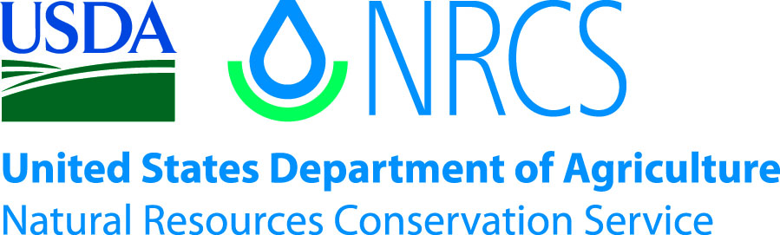

Plant Guide

# Wooly Groundsel

## Packera cana W.A. Weber & Á. Löve

Plant Symbol = PACA15

*Contributed by*: USDA NRCS Aberdeen Plant Materials Center

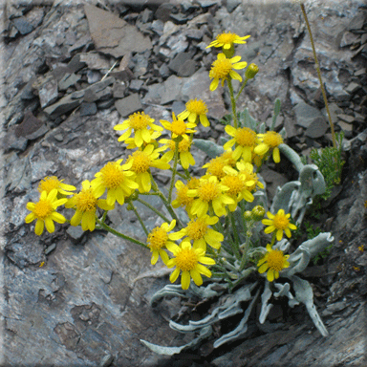**Wooly groundsel. Photo from Wildaboutflowers.com.**

### Alternate Names

*Senecio cana, S. convallium, S. halii, S. harbourii, S. howelii, S. purshianus*

Gray ragwort, Silvery ragwort, wooly ragwort, wooly butterweed

### Uses

Wooly groundsel has value as a food source for insects. *Nymphalis* and *Pontia* butterflies have been observed foraging nectar from wooly groundsel (Ezzeddine and Matter 2008).

Wooly groundsel is browsed by pronghorn antelope (Kessler et al 1981). It is rated as having medium palatability for sheep and low to medium palatability for cattle and horses (Hermann 1966). However it is considered to have moderate levels of toxicity and may be harmful in sufficient quantities (USDA NRCS 2012).

### Status

Wooly groundsel t is listed as an endangered species in Minnesota. Gravel mining and overgrazing in wooly groundsel t habitat are cited as major threats (Minnesota DNR 2012). Please consult the PLANTS Web site and your State Department of Natural Resources for this plant’s current status (e.g., threatened or endangered species, state noxious status, and wetland indicator values).

### Description

*General*: Sunflower family (Asteraceae). Wooly groundsel is a low growing perennial forb with short rhizomes. Mature plants reach 8 to 30 cm (3 to 12 in) in height. The stems and leaves are densely wooly giving it a grayish appearance. The basal leaves are lanceolate to oblanceolate, 1 to 5 cm (0.4 to 2 in) long and 0.3 to 3 cm (0.12 to 1.2 in) wide. The margins are entire to minutely toothed. The stem leaves reduce in size going upward along the stem. In late spring the plants bear 2 to 10 flower heads with orange disk flowers and 8 to 13 yellow ray flowers approximately 5 to 10 mm (0.2 to 0.4 in) in length (Welsh et al 2003). The fruit is an achene with a pappus of capillary bristles. The seed is wind dispersed (Andersen 1993). There are approximately 600,000 seeds per pound (USDA NRCS 2012).

*Distribution*: Wooly groundsel is found from Kansas, Minnesota and Manitoba westward to the Pacific states and south to California, Nevada and Colorado. For current distribution, please consult the Plant Profile page for this species on the PLANTS Web site.

*Habitat*: Wooly groundsel occupies rocky sites in mountain shrub, pinyon-juniper, Douglas fir, spruce-fir and alpine tundra communities. It can often be found in talus slopes and high ridges.

**Adaptation**

Wooly groundsel is adapted to a broad range of soils from coarse to fine, but is typically found in sandy to rocky areas with a soil pH of 6.5 to 8.5. It can be found in areas receiving as little as 200 mm (8 in) annual precipitation (USDA NRCS 2012).

### Establishment

### No seed or plant establishment information could be located.

### Management

Wooly groundsel can be used as a minor component of seed mixtures. Management strategies should be based on the key species in the established plant community. Grazing should be deferred on seeded lands for at least two growing seasons to allow for full stand establishment.

### Pests and Potential Problems

Many members of the genus *Packera* and *Senecio* are known to contain toxic alkaloids which can cause liver disease in livestock and humans (Burrows and Tyrl 2001). Wooly groundsel is a host plant for the aphid species *Aphis senecionis* (Williams 1891).

### Environmental Concerns

Wooly groundsel is native to western North America. There are no known environmental concerns associated with this species. The toxic compounds found in these species pose a threat to grazing animals if consumed in sufficient quantities.

### Seed and Plant Production

No propagation or seed production information could be found for this species.

### Cultivars, Improved, and Selected Materials (and area of origin)

### There are currently no commercial releases of wooly groundsel. Common seed and greenhouse grown materials are available on the commercial market.

The Aberdeen Plant Materials Center cooperated with the USDA-Agricultural Research Service, Poisonous Plants Laboratory to evaluate a number of *Senecio* and *Packera* species including wooly groundsel for toxic properties. Based on the findings, the plant materials center discontinued further evaluation of *Senecio* and *Packera* spp. for potential release (Tilley and St. John 2011).

### References

Andersen, M.C. 1993. Diaspore morphology and seed dispersal in several wind-dispersed asteraceae. American Journal of Botany. 80(5): 487-492.

Burrows, G.E. and R.J. Tyrl. 2001. Toxic Plants of North America. Iowa State University Press. Ames, Iowa. 1342p.

Ezzeddine, M. and S.F. Matter. 2008. Nectar flower use and electivity by butterflies in sub-alpine meadows. Journal of the Lepidopterists’ Society. 62(3): 138-142.

Hermann, F.J. 1966. Notes on Western Range Forbs: Cruciferae through Compositae. U.S.D.A. Forest Service. Agriculture Handbook No. 293.365p.

Kessler, W.B., Kasworm, W.F., and W.L. Bodie. 1981. Three methods compared for analysis of pronghorn diets. Journal of Wildlife Management. 45(3): 612-619.

Minnesota Department of Natural Resources. 2012. Rare Species Guide [Online]. Available at http://www.dnr.state.mn.us/rsg/index.html (accessed 6 June 2012).

Tilley D, and St. John L. 2011. Initial toxicity screening of groundsel (*Senecio* spp.); 2011 Progress Report. Aberdeen (ID): USDA Natural Resources Conservation Service, Aberdeen Plant Materials Center. 3p.

Welsh, S.L., N.D. Atwood, S. Goodrich, and L.C. Higgins. 2003. A Utah Flora. Third Edition, revised. Brigham Young University, Provo, UT.

USDA-NRCS. 2012. The PLANTS Database [Online]. Available at http://plants.usda.gov (accessed 5 June 2012). USDA-NPDC, Baton Rouge, LA.

Williams, T.A. 1891. Host-plant List of North American Aphidae. The Hunter Printing House. Lincoln. NE. 27p.

**Prepared By**:

Derek Tilley, USDA NRCS Plant Materials Center, Aberdeen, ID

Loren St. John, USDA NRCS Plant Materials Center, Aberdeen, ID

### Citation

Tilley, D.,and L. St. John. 2012. Plant Guide for wooly groundsel (*Packera cana*). USDA-Natural Resources Conservation Service, Aberdeen Plant Materials Center. Aberdeen, Idaho 83210.

Published June 2012

Edited: 5June2012djt; 6June2012ls

For more information about this and other plants, please contact your local NRCS field office or Conservation District at <http://www.nrcs.usda.gov/> and visit the PLANTS Web site at <http://plants.usda.gov/> or the Plant Materials Program Web site <http://plant-materials.nrcs.usda.gov>.

PLANTS is not responsible for the content or availability of other Web sites.

**USDA IS AN EQUAL OPPORTUNITY PROVIDER AND EMPLOYER**