|  |
| --- |
| fall panicgrass |
| *Panicum dichotomiflorum* Michx. |
| Plant Symbol = PADI |

*Contributed by: USDA, NRCS, Louisiana State Office, National Plant Data Center, & the Grazing Land Conservation Initiative-South Central Region*

## Alternative Names

Fall panic grass, fall panicum, kneegrass, spreading panicgrass, spreading panicum, spreading witchgrass, sprouting crabgrass, and zigzag grass. The genus, panicum refers to the type of seed head. *Dichotomiflorum* refers to the individual flowers arranged in pairs. Fall panicgrass resembles switchgrass (*Panicum virgatum*) and witchgrass (*Panicum capillare*). However, switchgrass is a perennial, clump-forming grass that does not fall to the ground after the beginning of winter. Witchgrass has a rounder, dense seed head and the seeds are smaller.

## Uses

*Warning-Livestock:* Fall panicgrass has been blamed for causing nitrate poisoning and extreme sensitivity to light in livestock (called photosensitivity).

of any skin that is not protected from the sun.

*Noxious:* Fall panicgrass has become a nuisance in cultivated fields, such as corn, alfalfa, and soybeans.

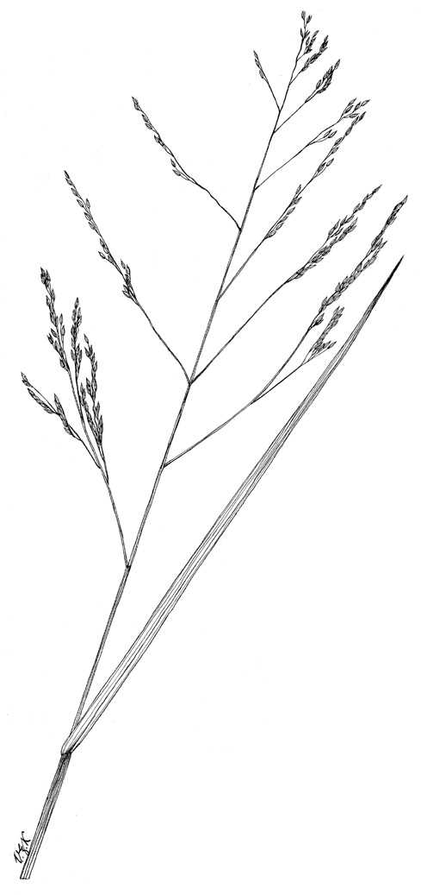

Grass Images

@ Texas A&M University

*Wildlife*:Small seed eating birds and ducks eat the small seeds. Fall panicgrass produces a large number of seeds. After the first frost, the seeds fall to the water and the sites are used as feeding and loafing areas for ducks, coots, and wading birds. It provides browse for deer and rabbits.

*Conservation Practices*: Fall panicgrass, because of its growth habit, potentially has application when established with certain conservation practices; however, conservation practice standards vary by state. For localized information, consult your local NRCS Field Office.

## Status

Consult the PLANTS Web site and your State Department of Natural Resources for this plant’s current status, such as, state noxious status and wetland indicator values.

## Description

*General*: Grass Family (Poaceae). It is a tufted, annual, vigorous grass, which belongs to the largest genus. Culms are erect to ascending and range in heights of 6 feet. Basally, the culms are decumbent to geniculate and root at the nodes. The culms bend at the nodes forming a zigzag pattern; hence the name zigzag grass. The blades are flat, smooth, up to 20 inches long, and ¾ inch wide. The margins on the underside are scantily ciliate. The leaf sheaths are loose, purplish, and smooth with the margins thin and dry. The ligules are membranous and are surrounded in thick, small, white hairs. The inflorescence is a panicle located on the top of the main stem or on the primary stems. The spikelets are purple to brown, oblong and range in lengths of up to 10 inches long. The first glume is about ¹∕20 inch long and with 1 to 3 indistinct nerves. The second glume and the sterile lemma are even in length, green or partially purple, acute, 5 to 7 nerved, and are twice as long as the first glume. The fertile palea and lemma are acute, light to dark brown or purple, and ⅛ to ¹∕6 inch long. The caryopsis is yellow-brown, and elliptic.

## Distribution

Fall panicgrass is found mostly in moist areas along streams, floodplains, wet clearings, and as a weed in cultivated areas and waste sites. It is commonly found with *Echinochloa walteri* and *Echinochloa crusgalli.* Fall panicgrass is located throughout the United States, Nova Scotia and in the West Indies. It is native to Louisiana. For current distribution, consult the Plant Profile page for this species on the PLANTS Web site.

## Establishment

*Adaptation*: Fall panicgrass is found in freshwater to intermediate water where salinity ranges from 0 to 3.5 parts per thousand. During the summer, a change from moist soils to dry soils is required for the seeds to germinate. Shallow flooding after germination provides for maximum growth. Organic soils produce the most prolific stands; however, it can grow on mineral soils. Fall panicgrass is an indicator plant for anaerobic, compacted soil.

*General*: Seeds propagate fall panicgrass. Stratification of mature seeds must occur before the seeds will germinate. Germination takes place from April to May and will continue throughout the summer months. To obtain the highest germination percentage, a soil temperature of 80° F is suggested. If competition is suppressed, plants that germinate first will produce up to ten times more dry matter than those maturing later in the year did. Before flowering from August to September, fall panicgrass is at its peak in growth.

It is not recommended to mix fall panicgrass seeds with warm season grass seeds. In Louisiana, the warm season grasses can be taken over because they develop slower than the cool season grasses. It is also recommended that seed not be moved more than 300 miles north, 100 miles east or west, or 200 miles south of its point of origin.

## Management

The best control method for fall panicgrass in cultivated fields is to establish a shady crop canopy, because fall panicgrass must have full sun to grow. Check with the local extension service for recommended herbicides. Fall panicgrass is susceptible to the following diseases: Barley yellow dwarf luteovirus, Maize chlorotic mottle machlomovirus, Maize white line mosiac virus, and insusceptible to Panicum mosiac sobemovirus.

## Cultivars, Improved and Selected Materials (and area of origin)

Contact your local NRCS Field Office. Common seed and container plants are readily available from a number of growers, wholesalers, and retailers of native seed.

## References

Hitchcock, A.S. 1950. *Manual of the grasses of the United States*. USDA Miscellaneous Publication No 200. Agricultural Research Administration, Washington, D.C. Pp. 685.

Texas A&M University 1997. *Grass images: Panicum dichotomiflorum.* <http://www.csdl.tamu.edu/FLORA/taesgrass/4638200e.jpg>. Bioinformatics Working Group, College Station, Texas.

USDA, NRCS 2003. *The PLANTS database*. <http://plants.usda.gov>. 001106. National Plant Data Center, Baton Rouge, Louisiana.

## Prepared By

# *Selena Dawn Newman*

USDA NRCS Louisiana State Office

# *Maraya Gates*

Formerly USDA, NRCS, National Plant Data Center

## Species Coordinator

# *Mike Materne*

Louisiana State University, Agricultural Center, Baton Rouge, Louisiana

Edited 06dec00 jsp;05feb03ahv; 10aug03 jsp; 25may06jsp

For more information about this and other plants, please contact your local NRCS field office or Conservation District, and visit the PLANTS Web site<<http://plants.usda.gov>> or the Plant Materials Program Web site <<http://Plant-Materials.nrcs.usda.gov>>

*The U.S. Department of Agriculture (USDA) prohibits discrimination in all its programs and activities on the basis of race, color, national origin, sex, religion, age, disability, political beliefs, sexual orientation, and marital or family status. (Not all prohibited bases apply to all programs.) Persons with disabilities who require alternative means for communication of program information (Braille, large print, audiotape, etc.) should contact USDA's* [*TARGET Center*](http://www.usda.gov/oo/target.htm) *at 202-720-2600 (voice and TDD).*

*To file a complaint of discrimination write USDA, Director, Office of Civil Rights, Room 326-W, Whitten Building, 14th and Independence Avenue, SW, Washington, DC 20250-9410 or call 202-720-5964 (voice or TDD). USDA is an equal opportunity provider and employer.*

*Read about* [*Civil Rights at the Natural Resources Convervation Service*](http://www.nrcs.usda.gov/about/civilrights/)*.*