|  |
| --- |
| maidencane |
| *Panicum hemitomon* J.A. Schultes |
| Plant Symbol = PAHE2 |

*Contributed by: USDA, NRCS, Louisiana State Office, National Plant Data Center, & the Grazing Land Conservation Initiative-South Central Region*

## Alternative Names

Paille fine, canouche. The genus name, *Panicum*, is the largest group of grass genera with approximately 500 species identified, which are generally found in warmer regions.

## Uses

*Livestock:* Maidencane’s forage value has been rated excellent for livestock. It is known to produce as much as 5 tons of forage per acre, which has been proved to be high in crude protein. When grazed, the digestibility is at a peak of 50% and protein is at a peak of 10 to 11%. One acre of the best range of maidencane will support an animal unit for a six- month grazing period. However, as the plant dies back, it becomes tougher and less desirable as a forage food. The best practice is using the grass during the winter and spring, with a rest in the summer and fall. In wetter areas, cattle walkways may be needed for greater accessibility.

*Wildlife*:Maidencane’s forage value for wildlife has been rated fair for wildlife. Burning maidencane in the late fall, provides nesting and food for other mammals, reptiles, birds, amphibians, and vertebrates; however, the vegetation may become so dense that it is less appealing to other wildlife. Also, fishermen are often seeking out clumps of maidencane located in at least two feet of water because the openings in the clumps are likely to be filled with bass.

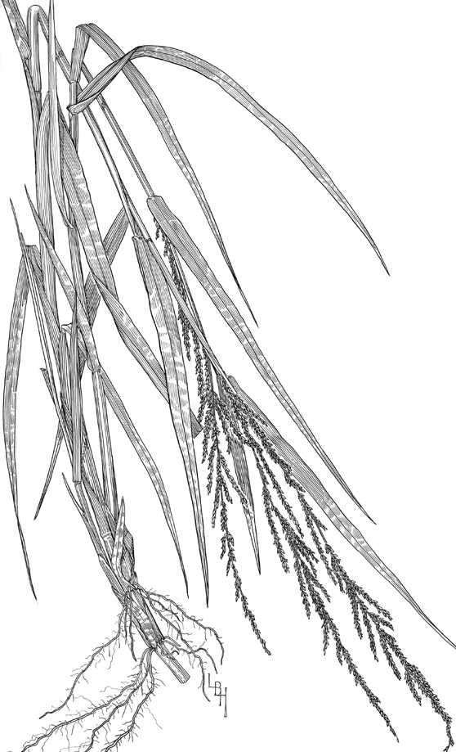

Grass Images

@ Texas A&M University

*Erosion:* Maidencane is used for erosion control along shorelines of ponds, lakes and other waterways because its expansive rhizomes stabilize the soil. Shoreline erosion can be prevented if the waves do not exceed 2 to 3 feet high for an extended period of time. It can spread 24 to 30 inches per growing season; therefore, it is one of the best plants to use to control erosion.

*Conservation Practices*: Maidencane, because of its growth habit, potentially has application when established with certain conservation practices; however, conservation practice standards vary by state. For localized information, consult your local NRCS Field Office.

## Status

Consult the PLANTS Web site and your State Department of Natural Resources for this plant’s current status, such as, state noxious status and wetland indicator values.

## Description

*General*: Grass Family (Poaceae). It is a warm season, aquatic or sub-aquatic, extensively rhizomatous perennial that forms almost pure stands. The culms are glabrous and range in heights of 3 to 5 feet. The leaf sheaths are overlapping, glabrous to greatly pubescent. The margins are generally ciliate. The blades are flat and range in lengths of 8 to 12 inches, ½ inch wide, usually scabrous on top, and glabrous on the bottom. The blades are slightly narrowed at the base, tapering as it reaches the tip, and the margins are scabrous. The ligules are membranous with irregular margins. The inflorescence consists of rames. The lower rames are spaced out, whereas, the upper rames are spaced closely together. The spikelets are awnless, broadest at the base and up to ¹∕6 inch long. The first glume is 3 nerved, sharply angled, glabrous or scantily scabrous apically, and ½ as long as the second glume. The second glume is 5 nerved, sharply angled, and scantily scabrous on mid-nerve apically with opaque margins. The sterile lemma is 3 nerved, glabrous, and strongly angled to acuminate with opaque margins. The sterile paleas are strongly angled to acuminate and have opaque margins. The fertile lemma and palea are straw colored and acuminate. The caryopsis is ellipsoid and smooth.

*Distribution*: Maidencane is found in coastal and freshwater marshes, edges of ponds, lakes, ditches, canals, and cypress-gum ponds. It is found in coastal states reaching from New Jersey to Texas, also in Arkansas, Tennessee, and Brazil. It is native to Louisiana. For current distribution, consult the Plant Profile page for this species on the PLANTS Web site.

## Establishment

*Adaptation*: Maidencane is found in all of Louisiana’s Major Land Resource Areas (MLRA) except for Western Gulf Coast Flatwoods (152B). Pure stands of maidencane are frequently found in shallow regions, usually ranging at water levels that fluctuate from 2 inches above the soil surface to 4 inches below the soil surface. However, it may be found in areas of water depths of up to 7 feet or more. It is found in freshwater where salinities range from 0 to 0.5 parts per thousand. Intrusion of salt water can destroy maidencane. It thrives on a wide range of soils, from firm mineral clay to floating organic soils. Maidencane is probably the major contributor of organic matter to the Louisiana coastal marsh.

Maidencane can be propagated by seed or by plant division. It grows from late winter until fall and flowers through the months of April to October. Maidencane fruits abundantly during wet years that follow periods of drought. The fresh shoots appear from January to March and a second growing period may take place from October to December. Maidencane should be planted in a high to normal water level.

The rhizomes are transplanted on wet, periodically flooded freshwater sites in late winter or early spring. The plants should not be placed in water over 1 inch deep. Maidencane rhizomes should not be planted more than 2 inches deep in the soil and spaced at one foot apart or less. If planted in furrows, cover the rhizome with soil. At establishment, broadcast five pounds of 13-13-13 fertilizers or its equivalent per 100 feet of planted row. No fertilizer is needed if planted on catfish pond levees or in constructed wetlands. The nutrients in the water will supply enough fertility for the plants.

In parts of the United States where cool season grasses dominate, the warm season grasses can be taken over because they develop slower than the cool season grasses. It is also recommended that seed not be moved more than 300 miles north, 100 miles east or west, or 200 miles south of its point of origin.

When the rhizomes are deeply submerged and protected and the water levels do not recede more than 4 inches below the soil surface, fire can have a positive impact on maidencane. Burned during stable conditions, maidencane’s re-growth is healthier and faster by producing new shoots 3 to 4 days after and it is denser in 6 months than it was before the fire. Not only does fire cause maidencane to flower sooner, it also increases the number of inflorescences. Regrowth depends on the following three factors: how quickly it was burned, depth the soil was burned, and how slowly the water levels increase. Studies have shown that inundation after a fire and burning too late in the year have not produced desirable effects. If the fires do not occur, then woody species would invade the area and maidencane would eventually disappear. If burning maidencane is not a preference, roller chopping in the late winter or early spring produces the similar desired effects.

## Management

Sometimes, maidencane can become a weed in moist cultivated fields. If it becomes a weed, then periodic mowing is recommended. Spraying herbicides in dense stands can create openings. Check with the local extension service for recommended herbicides. Maidencane has no known pests or problems.

## Cultivars, Improved and Selected Materials (and area of origin)

Contact your local NRCS Field Office. Common seed and container plants are readily available from a number of growers, wholesalers, and retailers of native seed. The USDA, Natural Resources Conservation Service, in cooperation with the Mississippi Agricultural and Forestry Experiment Station, released ‘Halifax’ in 1974. It was collected near Halifax, North Carolina. ‘Halifax’ was selected for growth and persistence in erosion control on sites at the waterline and constructed wetlands.

## References

Hitchcock, A.S. 1950. *Manual of the grasses of the United States*. USDA Miscellaneous Publication No 200. Agricultural Research Administration, Washington, D.C. Pp. 704-706.

Texas A&M University 1997. *Grass images: Panicum hemitomon*. <http://www.csdl.tamu.edu/FLORA/taesgrass/4639900c.jpg>. Bioinformatics Working Group, College Station, Texas.

USDA NRCS 2003. *The PLANTS database*. Version: 10aug03. National Plant Data Center, Baton Rouge, LA. <http://plants.usda.gov>

## Prepared By

# *Selena Dawn Newman*

USDA, NRCS, Louisiana State Office

# *Maraya Gates*

Formerly of USDA, NRCS, National Plant Data Center

## Species Coordinator

# *Mike Materne*

Louisiana State University, Agricultural Center, Baton Rouge, Louisiana

Edited 06dec00 jsp;05feb03ahv; 10aug03 jsp; 25may06jsp

For more information about this and other plants, please contact your local NRCS field office or Conservation District, and visit the PLANTS Web site<<http://plants.usda.gov>> or the Plant Materials Program Web site <<http://Plant-Materials.nrcs.usda.gov>>

*The U.S. Department of Agriculture (USDA) prohibits discrimination in all its programs and activities on the basis of race, color, national origin, sex, religion, age, disability, political beliefs, sexual orientation, and marital or family status. (Not all prohibited bases apply to all programs.) Persons with disabilities who require alternative means for communication of program information (Braille, large print, audiotape, etc.) should contact USDA's* [*TARGET Center*](http://www.usda.gov/oo/target.htm) *at 202-720-2600 (voice and TDD).*

*To file a complaint of discrimination write USDA, Director, Office of Civil Rights, Room 326-W, Whitten Building, 14th and Independence Avenue, SW, Washington, DC 20250-9410 or call 202-720-5964 (voice or TDD). USDA is an equal opportunity provider and employer.*

*Read about* [*Civil Rights at the Natural Resources Convervation Service*](http://www.nrcs.usda.gov/about/civilrights/)*.*