

Plant Guide

## WHIPLASH PAPPUSGRASS Pappophorum vaginatum Buckley

### Plant Symbol = PAVA2

Contributed by: USDA NRCS Kika de la Garza Plant Materials Center

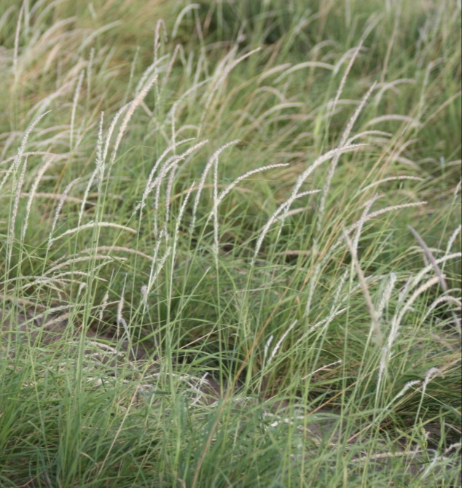

Forrest Smith, South Texas Natives

#### **Alternate Names**

*Pappophorum mucronulatum*

## Uses

Whiplash pappusgrass is useful for upland wildlife plantings, highway right-of-ways and ecosystem restoration. It provides fair forage for livestock.

#### **Status**

#### Please consult the PLANTS Web site and your State Department of Natural Resources for this plant’s current status (e.g. threatened or endangered species, state noxious status and wetland indicator values).

#### **Description**

*General:* Whiplash pappusgrass is a native, warm‑season, perennial bunch grass with a height of 2 to 3 1/2 feet. The leaf blade is flat, narrow up to 10 inches long with edges that may roll inward. The seedhead is 4 to 8 inches long, narrow, tightly contracted, with a whitish or tawny appearance only rarely with a slight purple tinge (Gould, 1975).

*Distribution*: For current distribution, please consult the Plant Profile page for this species on the PLANTS Web site. It is found in Texas, New Mexico and Arizona.

*Habitat*: Whiplash pappusgrass is found in dry rangelands of Texas to Arizona with annual rainfall of 10 to 20 inches. In the west it occurs at elevations of 2,500 to 4,000 feet. It is located on a wide variety of range sites including gray sandy loam, claypan prairie, and saline clay. It is associated with Arizona cottontop, false Rhodes grass, alkali sacaton, plains bristlegrass, and vine mesquite.

#### **Adaptation**

Whiplash pappusgrass grows well on most soil types, including sandy loam, clay, clay loam and saline clay soils

#### **Establishment**

Seedbed preparation should begin well in advance of planting. Planting can be scheduled for early spring or where there are few cool-season weeds, whiplash pappusgrass can be planted in the late summer. In Arizona and New Mexico planting should be timed to catch the summer monsoons. Establish a clean, weed-free seedbed by either tillage or herbicides. Prior to planting, the site should be firm and have accumulated soil moisture.

Whiplash pappusgrass is best seeded using a native-grass drill with picker wheels to ensure a good planting of the fluffy seed. Broadcast seeding may be used in areas not easily planted with a drill, but some type of additional coverage such as culti-packing or light dragging will be beneficial to ensure good seed to soil contact. Seed coatings (talc based) can also be used to increase the flowability of the fluffy seed through standard seed drills.

Seed should be planted 1/8 to 1/4 inch deep. It is better to plant too shallow than too deep. For calibration purposes, Webb Germplasm whiplash pappusgrass contains approximately 436,250 uncoated seeds per bulk pound. A seeding rate of 3 pounds of pure live seed (PLS) per acre is recommended. In planting mixtures reduce the rate according to the percent of whiplash pappusgrass in the mixture.

Soil analysis should be performed prior to planting to determine the necessary levels of nitrogen, phosphorus and potassium. Nitrogen should not be applied until the stand is established. If 1 to 2 plants per square foot have become established, the planting has been successful.

#### **Management**

Arizona cottontop should not be grazed the first year. After a stand is established, either continuous or rotational grazing can be used. Contact your local NRCS field office for assistance in developing a prescribed grazing plan. Plants should be allowed to produce seed occasionally to insure stand health. Whiplash pappusgrass is a long-lived perennial that is extremely drought and fire tolerant once established.

#### **Pests and Potential Problems**

Common pests of whiplash pappusgrass seed include fall armyworms (*Spodoptera* spp.), thrips (*Thrips* spp.), and rice stink bugs (*Oebalus pugnax*). Control of pests may be necessary in order to produce seed crops in dry years under irrigation

#### **Seeds and Plant Production**

Seed increase plots have been planted on 36” bedded rows, however flat plantings may be possible with frequent weeding. Whiplash pappusgrass can also be established with vegetative transplants. Rapid spread and growth has been observed in transplant established stands providing seed harvests within the first year. Furthermore transplants stands facilitate better weed control in the seed production fields.

Deep soil tillage or frequent close cultivation is recommended to promote seed production. Commercial herbicides are available for weed control once plants are beyond the seedling growth stage. Consult your local extension weed specialist for recommended herbicides.

Whiplash pappusgrass produces seed throughout the year. Seed is harvested with a Flail Vac or similar brush-type harvester. The use of slow travel and RPM speeds while harvesting results in relatively clean seed, needing little cleaning or processing. Debearding of the seed has been accomplished through the use of a Westrup brush machine. However, do not aggressively debeard the seed such that it removes the caryopsis from the glumes as seed damage or reductions in seed life have been observed. To clean stems and chaff from harvests, a clipper seed cleaner has been used following the debearding treatment.

On average one should expect to produce 50 bulk pounds per harvest of clean seed per acre. Purity of the seed is usually around 54% and germination rates are about 47%. Adequately stored seed in humidity and temperature controlled facilities can be expected to stay viable for 5 to 10 years.

#### **Cultivars, Improved, and Selected Materials (and area of origin)**

Webb Germplasm whiplash pappusgrass is a blend of 3 collections from the Rio Grande Plains of Texas and was released by Texas A&M-Kingsville *South Texas Native*, the USDA-NRCS E.”Kika” de la Garza Plant Materials Center and Texas AgriLife Research Station in Beeville, Texas in 2010. It was selected for its good seed germination and seedling vigor, as well as excellent soil, seed viability. It is predominantly adapted to sandy loam, claypan prairie, and saline clay range sites in south Texas. Breeder seed is maintained by *South Texas Natives* in conjunction with Texas Foundation Seed Service.

Pima Germplasm whiplash pappusgrass is a blend of 16 collections from Arizona and was released in 2006 by the USDA-NRCS Tucson Plant Materials Center. It was selected for release for ecosystem restoration, erosion control, wildlife cover and restoration of disturbed areas in southern Arizona. Breeder seed is maintained by USDA-NRCS Tucson Plant Materials Center (Garner, Hershdorfer, and Munda, 2006).

#### **References**

Garner, E.R., M.E. Hershdorfer, and B. Munda. 2006. Notice of Release of Pima Pappusgrass Selected Class of Germplasm. USDA-NRCS Tucson Plant Materials Center. Tucson, AZ.

Gould, F.W. 1975. The Grasses of Texas. Texas A&M University Press. College Station, TX.

#### **Prepared By**

*John Lloyd-Reilley*, Manager

USDA-NRCS, E. “ Kika” de la Garza Plant Materials Center, Kingsville, Texas

#### **Citation**

Lloyd-Reilley, J. 2010. Plant guide for whiplash pappusgrass (*Pappophorum vaginatum)*. USDA-Natural Resources Conservation Service, Kika de la Garza Plant Materials Center. Kingsville, TX.

Published October, 2010

Edited: [ 14Sep2010 sdm]

For more information about this and other plants, please contact your local NRCS field office or Conservation District at <http://www.nrcs.usda.gov/> and visit the PLANTS Web site at <http://plants.usda.gov/> or the Plant Materials Program Web site <http://plant-materials.nrcs.usda.gov>.

PLANTS is not responsible for the content or availability of other Web sites.

**USDA IS AN EQUAL OPPORTUNITY PROVIDER AND EMPLOYER**