

Plant Guide

# sharpleaf penstEmon

*Penstemon acuminatus*

Douglas ex Lindl.

Plant Symbol = PEAC

Contributed by: Aberdeen Plant Materials Center and Idaho NRCS State Office

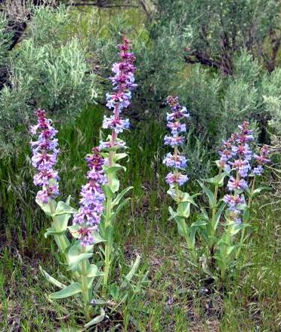**Sharpleaf penstemon (Nancy Shaw, USDA, FS, Boise, ID)**

Alternate Names

Sand penstemon; sand-dune penstemon

Uses

Sharpleaf penstemon is primarily used as a forb component for wildlife habitat enhancement and restoration efforts. Its showy flowers attract numerous pollinators and other insects that provide a food source for birds and other vertebrates. This species is used in xeriscaping and other low-water-use landscaping. It is suited for roadside and other beautification plantings.

Status

Consult the PLANTS Website and your State Department of Natural Resources for this plant’s current status (e.g. state noxious status).

Description

*General*: Figwort Family (Scrophulariaceae).

Sharpleaf penstemon is a short-lived perennial forb 20 - 60 cm (8 - 24 inches) tall. One to several erect stems arise from a thick crown. Stems and leaves can be both glabrous and glaucous. The fleshy leaves are entire with the basal leave oblanceolate and tapering to a petioled base. The basal leaves are 4 - 10 cm long and 7 - 15 mm wide. The upper leaves are 2 - 7 cm long and 10 - 35 mm wide, often sessile and clasping, and ranging from lanceolate to ovate with acute to acuminate tips. Flower clusters are compact and subtended by bracts that are usually wider than long with overlapping, heart-shaped bases. The calyx is 4.5 - 9 mm long during flowering and elongates as it matures. The individual sepals are narrowly lanceolate in shape. The blue to lavender or pink corolla ranges from 11 - 20 mm long with the tube narrow at the base, tapering gradually to a wide throat. The corolla lobes flare broadly. The anthers are glabrous and black outside, the sacs splitting completely to become opposite and boat-shaped. The stamen is glabrous or often with a short, yellow beard at the tips. Flowering season is from May to July. There are 400,000 – 500,000 seeds per pound.

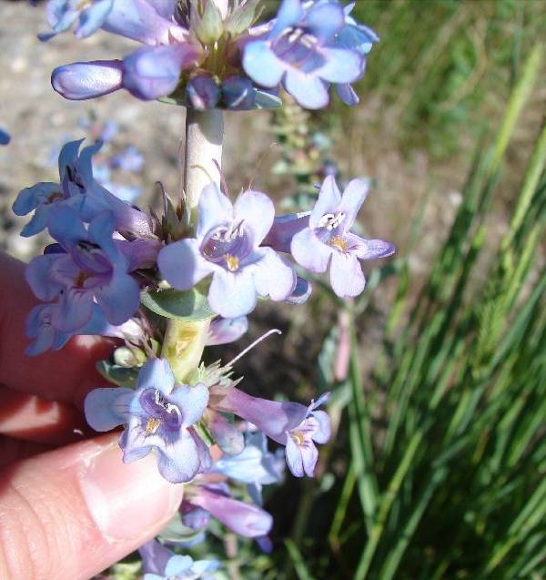

**Sharpleaf penstemon flower (Cassondra Skinner, USDI-BLM, Idaho)**

**Distribution**

Sharpleaf penstemon is found in low elevations east of the Cascade Mountains in Washington and Oregon, northern Nevada, northern Utah and southern Idaho, throughout the Snake River Plains.

**Habitat**

Sharpleaf penstemon inhabits loam to fine sandy loam to sandy soils of dunes and other dry locations at elevations from 2,150 to 6,000 feet (640 to 830 m).

Adaptation

This species is adapted to well-drained soils with a pH range of 5.0 to 8.0. For xeriscaping and low water-use gardening, the species is recommended for use in USDA hardiness zones 6-8 in areas receiving 8 to 10 inches or more annual precipitation.

Management

When planted in a native reclamation mix, sharpleaf penstemon should be a minor component of the mixture and establishing plant community. Therefore, management should be based on other key species in the established plant community. Grazing on seeded lands should be deferred for at least two growing seasons to allow for establishment.

Pests and Potential Problems

Impact from insect pests on penstemon seed production can be significant. Penstemon borer larva can infect the crown and upper root area of all penstemon species, resulting in the loss of individual plants and entire fields. Presently, penstemon borers are known only from extreme southwestern Colorado.Penstemonclearwing (Penstemonia spp.) attacks multiple penstemon species. The larvae feed within the stems of the crown and lower above-ground portions of the plant. A pheromone is available for monitoring these adult pests. Other potentially significant pests include Lygus bugs and raceme-boring moths. Sharpleaf penstemon is also susceptible to soil-borne fusarium and rhizoctonia root rot, which can be severe in poorly drained loam and clay-textured soils.

**Seed and Plant Production**

Fields for seed production can be established by transplanting greenhouse-grown containerized stock or from direct seeding. Direct seeding should take place in the fall to allow for natural stratification of the seed. Greenhouse materials can be established by seeding into cones or flats in winter for natural stratification or by stratifying the seed for 8 - 12 weeks in cold/moist conditions. Prechilling requirements can be reduced with a liquid smoke treatment. Germination can also be enhanced by watering with a weak solution of giberellic acid (250 ppm) though treated seedlings appear to be less vigorous than non-treated. Seed should be planted to a depth of 0 - 6 mm (0 - 0.25 in).

Chemical weed control in seed production fields of forbs is a challenge and preliminary work is only getting underway. In herbicide tolerance screening trials conducted at the Malheur Experiment Station in Oregon, sharpleaf penstemon had good tolerance (based on seed yields) to post-emergence applications of Outlook (Dimethenamid-P), and Prowl (Pendimethalin). Sharpleaf penstemon showed sensitivity to post-emergence applications of Buctril (bromoxynil octanoate), Caparol (Prmetryn) and Select (Clethodim). Considerable efforts to register herbicides for use on native forb seed production will be required.

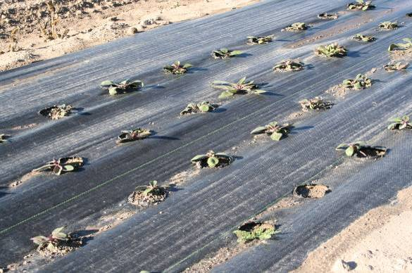

**Penstemon seedlings grown in weed barrier fabric for seed production. (Derek Tilley, USDA, NRCS, Aberdeen, ID)**

Because of the limited number of available herbicides that can be used on broadleaf forbs, planting into weed-barrier fabric (pictured above) is a viable alternative to control weeds in forb seed production fields. Planting holes should be 3 - 4 inches in diameter at 9 - 18 inch spacing.

Successful pollination is essential for commercial seed production of sharpleaf penstemon. Bees and wasps that have been observed pollinating sharpleaf penstemon include sweat bees, bumble bees, honey bees and leafcutter bees. The flowers bloom from May to July. The seed is mature when the capsule turns brown and begins to open. This typically occurs 5 - 8 weeks after flowering. Seeds are rapidly dispersed.

Seed harvest can be accomplished by hand or by direct combining. Harvest should occur when the stems and capsules begin to dry and open. Seed capsules open and seed is dispersed rapidly at maturity. Seed can be cleaned with a small clipper or air-screen cleaner. Seed yields range from 150 - 250 lb/ac (165 – 280 kg/ha).

Cultivars, Improved, and Selected Materials (and area of origin)

There are currently no releases of sharpleaf penstemon. Wildland harvested seed is available through commercial sources.

References

Barner, Jim. 2008. Propagation protocol for production of *Penstemon acuminatus* seeds. USDA FS – R6 Bend Seed Extractory, Bend, Oregon. In: Native Plant Network. URL: http://www.nativeplantnetwork.org

(accessed 12 Jan 2009). University of Idaho, College of Natural Resources, Forest Research Nursery.

Davis, R.J. 1952. Flora of Idaho. WM. C. Brown Company. Dubuque, Iowa. 828 p.

Debolt, A. and H. Parkinson. 2005. Propagation protocol for production of container *Penstemon accuminatus* plants. USDA FS – Rocky Mountain Research Station, Boise, Idaho. In: Native Plant Network. URL: http://www.nativeplantnetwork.org (accessed 12 Jan 2009). Moscow (ID): University of Idaho, College of Natural Resources, Forest Research Nursery.

Shaw, N., Walker, S., Jensen, S., Thompson, T. and A. DeBolt. 2003. Native plant material development and seed and seeding technology for native Great Basin forbs and grasses. In: Great Basin Native Plant Selection and Increase Project FY03 Progress Report.

Shock, C., Ishida, J. and E. Feibert. 2008. Identification of herbicides for use in native forb seed production. In: Great Basin Native Plant Selection and Increase Project FY07 Progress Report.

Slichter, P. 2007. *Penstemon acuminatus* var. *acuminatus*. http://ghs.greshan.k12.or.us/science/ps/nature/basin/5 petal/figwort/penstemon/yellow.htm

(accessed 12 Jan 2009).

USDA Natural Resources Conservation Service. 2008. The PLANTS database, version 3.5. URL: http://plants.usda.gov (accessed 12 Jan 2009). Baton Rouge, LA. National Plant Data Center.

Western Colorado Extension: Native Plant Seed Production. 2008. http://wsprod.colostate.

edu/cwis487/wci/seed_production.html. (accessed 12 Jan 2009).

Prepared By

Loren St. John, USDA NRCS Plant Materials Center, Aberdeen, ID

Dan Ogle, USDA NRCS Idaho State Office, Boise, ID

Nancy L. Shaw, USDA Forest Service,

Rocky Mountain Research Station, Boise, ID

Species Coordinator

Dan Ogle, USDA NRCS Idaho State Office, Boise, ID

#### **Citation**

St. John, L., D.G. Ogle, D. Tilley. 2010. Plant Guide for Strawberry Clover (*Trifolium fragiferum*). USDA-Natural Resources Conservation Service, Aberdeen, ID Plant Materials Center.

Published November, 2009

Edited: 011209LWS; 011209DGO; 011509NLS

For more information about this and other plants, please contact your local NRCS field office or Conservation District at <http://www.nrcs.usda.gov/> and visit the PLANTS Web site at <http://plants.usda.gov/> or the Plant Materials Program Web site <http://plant-materials.nrcs.usda.gov>.

PLANTS is not responsible for the content or availability of other Web sites.

**USDA IS AN EQUAL OPPORTUNITY PROVIDER AND EMPLOYER**