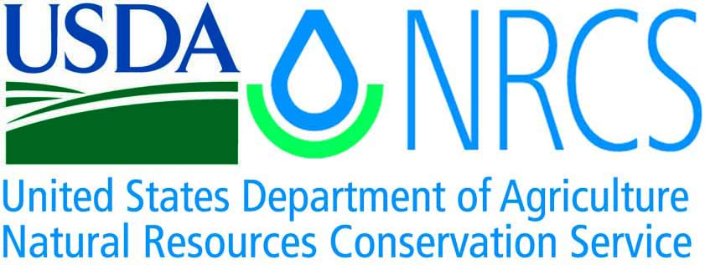

Plant Guide

# San rafael cactus

## Pediocactus despainii S.L. Welsh & Goodrich

### Plant Symbol = PEDE17

#### Contributed by: USDA NRCS Idaho Plant Materials Program

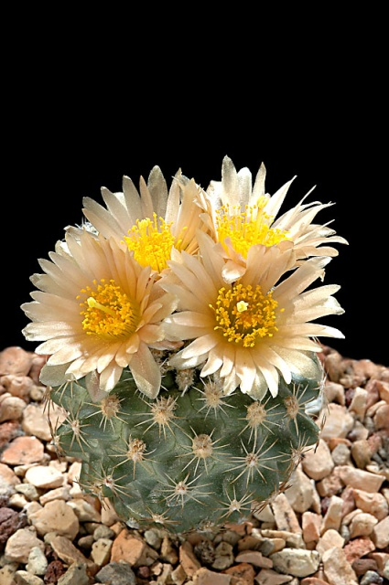

Figure . San Rafael Cactus (Pediocactus despainii). Photo from Cactusfriends.com (2010).

#### **Alternate Names**

Despain’s footcactus

#### **Uses**

There are no known human uses associated with San Rafael cactus.

#### **Status**

San Rafael cactus was determined endangered and under the protection of the Endangered Species Act by the US Fish and Wildlife Service in 1987 (USDI FWS 1987). Monitoring data show the species to be in decline based on a decrease in the number of vegetative individuals capable of reproducing.

Consult the PLANTS Web site and your State Department of Natural Resources for this plant’s current status (e.g., threatened or endangered species, state noxious status, and wetland indicator values).

#### **Description**

*General*: Cactus family (Cactaceae). San Rafael cactus arises from solitary, hemispheric stems. The plants are 4 to 6 cm tall with spirally arranged tubercles. The spines are 2 to 6 mm (0.08 to 0.2 in) long and pale yellowish. Flowers are born at the top, are 15 to 25 mm (0.6 to 1.0 in) across with yellow to peach flowers (Welsh et al 2003). The plants shrink underground for several months during dry or cold seasons, and are only noticeable in flower.

*Distribution*:This rare species is limited in distribution to five populations in the San Rafael Swell region of Emery County, Utah. Current surveys estimate the total number of individuals at about 20,000.

*Habitat*: San Rafael cactus occurs on Juniper/pinyon and salt desert shrub communities on hills, benches and flatlands of the Colorado Plateau.

#### **Adaptation**

This species is adapted to limestone gravels, shales, clays and silty substrates of the Morrison, Carmel, and Moenkopi formations at 1850 to 2050 m (6070 to 6700 ft).

#### **Management**

San Rafael cactus is highly sought by cactus enthusiasts. It is also under threat from ORV use which is popular in its native habitat. Additionally, approximately half of the species range is covered by oil and gas leases and mining claims.

Management goals are focused on the protection of habitat from disturbance. These include the prevention of plant collection in natural populations, and implementing conservation measures to minimize and mitigate land use activities (USDI FWS 2007).

#### **Pests and Potential Problems**

The cactus borer beetle (*Moneilema semipunctatum*) is known to parasitize San Rafael cactus.

#### **Environmental Concerns**

There are no known environmental concerns associated with this species.

#### **Seeds and Plant Production**

Plants of San Rafael cactus are illegally taken by cactus collectors and transplanted to pots and gardens. There is however no information available on plant production from seed.

#### **References**

##### USDI Fish and Wildlife Service. 1987. Endangered and threatened wildlife and plants; determination of endangered status for Pediocactus despainii (San Rafael Cactus). Federal Register. 52 (179): 34914-34917.

USDI Fish and Wildlife Service. 2007. Recovery outline for San Rafael Cactus (Pediocactus despainii_ and Winkler cactus (Pediocactus winkleri). U.S. Fish and Wildlife Service, Salt Lake City, UT. 10 pp.

Welsh, S.L., N.D. Atwood, S. Goodrich, and L.C. Higgins. 2003. A Utah Flora. Third Edition, revised. Brigham Young University, Provo, UT.

#### **Prepared By**

*Derek Tilley*; USDA NRCS Plant Materials Center, Aberdeen, Idaho.

*Loren St. John*, USDA NRCS Plant Materials Center, Aberdeen, Idaho.

*Dan Ogle*, USDA NRCS State Office, Boise, Idaho.

#### **Citation**

Tilley, D., St. John, L. and D. Ogle. 2010. Plant guide for San Rafael cactus (*Pediocactus despainii*). USDA-Natural Resources Conservation Service, Idaho Plant Materials Center. Aberdeen, ID.

Published: November 2010

Edited: 28Jul2010djt; 25Aug2010lsj; 24Aug2010dgo

For more information about this and other plants, please contact your local NRCS field office or Conservation District at <http://www.nrcs.usda.gov/> and visit the PLANTS Web site at <http://plants.usda.gov/> or the Plant Materials Program Web site <http://plant-materials.nrcs.usda.gov>.

PLANTS is not responsible for the content or availability of other Web sites.

**USDA IS AN EQUAL OPPORTUNITY PROVIDER AND EMPLOYER**