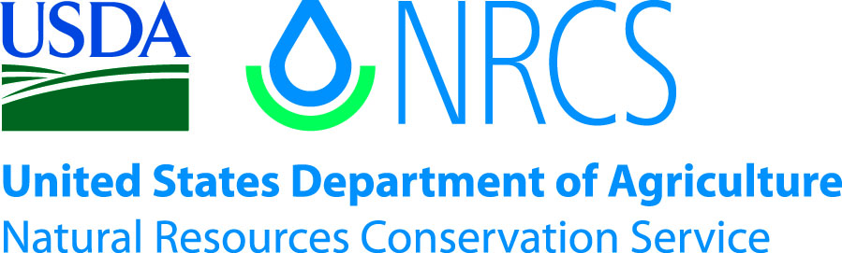

Plant Guide

# Rydberg’s penstemon

## Penstemon rydbergii A. Nelson

Plant Symbol = PERY

*Contributed by*: USDA NRCS Idaho State Office and National Plant Data Center

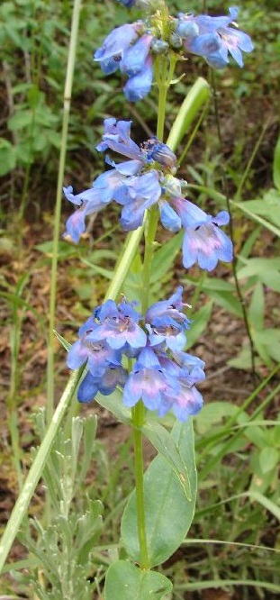

Rydberg's penstemon. Sheri Hagwood, USDA-NRCS PLANTS Database.

### Alternate Names

*Common Alternate Names:* meadow beardtongue, mountain meadow beardtongue

*Scientific Alternate Names: Penstemon rydbergii* var. *rydbergii, Penstemon rydbergii* var. *oreocharis, Penstemon rydbergii* var. *aggregatus*

### Uses

*Grazing/rangeland:* Rydberg’ penstemon is one of the more palatable species of penstemon and provides forage for wildlife, cattle and sheep (Forest Service, 1937; Bowns and Bagley,1986) and provides diversity in the plant communities where it is found.

*Erosion control/reclamation:* Penstemon species are used in seed mixes for erosion control and reclamation.

*Pollinators:* Rydberg’s penstemon attracts hummingbirds, butterflies and insects (Pollinator Partnership, 2013).

### Status

Please consult the PLANTS Web site and your State Department of Natural Resources for this plant’s current status (e.g., threatened or endangered species, state noxious status, and wetland indicator values).

### Description

*General*: Rydberg’s penstemon, a member of the Figwort Family (Schrophulariaceae), is a semi-evergreen, perennial forb with a tap root, well-developed basal leaves and is 20-40 cm tall. The plant is mostly glabrous with pubescence sometimes restricted to lines on the stems below the junction with the leaves. The lower leaves are oblanceolate, entire, 4-7 cm long and 9-15 mm wide. The upper leaves are smaller, 2.5-6 cm long, 3-14 mm wide and are lanceolate. Flower clusters are dense with 2-7 flowers. The flower is 10-16 mm long and tubular. The limb of the flower is blue to blue-violet or purple in color and the tube is violet to blue purple colored and glabrous. The stamens are golden to yellow colored. The fruit is a capsule 5-10 mm long and seeds are 0.6-1 mm long. Cronquist et al., (1984) recognizes three botanical varieties and provides a key to distinguish them based on floral characteristics as well as geographic distribution.

*Distribution*: Rydberg’s penstemon is found in the western United States from Montana south to New Mexico and westward to the Pacific Coast states of California, Oregon, and Washington. For current distribution, please consult the Plant Profile page for this species on the PLANTS Web site.

*Habitat*: Rydberg’s penstemon grows on moderately moist to dry slopes, meadows and streambanks from valleys to sub alpine and alpine sites (Cronquist et. al., 1984) in mountain brush, aspen, coniferous forests and open parklands (Monsen et. al., 2004).

**Adaptation**

Rydberg’s penstemon is adapted to basic and acid soils (Monsen et. al., 2004) medium to fine textured soils in areas receiving 20-30 inches annual precipitation (USDA, NRCS, 2013), and 4,265-10,827 feet elevation (Cronquist et. al., 1984).

### Establishment

Monsen et. al., (2004) state that the planting process for Rydberg’s penstemon is similar to other penstemon species. The general recommendation is to plant seed in the fall from 1/8 to no more than ¼ inch depth into a firm, weed-free seedbed. Good seed to soil contact is important for germination and establishment. There are approximately 850,000 seeds per pound (Stevenson Intermountain Seed, 2013). To achieve a target seeding rate of 50 seeds per square foot, 2.5 pounds PLS (Pure Live Seed) /ac should be planted to achieve a full stand. When used as a component of a seed mix adjust the seeding rate to the percent of mix desired. Rydberg’s penstemon should be drilled through a legume box or with a seed dilutent such as rice hulls because the seeds are small and may separate from other seeds in the mix.

Mulching, irrigation and weed control benefit stand establishment. Some seed may not germinate until the second growing season. Plants begin growth early in the spring and flower blossoms appear in the late spring and early summer. Flowering should not be expected until the second growing season.

Weed control will be required during establishment. Because penstemon is a broadleaf plant, the use of broadleaf type herbicides is not recommended. Mowing weeds when they are beginning to bloom will help reduce weed seed development.

### Management

Rydberg’s penstemon should be used as a minor component of seed mixtures. Management strategies should be based on the key species in the established plant community. Grazing should be deferred on seeded lands for at least two growing seasons after seeding to allow for full stand establishment. It is a short-lived plant, but with proper management, natural regeneration should maintain plants in the vegetative community.

### Pests and Potential Problems

Information on pests and diseases of Rydberg’s penstemon is not well known. In general, penstemon is susceptible to soil-borne fusarium and rhizoctonia root rot which can be severe in poorly drained loam and clay textured soils. Grasshoppers and other insects may also damage plants.

### Environmental Concerns

Rydberg’s penstemon is a native plant species found in western North America and has no known negative impacts on wild or domestic animals. It is not considered a weedy or invasive species but can spread to adjoining vegetative communities under ideal conditions. It co-exists with other native species and adds biodiversity to plant communities.

### Seed and Plant Production

There can be considerable variability in seed dormancy among collections of the same species of penstemon. A few methods can be used to overcome dormancy including the use of aged seed where after-ripening causes seed to lose dormancy, and moist pre-chilling (stratification). However, there is no published information specific to the propagation of Rydberg’s penstemon.

A standard method for propagating penstemon for transplants is to stratify the seed for 8-12 weeks in cold and moist conditions. Seed should be surface sown into plant containers, pressed into the soil surface with containers then stored under cool (36° F), dark conditions for 8-12 weeks. After the stratification period, bring plants into greenhouse conditions and allow plants to grow for 8-12 weeks before transplanting in the field. Propagation of new plants from division of older plants is also possible.

Fields for seed production can be established from direct seeding or from transplanting greenhouse grown containerized stock. Direct seeding should occur in late fall to allow for natural stratification of the seed. Rydberg’s penstemon should be seeded in 30-36 inch rows at a rate of 0.85 pounds PLS/ac (target 50 pure live seeds per linear foot of drill row) to allow for mechanical weed control (Cornforth et. al., 2001). The use of weed barrier fabric is an alternative to allow closer spacing, reduce weeds and conserve soil moisture. Plant spacing of 18 inches provides for maximum growth and seed yield when using weed barrier fabric.

Seed normally ripens from mid-August to mid-September and is mature when seed capsules dry and become hard and dark in color. Seed will shatter once capsules have opened. Seed can be harvested by hand-stripping or with a combine. Seed is separated from the capsule with use of a hammermill or barley debearder followed by fan cleaning. Seed yields average 100 pounds per acre.

### Cultivars, Improved, and Selected Materials (and area of origin)

There are no cultivars, improved, or selected materials of Rydberg’s penstemon. Common wildland collected seed is available from commercial sources (Native Seed Network).

### References

Bowns, J., Bagley, C. 1986. Vegetation Responses to Long-term Sheep Grazing on Mountain Ranges. Journal of Range Management. 39(5) 431-434.

Cronquist, A., Holmgren, A., Holmgren, N., Reveal, J., Holmgren, P. 1984. Intermountain Flora. Volume Four. Subclass Asteridae (except Asteraceae). The New York Botanical Garden, Bronx, New York.

Forest Service, 1937. Range Plant Handbook. U.S. Department of Agriculture, Forest Service. United States Government Printing Office. Variously paginated.

Monsen, S. Stevens, R., Shaw, N. comps. 2004. Restoring western ranges and wildlands. Gen Tech. Rep. RMRS-GTR-136-vol 2. Fort Collins, CO: U.S. Department of Agriculture, Forest Service, Rocky Mountain Research Station. p 457.

Native Seed Network. http://www.nativeseednetwork.org (accessed 24 September, 2013)

Pollinator Partnership, 2013. Selecting Plants for Pollinators. A Regional Guide for Farmers, Land Managers and Gardeners in the Northern Rocky Mountain Forest-Steppe. www.pollinator.org (accessed 17 September, 2013)

Stevenson Intermountain Seed, 2013. http://stevensonintermountainseed.com (accessed 19 September, 2013)

USDA, NRCS, 2013. The PLANTS Database, National Plant data Team, Greensboro, NC http://plants.usda.gov (accessed 18 September, 2013)

**Prepared By**:

Daniel G. Ogle, USDA NRCS Idaho State Office, Boise, ID

J. Scott Peterson, USDA NRCS National Plant Data Center, Baton Rouge, LA

Loren St. John, USDA NRCS Plant Materials Center, Aberdeen, ID

### Citation

Ogle, D., Peterson, S., St. John, L. 2013. Plant Guide for Rydberg’s penstemon (*Penstemon rydbergii)*. USDA-Natural Resources Conservation Service, Plant Materials Center. Aberdeen, Idaho 83210.

Revised October, 2013. Original plant guide published June, 2003.

Edited: 05Dec2000jsp; 11Feb2003ahv; 08June2003jsp; 24Sep2013ls; 24Sep2013djt; 25Oct2013jab

For more information about this and other plants, please contact your local NRCS field office or Conservation District at http://www.nrcs.usda.gov/ and visit the PLANTS Web site at http://plants.usda.gov/ or the Plant Materials Program Web site http://plant-materials.nrcs.usda.gov.

PLANTS is not responsible for the content or availability of other Web sites.

**USDA IS AN EQUAL OPPORTUNITY PROVIDER AND EMPLOYER**