

Plant Guide

# Venus Penstemon

## Penstemon venustus Douglas ex Lindl.

Plant Symbol = PEVE2

*Contributed by*: USDA NRCS Idaho and Utah Plant Materials Program

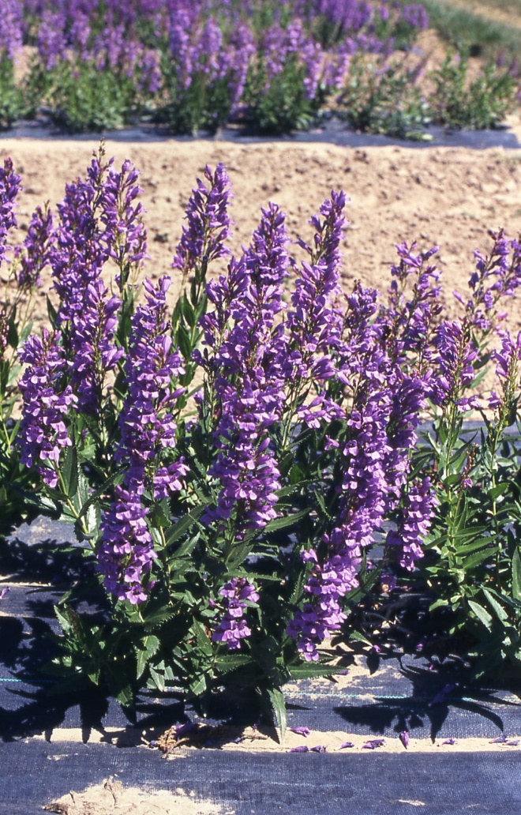

Clearwater Selection Venus penstemon (Loren St. John, Aberdeen PMC)

### Alternate Names

Shrubby Venus penstemon, alpine penstemon, elegant beardtongue

### Uses

Venus penstemon is primarily used as a forb component for restoration and wildlife enhancement projects. It is not noted for having value as forage for livestock or big game. Its showy flowers attract pollinators and other insects which provide a food source for birds and other animals. The heavy taproot and woody base make it an excellent plant for soil stabilization, low-water use landscaping and ornamental plantings.

There are no documented uses by Native Americans.

### Status

Consult the PLANTS Web site and your State Department of Natural Resources for this plant’s current status (e.g., threatened or endangered species, state noxious status, and wetland indicator values).

### Description

*General:* Figwort Family (Schrophulariaceae). Venus penstemon is a native, long-lived, herbaceous to woody subshrub 30-80 cm (12-32 in) tall. The leaves and stem are glabrous. The leaves are stiff, cauline and largest at mid-stem, 50-120 mm (2.9-4.7 in) long, lanceolate, and usually sharply serrate. The inflorescence is glabrous, and calyx is 3.4-6.2 mm (0.13-0.24 in) with ovate to lanceolate lobes. The corolla is 22-38 mm (0.87-1.50 in), lavender to purple. The filaments and inner margins of anthers are long-white-hairy. Chromosome number is 2n=64 (Jepson Flora Project). Von Arx and others (2006) documented a Venus penstemon plant in northeastern Oregon that was 23 years old.

*Distribution*: Venus penstemon is naturally found in the states of California, Idaho, Oregon, Washington and Utah at elevations of 1,000-6,000 feet (300-1,800 m) and 20-35 inches (50-90 cm) annual precipitation. The *Penstemon* genus is common to western North America and except for one minor species does not occur naturally outside of North America. For additional information on distribution, consult the Plant Profile page for this species on the PLANTS Web site.

*Habitat*: Venus penstemon is found on sunny, open slopes of mountain valleys and foothills at elevations of 1,000-6,000 feet (300-1,800 m) (Ogle et. al, 2011) on dry, rocky, exposed locations (Jepson Flora Project). It does not tolerate poorly drained soils.

**Adaptation**

Venus penstemon is adapted to shallow rocky to stony loams, sandy loams and gravelly loams that are moderately to very well-drained. It does not grow well in areas with poor drainage. It prefers full sunlight. It is adapted to USDA Plant Hardiness Zones 4a to 8b and pH ranges of 6.1 (mildly acidic) to 7.8 (mildly alkaline) (Dave’s Garden, 2011).

### Establishment

A study conducted to correlate habitat and germination response found that penstemon seed from colder winter sites had longer chill (stratification) requirements and were slower to establish than seed from warmer winter sites (Meyer,1992). Because of the seed stratification requirement, Venus penstemon should be seeded in late fall with a drill or broadcast planted and then pressed to a depth of ⅛ to ¼ inch into a firm seedbed. Good seed to soil contact is important for germination and establishment. The full seeding rate is 1 pound Pure Live Seed (PLS) per acre and there are approximately 1,090,000 seeds per pound (Ogle, et al. 2011). When used as a component of a seed mix, adjust to the percent of mix desired.

Mulching, irrigation and weed control benefit stand establishment. Some planted seed may not germinate until the second growing season. Flowering should not be expected until the second growing season.

Weed control will be required during establishment. Because Venus penstemon is a broadleaf plant, the use of broadleaf type herbicides is not recommended. Mow weeds at or prior to bloom stage.

### Management

Venus penstemon should be used as a minor component of seed mixtures. Management strategies should be based on the key species in the established plant community. Grazing should be deferred on seeded lands for at least two growing seasons to allow for full stand establishment.

### Pests and Potential Problems

Venus penstemon is susceptible to soil-borne fusarium and rhizoctonia root rot which can be severe in poorly drained loam and clay textured soils (USDA-NRCS, 2006). There is some indication that Venus penstemon is susceptible to powdery mildew (Love, personal communication). There are no known insect problems (USDA-NRCS, 2006).

### Environmental Concerns

Venus penstemon is a native plant species in western North America and has no known negative impacts on wild or domestic animals. It is not considered a weedy or invasive species but can spread to adjoining vegetative communities under ideal conditions. It co-exists with other native species and adds biodiversity to plant communities.

### Seed and Plant Production

Fields for seed production can be established from direct seeding or from transplanting greenhouse grown containerized stock. Direct seeding should take place in late fall to allow for natural stratification of the seed. Venus penstemon should be seeded in 30-36 inch rows at a rate of 0.7 pounds PLS per acre to allow for mechanical weed control. The use of weed barrier fabric is an alternative to allow closer spacing, reduce weeds and conserve soil moisture. Plant spacing of 18 inches provides for maximum growth and seed yield when using weed barrier fabric.

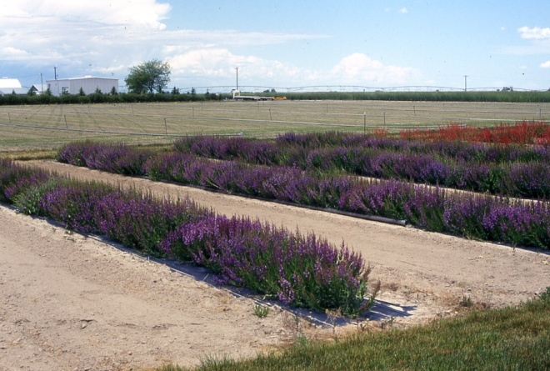

Clearwater Selection Venus penstemon seed production field at Aberdeen PMC utilizing weed barrier fabric. (Loren St. John, Aberdeen PMC).

Transplants grown in a greenhouse can be established by seeding into cones or flats placed outdoors in winter for natural stratification or by stratifying the seed for 8 to 12 weeks in cold and moist conditions prior to planting seed. Treatment of seed with gibberellic acid (GA3) may reduce the stratification requirement (Kitchen and Meyer, 1991). Seed should be surface sown and pressed firmly into the soil surface. Flats or containers should be blocked from sunlight during the stratification period to prevent mold and fungus from establishing on the soil surface during stratification. A very thin covering of fine to medium grade perlite on the soil surface after emergence in containers or flats helps prevent excessive moisture around the emerging seedling and limits damping-off of young seedlings. Allow seedlings to grow in the greenhouse for 8-12 weeks before transplanting to the field.

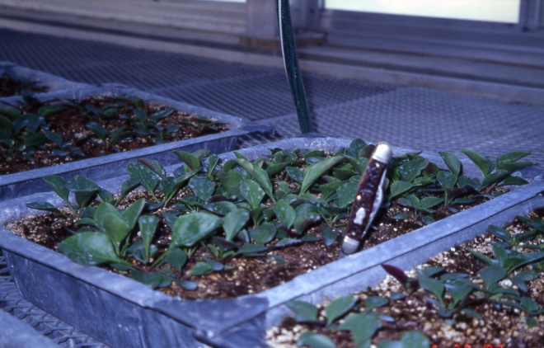

Penstemon seedlings growing in greenhouse trays. (Loren St. John, Aberdeen PMC)

Seed can be harvested by hand or by mechanical means. Seed is mature when capsules are dry and seed is hard and dark in color. Flowering is indeterminate with mature capsules and flowers present at harvest. Harvest should occur when the majority of seed capsules begin to dry and open. Plants may be swathed ahead of combining to allow more uniform ripening and drying. Plants are swathed to a height above most leaves to capture flower stalks. Stalks are then allowed to sit on top of the swathed plants for 4-5 days before combining. Seed can be separated from the capsule by use of a hammer mill or debearder and processed with an air-screen cleaner. Estimated seed yield ranges from 100 to 200 pounds per acre. Seed will maintain viability under cool and dry storage conditions for at least 10 years with a very gradual decline in viability over time. Due to the long-lived nature of the species, seed production fields will continue to produce seed for at least 10 years with little decline in yield. Venus penstemon attracts native specialist bees, bumble bees, and non-aggressive specialist pollen wasps.

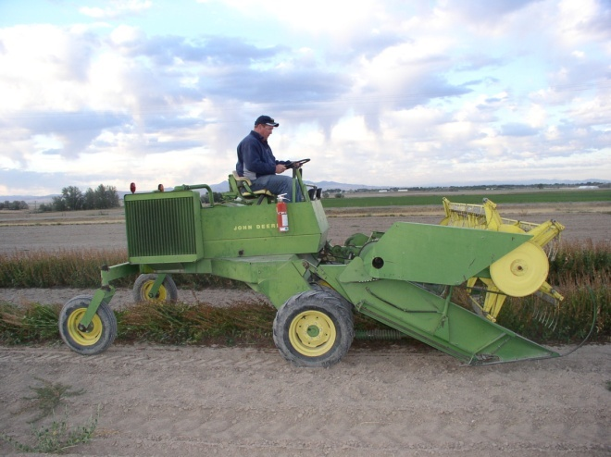

Swathing Clearwater Selection Venus Penstemon (Loren St. John, Aberdeen PMC)

### Cultivars, Improved, and Selected Materials (and area of origin)

**Clearwater Selection Venus penstemon** was released by the Aberdeen, Idaho Plant Materials Center in 1994 as pre-variety germplasm. The original collection was made near Dworshak Reservoir on the Clearwater River in northern Idaho and was selected from a collection of 119 penstemon accessions. The Clearwater Selection was released for its beauty, hardiness, seed production and natural range of adaptability. It had the best stand establishment and longest survival. Certified seed is available and Generation 1 (G1) seed is maintained by the Aberdeen Plant Materials Center. Growers may produce one generation each of G2 and G3 seed (USDA-NRCS, 2006).

### References

Dave’s Garden, 2011. http://davesgarden.com/guides/pf/go/173657/ (accessed November 14, 2011)

Jepson Flora Project. http://ucjeps.berkeley.eud/interchange/I_treat_indexes.html (accessed November 29, 2011)

Kitchen, S., Meyer, S. 1991. Seed Germination of Intermountain Penstemons as influenced by Stratification and GA3 Treatments. Journal of Environmental Horticulture. 9(1):51-56.

Love, S. personal communication. University of Idaho, Aberdeen Research and Extension Center.

Meyer, S. 1992. Habitat correlated variation in Firecracker Penstemon (Penstemon eatonii Gray: Scrophulariaceae) seed germination response. Bulletin of the Torrey Botanical Club 119(3). p 268-279.

Ogle, D., L. St. John, M. Stannard, and L. Holzworth. 2011. Conservation Plant Materials for the Intermountain West. Technical Note 24. USDA-Natural Resources Conservation Service, Boise, ID. 57 p.

USDA-NRCS, 2006. Plants for Solving Resource Problems: Clearwater Selection Venus Penstemon. Aberdeen Plant Materials Center. 2p.

Von Arx, G., Edwards, P., Dietz, H. 2006. Evidence for Life History Changes in High-altitude Populations of Three Perennial Forbs. Ecology 87(3) 665-674. Ecological Science Society of America.

**Prepared By**:

Loren St. John, USDA NRCS Plant Materials Center, Aberdeen, ID

Derek Tilley, USDA NRCS Plant Materials Center, Aberdeen, ID

Dan Ogle, USDA NRCS Idaho State Office, Boise, ID

### Citation

St. John, L., D. Tilley, and D. Ogle. 2011. Plant Guide for Venus penstemon (*Penstemon venustus*). USDA-Natural Resources Conservation Service, Plant Materials Center. Aberdeen, Idaho 83210.

Revised December, 2011. Original plant guide published September, 2002.

Edited: 29Nov2011 ls; 29Nov2011dgo; 29Nov2011jab;30Nov2011djt

For more information about this and other plants, please contact your local NRCS field office or Conservation District at <http://www.nrcs.usda.gov/> and visit the PLANTS Web site at <http://plants.usda.gov/> or the Plant Materials Program Web site <http://plant-materials.nrcs.usda.gov>.

PLANTS is not responsible for the content or availability of other Web sites.

**USDA IS AN EQUAL OPPORTUNITY PROVIDER AND EMPLOYER**