|  |
| --- |
| koleagrass |
| *Phalaris aquatica* L. |
| Plant Symbol = PHAQ |

Contributed by: USDA NRCS California State Office and Lockeford Plant Materials Center, California

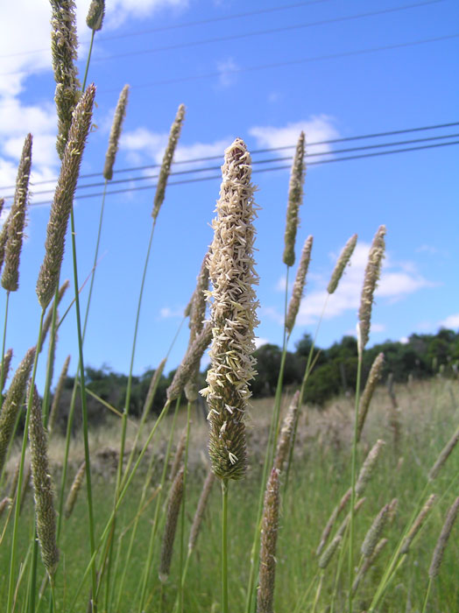

*©* Brianna M. Richardson

CalPhotos

Alternative Names

Bulbous canarygrass, hardinggrass, *Phalaris tuberosa* var. *hirtiglumis* (koleagrass), *Phalaris tuberosa* var. *stenoptera* (Harding grass), Towoomba canary grass, alpiste bulbeaux, phalaris tubereux, herbe de Harding, knolliges Glanzgras, capim-doce, rabillode cordero

**Uses**

Koleagrass was developed for improvement of annual grass range. Its forage production is typically no greater than can be expected from native range. However, this perennial produces forage earlier in the season and stays green longer. Fertilized Koleagrass can extend the green feed period two months or more in the winter compared to unfertilized native grasses, and can add about one month to the green feed period in spring when moisture is not limiting.NOTE: This species has been known to have toxic effects on sheep and cattle.

Koleagrass is now considered the standard perennial grass for improvement of annual grass range in California. Please consult the Related Web Sites on the Plant Profile for further information on this species.

Status

Please consult the PLANTS Web site and your State Department of Natural Resources for this plant’s current status (e.g. threatened or endangered species, state noxious status, and wetland indicator values).

Weediness

This plant may become weedy or invasive in some regions or habitats and may displace desirable vegetation if not properly managed. Please consult with your local NRCS Field Office, Cooperative Extension Service office, or state natural resource or agriculture department regarding its status and use. Weed information is also available from the PLANTS Web site. Please consult the Related Web Sites on the Plant Profile for this species for further information.

Description

*General*: Grass Family (Poaceae). Koleagrass is an introduced, tall, robust, rapid-developing bunchgrass with short rhizomes. This species includes both *Phalaris tuberosa* var. *stenoptera* (previously known as Harding grass) and *Phalaris tuberosa* var. *hirtiglumis* (previously known as koleagrass). P.t. var. *hirtiglumis* was recognized to have bigger seeds, more vigorous seedlings, yellow-green leaves, and hairy glumes. Both of these varieties have been submerged taxonomically into *Phalaris aquatica*.

*Distribution*: Koleagrass was introduced from Morocco. Used for pasture and erosion control in California and sparingly in other parts of the southwestern U.S. Consult the PLANTS Web site for its U.S. distribution.

**Adaptation**

Koleagrass is adapted in California below 2,000 feet to the Mediterranean-like climatic zone or where frost heaving is not a problem. It will grow where there is 12 inches of annual rainfall and there is soil profile development (clay layer). Moisture holding capacity of the soil becomes less critical as rainfall increases. It establishes itself early, grows well during cold winter months, and reseeds readily.

**Establishment**

Seedbed Preparation: Good stands require a spring-summer fallow to reduce competition from annuals in fall. Fall seeding is done on a firm, weed-free seedbed prepared after the first effective rains (1.5-2.0 inches). This ensures adequate moisture to support seedling growth and destroys the first crop of volunteer annuals. If fallow is prepared before weed species produce seed, the fall weed competition is reduced, but not eliminated. Fall seeding can follow a summer clean-up crop of Sudangrass *(Sorghum bicolor* ssp. *drummondii*). Planting is accomplished directly in the Sudangrass stubble.

Method of Seeding: Best results are obtained by drilling the seed. Use of a common grain drill is possible if the seed is first mixed with rice hulls as a dilutor and the drill is properly calibrated. If seed is broadcast and covered by harrowing or dragging, the seeding rate is increased 1.5 times. Seeding depth should be ¼-1/2 inch in all cases.

Weed Control: During the establishment season, mowing may be necessary to reduce competition from annuals. Set the mower at a height compatible with regrowth of the koleagrass and other perennials. Remove as little leaf area of the koleagrass and other perennials as possible so that development will not be retarded.

Fertilization: Do not apply fertilizer in the establishment year. In the second and subsequent years, 200 pounds per acre 16-20-0 (ammonium-phosphate-sulfate) is recommended in the fall.

Management

Koleagrass should not be grazed until completion of growth the first season. At the end of the green feed period, dry forage can be grazed if the plants are large enough to resist pulling by livestock. An average stubble height of three to four inches should be maintained.

Established Stands: Koleagrass starts growth in fall coincident with the first rains. Mature stands of koleagrass should be ready for grazing (6-8 inches high) by early January. The amount of growth depends on the amount of rain, its distribution, temperature and soil fertility. Cold tolerance is improved by the inclusion of phosphorus with nitrogen during fall fertilization. Grass can be grazed at range readiness without harm to the plant so long as the ground is firm and not so wet that damage from trampling might occur. Grazing should stop when fertilized annual range is ready for use or when there is a three-inch average stubble height. Grazing will normally end in late February. However, lack of moisture or poor growing conditions may require earlier termination. Infrequently, when abundant rainfall occurs in late winter, grazing can continue through mid-March. Following winter grazing, the perennials, including koleagrass, must be rested to allow recovery and re-growth. This deferment period should continue until the annual range grasses begin to dry up and lose their high feed value. By the time the annual range is dry, koleagrass will have produced seed and stored food reserves in the roots. The leaves will still be green and will remain green for about one month after the annuals are dry. This palatable forage can be grazed heavily until the average stubble height is three inches. When grazing ends, many plants will be heavily used, others partially grazed, and there will be numerous seed stalks left.

Pests and Potential Problems

None

Control

Please contact your local agricultural extension specialist or county weed specialist to learn what works best in your area and how to use it safely. Always read label and safety instructions for each control method. Trade names and control measures appear in this document only to provide specific information. USDA, NRCS does not guarantee or warranty the products and control methods named, and other products may be equally effective.

**Seeds and Plant Production**

Koleagrass can be grown as an annual for purposes of seed production. At the Lockeford Plant Materials Center, irrigated rows spaced 30 inches apart yield 400-600 pounds per acre of seed when harvested with a binder in late spring following fall seeding. Koleagrass seed averages 267,000 seeds per pound.

Cultivars, Improved, and Selected Materials (and area of origin)

‘Perla’ Cultivar- This cultivar was introduced from Morocco. It is easy to establish, grows well during cold winter months, and produces good seed crops. Stands frequently improve through natural reseeding. Also, it’s adapted to soils with restricting layer in Mediterranean climatic zone wherever average annual rainfall is 400mm or more.

Contact your local Natural Resources Conservation Service (formerly Soil Conservation Service) office for more information. Look in the phone book under ”United States Government.” The Natural Resources Conservation Service will be listed under the subheading “Department of Agriculture.”

References

Alderson, James and Sharp, Curtis. November 1994. *Grass Varieties in the United States.* USDA NRCS, Washington, DC.

USDA NRCS. 1974. *Management and uses of Perla Koleagrass.* USDA NRCS, Davis, CA.

Prepared By:

*Dyer, Dave*, USDA NRCS Plant Materials Center, Lockeford, CA and Reina O’Beck, California State Office, Davis, CA.

Species Coordinator:

*Dave Dyer*, USDA NRCS Lockeford Plant Materials Center, California.

Edited: 14sep2005 jsp; 060802 jsp

For more information about this and other plants, please contact your local NRCS field office or Conservation District, and visit the PLANTS Web site<<http://plants.usda.gov>> or the Plant Materials Program Web site <<http://Plant-Materials.nrcs.usda.gov>>

*The U.S. Department of Agriculture (USDA) prohibits discrimination in all its programs and activities on the basis of race, color, national origin, sex, religion, age, disability, political beliefs, sexual orientation, and marital or family status. (Not all prohibited bases apply to all programs.) Persons with disabilities who require alternative means for communication of program information (Braille, large print, audiotape, etc.) should contact USDA's* [*TARGET Center*](http://www.usda.gov/oo/target.htm) *at 202-720-2600 (voice and TDD).*

*To file a complaint of discrimination write USDA, Director, Office of Civil Rights, Room 326-W, Whitten Building, 14th and Independence Avenue, SW, Washington, DC 20250-9410 or call 202-720-5964 (voice or TDD). USDA is an equal opportunity provider and employer.*

*Read about* [*Civil Rights at the Natural Resources Convervation Service*](http://www.nrcs.usda.gov/about/civilrights/)*.*