

Plant Guide

# TIMOTHY

## Phleum pratense L.

Plant Symbol = PHPR3

*Contributed by*: USDA NRCS Idaho State Office and Aberdeen, Idaho, Plant Materials Center

### Large Photo of Phleum pratenseTimothy (*Phleum pretense*). James R. Johnson @ USDA-NRCS PLANTS Database / USDA NRCS. 1992. Western wetland flora: Field office guide to plant species. West Region, Sacramento.

### Alternate Names

Herd grass, herd’s grass, meadow cat's-tail,Phleum nodosum

### Uses

*Livestock*: Timothy is preferred by cattle and horses, and timothy hay is a premium feed for horses. Sheep utilize timothy during the summer in mountainous areas. Timothy is used for pasture and silage, but mostly for hay. It is palatable and nutritious. It makes a first rate companion grass with alfalfa, birdsfoot trefoil, or clover species as it is one of the grasses least competitive with legumes.

*Erosion control*: Timothy can be used with legumes and/or other grasses in seed mixtures for cover, filter strips, herbaceous buffers, waterways, and other critical area applications. It can also be used for erosion control on cut- or burned-over forestland. Keep in mind that timothy is shallow-rooted and thus should not be considered the primary species for erosion control plantings.

*Wildlife*: Timothy is commonly found in wildlife seed mixtures for nesting, brood rearing, and escape cover.

### Status

Consult the PLANTS Web site and your State Department of Natural Resources for this plant’s current status (e.g. threatened or endangered species, state noxious status, and wetland indicator values).

### Weediness

Timothy is a relatively short-lived, introduced perennial grass that grows in stools or clumps. It spreads via seed distribution. It is not considered a "weedy" or invasive species, but can spread into adjoining vegetative communities under ideal climatic and environmental conditions. It is known to coexist with native plants. On favorable sites where it is best adapted, it can exist as a monoculture. There is no documentation that it crosses with native species. It is considered a weed in seed lots in the eastern states of Delaware, Maryland, New Hampshire, New Jersey, Pennsylvania, Virginia and West Virginia.

Consult with your local NRCS Field Office, Cooperative Extension Service office, state natural resource, or state agriculture department regarding its status and use. Weed information is also available from the PLANTS Web site at <http://plants.usda.gov/>. Consult the Related Web Sites on the Plant Profile for this species for further information.

### Description

*General*: Grass family (Poaceae). Timothyis a relatively short-lived, cool-season, introduced perennial grass that grows in stools or clumps. It has a shallow, compact, and fibrous root system. It grows in erect culms 50 to 100 cm (20 to 40 in) tall. Leaves vary in length from a few inches to more than a foot and are about 0.6 cm (0.25 in) wide, narrowing gently toward the tip.

Seedheads are spike-like and dense, from 5 to 15 cm (2 to 6 in) in length and 0.6 cm (0.25 in) in diameter. The sheath is split and hairless with overlapping margins.

Timothy is different from most grasses in that one or occasionally two of the basal internodes of the stem swell into a bulb-like growth called a “haplacorm”. This characteristic is often used for identification of the plant during its early stages of growth.

Timothy resembles the “native” alpine timothy (*P. alpinum*) to some extent. Alpine timothy is usually found in alpine meadows and bogs and occasionally at medium elevations along the west coast. Alpine timothy usually flowers in late July to early August in the mountains. The seedheads of alpine timothy are much shorter and the plant is also shorter in stature than timothy.

Timothy is also confused with meadow foxtail (*Alopecurus pratensis*) and creeping foxtail (*A. arundinaceus*). Meadow and creeping foxtail have short twisted awns giving the inflorescence a somewhat fuzzy appearance. Timothy is awnless. Additionally, cured seed heads of creeping foxtail have a dark to somewhat black appearance, while cured seed heads of timothy are tan to buff colored.

|  |  |  |
| --- | --- | --- |
| Alpine timothy | Timothy | Creeping foxtail |

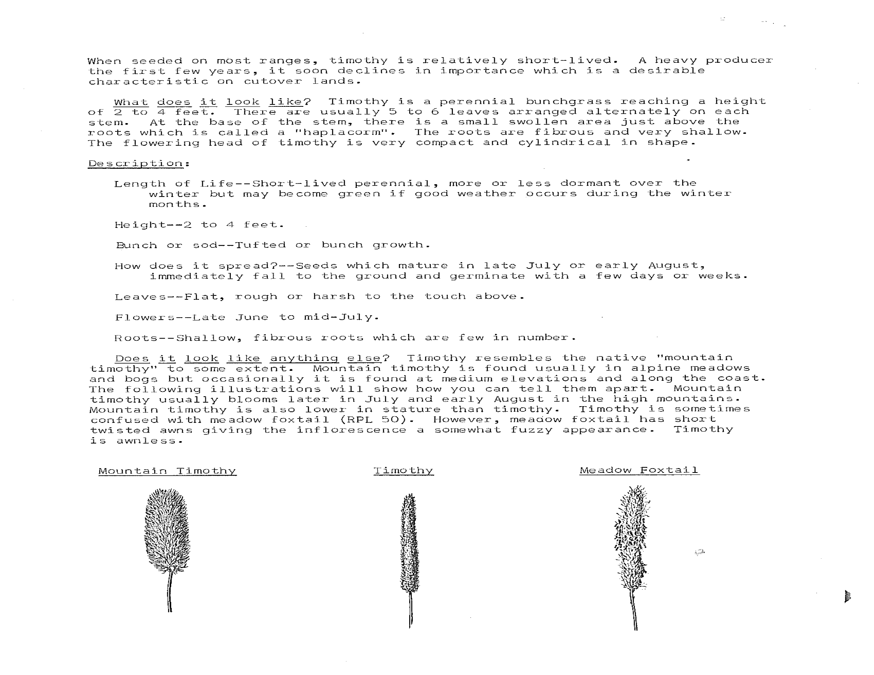

**Differences in seedhead morphology between alpine timothy, timothy, and creeping foxtail. Ben Zamora, Oregon State University, Range PlantLeaflet No. 47. Seed head examples are not to scale.**

Seed is very small and usually remains enclosed in the glumes. There are approximately 1,230,000 seeds per pound.

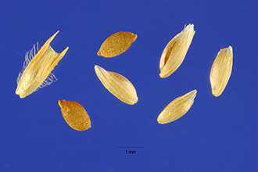

**Timothy seed. Steve Hurst. Provided by ARS Systematic Botany and Mycology Laboratory.**

*Distribution*: Timothy is distributed throughout the entire United States; however, it grows best in the northern half of the nation and along mountain chains further south.

Agricultural use of timothy in the U.S. occurs primarily in the Northwest, upper Midwest, and Northeast. For a current distribution map, consult the Plant Profile page for this species on the PLANTS Website.

*Habitat*: Timothy can be found growing in waterways, dry to wet meadows and other mesic environments. It is commonly found volunteering in canals and roadside borrow ditches.

**Adaptation**

Timothy is an introduced bunchgrass adapted to cool, humid areas and to high elevations. It performs well, with moderate to high yields, on wet fertile lands. It is adapted to irrigation and areas with effective annual precipitation of at least 45 cm (18 in). It prefers finer textured soils, such as clays to clay loams to loams and is adapted to soils with a pH of 5.5 to 7.0. It is tolerant of partially shaded conditions. Timothy is very winter-hardy. It exhibits tolerance to both cold temperature, and ice encasement, a major factor affecting winter survival. It is not well adapted to wet, flat land where water stands for extended periods of time, though it can withstand somewhat poorly-drained soils. It does not tolerate drought or prolonged high temperatures and it does not tolerate alkaline conditions.

Timothy is compatible in mixes with legumes. It establishes cover quickly, volunteers readily on preferred sites, is late maturing, and is very palatable early in the growing season (jointing stage) and only moderately palatable later in the growing season (post seedhead development). Timothy hay is a premium feed for horses and is compatible in legume mixes. Severe damage can result from early grazing under wet conditions. It regrows very slowly following grazing or haying. Other recommended sites include cool, moist meadows and open forests.

Timothy establishes quickly and volunteers readily on preferred sites. It invades wet areas along ditches, canals, drains, and streams and can be a weed in these areas.

### Establishment

Timothy is usually seeded in mixtures with legumes. This mixture may be planted with a small grain. If planted with a winter grain, the timothy is seeded with the grain in the fall, and the legume is planted early the following spring. Seeding depth of timothy should be about 0.3 to 1.3 cm (0.125 to 0.5 in). A firm, weed-free seedbed is a key to a successful planting. Common seeding rates are 3 to 6 pounds per acre when seeded alone and 1 to 3 pounds per acre when seeded in mixtures. The average number of seeds per square foot at 1 lb. seeding rate is 28 seeds. Seeding rates should be doubled if seed is broadcast planted.

### Management

Timothy is a short-lived, shallow-rooted, introduced, perennial bunchgrass.In spring, the crowns form swollen, bulblike internodes that store energy. Close grazing and trampling during moist conditions can damage these internodes and severely reduce stands.

Timothy should be grazed before the jointing stage and hayed before seed heads have emerged from boot to early bloom stage. Begin grazing during the vegetative stage, after grass has reached at least 15 cm (6 in) in height. A 10 cm (4 in) stubble height should remain following grazing. It regrows slowly following grazing or haying. A 28 to 35 day recovery period between grazing or haying cycles is recommended.

Timothy is highly responsive to fertilizers, which should be applied frequently based in accordance with soil tests. Fertilizer, especially nitrogen, is important when legumes such as clover species have almost disappeared from the hay or pasture mixture.

Timothy stands become weak under close and continuous grazing. A fundamental reason for the decline of timothy under poor grazing practices is injury to the bulblets (haplacorm). These bulblets form in the spring at the same time the stem elongates. Food reserves are stored in the bulblets, and they may be destroyed through trampling by grazing animals in the spring.

Timothy can be initially grazed before jointing and again between early head to full head. Second and successive grazing periods should occur before jointing and when basal sprouts appear at the soil surface. After the second grazing period, plants usually do not joint; therefore, sprouts are the primary grazing guide. Timothy should be cut for hayor silage from boot stage to early head or flowering stage. Make successive harvests for hay and silage when basal sprouts appear at the soil surface. Sterile seed-heads may be 38 to 50 cm (15 to 20 in) up the stems when sprouts appear at the time of second cutting. Growing points stay below ground level after the second cutting. Graze or cut to heights of 10 cm (4 in) or more.

### Pests and Potential Problems

Stem rust is a disease that can cause loss of vigor and forage quality to timothy. Rust-resistant varieties have been developed to control this disease. Purple eyespot (*Cladosporium phlei*) and leaf streak (*Drechslera phlei*) are diseases commonly found across western Canada. Timothy is also damaged by brown leaf blight and grasshoppers. New fields are also susceptible to wireworm or cutworms. European skipper larvae (a bright orange butterfly) are a pest of timothy in eastern Canada.

### Seed Production

Seed production fields should be soil tested before planting to determine soil nutrient levels and fertilizer needs. Seed should be drilled or broadcast into a weed free, firm seedbed. The optimum seeding depth is 0.3 to 1.3 cm (0.125 to 0.5 in). The drill seeding rate of 1 to 2 pounds PLS per acre in 45 to 60 cm (18 to 24 in) rows provides a good stand. Wider row spacing may be beneficial to seed production in dry climates.

Under irrigated conditions, seed yields average 450 to 670 kg/ha (400 to 500 lb/ac). Seed production under dryland conditions is not recommended in the western United States. In the eastern United States, seed production yields of 336 to 450 kg/ha (300 to 400 lb/ac) can be expected.

Timothy shatters readily but should not be swathed too soon. It is usually ready to swath when 5 to 10 percent of the seed have shattered (late July to early August). The seedheads will have a tan color and the stems and leaves will be a golden color. Swathing early in the morning will help reduce seed shatter. Allow 5 to 14 days of drying before combining.

### Cultivars, Improved, and Selected Materials (and area of origin)

Most of the timothy grown in the U.S. is common timothy. Improved cultivars and places of development are: ‘Essex’ and ‘Cornell 1777’ (New York); ‘Lorain’ and ‘Marietta’ (Ohio); ‘Itasca’ (Minnesota); ‘Clair’ (Kentucky), and ‘Verdant’ (Wisconsin). Canadian releases are ‘Bounty’, ‘Climax’, ‘Drummond’, ‘Medon’, ‘Milton’, ‘Paton’, and ‘Swallow’. Common timothy and most cultivars can be readily obtained from commercial sources. There are many proprietary timothy varieties grown under contract for seed companies.

### References

Agriculture and Agri-Food Canada. 2004. *Timothy Seed Production in Western Canada*. Online at: http://www1.agric.gov.ab.ca/$Department/deptdocs.nsf/all/agdex8696. [accessed Aug. 27, 2009].

Alderson, J. and WC Sharp 1994. *Grass varieties in the United States*. Agriculture Handbook No. 170. USDA, SCS, Washington, D.C.

Barkworth, Mary, et. al. 2007.*Manual of grasses for North America.* Intermountain Herbarium and Utah State University Press, Logan, Utah.

Cronquist, A., AH Holmgren, NH. Holmgren, JL. Reveal, & PK. Holmgren 1977. *Intermountain flora*. Vol. 6. The New York Botanical Garden. Columbia University Press, New York, New York.

Hitchcock, AS. 1950. *Manual of the grasses of the United States*. USDA, Washington, DC.

Holzworth, LK. and LE. Wiesner. 1985. *Grass and Legume Seed Production in Montana and Wyoming.* USDA-SCS Bridger Plant Materials Center. 31 p.

Majerus, M. 2009. *Forage and Reclamation Grasse of the Northern Great Plains and Rocky Mountains* Valley Printers, Bridger, Montana.

McElroy, AR and H.T. Kunelius. 1995. Timonthy. Pp. 305-311 in R.F. Barnes, D.A. Miller and C.J. Nelson (eds.) *Forages volume I: An introduction to grassland agriculture*. Iowa State University Press, Ames.

USDA, Forest Service 1996. *Fire effects information system*. Version: 000413. <http://www.fs.fed.us/ database/feis/>. Rocky Mountain Research Station, Fire Sciences Laboratory, Missoula, Montana.

USDA, NRCS 2000. *The PLANTS database*. Version: 000413. <http://plants.usda.gov>. National Plant Data Center, Baton Rouge, Louisiana.

Zamora, Ben, Oregon State University, *Range Plant Leaflet No. 47*. Corvallis, Oregon

**Prepared By**:

*Daniel G. Ogle*, Plant Materials Specialist USDA NRCS, Boise, ID

*Loren St. John*, Team Leader, USDA NRCS, Plant Materials Center, Aberdeen, ID

*Derek J. Tilley,* Agronomist,USDA NRCS, Plant Materials Center, Aberdeen, ID

Edited: 07Oct2009jfh; 10Oct2009mws; 18Mar2011dgo; 18Mar2011lsj; 18Mar2011djt;

### Citation

Ogle, DG, St. John, L and DJ Tilley. 2011. Plant guide for timothy (*Phleum pratense*). USDA-Natural Resources Conservation Service, Idaho State Office. Boise, ID.

Published March, 2011

For more information about this and other plants, please contact your local NRCS field office or Conservation District at <http://www.nrcs.usda.gov/> and visit the PLANTS Web site at <http://plants.usda.gov/> or the Plant Materials Program Web site <http://plant-materials.nrcs.usda.gov>.

PLANTS is not responsible for the content or availability of other Web sites.

**USDA IS AN EQUAL OPPORTUNITY PROVIDER AND EMPLOYER**