

Plant Guide

# James’ Galleta

## Pleuraphis jamesii Torr.

Plant Symbol = PLJA

*Contributed by*: USDA NRCS Idaho and New Mexico Plant Materials Centers

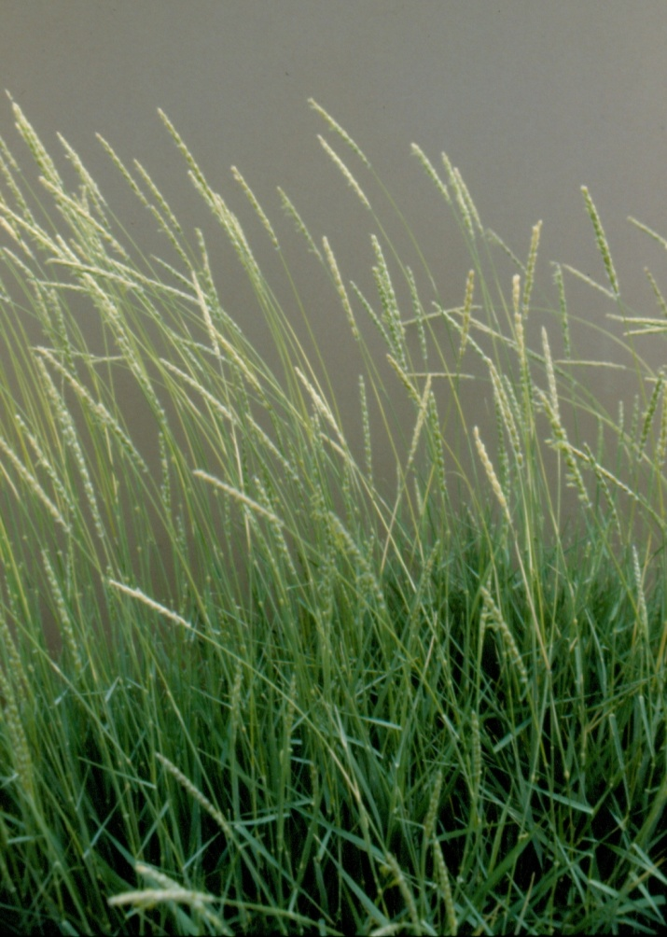

James' galleta. Photo by Los Lunas Plant Materials Center.

### Alternate Names

*Common Alternate Names:* Galleta, Curly grass, Jim’s laughing grass

*Scientific Alternate Names: Hilaria jamesii* (Torr.) Benth.

### Uses

Galleta is a desirable forage plant for cattle, horses and sheep during active plant growth in late spring and early summer. Palatability is rated as moderate during active growth and relatively unpalatable during dormant periods. Sheep typically feed upon central portions of galleta tufts, leaving the coarser growth around the outer edges. It is used to some extent by deer and antelope. Desert bighorn sheep of the Mojave Desert utilize galleta as forage. It provides poor cover for most wildlife species (Simonin, 2000).

Galleta can also be used for conservation ground cover on areas that have heavy foot traffic (campgrounds, picnic areas, and roadsides) because it can handle trampling. It is an excellent plant for erosion control on semi-desert sites (Pratt, et al., 2002).

### Status

Please consult the PLANTS Web site and your State Department of Natural Resources for this plant’s current status (e.g., threatened or endangered species, state noxious status, and wetland indicator values).

### Description

General: Grass Family (Poaceae). Galleta is a perennial, warm season grass with strong rhizomes, but commonly is found growing in bunches. Stems are erect, 30-50 cm (11-19 in) tall, leaves 2-4 mm (0.08-0.16 in) wide, 2-5 cm (0.79-1.97 in) long; leaf sides are smooth and edges are scabrous. Collars are pubescent with pilose hairs at the margins and auricles are absent. Ligules are membranous, 1.8-2.2mm (0.07-0.09 in) long, obtuse, ciliolate, and glabrous. Inflorescence is a raceme with a wavy rachis, 3-10 cm (1.18-3.94 in) long with spikelets in clusters of 3 per node. The central spikelets (next to the axis) are fertile and 1-flowered. The 2 lateral spikelets are staminate, 6-8 mm (0.24-0.31 in) long and hairy at base. Glumes are 4-5 mm (0.16-0.20 in) long, linear and unequally 2-lobed at the apex. Glumes of the central spikelet are sub equal, 4-5.5 mm (0.16-0.22 in) long, ciliate and apex is divided into 4-8 awned lobes. The awns are 1.5-5mm (0.06-0.20 in) long. Lemmas are 6-7 mm (0.24-0.28 in) long, 3-5 nerved, and blunt (Skinner, 2010).

Under favorable conditions, bunches merge forming a sod. Rhizomes occur 1-2 inches (2.5-5.1 cm) below the soil surface. Few roots extend further than 18 inches (50 cm) below the soil surface. The tough, woody rhizomes may reach 5-6 feet (1.5-1.8 m) in length (Simonin, 2000).

**Ethnobotany**

The Hopi tribe used galleta for basketry, coiled trays, and as floor and hair brushes. The Navajo tribe used it as a dietary/pediatric aid to make babies “want to eat a lot” and for horse and sheep feed because it withstands trampling and close grazing (Native American Ethnobotany, Online).

*Distribution*: Galleta is widespread throughout southern California to the desert mountains of Nevada, Arizona, New Mexico, Utah, Colorado, southern Wyoming, and western Texas. It is also found in the panhandle of Oklahoma and in extreme southwest Kansas. For current distribution, please consult the Plant Profile page for this species on the PLANTS Web site.

*Habitat*: Galleta is found in the pinyon-juniper (*Pinus*-*Juniperus*) and ponderosa pine (*P. ponderosa*) habitat types and in the conifer woodland-grassland transition zones, and plains grasslands in the southwest and also in northern desert-shrub plant communities of California, Nevada, Utah, Colorado, and southern Wyoming. Galleta is also found in the tallgrass plant communities along the Colorado-New Mexico border in association with little bluestem (*Schizachyrium scoparium*), western wheatgrass (*Pascopyrum smithii*), needleandthread (*Hesperostipa comata*), purple threeawn (*Aristida purpurea*), and sand dropseed (*Sporobolus cryptandrus*). In Arizona, galleta is found in pinyon-juniper, shortgrass, and sagebrush plant communities and in Utah in salt desert shrub, creosote bush (*Larrea tridentata*), sagebrush (*Artemisia spp*.), pinyon-juniper and blackbush (*Coleogyne ramosissima*) plant communities. In the central portion of the Great Basin, galleta forms a habitat type with big sagebrush (*Artemisia tridentata*). Other common grasses found in association with galleta include black grama (*bouteloua eriopoda*), blue grama (*Bouteloua gracilis*), Indian ricegrass (*Achnatherum hymenoides*), desert needlegrass (*Stipa speciosa*), bottlebrush squirreltail (*Elymus elymoides*), Sandberg bluegrass (*Poa secunda*), Alkali sacaton (*Sporobolus airoides*), and Fendler threeawn (*Aristida purpurea* ssp*. fendleriana*), (Simonin, 2000.)

**Adaptation**

Galleta is adapted to a wide variety of soils but prefers neutral to moderately alkaline soils with low water holding capacity and coarse loamy texture. It is also adapted to fine textured soils, often found on clay soils where other grasses are rare. Galleta is commonly found between 3,500 and 7,500 feet (1066-2286 m) elevation in 5-16 inch (127-406 mm) annual precipitation zones. In California, it is found on dry, sandy to rocky slopes and flats within scrub and woodland areas. In Arizona, it is most common on sandy plateaus and in Utah on dry flats and foothills. In the Colorado Plateau region of Utah it thrives on well-drained, sandy soils and fractured rockland. Preferred sites in Texas are dry rocky ledges, rolling slopes and valley flats (Pratt, et. al, 2002 and Simonin, 2000).

### Establishment

Seed should be planted into a clean, firm seedbed to a depth of ¼-½ inch. Drilling is preferred to ensure uniform seeding depth but broadcast seeding followed by harrowing and packing can be utilized where soil moisture is not lacking. The Los Lunas PMC provides seeding rate recommendations for galleta based on the caryopsis (the actual fruit, or “naked” seed) because of the extra, unnecessary bulk that is attached with the floret (caryopsis plus lemmas and paleas) and planting a caryopsis is much easier. There are approximately 151,850 florets per pound (PLANTS Database) and 269,520 caryopsis seed per pound (LLPMC).

The single species seeding rate based on caryopsis weight is 2-6 pounds pure live seed (PLS) per acre (NMSU CES, 1982 and LLPMC, NRCS 2008). For erosion control plantings, double the seeding rate to 4-12 pounds (caryopsis), PLS per acre (LLPMC, NRCS 2008). Seeding rates based on floret weight are 6-8 pounds PLS per acre and 12-16 pounds PLS per acre for erosion control plantings. If planted in a mixture, adjust the seeding rate to the percent of mix desired.

Stands may require weed control measures during establishment, but applications of broadleaf herbicides should not be made until plants have reached the four to six leaf stage. Mow above grass seedlings when weeds begin to bloom to reduce weed seed production. Insects may damage new stands and the use of insecticides may be required. Be sure to read and follow pesticide label directions.

### Management

Galleta greens up in early summer if rains are adequate. Growth is dependent on precipitation and is tolerant of close grazing and trampling. Management strategies should be based on key species in the plant community. Grazing should be deferred on seeded lands for at least two growing seasons to allow for full stand establishment.

### Pests and Potential Problems

Many of the pests that can cause problems in galleta are the same pests that can be problematic to many other native grass species such as; grasshoppers, mites, grass bugs, thrips, etc. Thrips, if found in large enough populations, can cause a sharp reduction in seed production of native grass species, and galleta is no exception (USU Bulletin 487, 1972).

### Environmental Concerns

Galleta is a native species that spreads very slowly by rhizomes and is commonly found as scattered bunches. It might spread into adjoining plant communities under ideal climatic and environmental conditions but does not pose any environmental concern to native plant communities.

### Seed and Plant Production

When producing grass seed of any species, the most important step is to obtain a clean, uniform stand of grass. The seed production field should be kept weed free, especially in the first year of establishment. If it is kept weed free in the first year and a uniform stand is produced, less work will be required to maintain an optimum seed production environment in subsequent years.

Maintaining the seed production field using cultivation and herbicide applications along with hand weeding will provide for an even stand of grass. This methodology will after the first year provide reduced labor costs in harvesting, cleaning and processing the seed crop (LLPMC, NRCS 2008, USDA M7-N-21281 July 1969).

Galleta seed production is rated as fair to poor. At the Los Lunas, New Mexico Plant Materials Center (LLPMC) seed production plantings of source-identified collections have consistently yielded less than the released cultivar ‘Viva’. Seed production depends on the percentage of flowers pollinated and the formation of viable seed. The pollination and subsequent seed development was found to be poor for galleta and for several other species found in genus *Pleuraphis* (USU Bulletin 487, August 1972). Seed should be visually checked for maturity under a magnifying apparatus to allow for harvesting the greatest amount of viable seed. In studies at the LLPMC, galleta grown in seed increase plantings ranged from 23 to 35 pounds of caryopsis pure live seed per acre (NMSU USDA NRCS ‘Viva’ Galleta Release Notice, March 1979).

### Cultivars, Improved, and Selected Materials (and area of origin)

**‘Viva’** was selected and released at the Los Lunas, New Mexico Plant Materials Center in 1979 in cooperation with the New Mexico and Colorado State University Experiment Stations. The original collection was from a native stand near Kirk, NM. Source material was increased and selected in comparison rows and field studies for improved seedling vigor, forage, and seed yield. Breeder and Foundation seed is maintained by the Los Lunas Plant Materials Center and Certified Seed is available (USDA, 1994).

There also may be other unnamed selections or ecotypes of this species available from commercial sources.

### References

Native American Ethnobotany. A Database of Foods, Drugs, Dyes and Fibers of Native American Peoples Derived from Plants. University of Michigan, College of Arts, Sciences, and Letters http://herb.umd.umich.edu/ (Accessed January 24, 2012)

New Mexico State University Cooperative Extension Service Circular 503 ‘Viva’ Galleta, (1982).

New Mexico NRCS Range Technical Note 81, Seeding Rate Statistic for Native and Introduced Species, 1998.

PLANTS Database. *Pleuraphis jamesii*. [Online]. <http://plants.usda.gov>. U.S. Department of Agriculture, Natural Resources Conservation Service. (Accessed January 23, 2012)

Pratt, M., Bowns, J., Banner, R., Rasmussen, A., 2002. Galleta. In: Range Plants of Utah, [Online]. Utah State University, USU Extension http://extension.usu.edu/range/Grasses/galleta.htm (Accessed January 23, 2012)

Simonin, K., 2000. *Pleuraphis jamesii*. In: Fire Effects Information System, [Online]. U.S. Department of Agriculture, Forest Service, Rocky Mountain Research Station, Fire Sciences Laboratory http://www.fs.fed.us/database/feis/ (Accessed January 23, 2012)

Skinner, Q., 2010. A Field Guide to Wyoming Grasses. Education Resources Publishing, Cumming, GA. 595 p.

USDA M7-M-21281 Plant Materials in the Soil Conservation Service (July 1969) 40 p.

USDA. 1994. Grass Varieties in the United States. Agriculture Handbook No. 170. United States Department of Agriculture, Soil Conservation Service. 296p.

USDA NRCS Los Lunas Plant Materials Center 2008: Basic Guidelines for Seeding Native Grasses in Arid and Semi-Arid Ecosystems.

Utah State University Bulletin 487 Galleta: Taxonomy, Ecology and Management of Hilaria jamesii on Western Rangelands (August 1972).

**Prepared By**:

Loren St. John, USDA NRCS Plant Materials Center, Aberdeen, ID

Derek Tilley, USDA NRCS Plant Materials Center, Aberdeen, ID

Danny G. Goodson, USDA NRCS Plant Materials Center, Los Lunas, NM

For more information about this and other plants, please contact your local NRCS field office or Conservation District at <http://www.nrcs.usda.gov/> and visit the PLANTS Web site at <http://plants.usda.gov/> or the Plant Materials Program Web site <http://plant-materials.nrcs.usda.gov>.

PLANTS is not responsible for the content or availability of other Web sites.

### Citation

St. John, L., D. Tilley, and D. Goodson. 2012. Plant guide for Galleta (*Pleuraphis jamesii*) USDA-Natural Resources Conservation Service, Plant Materials Center, Aberdeen, Idaho 83210.

Published April, 2012

Edited: 25Jan2012ls; 10Feb2012dg; 13 Mar2012ls; 13Mar2012dt, 14Mar2012jab; 12Apr2012ls

For more information about this and other plants, please contact your local NRCS field office or Conservation District at <http://www.nrcs.usda.gov/> and visit the PLANTS Web site at <http://plants.usda.gov/> or the Plant Materials Program Web site <http://plant-materials.nrcs.usda.gov>.

PLANTS is not responsible for the content or availability of other Web sites.

**USDA IS AN EQUAL OPPORTUNITY PROVIDER AND EMPLOYER**