|  |
| --- |
| Muttongrass |
| *Poa fendleriana* (Steud.) Vasey |
| Plant Symbol = POFE |

Contributed by: USDA NRCS Idaho State Office

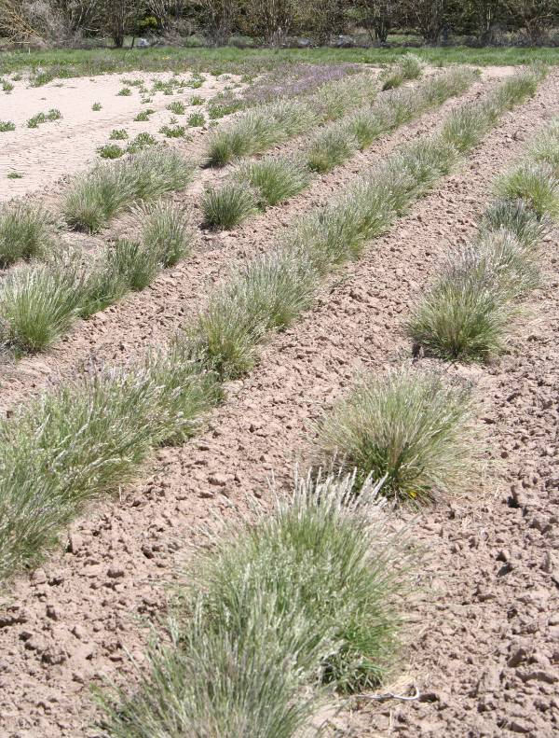

Photo by Derek J. Tilley

Alternate Names

Early bluegrass, mutton bluegrass, *Eragrostis fendleriana*, *Poa eatoni*, *P. montana, P. longiligula*

Uses

*Forage*: Muttongrass is a good source of forage and has been rated as excellent forage for cattle and horses, and good for sheep, elk and deer (USDA 1937). During the winter, seedheads are eaten by pronghorn antelope. Seeds and leaves are also utilized by birds.

*Erosion control*: The fibrous root system of this species reaches a depth of approximately 10 inches providing good surface erosion control in arid sites.

*Native species restoration*: Muttongrass has been used sparingly to improve diversity in sagebrush and piñon-juniper communities. It can be used to restore areas where juniper encroachment has depleted the herbaceous understory following juniper removal. The species is drought tolerant and has potential for use in restoration and native diversification projects throughout the West.

Status

Consult the PLANTS Web site and your State Department of Natural Resources for this plant’s current status (e.g. threatened or endangered species, state noxious status, and wetland indicator values).

Description

*General*: Muttongrass is a perennial bunchgrass growing 0.7 to 2.5 feet tall with narrow leaves (1 to 3mm wide). The species is generally considered apomictic (not requiring fertilization for seed production). The flowers are typically pistillate (only female), but occasional staminate (male) flowers arise giving the species the ability to hybridize with other bluegrasses (Welsh and others 2003). Some plants may also reproduce sexually from pollen received from male plants of other bluegrass species (Cronquist and others 1977).

*Distribution*: For current distribution, consult the Plant Profile page for this species on the PLANTS Web site. Historic records show muttongrass ranges from southern Canada to Texas and east to the Dakotas.

*Habitat*: Muttongrass is an important late successional understory component in juniper and piñon-juniper communities. Plants can also be found throughout ponderosa pine and into aspen forests and Engelmann spruce-lodgepole pine zones.

Adaptation

Muttongrass is among the most drought tolerant bluegrasses and should be considered for restoration and native diversification projects in western states. It is limited in its use however due to its low seed viability.

This species performs best on well-drained clay loams but is also found in drier, less fertile, gravelley and sandy soils (USDA 1937). Muttongrass is adapted to sites receiving 10 to 22 inches annual precipitation. In the northern extent of its range, muttongrass occupies lower elevation plant communities while it is found at higher elevations to the south.

Muttongrass has shown limited tolerance to fire. Some evidence indicates that muttongrass stands have responded well following fires (Gartner and others 1978) while others have observed stands being damaged.

Establishment

Plant in late fall (dormant) with a pure seeding rate of 2 lb PLS/acre. If seeding as part of a mix, adjust seeding rate to the desired percentage of the mixture. Seed should be planted with a drill ¼ inch deep, into a firm, weed-free seedbed or seed can be broadcast followed with a cultipacker or harrow operation to provide a shallow covering of soil.

Management

Weed control in seed production fields can be achieved by between-row cultivation but may require some hand weeding during the first growing season because seedlings are very small. After plants reach the 3 to 5 leaf stage, broadleaf herbicides can be applied at low rates.

Pests and Potential Problems

There are no known pests of muttongrass; however, plants may, like other bluegrass species, be susceptible to stem rust.

**Environmental Concerns**

Muttongrass is a species native to the western United States and is not considered a weedy or invasive species, but it can spread to adjoining vegetative communities under ideal environmental conditions.

**Seed and Plant Production**

Plant in early spring into a firm, weed-free seedbed at 24 to 36” spacing. Plants require 30 lb/ac available nitrogen during the establishment year and 45 lb/ac available nitrogen on established fields. Apply phosphorus according to soil test recommendations. For establishment, irrigate to maintain a moist soil surface and to avoid soil crusting. On established fields irrigate in early spring through boot stage. Do not irrigate during pollination or seed ripening. Irrigate after harvest to promote growth.

Harvest by direct combining in late May through mid-June. Muttongrass is very susceptible to seed shatter and timing of harvest is critical. Seed should be dried to approximately 10% moisture before cleaning and storage. Seed can be cleaned by lightly hammer milling followed with a clipper or air screen cleaner.

Yields for irrigated production fields average about 35 lb/acre but vary widely from year to year. Stands produce seed for up to 8 years. Low viability in seed prevents muttongrass from being more widely used. There are approximately 890,000 seeds/pound.

Cultivars, Improved, and Selected Materials (and area of origin)

There are no releases currently available. Wildland collected seed can be obtained through commercial vendors.

The Aberdeen, Idaho Plant Materials Center is currently evaluating accessions for potential release. Contact your local Natural Resources Conservation Service (formerly Soil Conservation Service) office for more information. Look in the phone book under ”United States Government.” The Natural Resources Conservation Service will be listed under the subheading “Department of Agriculture.”

References

Cronquist, A., A.H. Holmgren, N.H. Holmgren and J.L. Reveal. 1977. *Intermountain Flora: Vascular Plants of the Intermountain West*, U.S.A. The New York Botanical Garden.

Gartner, F.R., Butterfield, R.I., Thompson, W.W., and Roath, L.R. 1978. Prescribed burning of range ecosystems in South Dakota. In: Hyder, D.N., ed. Proceedings, 1st International Rangeland Congress; Denver, CO. Society for Range Management. 687 p.

Monsen, S.B., Stevens, R. and N. Shaw. 2004. Grasses. In: S.B. Monsen, R. Stevens, and N.L. Shaw [compilers]. Restoring western ranges and wildlands. Fort Collins, CO: USDA Forest Service, Rocky Mountain Research Station. General Technical Report RMRS-GTR-136-vol-2. p. 295-424.

Smith. S.R. and S. Smith, eds. 1997. Native grass seed production manual (including selected forbs). Cooperative project of U.S. Department of Agriculture Plant Materials Program, Ducks Unlimited Canada, Manitoba Forage Seed Association, and University of Manitoba. Oak Hammock Marsh, Manitoba, Canada: Ducks Unlimited Canada. 155 p.

U.S. Department of Agriculture, Forest Service. 1937. Range Plant Handbook. Washington DC: U.S. Department of Agriculture, Forest Service, Variously paginated.

Welsh, S. L., N. D. Atwood, S. Goodrich and L. C. Higgins. 2003. *A Utah Flora*. Brigham Young University Press. Provo, Utah. 912 p.

Prepared By

*Derek J. Tilley*, Range Conservationist (Plants) USDA NRCS Plant Materials Center, Aberdeen, ID

*Dan Ogle*, Plant Materials Specialist

USDA NRCS Idaho State Office, Boise, ID

*Loren St. John*, Manager

USDA NRCS Plant Materials Center, Aberdeen, ID

Species Coordinator

*Dan Ogle*, Plant Materials Specialist

USDA NRCS Idaho State Office, Boise, ID

Edited: djt101906; lstj102006; dgo111706; 061116 jsp

For more information about this and other plants, please contact your local NRCS field office or Conservation District, and visit the PLANTS Web site<<http://plants.usda.gov>> or the Plant Materials Program Web site <<http://Plant-Materials.nrcs.usda.gov>>

*The U.S. Department of Agriculture (USDA) prohibits discrimination in all its programs and activities on the basis of race, color, national origin, sex, religion, age, disability, political beliefs, sexual orientation, and marital or family status. (Not all prohibited bases apply to all programs.) Persons with disabilities who require alternative means for communication of program information (Braille, large print, audiotape, etc.) should contact USDA's* [*TARGET Center*](http://www.usda.gov/oo/target.htm) *at 202-720-2600 (voice and TDD).*

*To file a complaint of discrimination write USDA, Director, Office of Civil Rights, Room 326-W, Whitten Building, 14th and Independence Avenue, SW, Washington, DC 20250-9410 or call 202-720-5964 (voice or TDD). USDA is an equal opportunity provider and employer.*

*Read about* [*Civil Rights at the Natural Resources Conservation Service*](http://www.nrcs.usda.gov/about/civilrights/)*.*