

Plant Guide

# Maguire Primrose

**Primula cusickiana (A. Gray) A. Gray var. maguirei (L.O. Williams) N.H. Holmgren & S. Kelso**

### Plant Symbol = PRCUM

#### Contributed by: USDA NRCS Idaho and Utah Plant Materials Program

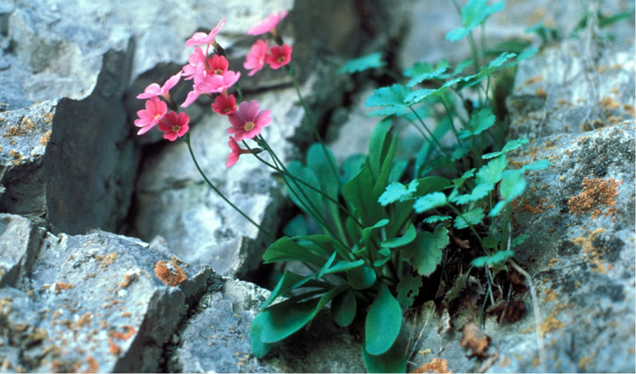 Maguire’s primrose (Primula cusickiana var. maguirei). Photo from USDA-FS

#### **Alternate Names**

Primula maguirei

#### **Uses**

There are no known uses associated with Maguire’s primrose.

#### **Status**

Maguire’s primrose has an estimated population size of about 3,000 individuals in six sites in Logan Canyon, Utah. The entire known habitat of Maguire’s primrose lies within Federal lands managed by the Logan Ranger District of the Wasatch-Cache National Forest. It was listed as a threatened species in 1985 (USDI-FWS, 1985). The species is highly vulnerable due to its restricted habitat and small population size. Its primary threats include habitat loss due to road construction and recreational activities.

Consult the PLANTS Web site and your State Department of Natural Resources for this plant’s current status (e.g., threatened or endangered species, state noxious status, and wetland indicator values).

#### **Description**

*General*: Primrose family (Primulaceae). Maguire’s primrose is a small, herbaceous, perennial forb. The leaves are clustered around the base of the plant and are oblanceolate to spatulate and range from 2 to 7 cm (1 to 3 in) long. They can be smooth edged or toothed and have glands on both sides. The flowers are born in a 1 to 3 flowered cluster on a naked stem reaching 15 cm (6 in) in height. Each plant can have 1 to several flower bearing stems. The flowers are rose to lavender in color with a yellow center (Welsh et al., 2003).

*Distribution*:

There are six known populations of Maguire’s primrose; all located in Logan Canyon, Cache County, Utah. For current distribution, consult the Plant Profile page for this species on the PLANTS Web site.

*Habitat*:

Maguire’s primrose is restricted to shallow dolomitic soils of the Laketown and Fish Haven geologic formations. It can be found in north facing exposures in cracks and crevices of cliff and boulder faces from 1,400 to 1,800 m (4,800 to 6,000 ft) elevation. It is always found in cool, moist microclimates. It can be found growing in association with pink alumroot (*Heuchera rubescens*), mat rockspirea (*Petrophytum caespitosum*)*,* tadpole buttercup (*Ranunculus ranunculinus)*, and narrowleaf wildparsley (*Musineon lineare*), surrounded by mountain shrub and coniferous forest plant communities.

#### **Adaptation**

Maguire’s primrose is found in cool, moist microclimates on dolomitic limestone derived soils. Mean annual precipitation in the canyon ranges from 18 to over 25 inches.

#### **Management**

The greatest threats to the continuing survival of Maguire’s primrose come from habitat loss as a result of highway construction and other activities (USDI-FWS, 1990). Maintenance and improvements of water pipelines through the canyon could also impact the species. Other threats include camping, rock climbing and horticultural plant collecting.

#### **Pests and Potential Problems**

There are no known pests or potential problems associated with Maguire’s primrose.

#### **Environmental Concerns**

There are no known environmental concerns associated with Maguire’s primrose.

#### **Seeds and Plant Production**

#### Limited efforts have been attempted to propagate and produce Maguire’s primrose. Past gardening attempts have been mostly unsuccessful.

#### **References**

USDI-FWS. 1985. Endangered and threatened wildlife and plants; final rule to determine primula maguirei (Maguire primrose) to be a threatened species. In: Federal Register. 50(162): 33731-33737.

USDI-FWS. 1990. Maguire primrose (Primula maguirei) recovery plan. USFWS, Denver, CO. 13 pp.

Welsh, S.L., N.D. Atwood, S. Goodrich, and L.C. Higgins. 2003. A Utah Flora. Third Edition, revised. Brigham Young University, Provo, UT.

#### **Prepared By**

*Derek Tilley*; USDA NRCS Plant Materials Center, Aberdeen, Idaho.

*Loren St. John*, USDA NRCS Plant Materials Center, Aberdeen, Idaho.

*Dan Ogle*, USDA NRCS State Office, Boise, Idaho.

#### **Citation**

Tilley, D., St. John, L. and D. Ogle. 2010. Plant guide for Maguire’s primrose (*Primula cusickiana* var*. maguirei*). USDA-Natural Resources Conservation Service, Idaho Plant Materials Center. Aberdeen, ID.

Published January, 2011

Edited: 20Dec2010djt; 20Dec2010lsj; 20Dec2010dgo

For more information about this and other plants, please contact your local NRCS field office or Conservation District at <http://www.nrcs.usda.gov/> and visit the PLANTS Web site at <http://plants.usda.gov/> or the Plant Materials Program Web site <http://plant-materials.nrcs.usda.gov>.

PLANTS is not responsible for the content or availability of other Web sites.

**USDA IS AN EQUAL OPPORTUNITY PROVIDER AND EMPLOYER**