

Plant Guide

# russian wildrye

## Psathyrostachys junceus (Fisch.) Nevski

Plant Symbol = PSJU3

*Contributed by*: USDA NRCS Idaho Plant Materials Program and USDA-ARS Forage and Range Research Laboratory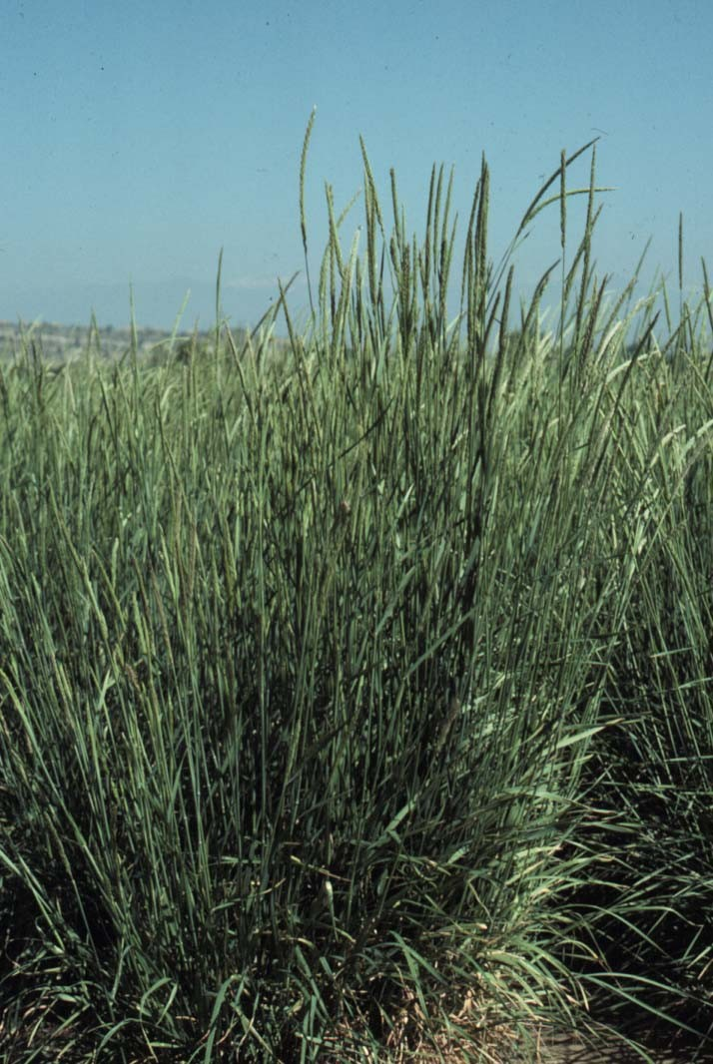

‘Bozoisky-Select’ Russian wildrye. Photo by Larry Holzworth.

### Alternate Names

*Scientific Alternate Names: Elymus junceus* (Fisch.), *Leymostachys korovinnii* Tzvelev

**Uses**

Russian wildrye is a long lived, introduced grass that has been widely used for pasture and rangeland seeding throughout the Rocky Mountains, Intermountain West and northern Great Plains of the United States because of its tolerance to drought, cold and saline soils. Russian wildrye provides good grazing in spring (May-June) and from late summer through late fall (September-December) but nutritional quality is optimum from late summer through late fall (Sedivec, et al., 2007). Russian wildrye is not well suited for hay production due to predominance of basal leaves which are difficult to pick up with harvesting equipment, but is tolerant to grazing and regrows quickly, lending itself for use as both dryland and irrigated pasture (Ogle, et al., 2011a). It is not the best choice for erosion control because stands gradually develop into widely spaced plants. It has good tolerance to salinity and is highly palatable to deer, elk, and antelope and is generally used by these animals in late summer through winter. Russian wildrye is also a good choice for use in green strips or vegetative fuel breaks because it stays green longer into the growing season than most other grasses in dry conditions and tends to exclude competition from other plants in established stands (St. John, et al., 2009)

### Status

Please consult the PLANTS Web site and your State Department of Natural Resources for this plant’s current status (e.g., threatened or endangered species, state noxious status, and wetland indicator values).

### Description

*General*: Grass Family (Poaceae). Russian wildrye is an introduced, cool season, perennial, densely tufted bunchgrass that grows 60-180 cm tall. The leaves are flat, 2-3 mm wide, 15-25 cm long and deeply grooved on both surfaces. The leaves are lax and mostly basal. The sheath is open, auricles rudimentary to 1 mm long. The ligule is membranous, 1-1.5 mm long and truncate. The spike is 3-11 cm long, disarticulating between the spikelets and is compact, cylindrical and the rachis is flattened. Spikelets are 8-10 mm long, usually 3 per node and 2 flowered. Glumes are 4-6.5 mm long, subequal and the lemmas 6.7-8.5 mm long, tapering to an awn that is 0.5-2 mm long (Majerus, 2009; Skinner, 2010). The roots may establish to depths of 6-8 feet. Approximately 75 percent of the roots are in the top 6-24 inches and horizontal spread can reach 4-5 feet allowing it to draw soil moisture within that space, making it an excellent competitor with weeds once Russian wildrye is established. Russian wildrye is predominantly diploid (2n=14), (Moser and Hoveland, 1996).

*Distribution*: Russian wildrye is native to the Russian and Mongolian steppes of central Asia (Barkworth, et al., 2007). For current distribution, please consult the Plant Profile page for this species on the PLANTS Web site.

*Habitat*: Russian wildrye has been successfully planted in pinyon-juniper, sagebrush, saltgrass meadow, blue grama grassland, salt desert shrub, mountain brush, northern shrub, tall grass and mixed prairie habitats in North America (Taylor, 2005).

**Adaptation**

Russian wildrye is well adapted to silt loam to heavy clay soil types but is most productive on fertile loam soils in areas receiving 8-16 inches annual precipitation (Ogle, et al., 2011). It grows poorly on soils with low fertility and can be difficult to establish. It grows on elevations ranging from 2,900 to 7,500 feet in northern latitudes and from 4,200 to 9,000 feet in southern latitudes (Taylor, 2005). It is exceptionally cold and drought tolerant and has good salinity tolerance (Sedevic, et al., 2007). It is not tolerant of spring flooding or high water tables.

### Establishment

Russian wildrye can be difficult to establish. It must be planted in a firm weed-free seedbed at ¼ inch depth or less. It is very sensitive to deeper seed placement. Seedlings are slow growing and weak and require more time to establish compared to many other introduced grass species. However, once established, Russian wildrye is very competitive. The recommended seeding rate is 6 pounds Pure Live Seed (PLS) per acre (Ogle, et al., 2011). For mixtures, adjust the seeding rate to percentage of the species desired in the mix. There are approximately 162,600 seeds per pound (PLANTS Database).

Because of its heavy root growth and strong competition for water and nutrients, Russian wildrye is often planted at wide row spacing; 18 inches or greater are recommended. Trials in the northern Great Plains indicate that 24 inch wide row spacing is optimal for forage production (Moser and Hoveland, 1996). Forage yields can be increased by seeding mixtures with legumes. Seeding the legume in alternate rows or cross-seeded rows decreases competition for the legume and optimizes forage quality and yield (Baldridge and Lohmiller eds., 1990).

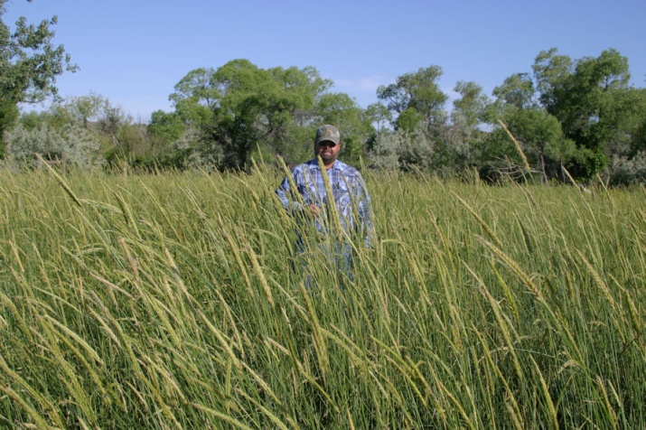

Two year old stand of ‘Bozoisky-Select’ Russian wildrye. Photo by Roger Hybner, Bridger, MT PMC.

### Management

Russian wildrye begins growth in the spring a little later than crested wheatgrass and should not be grazed as early. However, fall regrowth of Russian wildrye is better than crested wheatgrass.

Russian wildrye is very tolerant of grazing and regrows quickly after grazing. Although grazing can occur during any season, it is best to graze this grass lightly in the spring, if at all, and save most growth for late summer to fall or winter when other grasses are low in forage quality. Stands can be injured from extensive use by livestock and wildlife in early spring. Grazing should be carefully managed to avoid over-utilization (Ogle et al., 2009).

It remains palatable and of adequate nutritive quality for mature stock on winter maintenance rations. It is palatable to all classes of livestock and wildlife. It is high in protein and retains higher protein content than most grasses after maturity. Crude protein levels of 5 to 7 percent can be expected in late fall through winter (Sedivec et al., 2007). Because of its high palatability, competitiveness with other vegetation as well as itself, it is recommended for planting in pure stands and fenced for better utilization.

As a pasture grass, it recovers rapidly after grazing if soil moisture is available. Because of this characteristic, it has been used for irrigated pasture in rotational grazing systems. It also responds very well to applications of fertilizer and also to supplemental irrigation (Ogle, et al., 2011).

### Pests and Potential Problems

Grasshoppers and cutworms can attack Russian wildrye and it is susceptible to *Septoria* leaf spot diseases and head smut. It is relatively resistant to the bluegrass billbug and barley-yellow-dwarf virus (Taylor, 2005).

### Environmental Concerns

Russian wildrye is native to the Russian and Mongolian steppes of central Asia and was first grown in nurseries near Mandan, North Dakota in 1927. Because of erratic seed yields it did not come into common use until the 1950s. Since that time it has been widely used in western North America for seeding disturbed rangeland, forage production, and erosion control. It has not posed any environmental concerns. It is not considered weedy but could spread into adjoining degraded plant communities via seed under ideal conditions.

### Seed and Plant Production

Because Russian wildrye is extremely competitive once it is established, row spacing for seed production should be a minimum of 36 inches on irrigated fields to 48 inches on dryland (16 inches annual precipitation, minimum). The recommended seeding rate for 36 inch row spacing is 3.2 pounds PLS/ac and 2.0 pounds PLS/ac for 48 inch row spacing (Cornforth, et al., 2001). Seed should be planted to a depth of ¼ to ½ inch into a clean, weed-free and firm seedbed. Cultivation of the seed crop will be needed to control weeds and to maintain the row culture.

Fertilization of seed production fields is essential to maintain high yields of seed, especially following the first seed production year. Soil testing is recommended to ensure proper fertilization (Cornforth, et al., 2001). During establishment, apply 30 to 60 pounds actual Nitrogen (N) per acre (lower rate for dryland, higher rate for irrigated) and 50 to 80 pounds per acre on established stands.

Russian wildrye has a high rate of seed shatter and requires close scrutiny of maturing stands to determine optimum harvest date. Seed is generally harvested in late July and the preferred method of harvest is to swath the field when seed is in the hard dough stage prior to shatter. Allow 2-3 days curing time in the windrow and then combine using a pickup attachment. Direct combining can be an option but the field must be monitored closely and seed harvested when seed is mature and before seed shatter occurs. The seed should be dried to 12 percent moisture content if stored in bins and to 15 percent if stored in sacks. Average production of 100-200 pounds per acre can be expected under dryland conditions and 300-700 pounds per acre can be expected under irrigated conditions. Seed remains viable for at least ten years under good (cool and dry) seed storage conditions. Seed production declines as stands get older.

Crop residue from seed fields must be removed after each harvest to maintain plant health, plant vigor, and future seed yields. Seed fields are usually productive for at least 4 years with good management practices.

**Cultivars, Improved, and Selected Materials (and area of origin)**

Foundation and Registered seed is available through the appropriate state crop improvement associations or commercial sources to grow certified seed.

**‘Bozoisky-Select’** Russian wildrye was cooperatively released by the USDA-ARS at Logan, Utah in 1984 for improved seedling vigor, and increased forage yield. At eight semiarid test locations in Utah, Idaho and Wyoming it yielded 23 percent more forage that ‘Vinall’ during the first two production years and stand establishment was also superior to Vinall. It had better seedling vigor and larger seeds than Vinall or ‘Swift’ in laboratory trials (Asay et al., 1985).

**‘Bozoisky II’** was cooperatively released by the USDA-ARS at Logan, Utah in 2005. It was selected for improved seedling vigor (emergence from deep planting depth) seed mass, seed yield, vegetative vigor, total dry matter production, and response to drought. Bozoisky II has a much broader genetic base than other Russian wildrye cultivars and was extensively evaluated on rangeland sites in the western United States (Jensen, et al., 2006).

**‘Cabree’** Russian wildrye was selected by Agriculture Canada Research Station, Lethbridge, Alberta, Canada for its improved seed retention, resistance to powdery mildew, leaf rust and spot blotch. It was released in 1976 and is recommended for dryland pasture in the Canadian prairie region (Alderson and Sharp, 1994).

**‘Mankota’** Russian wildrye was selected by USDA ARS at Mandan, North Dakota for resistance to leaf spot and improved forage yields and was released in 1991. Its heading date is approximately two days later than other Russian wildrye cultivars and it produces large forage yields on optimal sites (Alderson and Sharp, 1994).

**‘Mayak’** Russian wildrye was selected by Agriculture Canada Research Station, Lethbridge, Alberta, Canada for its high forage and seed yields, good curing qualities, and resistance to leaf spot. It was released in 1971 and is recommended for dryland pasture in the Canadian prairie region (Alderson and Sharp, 1994).

**‘Swift’** Russian wildrye was selected by Agriculture Canada Research Station, Lethbridge, Alberta, Canada for better seedling emergence and good resistance to leaf spot. It was released in 1978 and is recommended for dryland pasture in the Canadian prairie region (Alderson and Sharp, 1994).

**‘Tetracan’** Russian wildrye, a colchicine induced tetraploid was developed at Agriculture Canada Research Station, Lethbridge, Alberta, Canada for its excellent seedling vigor, large seed size, and better seedling emergence from deeper seeding depths. It was released in 1988 and is recommended for dryland pasture in the Canadian prairie region (Moser and Hoveland, 1996; Alderson and Sharp, 1994).

**‘Vinall’** Russian wildrye was selected by USDA ARS at Mandan, North Dakota. It was the first released cultivar of Russian wildrye, released in 1960. It is no longer recommended but seed is available (Alderson and Sharp, 1994).

The Russian wildrye cultivars that have performed best in replicated plantings in the Northern Great Plains and Intermountain West (Idaho, Montana, Nevada, North Dakota, Wyoming, and Utah) are Bozoisky-Select, Bozoisky II, and Mankota.

**References**

Alderson, J., Sharp, W. 1994. Grass Varieties in the United States. Agriculture Handbook No. 170. United States Department of Agriculture Soil Conservation Service. Washington, D.C. 296p.

Asay, K., Dewey, D., Gomm, F., Johnson, D., Carlson, J. 1985. Registration of ‘Bozoisky-Select’ Russian Wildrye. Crop Sci. 25: 575-576.

Baldridge, D., Lohmiller, R. (eds). 1990. Montana Interagency Plant Materials Handbook. Montana State University, Extension Service. EB 69. Bozeman, MT. 337 p.

Barkworth, M., Anderton M., Capels, K., Long, S., Piep M., 2007. *Psathyrostachys.* In Manual of Grasses for North America. Utah State University Press, Logan, UT. 627 p.

Cornforth, B., St. John, L., Ogle, D. 2001. Seed Production Standards for Conservation Plants in the Intermountain West. Technical Note 14. USDA-Natural Resources Conservation Service. Boise, ID 15 p.

Jensen, K., Asay, K., Johnson, D., Larson, S., Waldron B. Palazzo, A. 2006. Registration of ‘Bozoisky II Russian Wildrye. Crop Sci. 46:986.

Majerus, M. 2009. Forage and Reclamation Grasses of the Northern Plains and Rocky Mountains. Valley Printers, Bridger, MT. 161 p.

Moser, L.E. and C.S. Hoveland. 1996. Wildryes p. 725-733 In: L. E. Moser, et al. (ed.) Cool Season Forage Grasses. Agron. Monogr. 34. ASA, CSA, and ASSA, Madison, WI.

Ogle, D., L. St. John, M. Stannard. 2009. Pasture Species Selection and Grazing Management Guidelines. Technical Note 11. USDA-Natural Resources Conservation Service. Boise, ID. 27 p.

Ogle, D., L. St. John, M. Stannard, L. Holzworth. 2011. Conservation Plant Materials for the Intermountain West. Technical Note 24. USDA-Natural Resources Conservation Service. Boise, ID. 57 p.

PLANTS Database, Online. Russian wildrye (*Psathyrostachys juncea*). http://plants.usda.gov (Accessed August 27, 2012)

Skinner, Q. 2010. A Field Guide to Wyoming Grasses. Education Resources Publishing, Cumming GA. 595 p.

Sedivec, K., Tober, D., Duckwitz, W., Dewald, D., Printz, J. 2007. Grasses for the Northern Plains. Volume 1 Cool Season. North Dakota State University Extension, Fargo, ND. 89 p.

St. John, L., Ogle, D. 2009. Green Strips or Vegetative Fuel Breaks. Technical Note 16. USDA-Natural Resources Conservation Service. Boise, ID. 16 p.

Taylor, J., 2005). *Psathyrostachys juncea*. In: Fire Effects Information System, [Online]. U.S. Department of Agriculture, Forest Service, Rocky Mountain Research Station, Fire Sciences Laboratory. http://www.fs.fed.us/database/feis. (Accessed August 28, 2012).

**Prepared By**:

Dan Ogle, USDA NRCS, Boise, ID

Loren St. John, USDA NRCS, Aberdeen, ID

Jim Cornwell, USDA NRCS, Boise, ID

Larry Holzworth, USDA NRCS, Bozeman, MT

Mark Majerus, USDA, NRCS, Bridger, MT

Dwight Tober, USDA NRCS, Bismarck, ND

Dr. Kevin B. Jensen, USDA-ARS, Forage and Range Research Laboratory, Utah State University, Logan, UT

Dr. Ken Sanders, University of Idaho, Twin Falls, ID

### Citation

Ogle, D., St. John, L., Cornwell, J., Holzworth, L., Majerus, M., Tober D., Jensen, K., Sanders, K. Ed. (rev) St. John, 2012. Plant Guide for Russian Wildrye (*Psathyrostachys junceus*). USDA-Natural Resources Conservation Service, Aberdeen Plant Materials Center. Aberdeen, Idaho 83210.

Published November, 2012

Edited: 28sept04dgo; 10sept04kbj; 13sept04ls; 20sept04ks; 21sept04jc; 22sept04lkh; 27sept04dt; 28sept04mm; 12oct04rln; 16feb05rln; 060803 jsp; 23Oct2012ls; 24Oct2012jab; 24Oct2012klj; 1Nov2012ls

For more information about this and other plants, please contact your local NRCS field office or Conservation District at <http://www.nrcs.usda.gov/> and visit the PLANTS Web site at <http://plants.usda.gov/> or the Plant Materials Program Web site <http://plant-materials.nrcs.usda.gov>.

PLANTS is not responsible for the content or availability of other Web sites.

**USDA IS AN EQUAL OPPORTUNITY PROVIDER AND EMPLOYER**