

Plant Guide

# dog rose

***Rosa canina* L.**

Plant Symbol = ROCA3

*Contributed by*: NRCS Plant Materials Center, Pullman, Washington

### Photo of Rosa canina plant by Robert Videki

*Rosa canina*. Robert Videki, Bugwood.org

### Alternate Names

*Common Alternate Names:* common briar, dog brier (USDA ARS, 2012)

## Scientific Alternate Names: Rosa corymbifera Borkh. (USDA NRCS, 2012), [Rosa bakeri](http://www.ars-grin.gov/cgi-bin/npgs/html/taxon.pl?70572) Déségl., [Rosa lutetiana](http://www.ars-grin.gov/cgi-bin/npgs/html/taxon.pl?5394) Léman, [Rosa montivaga](http://www.ars-grin.gov/cgi-bin/npgs/html/taxon.pl?32101) Déségl., (USDA ARS, 2012)

### Uses

*Ornamental: Rosa canina* is a Eurasian species planted in landscaped settings in the U.S. and Canada. It has escaped cultivated gardens and become problematic in natural areas.

*Ethnobotanical:* Dog rose has multiple medical uses dating back to Hippocrates in ancient Greek times (Haas, 1995). It was used in prescriptions, but its precise use is unknown. Pliny, the Roman naturalist, attributed the plant’s name to a belief that the root could cure the bite of a mad dog (Haas, 1995). During World War II, Britain was unable to import citrus fruits so the government encouraged the gathering of dog rose hips as a source of vitamin C (Haas 1995). Rose hip extracts are currently used in traditional European folk medicine as a diuretic, laxative, for kidney and lower urinary tract disorders, arthritis, gout, fever, colds and for vitamin C deficiency (Chrubasik et al., 2008). Research has proven several compounds in extracts in the hips of dog rose have antioxidant and anti-inflammatory properties (Lattanzio et al., 2011).

### Weediness

This plant is weedy and invasive in some regions or habitats and may displace desirable vegetation (Center for Invasive Species and Ecosystem Health, 2012). Consult with your local NRCS Field Office, Cooperative Extension Service office, state natural resource, or state agriculture department regarding its status. Weed information is also available from the PLANTS Web site at <http://plants.usda.gov/>. Please consult the Related Web Sites on the Plant Profile for this species for further information.

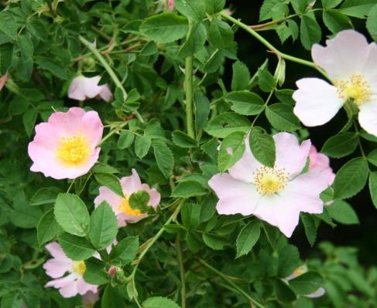

*Rosa canina* flowers.Robert Videki, Bugwood.org

### Description

*General*: Rose family (Rosaceae). *Rosa canina* is a shrub introduced from Eurasia. It grows up to 9 feet tall and has multiple arching stems. Stems are covered with thorns that are stout, flattened, downward-curving and unequal in size. Leaves are alternate and pinnately divided into 5 to 7 leaflets with serrated margins. Both sides of the leaves are glandless and smooth. Flowers are solitary or in small clusters at the ends of branches and bloom in June to July. Flowers have five white to pink petals 0.8 to 1 inch long, five sepals, usually 10 or more pistils, and multiple stamens. Sepals are glandless, often have slender lateral lobes, curve backward at the time of anthesis and are deciduous. Fruits ripen in September to October, are smooth, bright red and 0.6 to 0.8 inches long. Fruits persist on the plant for several months and become black. Plants reproduce sexually by seed, and vegetatively by suckering and layering. (Hitchcock and Cronquist 1973; Young and Young, 1992; Burke Museum of Natural History and Culture 2012).

*Distribution*: *Rosa canina* is found on the east coast of North America, from Quebec to North Carolina and west to Kansas. It is also found on the west coast, from British Columbia to California and east to Utah. For current distribution, please consult the Plant Profile page for this species on the PLANTS Web site.

*Habitat*: *Rosa canina* is found along roadsides, in pastures, Conservation Reserve Program fields, and natural areas.

**Adaptation**

This plant is adapted to low elevations.

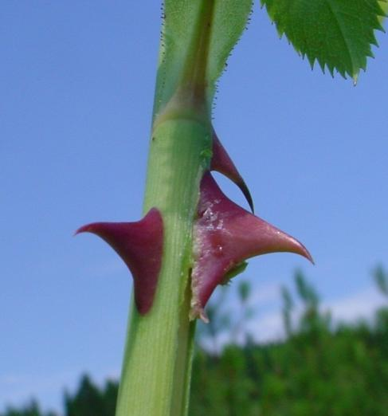

*Rosa canina* thorns. Richard Old, XIDservices.com

### Pests and Potential Problems

### Numerous galls are often found on *Rosa canina* stems. The galls are caused by a gall-forming wasp (*Diplolepis rosae*) which, like the plant, is a European species. The galls do not cause any harm, and are hosts for parasitoid wasps. The plantis susceptible to fungal diseases such as powdery mildew (*Sphaerotheca pannosa* var. *rosae*) and downy mildew (*Perenospora sparsa*).

### Environmental Concerns

Birds and other wildlife consume the hips of dog rose and spread the seed. Areas invaded with dog rose can become dominated by the plant, resulting in a decline in native plant species and other desirable vegetation. The forage value of pastures decreases rapidly following the invasion and spread of the plant. In addition, dog rose impedes the movement of livestock, wildlife and vehicles.

### Control

Dog rose is difficult to control due to its large size and regeneration from sprouts. Control often requires multiple years of treatment. Plants can be eliminated by extracting from the ground with an ATV or other vehicle in the spring, then spraying the sprouts that emerge with an herbicide. In areas where plants are numerous, mowing with a brush machine will facilitate herbicide application. Effective herbicides include glyphosate, picloram plus 2-4-D, and triclopyr ester.

Contact your local agricultural extension specialist or county weed specialist to learn what works best in your area and how to use it safely. Always read label and safety instructions for each control method. Trade names and control measures appear in this document only to provide specific information. USDA NRCS does not guarantee or warranty the products and control methods named, and other products may be equally effective.

### Seeds and Plant Production

### *Rosa canina* has 31,000 seeds per pound (Young and Young, 1992). The seed does not require a stratification period if it is fresh, however if it has a chance to dry, a stratification period is required to break dormancy (Young and Young, 1992).

### Cultivars, Improved, and Selected Materials (and area of origin)

This plant is sold by many garden nurseries. However, gardeners should consider its invasive nature before planting. Spread of its seed by birds and wildlife cannot be prevented unless the rose hips are removed soon after development. Several native rose species are available as alternatives that have similar aesthetic attributes and pose no threat to surrounding plant communities.

### References

**Burke Museum of Natural History and Culture. 2012. Available at http://biology.burke.washington.edu/herbarium/imagecollection.php (accessed 15 Oct 2012). University of Washington, Seattle, WA.**

Center for Invasive Species and Ecosystem Health. 2010. Available at http://www.invasive.org (accessed 29 Nov 2012). University of Georgia, Athens, GA.

Chrubasik, C., B.D. Roufogalis, U. Muller-Ladner, and S. Chrubasik. 2008. A systematic review on the *Rosa canina* effect and efficacy profiles. Phytother. Res. 22:725-733.

Hass, L.F. 1995. Dog rose (*Rosa canina*). J. Neurol. Neurosurg. Psychiatry 59:470.

Hitchcock, C.L. and A. Cronquist. 1973. Flora of the Pacific Northwest. University of Washington Press, Seattle and London.

Lattanzio, F., E. Greco, D. Carretta, R. Cervellati, P. Govoni and E. Speroni. 2011. *In vivo* anti-inflammatroy effect of *Rosa canina* L. extract. J. Ethnopharm. 137:880-885.

USDA ARS, National Genetic Resources Program,  
Germplasm Resources Information Network (GRIN). 2012. Available at http://www.ars-grin.gov/cgi-bin/npgs/html/taxon.pl?5309 (accessed 17 October 2012). National Germplasm Resources Laboratory, Beltsville, MD.

USDA NRCS. 2012. The PLANTS Database. Available at http://plants.usda.gov (accessed 5 October 2012). National Plant Data Team, Greensboro, NC.

Young, J.A. and C.G. Young. 1992. Seeds of Woody Plants of North America. Disocorides Press, Portland, OR.

**Prepared By**

*Pamela L.S. Pavek*, USDA NRCS Plant Materials Center, Pullman, Washington

### Citation

Pavek, P.L.S. 2012. Plant guide for dog rose (*Rosa canina* L.). USDA-Natural Resources Conservation Service, Pullman, WA.

Published November 2012

Edited: 29Nov2012 jab; 30Nov2012 gm; 30Nov2012 plsp

For more information about this and other plants, please contact your local NRCS field office or Conservation District at <http://www.nrcs.usda.gov/> and visit the PLANTS Web site at <http://plants.usda.gov/> or the Plant Materials Program Web site <http://plant-materials.nrcs.usda.gov>.

PLANTS is not responsible for the content or availability of other Web sites.

**USDA IS AN EQUAL OPPORTUNITY PROVIDER AND EMPLOYER**