

Plant Guide

# BaldHIP rose

## Rosa gymnocarpa Nutt.

Plant Symbol = ROGY

*Contributed by*: NRCS Plant Materials Center, Pullman, Washington

### Photo shows flower and leaves. Both are described in the text.

*Rosa gymnocarpa*. Ben Legler, University of Washington Burke Museum of Natural History and Culture

### Alternate Names

*Alternate Common Names:* wood rose, dwarf rose, little wild rose (Hitchcock and Cronquist, 1973; Burke Museum of Natural History and Culture, 2012)

*Alternate Scientific Names*: *Rosa apiculata* Greene, *Rosa dasypoda* Greene, *Rosa helleri* Greene, *Rosa leucopsis* Greene, *Rosa prionota* Greene (Hitchcock et al., 1969)

### Uses

*Wildlife:* Baldhip rose fruits remain on the plant throughout the winter, and are eaten by small mammals, birds and insects (Conrad, 1987 as cited by Reed, 1993). *Rosa* species are important browse for Rocky Mountain elk in summer, but the use is lower in fall and winter (Kufeld, 1973). White-tailed and mule deer browse baldhip rose, especially in burned areas (Keay and Peek, 1980).

*Livestock*: Livestock will browse baldhip rose plants, however browsing inhibits the spread of the plant, probably due to damage to the rhizomes from trampling (Zimmerman and Neuenschwander, 1984).

*Pollinators and Beneficial Insects:* The primary insect pollinators of roses are pollen-gathering bees (Mader et al., 2011). The open-faced flowers of native roses are more attractive to pollinators than ornamental varieties with double flowers (Mader et al., 2011).

*Ethnobotanical:* Baldhip rose was used for a variety of purposes by native people in the Pacific Northwest. The Okanagan-Colville and Thompson used the stems and branches to construct baby carriers and arrows. They made a decoction of the branches and leaves for a body and hair wash in sweat baths, as a wash for sore eyes, to soak fishing lines and nets for good luck, for hunters to remove human scent, and as a tea for protection from bad spirits, for general disposition, and a tonic. They also used a poultice of chewed leaves for treating bee stings, and smoked dried leaves with leaves from other plants. The rose hips were a minor source of food, and children played with them as beads. (Moerman, 2012). Interior Salish people also used dwarf rose for similar purposes (Parish et al., 1996).

Hips of all wild roses are high in vitamin C and are made into jams, jellies, syrups and teas.

### Status

Please consult the PLANTS Web site and your State Department of Natural Resources for this plant’s current status (e.g., threatened or endangered species, state noxious status, and wetland indicator values).

### Description

*General*: Rose family (Rosaceae). *Rosa gymnocarpa* is an erect to spreading, long-lived shrub native to the western U.S. and Canada. It grows 1 to 4 feet tall and has multiple slender stems that are covered with straight, weak prickles, or are sometimes unarmed. Leaves are alternate, deciduous, and odd-pinnate with 5 to 9 leaflets. The leaf stems and underside of the leaf midrib have stalked glands. Leaflets are elliptic to elliptic-ovate, and have doubly serrated margins with gland-tipped teeth, otherwise the leaflets are smooth. Flowers occur at the ends of branches, bloom in May through July, and are usually solitary and small. Petals are 0.4 to 0.6 inch long, are light to dark pink, and are broadly notched. Flowers have numerous stamens and pistils, and the styles are deciduous as the fruit matures. The pedicels and sepals have stalked glands, and the sepals are erect or ascending at anthesis, then deciduous. The fruit is a pear-shaped hypanthium (hip) 0.4 inches long. It is bright red when it is mature in August to September. The fruit contains several seeds that are angled achenes. The plant reproduces sexually by seed and vegetatively by sprouts, rhizomes and layering. (Hitchcock and Cronquist, 1973; Young and Young, 1992; Burke Museum of Natural History and Culture, 2012).

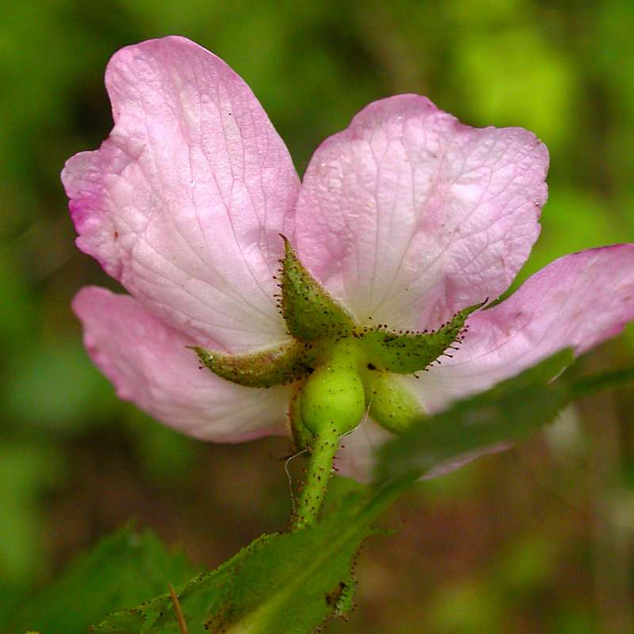

*Rosa gymnocarpa* pedicel and sepals. Ben Legler, University of Washington Burke Museum of Natural History and Culture

*Rosa* is a complex and variable genus which hybridizes freely with other native roses and sometimes exhibits polyploidy and/or apomixis (Hitchcock, et al., 1969). *Rosa gymnocarpa* occasionally hybridizes with *R. acicularis* (prickly rose) and *R. nutkana* (Nootka rose) (Hitchcock et al., 1969).

The genus name *Rosa* is an ancient Latin name for rose (St. John, 1963). The species name *gymnocarpa* is from Greek gymnos, "naked," and karpos, "fruit" (Charters, 2012), referring to the deciduous characteristic of the sepals (Parish et al., 1996).

*Distribution: Rosa gymnocarpa* is found in southern British Columbia, on both sides of the Cascade Mountains in Washington and Oregon, in the Sierra Nevada of California, in northern and central Idaho, and in western Montana. The genus is divided into two varieties: var. *gymnocarpa,* which grows throughout all of the species’ range, and var. *serpentina*, which grows only in California and Oregon. For current distribution, please consult the Plant Profile page for this species on the PLANTS Web site.

*Habitat*: *Rosa gymnocarpa* grows as an understory plant in dry and moist forest communities, including Douglas-fir (*Pseudotsuga menziesii*), ponderosa pine (*Pinus ponderosa*), western white pine (*Pinus monticola*), mountain hemlock (*Tsuga mertensiana*), Sitka spruce (*Picea sitchensis*), larch (*Larix* spp.), lodgepole pine (*Pinus contorta*), redwood (*Sequoia sempervirens*), sagebrush (*Artemisia* spp.), pinyon pine (*Pinus* spp.), and juniper (*Juniperus* spp.) (Burke Museum of Natural History and Culture, 2012; Reed, 1993). It also grows in chaparral and in mountain grasslands (Reed, 1993). It is often found in association with salal (*Gaultheria shallon*), oceanspray (*Holodiscus discolor*), Oregon grape (*Mahonia nervosa*), creeping Oregon grape (*Mahonia repens*), ninebark (*Physocarpus malvaceus*), big thimbleberry (*Rubus parviflorus*), and huckleberry (*Vaccinium membranaceum*) (Reed, 1993).

**Adaptation**

This plant is adapted to soils with medium texture, moderate fertility, and neutral pH (USDA NRCS, 2012). It can tolerate a moderate level of salinity. The shrub grows in areas receiving 12 to 24 inches of annual precipitation (USDA NRCS, 2012) at sea level to 6,000 feet elevation (Hitchcock et al., 1969). It often grows in shade (Piper 1989; and Hungerford, 1986 as cited by Reed, 1993). The plant is adapted to low and medium severity fires (Reed, 1993), and is moderately tolerant of drought (USDA NRCS, 2012).

### Establishment

### Freshly cleaned dwarf rose seed can be sown in the field by broadcasting or drilling ¼ to ¾ inch deep, and covering with firm soil and mulch (Young and Young, 1992). Dried seed needs a cold stratification period of 90 days for optimal germination.

### Pests and Potential Problems

None known

### Environmental Concerns

None

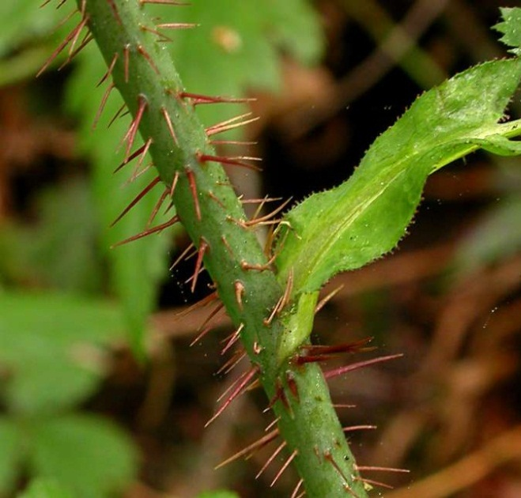

*Rosa gymnocarpa* thorns. Ben Legler, University of Washington Burke Museum of Natural History and Culture

### Seeds and Plant Production

*Rosa gymnocarpa* plants are sexually reproductive after 3 to 5 years of growth (Hungerford, 1957 as cited by Reed, 1993). Seed is obtained by collecting rose hips after they turn a bright red color (Gill and Pogge, 1974). The seeds can be removed from the hip flesh by macerating the hips in water and allowing the debris to float to the surface. Seeds collected soon after ripening and not allowed to dry are less dormant than dried seeds (Gill and Pogge, 1974; Young and Young, 1992). Dried seeds have a hard seed coat and require a cold moist stratification period of 90 days to improve germination (Mirov and Kraebel, 1939; Gill and Pogge, 1974; Piper, 1986; Meyer, 2008). Dried seeds stored in air-tight containers will remain viable for 2 to 4 years (Young and Young, 1992). There are about 28,000 seeds per pound (Young and Young 1992; USDA NRCS, 2012).

Plants can be produced by sowing seed into pots or flats in October or November, then moving into a greenhouse in January or February. Seedlings should be moved to a lath house or other structure in the spring and grown for one year to develop an adequate root system before transplanting.

Baldhip rosecan also be reproduced by cuttings or root suckers. Rose et al. (1998) states one successful method uses semi-hardwood cuttings treated with indole-3-butyric acid (IBA) grown in a mist chamber. All seedlings and propagated plants should be hardened off for two to four weeks prior to transplanting in desired field location.

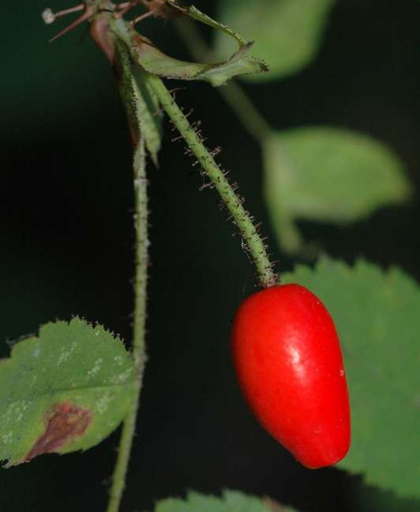

*Rosa gymnocarpa* fruit (hip). Ben Legler, University of Washington Burke Museum of Natural History and Culture

### Cultivars, Improved, and Selected Materials (and area of origin)

None, but seeds and seedlings are commercially available.

### References

**Burke Museum of Natural History and Culture. 2012. Available at http://biology.burke.washington.edu/herbarium/imagecollection.php (accessed 15 Nov 2012). University of Washington, Seattle, WA.**

Charters, M.L. 2012. California Plant Names: Latin and Greek Meanings and Derivations. Available at http://www.calflora.net/botanicalnames/ (accessed 27 Nov 2012) Michael L. Charters, Sierra Madre, CA.

Gill, J.D. and F.L. Pogge. 1974. *Rosa* L. Rose. In: Seeds of Woody Plants of the United States. Agriculture Handbook No. 450. USDA Forest Service, Washington, D.C.

Hitchcock, C.L., A. Cronquist, M. Ownbey, and J.W. Thompson. 1969. Vascular Plants of the Pacific Northwest. University of Washington Press, Seattle and London.

Hitchcock, C.L. and A. Cronquist. 1973. Flora of the Pacific Northwest. University of Washington Press, Seattle and London.

Keay, J.A. and J.M. Peek. 1980. Relationships between fires and winter habitat of deer in Idaho. J. of Wildlife Mgmt. 44(2): 372-380.

Kufeld, R. 1973. Foods eaten by the Rocky Mountain elk. J. of Range Mgmt. 26:106-113.

Mader, E., M. Shepherd., M. Vaughan, S.H. Black, and G. LeBuhn. 2011. Attracting Native Pollinators. The Xerces Society. Storey Publishing, North Adams, MA.

Meyer, Susan E. 2008. *Rosa* L. rose, briar. In: Woody Plant Seed Manual. USDA Forest Service Agriculture Handbook No. 727. Bonner, F.T., and R.G. Nisley (eds.). Available at http://www.nsl.fs.fed.us/wpsm/ (accessed 4 Dec 2012). USDA Forest Service, Provo, UT.

Mirov, N.T., and C.J. Kraebel. 1939. Collecting and Handling Seeds of Wild Plants. Civilian Conservation Corps Forestry Publ. No.5. US Government Printing Office. Washington, DC.

Moerman, D. 2012. Native American Ethnobotany Database. Available at http://herb.umd.umich.edu/

(accessed 27 Nov 2012) University of Michigan-Dearborn, Dearborn, MI.

Parish, R., R. Coupe, and D. Lloyd (eds.) 1996. Plants of Southern Interior British Columbia and the Inland Northwest. Lone Pine Publishing, Vancouver, BC.

Piper, J.K. 1989. Seasonality of Fruit Characteristics and Seed Removal by Birds. Oikos 46:303-310.

Reed, W.R. 1993. *Rosa gymnocarpa*. In: Fire Effects Information System, [Online]. U.S. Department of Agriculture, Forest Service, Rocky Mountain Research Station, Fire Sciences Laboratory. Available: http://www.fs.fed.us/database/feis/ [15 Nov 2012].

Rose, R., C.E.C. Chachulski, and D.L. Haase. 1998. Propagation of Pacific Northwest Native Plants. Oregon State University Press, Corvallis, OR.

St. John, H. 1963. Flora of Southeastern Washington and of Adjacent Idaho (3rd ed.). Outdoor Pictures, Escondido, CA.

USDA NRCS. 2012. The PLANTS Database (http://plants.usda.gov, 15 Nov 2012). National Plant Data Team, Greensboro, NC.

Young, J.A. and C.G. Young. 1992. Seeds of Woody Plants of North America. Dioscorides Press, Portland, OR.

Zimmerman, G.T., and L.F. Neuenschwander. 1984. Livestock grazing influences on community structure, fire intensity, and fire frequency within the Douglas-fir/ninebark habitat type. J. of Range Mgmt. 37(2):104-110.

**Prepared By**

*Pamela L.S. Pavek*, USDA NRCS Plant Materials Center, Pullman, Washington

*David M. Skinner,* USDA NRCS Plant Materials Center, Pullman, Washington (*retired*)

### Citation

Pavek, P.L.S. and D.M. Skinner. 2013. Plant guide for baldhip rose (*Rosa gymnocarpa* Nutt.). USDA Natural Resources Conservation Service, Pullman, WA.

Published March 2013

Edited: 6Dec2012 dms; 26Feb2013 jab; 1Mar2013 plsp

For more information about this and other plants, please contact your local NRCS field office or Conservation District at <http://www.nrcs.usda.gov/> and visit the PLANTS Web site at <http://plants.usda.gov/> or the Plant Materials Program Web site <http://plant-materials.nrcs.usda.gov>.

PLANTS is not responsible for the content or availability of other Web sites.

**USDA IS AN EQUAL OPPORTUNITY PROVIDER AND EMPLOYER**