

Plant Guide

# SWEETBRIAR ROSE

## Rosa rubiginosa L.

Plant Symbol = RORU82

*Contributed by*: NRCS Plant Materials Center, Pullman, Washington

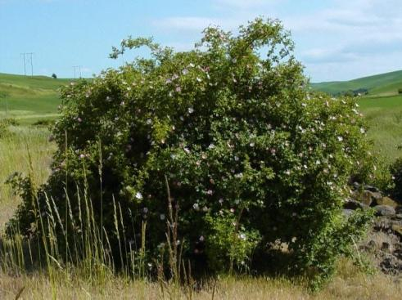

*Rosa rubiginosa*. Richard Old, XIDservices.com

**Alternate Names**

*Common Alternate Names*:eglantine rose (USDA ARS, 2012)

*Scientific Alternate Names*:Rosa eglanteria L. (USDA ARS, 2012)

### Uses

*Rosa rubiginosa* is valued by gardeners for its sweet, apple-like fragrance. It is often misidentified as a desirable species in natural areas and mistakenly planted for wildlife habitat. This rose can be very aggressive and dominate an area within a few years. It should not be planted in a home landscape, for wildlife habitat, or for any other use.

### Weediness

This plant is weedy and invasive in some regions or habitats and may displace desirable vegetation (Center for Invasive Species and Ecosystem Health, 2012). Consult with your local NRCS Field Office, Cooperative Extension Service office, state natural resource, or state agriculture department regarding its status. Weed information is also available from the PLANTS Web site at <http://plants.usda.gov/>. Please consult the Related Web Sites on the Plant Profile for this species for further information.

### Description

*General*: Rose family (Rosaceae). *Rosa rubiginosa* is a shrub introduced from Europe. It grows up to 10 feet tall and has multiple arching stems. Stems have thorns that are stout, flattened, downward-curving and unequal in size. Leaves are alternate and pinnately divided into 5 to 7 leaflets with doubly serrated margins and gland-tipped teeth. The undersides of leaves have hairs and stalked glands that impart a sweet aroma when crushed. Flowers are solitary or in small clusters at the ends of branches and bloom in June to July. Flowers have five pale to dark pink petals 0.6 to 0.8 inches long, five sepals, usually 10 or more pistils, and multiple stamens. Sepals have slender lateral lobes and stalked glands, curve backward at the time of anthesis and are deciduous. Fruits ripen in September to October, are smooth, bright red, 0.4 to 0.6 inches long, and persist on the plant after ripening. Plants reproduce sexually by seed and vegetatively by layering and suckering (Hitchcock and Cronquist 1973; Young and Young, 1992; Burke Museum of Natural History and Culture 2012).

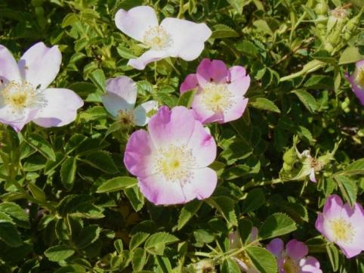

*Rosa rubiginosa* flowers. Richard Old, XIDservices.com

*Distribution*: *Rosa rubiginosa* grows in most states and provinces throughout the US and Canada. For current distribution, consult the Plant Profile page for this species on the PLANTS Web site.

*Habitat*: This plant is found along roadsides, in pastures, Conservation Reserve Program fields, and natural areas.

**Adaptation**

Sweetbriar rose is adapted to all soil types with moderate fertility, and can tolerate moderate saline conditions (USDA NRCS, 2012). It requires 18 to 45 inches of annual precipitation. It is not shade tolerant (USDA NRCS, 2012).

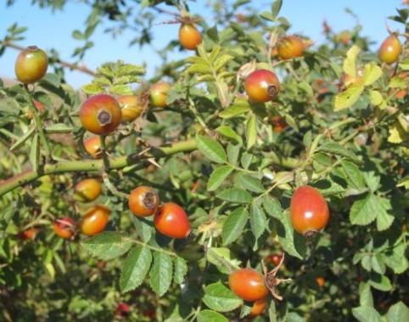

Fruit (rose hips) of *Rosa rubiginosa*. Pamela Pavek

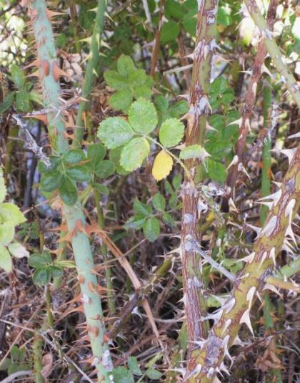

Thorns on lower stems of *Rosa rubiginosa*. Pamela Pavek

### Pests and Potential Problems

### Numerous galls are often found on *Rosa rubiginosa* stems. The galls are caused by a gall-forming wasp (*Diplolepis rosae*) which, like the plant, is a European species. The galls do not cause any harm, and are hosts for parasitoid wasps. The plantis susceptible to fungal diseases such as powdery mildew (*Sphaerotheca pannosa* var. *rosae*) and downy mildew (*Perenospora sparsa*).

### Environmental Concerns

Birds and other wildlife eat the hips of sweetbriar rose and spread the seed. Areas invaded with sweetbriar rose can become dominated by the plant, resulting in a decline in native plant species and other desirable vegetation. The forage value of pastures with sweetbriar rose decreases rapidly following the invasion and spread of the plant. In addition, sweetbriar rose impedes the movement of livestock, wildlife and vehicles.

### Control

Sweetbriar rose is difficult to control due to its large size and regeneration from sprouts. Control often requires multiple years of treatment. Plants can be eliminated by extracting from the ground with an ATV or other vehicle in the spring, then spraying the sprouts that emerge with an herbicide. In areas where plants are numerous, mowing with a brush machine will facilitate herbicide application. Effective herbicides include glyphosate, picloram plus 2-4-D, and triclopyr ester (Peachey, 2012).

Contact your local agricultural extension specialist or county weed specialist to learn what works best in your area and how to use it safely. Always read label and safety instructions for each control method. Trade names and control measures appear in this document only to provide specific information. USDA NRCS does not guarantee or warranty the products and control methods named, and other products may be equally effective.

### Seeds and Plant Production

*Rosa rubiginosa* has 31,000 seeds per pound (USDA NRCS, 2012). The seed does not require a stratification period if it is fresh, however if it has a chance to dry, a stratification period is required to break dormancy (Young and Young, 1992).

### Cultivars, Improved, and Selected Materials (and area of origin)

This plant is sold by garden nurseries and numerous cultivars are available. However, gardeners should consider its invasive nature before planting. Spread of its seed by birds and wildlife cannot be prevented unless the rose hips are removed soon after development. Several native rose species are available as alternatives that have similar aesthetic attributes and pose no threat to surrounding plant communities.

### References

**Burke Museum of Natural History and Culture. 2012. Available at ttp://biology.burke.washington.edu/herbarium/imagecollection.php (accessed 3 Oct 2012). University of Washington, Seattle, WA.**

Center for Invasive Species and Ecosystem Health. 2010. Available at http://www.invasive.org (accessed 29 Nov 2012). University of Georgia, Athens, GA.

Hitchcock, C.L. and A. Cronquist. 1973. Flora of the Pacific Northwest. University of Washington Press, Seattle and London.

Peachey, E. (ed.) 2012. Northwest Weed Management Handbook. Available at http://pnwhandbooks.org/weed/ (accessed 3 Oct 2012). Oregon State University, Corvallis, OR.

USDA ARS, National Genetic Resources Program,  
Germplasm Resources Information Network (GRIN). 2012. Available at http://www.ars-grin.gov/cgi-bin/npgs/html/taxon.pl?5337 (accessed 5 October 2012). National Germplasm Resources Laboratory, Beltsville, MD.

USDA NRCS. 2012. The PLANTS Database. Available at http://plants.usda.gov (accessed 5 October 2012). National Plant Data Team, Greensboro, NC.

Young, J.A. and C.G. Young. 1992. Seeds of Woody Plants of North America. Disocorides Press, Portland, OR.

**Prepared By**

*Pamela L.S. Pavek*, USDA NRCS Plant Materials Center, Pullman, Washington

### Citation

Pavek, P.L.S. 2012. Plant guide for sweetbriar rose (*Rosa rubiginosa* L.). USDA-Natural Resources Conservation Service, Pullman, WA.

Published December 2012

Edited: 29Nov2012 jab; 30 Nov 2012 gm; 30Nov2012 plsp

For more information about this and other plants, please contact your local NRCS field office or Conservation District at <http://www.nrcs.usda.gov/> and visit the PLANTS Web site at <http://plants.usda.gov/> or the Plant Materials Program Web site <http://plant-materials.nrcs.usda.gov>.

PLANTS is not responsible for the content or availability of other Web sites.

**USDA IS AN EQUAL OPPORTUNITY PROVIDER AND EMPLOYER**