

Plant Guide

Black willow

*Salix nigra* Marsh.

Plant Symbol = SANI

Contributed by: USDA NRCS Plant Materials Center, Manhattan, Kansas & Kansas State University, Forestry Research

*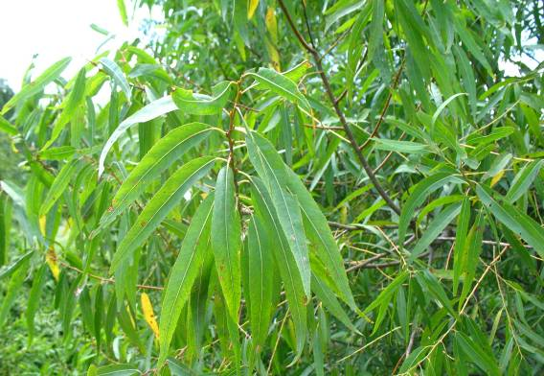 Photos Courtesy of Philip Barbour, Wildlife Biologist, USDA NRCS, Madison, Mississippi*

Alternate Names

American, Brittle, Champlain, Dudley, Gooding, gulf black, puzzle, rough American, scythe-leaf, scythe-leaved, southwestern black, swamp, tall black, Texas black, and western black willow; sauce, saule, saule noir, sauz (Espanol), swamp walnut**,** weide, wilg, willow, and willow catkins

The name willow derives from the Old English *wilwe.* The botanical name *Salix* was the name given by the ancient Romans.

**Uses**

*Conservation:*  One of the greatest services of the willows is as a soil-binder. Growing along the banks of countless streams, their fibrous roots help to prevent the soil from being washed away. Willow has been planted frequently to help stabilize the banks of eroding streams, to hold the soil in road cuts and embankments, and to bind shifting sands. Black willows dense root system is excellent for stabilizing eroding lands (Pitcher and McKnight, 1990).

*Ethnobotanic:* The ancient Greeks knew the therapeutic values of willow. Tea made from willow bark was used for stiff joints and rheumatic pains.

By the 1840’s, chemists had isolated salicylic acid from willow and found it produced marked antipyretic (fever-reducing) and analgesic (pain-killing) effects and “striking relief of acute articular rheumatism.” Modern aspirin (acetylsalicylic acid) is a synthetic product. Salicylic acid got its name from Salix (Randall, 1969).

Aboriginal peoples of North America used various plant parts of black willow for uses such as drugs to treat aliments, fiber for basketry and other uses.

Drug Uses – “The medicinal part of the plant is the inner bark and was used as a pain reliever for a variety of ailments (arnatural.org, 2010).” Antiperiodic: a medicine preventing the recurrence of periodic disturbances and irregularities. Anti-rheumatics: medicines correcting and relieving rheumatism. Antiseptics: agents preventing or countering decay, or the formation of pus. Astringents: agents producing contractions of organic tissues, or the arrest of a discharge. (Meridian Institute, 2010). Analgesic: Infusion of roots taken by the Koasati for headaches (Taylor, 1940). Antidiarrheal:An infusion of bark used by the Cherokee to check the bowels (Hamel and Chiltoskey, 1975); Blood Medicine: a decoction of roots and bark taken by the Houma for “feebleness” due to thin blood (Speck, 1941). Carminative: A compound decoction taken for stomach gas by the Iroquois (Herrick, 1977). Cough Medicine: A compound decoction was taken by the Iroquois for coughs (Herrick, 1977). Dermatological Aid: The Cherokee used a decoction or infusion of bark as a wash to make the hair grow; and the bark was also used as a poultice (Hamel and Chiltoskey, 1975); The Micmac made a poultice of bruised leaves used on sprains and bruises; also a poultice of scraped root and spirits was applied to bruises and sprains (Speck, 1917). Febrifuge: An infusion taken by the Cherokee for fever (Hamel and Chiltoskey, 1975); the Houma made a decoction of roots and bark was taken for fever (Speck, 1941); Cold infusion of roots was taken for fevers by the Koasati (Taylor, 1940). Gastrointestinal Aid: decoction of roots taken by the Koasati for dyspepsia (Taylor, 1940). Orthopedic Aid: the Micmac applied a poultice of bruised leaves to use on sprains and bruises; also a poultice of scraped root and spirits was applied to sprains and broken bones (Speck, 1917). Respiratory Aid: the root was chewed by Cherokee ball players “for wind” (Hamel and Chiltoskey, 1975). Throat Aid: infusion of inner bark taken for lost voice and root chewed for hoarseness by the Cherokee (Hamel and Chiltoskey, 1975) and used by the Iroquois for mouth and throat abscesses (Herrick, 1977). Tonic: the bark was also used as a tonic by the Cherokee (Hamel and Chiltoskey, 1975).

Basketry and Weaving – The Papago split twigs in half lengthwise, sun dried and used as a foundation in coiled basketry and used for sewing coiled basketry; also used for curved structures in wrapped weaving (Castetter and Underhill, 1935).

Dyeing Agent – A dye made from willow bark has good wash fastness and fair light fastness. The bark also contains a natural catechol tanning agent used to prepare leather for tanning (Cameo.mfg.org, 2010). The Patowatomi made a scarlet colored dye from the willows roots (Active Concepts, 2010). The roots are also used to make a yellow dye for dyeing porcupine quills (Prindle, 2010).

Other – Rodent proof granaries (Anonymous No. 3, 2008).

*Industry:* Most black willow lumber goes into shipping boxes, baskets, and other containers, and into furniture (especially kitchen cabinets) and caskets. The lumber is sometimes used in building construction for roof and wall sheathing, and sub-flooring. It has been used for making charcoal, slack cooperage, veneer, cutting boards, woodenware, sash, doors, and other millwork, and for paper pulp. It is used sometimes as a core in hardwood plywood (Panshin and deZeeuw, 1980; Anonymous No. 1, 2008).

*Wood characteristics:* The wood is of moderately light to light density (specific gravity approximately 0.34 green, .42 oven dry), moderately soft. It does not splinter easily, which makes excellent wood for toys, crates, and barn floors. When properly seasoned, it warps very little. The heartwood is grayish-brown or reddish-brown color, often with darker streaks along the grain. Sapwood is whitish or creamy yellow (Panshin and deZeeuw, 1980). The wood is uniformly textured, grain somewhat interlocking, and has no characteristic odor or taste (Anonymous No. 4, 2008).

*Ornamental:* Black willow can be planted as an ornamental where a fine-textured shade tree is desired. It will tolerate dry soils with reduced vigor (Ohio Trees, 2008).

*Wildlife:* The willows are among the first plants to provide honey bees, after long winters, with nectar and pollen. Domestic grazing animals browse in willow thickets. Elk and beaver browse on willow leaves in the summer and willow twigs in the winter. Willow shoots are common food of beaver, hares, and rabbits. Black willow and other willows are host plants for Viceroy and red-spotted purple butterflies (Anonymous No. 2, 2008)

Status

Please consult the PLANTS Web site and your State Department of Natural Resources for this plant’s current status (e.g. threatened or endangered species, state noxious status, and wetland indicator values).

Description

*General:* About 90 species of *Salix* are native to North America, but only 27 of them attain tree size, of which, black willow is the most abundant. Most of the commercial willow timber is produced by *S. nigra* (Pitcher and McKnight, 1990)*.* A member of the Willow Family (Salicaceae), black willow is a small to medium-sized tree 30 to 60 ft high and about 14 inches in diameter (max. 140 by 9 ft) with a broad, irregular crown and a superficial root system (Dirr, 1977). The leaves are simple, alternate, deciduous; narrow, lance-shaped, with tapered tip, rounded base, 5-13 cm long, 8-12 mm wide; finely toothed margin; blade yellow-green on both sides with a few small hairs on the lower surface; petiole slender, 6-10 mm long. The bark is dark gray-brown to nearly blackish, divided into deep fissures separating thick, interlacing, sometimes scaly ridges (Harlow *et al.*, 1979). Black willow is named for its dark gray-brown bark (Nix, 2010).

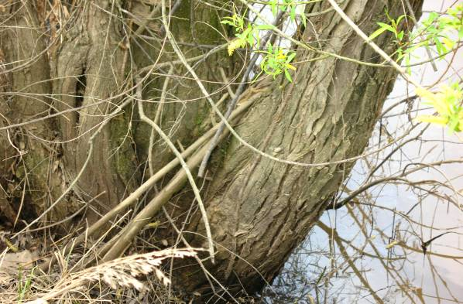 Black willow bark

Twigs are light-red, slender, and flexible. Buds narrow, conical, orange-brown; leaf scars narrow, crescent shaped; broad, flat, often shaggy ridges; pith pale brown, small. Flowers of black willow: male and female catkins on separate trees. Catkins are 4-5 cm long, on ends of leafy shoots, many small, yellow-green flowers without petals (Stephens, 1969).

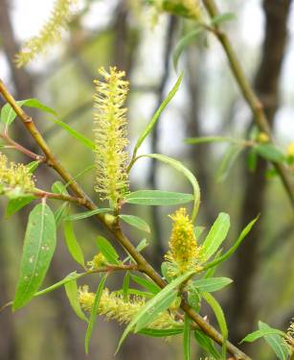

Black Willow Catkins

The biggest tree, a champion black willow, according to The American Forestry Association’s Hall of Fame for Trees was in Traverse City, Michigan, with a circumference at breast height of 7.9 m (26 ft-1 in), a height of 25.9 m (85 ft), and a spread of 24.1 m (79 ft) (American Forests, 2008). The estimated life span for black willow averages 65 years with a range of 40 to 100 years (Stringer, 2006).

*Flowering and Fruiting:* Black willow flowers between February and April in the southern part of its range and as late as May or June in the northern part. Flowers usually appear with the leaves. The trees begin to bear fruit at about 10 years of age; however, optimum seed-bearing age ranges from 25 to 75 years. The mature seeds fall between April and July (Fowells, 1965).

*Distribution*: Black willow ranges from New Brunswick to Manitoba, south to Florida and Texas (Steyermark, 1963). For current distribution, please consult the Plant Profile page for this species on the PLANTS Web site.

*Habitat*: This species is usually found on moist or wet soils along banks of streams, lakes, swamps around farm ponds, and pasture sloughs (Stephens, 1969).

Adaptation

Black willow ranges over most of the eastern half of the United States and attains tree size throughout the greater part of its range, commercial production of its lumber occurs mainly in the alluvial bottomlands of the lower Mississippi River. The species grows best where the average annual rainfall is 51 inches, of which 20 inches falls during the growing season, April through August. The willow survives temperature extremes of 115ºF to -50ºF in parts of its range. Typically, the average maximum is 93ºF in summer and 60ºF in winter (Fowells, 1965).

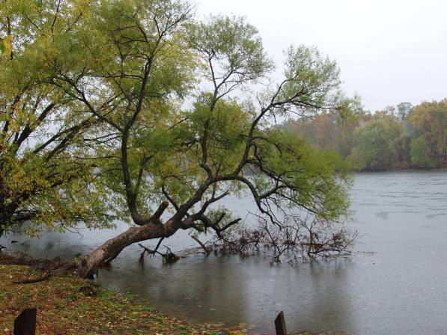

*Photo Courtesy of Chris Hoag, Wetland Plant Ecologist, USDA NRCS, Aberdeen Plant Materials Center*

Establishment

Black willow is easily established from cuttings. Stringent requirements of seed germination and seedling establishment limit black willow to wet soils, especially flood plains where it grows in pure stands near water courses (Pitcher and McKnight, 1990).

Management

Stands of black willow can stagnate if not properly thinned. A light thinning to remove understory trees should occur early and frequently to forestall stagnation and mortality. Avoid over thinning as open stands are subject to heavy windthrow and stem breakage. A proper thinning should leave a stand of about 65-75 square feet of basal area per acre (Fowells, 1965).

Pests and Potential Problems

A number of insect species attack black willow but few cause serious damage. Forest tent capterpillar (*Malacosoma disstria*), gypsy moth (*Lymantria dispar*), cotton wood leaf beetle (*Chrysomela scripta*), willow sawfly (*Nematus ventralis*), and the imported willow leaf beetle (*Plagiodera* *versicolora*) sometimes partially, occasionally completely, defoliate willow trees, reducing growth but seldom killing. Stem borers, such as the cottonwood borer (*Plectrodera scalator*) attack willows and may kill by girdling the base. Twig borers such as the willow-branch borer (*Oberea ferruginea*), feed on the branches and cause deformities that may be undesirable in ornamentals (Pitcher and McKnight, 1990).

A number of diseases plaguing willows are transmitted by insects. Willow blight, *Pollaccia* *saliciperda*, is transmitted by borers of which Salix species are the only known hosts (Pitcher and McKnight, 1990). Symptoms are dead leaves and shoots due to fungal infection with striking black spots on the leaves shoot tips blackened and shaped like hooks. The damage can be so extensive that entire tree appears to have been denuded by feeding insects (Stihl, 2010). *Phytophthora cactorum* causes bleeding canker, lesions on the lower trunk that discharge a dark-colored, often slimy liquid. Confined to the phloem and cambium area, it can result in death if the canker girdles the trunk. *Cytospora chrysosperma* causes canker in poplar and willow. Under forest conditions, cytospora canker is of little consequence but when trees become weakened by drought, competition, or neglect, losses can be heavy. In nursery beds, losses of up to 75 percent of cuttings have been reported. Leaf rust caused by *Melampsora* spp. iscommon on seedlings throughout the range of black willow. Mistletoes (*Phoradendron* spp*.*)damage and deform but seldom kill willows (Pitcher and McKnight, 1990).

Droughts that lower the water table can cause serious mortality where willow tends to be shallow-rooted as on clay-capped alluvial soils (Fowells, 1965).

Environmental Concerns

None known

Seeds and Plant Production

Good seed crops occur almost every year with only a few interspersed poor crop years. Failures resulting from late freezes after the flower buds have begun to open are rare. Large volumes of seed are produced with an average of 2 to 3 million per pound. The seeds are widely disseminated by wind and water. When the seeds fall, the long silky hairs act as wings to carry the seed very long distances (Fowells, 1965).

Willow seed must be collected as soon as it ripens and sown immediately. Stem cuttings are highly desirable to propagate trees (Brinkman, 1974).

**Fire Effects**

Although fires are rare in the bottomland areas where black willow grows, black willow is very susceptible to fire. Hot fires can kill entire stands of willows. Slow, light fires can seriously wound willows, allowing wood rooting fungi to enter. Young seedlings and saplings will be destroyed by fire. Black willow will sprout at the base following fire (Tesky, 1992; Pitcher and McKnight, 1990).

**Cultivars, Improved, and Selected Materials** **(and area of origin)** ‘Webb’ compact willow is a “strikingly different vase-shaped form of black willow. It forms a small, dense tree. This unusual form occurred as a single tree on the farm of Mr. Charles Webb in Madison County, Florida” (Woodlanders, 2008).

Contact your local Natural Resources Conservation Service (formerly Soil Conservation Service) office for more information. Look in the phone book under “United States Government.” The Natural Resources Conservation Service will be listed under the subheading “Department of Agriculture.”

**Control**

Please contact your local agricultural extension specialist or county weed specialist to learn what works best in your area and how to use it safely. Always read label and safety instructions for each control method. Trade names and control measures appear in this document only to provide specific information. USDA, NRCS does not guarantee or warranty the products and control methods named, and other products may be equally effective.

**References**

Active Concepts. 2010. ABS Willow Bark Extract. Technical Data Sheet. http://www.in- cosmetics.com/ExhibitorLibrary/830/ABS_Willow_ Bark_Extract_Powder-Technical_Data_Sheet- v5_3.pdf [online: cited 25 Feb 2010].

arnatural.org. 2010. Willow-Nature’s Aspirin. Univ. of Arkansas, Div. of Agriculture, Co-op Ext. Serv. http://www.arnatural.org/Wildfoods/Uses_Trees.htm

[online: cited 25 Feb 2010].

Anonymous No. 1. 2008. Black willow wood properties by Connected Lines. http://www.connectedlines.com/wood/wood15.htm [online: cited 23 May 2008].

Anonymous No. 2. 2008. http://www.butterflygardeningandconservation.com/p lant/host/s-nigra.php [online: cited 17 November 2008].

Anonymous No. 3. 2008. Southern California Culture

http://www.fourdir.com/southern_california_culture. htm[online: cited 9 Dec 2008].

Anonymous No. 4. 2008. http://www.exotichardwoods- northamerica.com/willow.htm [online: cited 17 November 2008].

American Forests, National Tree Register of Big Trees: *Salix nigra*. http://americanforests.org/resources/bigtrees/register. php?details=623 [online: cited 23 May 2008].

Brinkman, K. A. 1974. *In* Schopmeyer, C.S. Tech. Cord. *Seeds of woody plants in the United States*. USDA- FS Agriculture Handbook No. 450. Washington, DC.

Cameo.mfg.org. 2010. Material Name: willow bark. http://cameo.mfa.org/browse/popup_print_material.as p?materialid=10102&type=all

[online: cited 25 Feb 2010].

Castetter, E. F. and R. M. Underhill. 1935. Ethnobiological Studies in American Southwest II. The Ethnobiology of the Papago Indians. Univ. of New Mexico Bull. 4(3): 1-84.

Dirr, M. A. 1977**.** *Manual of Woody Landscape Plants: Their Identification, Ornamental Characteristics, Culture, Progation and Uses*. Stipes Publishing Co., Champaign, Ill.

Fowells, H. A. 1965. *Silvics of Forest Trees of the United States.* Agriculture Handbook No. 271. USDA Forest Service, Washington, DC.

Hamel, P. B. and M. U. Chiltoskey. 1975. *Cherokee Plants and Their Uses – A 400 Year History*. Herald Publ. Co., Sylva, N.C.

Harlow, W. H., E. S. Harrar, and F. M. White. 1979. p. 224-225. *In* *Textbook of Dendrology.* Sixth Edition. McGraw-Hill Book Co., New York.

Herrick, J. W. 1977. Iroquois Medical Botany. State Univ. of New York, Albany, PhD Thesis.

Mausert, O. 1932. *Herbs for Heath*. www.meridianinstitute.com/echerb/Files/classics/ma usert/matmedin.html [online: cited 25 Feb 2010].

Ohio Trees 2008.

http://www.ohiodnr.com/forestry/trees/willow_black/ tabid/5432/Default.aspx [online: cited 14 Nov 2008].

# Nix, s. 2010. Black Willow, A Common Tree In North America. Http://forestry.about.com/od/hardwoods/tp/salix_nigr a.htm [online: cited 5 mar 2010].

Panshin, A.J. and C. deZeeuw. 1980. p. 547-549. *In* *Textbook of wood technology*, 4th Edition. McGraw- Hill Series in Forest Resources. McGraw-Hill Book Company, New York.

Pitcher, J. A. and J. S. McKnight. 1990. *Salix nigra* Marsh. Black Willow. *In* Silvics of North America. USDA-FS Agriculture Handbook No. 654. http://www.na.fs.fed.us/spfo/pubs/silvics_manual/vol ume_2/Salix/nigra.htm [online: cited 14 Nov 2008].

Prindle, T. 2010. Natural Dyes for Porcupine Quills. http://www.nativetech.org/quill/dyes.html [online: cited 25 Feb 2010].

Randall, C. E. 1969. A willow grows aslant a brook. Enjoying Our Trees. American Forestry Association. P. 101-107.

Speck, F. G. 1917. Medicine Practices of the Northeastern Algonguians. Proceedings of the 19th International Congress of Americanists.

Speck, F. G. 1941. A List of Plant Curatives Obtained From the Houma Indians of Louisiana. Primitive Man 14:49-75.

Stephens, H.A. 1969. Trees, Shrubs, and *Woody Vines of Kansas.* Univ. Press of Kansas, Lawrence.

Steyermark, J. A. 1963. *Flora of Missouri*. Iowa State University Press, Ames, Iowa.

Stihl. 2010. Encyclopaedia of tree diseases. http://www.stihl.com [online: cited 4 Mar 2010].

Stringer, J. 2006. Two-age system and deferment harvests. Professional Hardwood Notes SP 679. http://www.uky.edu/Ag/Forestry/extension/pub/pdf/f or103.pdf [online: cited 9 Dec 2008].

Taylor, L. A. 1940. *Plants Used As Curatives by Certain Southeastern Tribes*. Botanical Museum of Harvard Univ. Cambridge, MA.

Tesky, J. 1992. Salix nigra. *In* Fire Effects Information System, [Online]. USDA-FS Rocky Mountain Exp. Sta., Fire Sciences Laboratory (Producer). http://www.fs.fed.us/database/feis/plants/tree/salnig/a ll.html [online: cited 18 Nov 2008].

# Woodlanders. 2008. Salix nigra “Webb” Willow, Webb, compact from Woodlanders, Inc. http://www.woodlanders.net/index.cfm?fuseaction=pl ants.plantdetail&plant_id=229 [online: cited 17 nov 2008].

Prepared By

*John M. Row*

USDA NRCS, Manhattan Plant Materials Center, Manhattan, Kansas

*Wayne A. Geyer*

Forestry Division, Kansas State University, Manhattan, Kansas

Published June 2010

Edited:

For more information about this and other plants, please contact your local NRCS field office or Conservation District at <http://www.nrcs.usda.gov/> and visit the PLANTS Web site at <http://plants.usda.gov/> or the Plant Materials Program Web site <http://plant-materials.nrcs.usda.gov>.

PLANTS is not responsible for the content or availability of other Web sites.

**USDA IS AN EQUAL OPPORTUNITY PROVIDER AND EMPLOYER**