

Plant Guide

# Oregon saxifrage

## Saxifraga oregana Howell

Plant Symbol = SAOR2

*Contributed by*: USDA NRCS Corvallis Plant Materials Center, Oregon

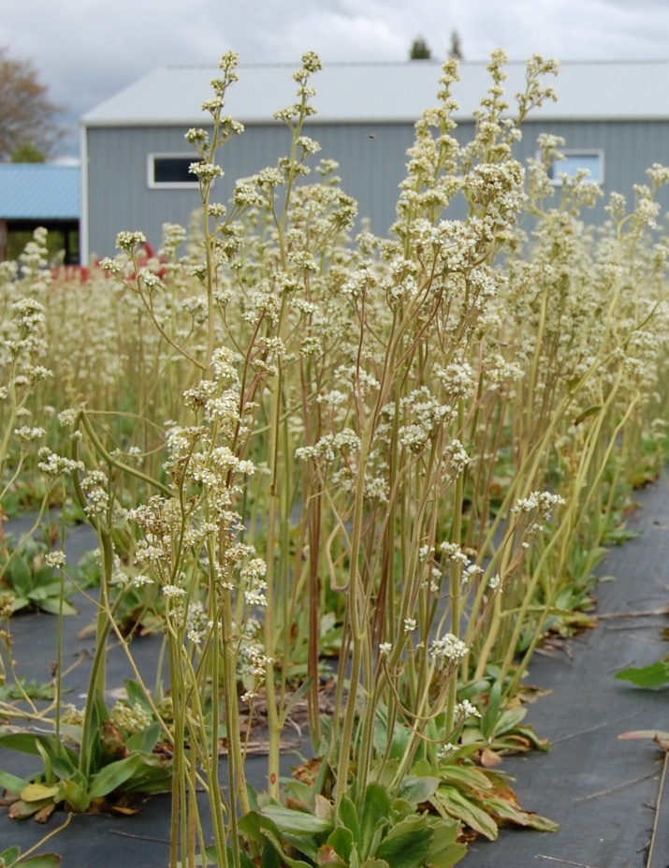

Oregon saxifrage seed increase field at the Corvallis Plant Materials Center. Photo by Amy Bartow

### Alternate Names

*Alternate Common names:* bog saxifrage, Oregon bog saxifrage, swamp saxifrage, Oregon marsh saxifrage

*Alternate Scientific Names:* Micranthes arnoglossa Small, Micranthes brachypus Small,Micranthes oregana (Howell) Small, Saxifraga montanensis Small, Saxifraga oregana Howell var. montanensis (Small) C.L. Hitchc., Saxifraga oregana Howell var. sierrae Coville

### Uses

*Restoration:* Oregon saxifrage can be planted on restoration sites that contain wet areas such as stream banks, seasonal wetlands, or vernal pools. This species is used for NRCS Conservation Reserve Program (CRP), Wetland Reserve Program (WRP) and Wildlife Habitat Incentives Program (WHIP) plantings.

*Pollinator habitat*: Oregon saxifrage provides an important early season nectar source for many native pollinator species.

*Ornamental:* This species is a resilient, long-lived perennial that can add some early spring texture to a landscape that contains other later blooming species. It can also be used in places within a landscape where the soil is waterlogged throughout the winter and spring months.

### Status

In the Intermountain region and California, Oregon saxifrage is considered an obligate wetland species, meaning it almost always occurs in wetlands, and in the Northwest region it is considered a facultative wetland plant that usually occurs in wetlands, but may occasionally be found in non-wetlands (USDA-NRCS, 2012). Please consult the PLANTS Web site and your State Department of Natural Resources for this plant’s current status (e.g., threatened or endangered species, state noxious status, and wetland indicator values).

### Description

*General*: Oregon saxifrage is a strong perennial that comes back from a simple or branched persistent and sometimes woody base, or caudex (Hitchcock and Cronquist, 1961). The glandular, densely hairy leaves are 3-10 inches long and are linear to widely egg shaped, tapering to a petiole (leaf stem) of 0-2 inches in length (Hitchcock and Cronquist, 1961; Turner and Gustafson, 2006). Leaf margins may be entire (smooth) or toothed. The 11-47 inch tall flowering stalks have a dense covering of hairs, becoming glandular toward the top, and are leafless. The inflorescence is comprised of clusters of small white to greenish-white flowers with oval petals. The fruit is a capsule-like structure that has multiple chambers which contain the tiny, brown seeds. Plants flower from April to August, depending on latitude and elevation.

*Distribution*: Oregon saxifrage is found on the west slopes of the Cascade Mountains from Whatcom County, WA, southward throughout the Willamette Valley and Cascade Mountains of Oregon and Northern California, into the Sierra Nevada range of California and Nevada (Hitchcock and Cronquist, 1961; USDA-NRCS, 2012). This species is also found in seasonally wet areas of the Rocky Mountains in Alberta, Idaho, Montana, Wyoming, and Colorado. Oregon saxifrage grows from about 300 ft in Washington and Oregon to elevations of 3,200 to 8,200 feet in California and up to 8,800 ft in the Rocky Mountains (Burke Herbarium, 2012; Jepson Flora Project, 2012). For current distribution, please consult the Plant Profile page for this species on the PLANTS Web site.

*Habitat*: Oregon saxifrage is found along stream banks and in bogs, marshes, wet prairies, vernal pools and moist meadows with seasonally wet soils (Hitchcock and Cronquist, 1961; Jepson Flora Project, 2012; Turner and Gustafson, 2006).

**Adaptation**

Oregon saxifrage is adapted to grow in most soil types with adequate winter and spring moisture. The plants flower in the spring and go dormant by mid-summer to cope with dry conditions.

### Establishment

### Seeds are not dormant and will germinate best when exposed to late summer/early fall temperatures. In germination trials at the Corvallis Plant Materials Center, highest germination occurred after exposure to warm temperatures (65°F or above) for two weeks followed by cool temperatures (50°F) for 4 weeks. Seeds should be broadcast on the soil surface on sites in the early fall while soils are still warm. Seeds can be sown on restoration sites in the fall at a rate of 1 pound per acre, or 300 seeds per square foot. The seedlings are very small and grow slowly, so it may take up to four years before they become obvious on the site.

Establishment may be done with plugs or crown divisions if a quicker result is desired. The caudex of a large plant may be divided into ten or more propagules. They can be planted out in spring or fall as long as there is adequate soil moisture. Plugs or crown divisions often flower and produce seed in the first year.

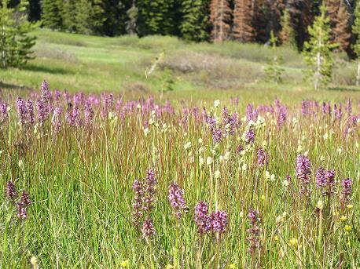

Oregon Saxifrage growing in its native habitat., Elk Meadows, Mt Hood National Forest, Oregon. Photo by Amy Bartow.

### Management

Periodic mowing, grazing or burning may be necessary to keep perennial grasses and shrubs from displacing Oregon saxifrage.

### Pests and Potential Problems

There is no current information on pests or diseases of this species.

### Environmental Concerns

There are no known environmental concerns associated with Oregon saxifrage.

### Seeds and Plant Production

*Field Establishment:* Seeds are very small and seedlings grow slowly.For best seed production field establishment, sow seeds in containers placed outside in early September until germination occurs. Then move containers into a greenhouse to grow throughout the winter. In spring, transplant into a field covered with weed fabric containing holes on 1 foot by 1 foot spacing. Plants grow vigorously in the cool, wet fall and winter months and bloom in early spring.

*Harvest Techniques:* Seed heads ripen unevenly and individual stalks may be harvested by hand once the majority of the seed is ripe. Seeds are ripe when the seed bearing structure turns yellow or brown and the tip starts to open. Generally, once half of the seed structures have matured, the whole stalk should be harvested to avoid an excessive amount of seed shatter. Care must be taken when cutting the stalks or much of the seed will spill out. After each stalk is cut, it needs to remain vertical until it is over a tarp or a barrel to prevent the seed from falling onto the ground. For highest yields, vacuum seed from the weed fabric once all of the stalks have been harvested. Place the harvested stalks on a tarp to dry.

*Seed Cleaning Techniques:* Dried seed stalks can be threshed or put into a brush machine to remove the seed from the plant material. An air screen machine can be used to separate good seed from small pieces of plant material, chaff and soil.

*Yield:* The yield is highly variable depending on spring weather and harvest technique. At the Corvallis Plant Materials Center, yields have been between 30 and 100 pounds per acre.

### Cultivars, Improved, and Selected Materials (and area of origin)

Seed of this species may be available from native plant nurseries from within its range. Contact your local Natural Resource Conservation Service office for more information on availability.

### References

Burke Herbarium. 2012. *Micranthes oregana* (with synonyms). In: Vascular plant database [online]. Univ. of Washington, Seattle. <http://biology.burke.washington.edu/herbarium/collections/vascular/search.php> (accessed 8 May 2012).

Hitchcock, L.C., and A. Cronquist. 1961. Vascular plants of the Pacific Northwest. Part 3: Saxifragaceae to Ericaceae. Univ. of Washington Press, Seattle.

Jepson Flora Project. 2012 (v. 1.0). Jepson eFlora, *Micranthes oregana*, M.S. Park, <http://ucjeps>. berkeley.edu/cgi-bin/get_IJM.pl?tid=33448 (accessed 8 May 2011).

Turner, M., and P. Gustafson. 2006. Wildflowers of the Pacific Northwest. Timber Press, Inc., Portland, OR.

Turner, M. 2012. Oregon Saxifrage. Turner Photographics, Bellingham, WA. Available online at http://www.pnwflowers.com/flower/saxifraga-oregana (accessed 3 May 2012).

USDA-NRCS. 2012. The PLANTS Database, [http://plants.usda.gov](http://plants.usda.gov/) (accessed 8 May 2012). National Plant Data Team, Greensboro, NC.

**Prepared By**:

Tyler C. Ross

USDA NRCS Corvallis Plant Materials Center, Oregon

### Citation

Ross, T.C. 2012. Plant guide for Oregon saxifrage(*Saxifraga oregana)*. USDA-Natural Resources Conservation Service, Plant Materials Center, Corvallis, OR.

Published May 2012

Edited: 08May2012 aym; 15October2012 jab

For more information about this and other plants, please contact your local NRCS field office or Conservation District at <http://www.nrcs.usda.gov/> and visit the PLANTS Web site at <http://plants.usda.gov/> or the Plant Materials Program Web site <http://plant-materials.nrcs.usda.gov>.

PLANTS is not responsible for the content or availability of other Web sites.

**USDA IS AN EQUAL OPPORTUNITY PROVIDER AND EMPLOYER**