|  |
| --- |
| strand tangantangan |
| *Schleinitzia fosbergii* Nevi & Niezgoda |
| Plant Symbol = SCFO2 |

Contributed by: CSIRO Forestry & Forest Products and USDA NRCS Pacific Basin Office

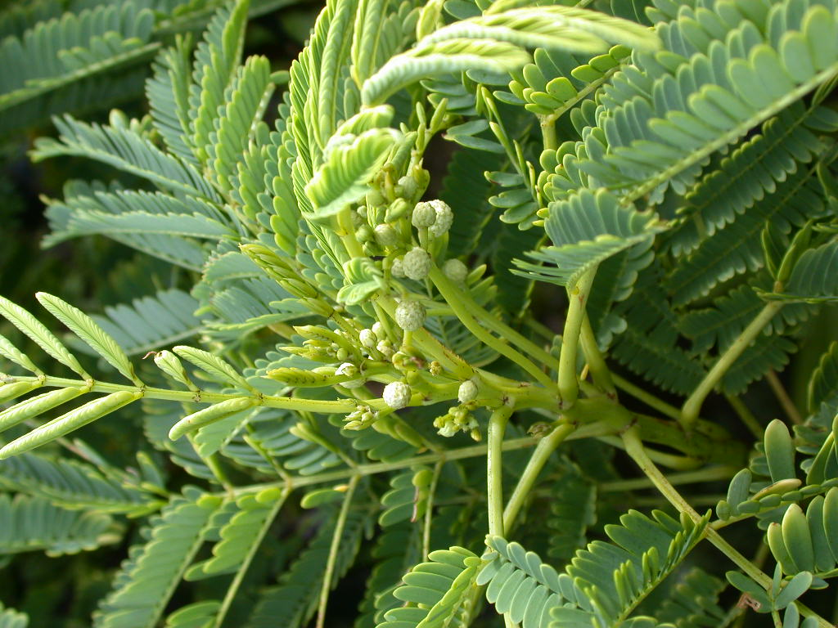

John Lawrence

USDA NRCS Pacific Basin Office

**Alternate Names**

Strand leucaena; *Leucaena insularum* (Guill.) Daniker var. *guamensis* Fosberg & Stone is a synonym for *S. fosbergii*. *Schleinitzia* plants differ from *Leucaena* in their indehiscent (non-splitting) pods, anthers with glands and albuminous seeds (cf. little albumen in *Leucaena*) (Nevling and Niezgoda 1978).

##### Uses

The wood is reportedly used as fuel on Guam (Limtiaco and Guzman 1999), but other larger and more woody species from the same habitat would generally be used in preference to this species.

The leaves are reportedly used as fodder on Guam (Limtiaco and Guzman 1999), but possibly this record arises due to confusion with *Leucaena leucocephala*. Its suitability as a fodder needs to be clarified.

The species has some environmental importance in the protection of fragile seaside ecosystems, including nitrogen inputs to infertile sandy soils. It may have some potential application in Pacific atoll environments for addition of nitrogen and carbon to taro production systems, especially where organic matter has been lost due to drought.

##### Status

Please consult the PLANTS Web site and your State Department of Natural Resources for this plant’s current status (e.g. threatened or endangered species, state noxious status, and wetland indicator values).

##### Description

*General: Pea Family (Fabaceae). Schleinitzia fosbergii* is a nitrogen-fixing large shrub with a restricted distribution in strandline habitats in the Western Pacific. *Schleinitzia* is a genus of three species in the family *Fabaceae*, subfamily *Mimosoideae*, and tribe *Mimoseae* or *Adenanthereae*. The three species are found in the Pacific basin (including New Guinea, Melanesia, Micronesia and Polynesia). They resemble and have sometimes been placed in the widespread genera *Leucaena*, *Piptadenia* and *Prosopis*, but differ in their pollen grains, which are arranged in tetrahedral tetrads (Nevling and Niezgoda 1978). The genus *Schleinitzia* was originally established by Warburg (1891), and has been recently re-established by Verdcourt (1977). The specific epithet honors the Pacific botanist, Dr F.R. Fosberg. Botanical descriptions have been provided inNevling and Niezgoda (1978) and Stone (1970) (as *Leucaena* *insularum* var. *guamensis*), and the following information is principally derived from these sources.

It is typically a spreading, brittle, large shrub up to 2 m tall, and only very rarely attaining the status of a small bushy tree to 4-6 m tall. The branches are glabrescent or glabrous.

It has bipinnate leaves, typically with 4-6 pairs of pinnae, each with 20-25 pairs of glabrous leaflets, each leaflet 5-10 mm long x 2-3 mm wide. The leaf rachis bears 1 (-2) cup-shaped glands between the pinnae of the lower-most pair and between all or the upper 2-3 pairs of pinnae. Stipules are erect, recurved or reflexed and 1-2.5 mm long.

The inflorescences are globular, white, and consist of numerous tiny flowers. Individual flowers may be bi-sexual or male (staminate). Each flower has about five petals and ten filaments, and is subtended by a short peltate bract, 2-2.5 mm long.

One to five fruits are set per flower-head and these are borne on a stout peduncle. Fruits are dark brown to black, hard/tough, indehiscent pods, with a narrowly winged edge, and covered with a conspicuous network of veins. Each pod is 7.5-11 cm long x c. 1.5 cm wide and holds 8 to 12 (-14) seeds.

Flowering and fruiting times are unknown. There is no published information on variation in *S. fosbergii*. However, there is likely to be limited genetic variation given its narrow natural distribution. This would be especially the case if the species has evolved relatively recently, and is derived from *S. insularum* following long range dispersal by people in ancient times as has been suggested by Nevling and Niezgoda (1978).

*Distribution*: *S. fosbergii* is restricted to south-eastern Guam and adjacent islands, including the Cocos Islands, in the southern part of the Marianas chain in the northern Pacific. On Guam, it is an uncommon species on the south-central east coast from Yona to Ipan Talofofo.

It is most closely related to the widespread *S. insularum* and probably evolved from this species. It is distinguished from *S. insularum* by its:

* Fewer number of pinnae pairs per bi-pinnate leaf (4-5 cf. 7-16 pairs), and
* Glabrous leaflets, which are also fewer in number (20-25 cf. 25-35).

For current distribution, please consult the Plant Profile page for this species on the PLANTS Web site, http://plants.usda.gov.

*Habitat*: The species is found in maritime, tropical climates. The annual rainfall is typically 2000-2500 mm (range 1800-2700mm). The wettest period is from July-October, with more than half of the annual rainfall occurring in these four months. The period from January-May is drier and fires are frequent in the dry season. Tropical cyclones or typhoons occur in most years. Temperatures show limited seasonal and diurnal variation. The mean maximum temperature for the hottest month is 29-31oC, mean minimum temperature for the coolest month is 22-25oC and mean annual temperature 26-27oC. The entire distribution is frost-free.

The species is an uncommon component of strand vegetation, including cliff shores. Associated tree and shrub species include *Argusia argentia*, *Cocos nucifera*, *Pemphis acidula, Scaevola sericea* and *Sophora tomentosa.* Associated herbaceous species include *Ipomoea pescaprae*, *Lepturus repens* and *Paspalum distichum*. The species occupies a narrow band just above the high tide boundary, may have been displaced from upper strandline niches, including near-seashore secondary forests and thickets, by the introduced, related species *Leucaena leucocephala*.

*S. fosbergii* has a preference for well-drained alkaline sands. The recorded substrates include coastal limestone and coral sand (Limtiaco and Guzman 1999). The soils may contain moderately high levels of salts, but due to their good aeration, combined with periodic flushing of salts, the salinity hazard is only moderate.

##### Adaptation

This species is well-adapted to harsh coastal sites that are subject to strong salt spray. Accordingly, it may have some environmental importance in beach stabilization, including nitrogen inputs to infertile sandy soils.

##### Management

Propagate from seed that has been pre-treated to overcome hard-seededness. Seed germinates readily and rapidly, taking about 5-7 days. The recommended pre-treatment is boiling water, pour and soak: this involves adding seed to just-boiled water, stirring for 60 seconds and leaving stand for five minutes. Manual nicking or clipping, followed by soaking in tap water for 12 hours, is an effective pre-treatment for smaller quantities of seed.

In nurseries in Guam, seedlings have been damaged by insects infestations near to the stem junction with the soil. Due to the difficulties in raising contained seedling stock the species is unknown in cultivation. It is expected to grow at a moderate rate in strandline habitats similar to those in which it naturally occurs.

##### Environmental Concerns

The greatest threat to this species in Guam is the invasion and replacement by non-native species, including *Leucaena leucocephala*, in those portions of the strand habitat outside of the influence of salt spray and wave action during severe weather events. Stands may also be destroyed by typhoons.

### Cultivars, Improved and Selected Materials (and area of origin)

##### Contact your local Natural Resources Conservation Service (formerly Soil Conservation Service) office for more information. Look in the phone book under ”United States Government.” The Natural Resources Conservation Service will be listed under the subheading “Department of Agriculture.”

##### References

Limtiaco D. & L.C. Guzman. 1999. *State of Forest and Tree Genetic Resources in the Pacific Islands, and Sub-Regional Action Plan for their Conservation and Sustainable Use*. Guam Country Report to the Pacific Sub-Regional Workshop on Forest and Tree Genetic Resources 12-16 April, 1999. Forestry & Soil Resources Division, Department of Agriculture, Government of Guam.

Nevling LI, Niezgoda, Ch.J, 1978. On the genus *Schleinitzia* (Leguminosae-Mimosoideae). *Adansonia* 18 (3): 345-363.

*Stone, B. 1970. The Flora of Guam, Micronesica, Vol. 6. University of Guam.*

Verdcourt B, 1977. New taxa of Leguminosae from New Guinea. *Kew Bulletin* 32: 225-251.

USDA NRCS 2004. The PLANTS database <plants.usda.gov>. National Plant Data Center, Baton Rouge, Louisiana. Accessed 13apr04.

Warburg O, 1891. Beiträge zur Kenntnis der Papuanischen Flora. *Bot. Jahrb*. 13: 230-455.

##### Prepared By:

*Lex Thomson*, CSIRO Forestry & Forest Products Canberra, ACT, Australia

*John Lawrence*, USDA NRCS Pacific Basin Office Mongmong, Guam

##### Species Coordinator:

*John Lawrence*, USDA NRCS Pacific Basin Office Mongmong, Guam

Edited: 28apr03; 13oct04 jsp, 21oct04 rln; 060817 jsp

For more information about this and other plants, please contact your local NRCS field office or Conservation District, and visit the PLANTS Web site<<http://plants.usda.gov>> or the Plant Materials Program Web site <<http://Plant-Materials.nrcs.usda.gov>>

*The U.S. Department of Agriculture (USDA) prohibits discrimination in all its programs and activities on the basis of race, color, national origin, sex, religion, age, disability, political beliefs, sexual orientation, and marital or family status. (Not all prohibited bases apply to all programs.) Persons with disabilities who require alternative means for communication of program information (Braille, large print, audiotape, etc.) should contact USDA's* [*TARGET Center*](http://www.usda.gov/oo/target.htm) *at 202-720-2600 (voice and TDD).*

*To file a complaint of discrimination write USDA, Director, Office of Civil Rights, Room 326-W, Whitten Building, 14th and Independence Avenue, SW, Washington, DC 20250-9410 or call 202-720-5964 (voice or TDD). USDA is an equal opportunity provider and employer.*

*Read about* [*Civil Rights at the Natural Resources Convervation Service*](http://www.nrcs.usda.gov/about/civilrights/)*.*