

Plant Guide

# tall blacktip ragwort

## Senecio atratus Greene

Plant Symbol = SEAT

*Contributed by*: USDA NRCS Aberdeen Plant Materials Center

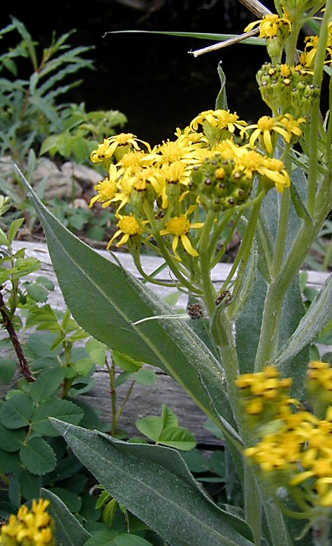**Tall blacktip ragwort. Photo by Barry Breckling © 2009.**

### Alternate Names

Black groundsel

Slide butterweed

### Uses

Tall blacktip ragwort has been seeded and transplanted into restoration and reclamation projects at upper elevation sites in the Rocky Mountains. It has value as a food source for insects. Due to its toxic properties, it is not a good source of forage for livestock or game animals.

### Status

Please consult the PLANTS Web site and your State Department of Natural Resources for this plant’s current status (e.g., threatened or endangered species, state noxious status, and wetland indicator values).

### Description

*General*: Sunflower family (Asteraceae). Tall blacktip ragwort is a perennial, subrhizomatous forb from a branching caudex. The plants have an erect growth habit and reach a mature height of 20 to 80 cm (8 to 32 in). The leaves and stems are densely hairy causing the herbage to appear grayish. The leaves are oblanceolate, 8 to 30 cm (3 to 12 in) long and 1 to 4 cm (0.4 to 1.6 in) wide. The leaf margins are dentate to nearly entire. The inflorescence is a compact cluster of 15 to 60 floral heads. The floral heads are 6 to 8 mm (0.24 to 0.31 in) in height and 3 to 6 mm (0.12 to 0.24 in) wide with yellow ray and disk flowers. The bracts are green to brownish with black tips. The fruit is an achene bearing a white pappus (Welsh et al 2003).

*Distribution*: Tall blacktip ragwort is found in the Rocky Mountain regions of Utah, Wyoming, Colorado and New Mexico. For current distribution, please consult the Plant Profile page for this species on the PLANTS Web site.

*Habitat*: Tall blacktip ragwort is found in montane plant communities from 2,400 to 3,600 m (7,800 to 11,800 ft). It is commonly associated with aspen, spruce-fir, mixed conifer and tall forb communities.

**Adaptation**

Tall blacktip ragwort is adapted to sites receiving 18 or more inches (457 mm) of mean annual precipitation.

### Establishment

A high altitude seeding in Rocky Mountain National Park showed high levels of establishment and survivorship 6 years after seeding (Harrington 1946).

### Management

Tall blacktip ragwort has been used as a minor component of seed mixtures. Management strategies should be based on the key species in the established plant community. Grazing should be deferred on seeded lands for at least two growing seasons to allow for full stand establishment.

### Pests and Potential Problems

Many members of the genus *Senecio* are known to contain toxic alkaloids which can cause liver disease n livestock and humans (Burrows and Tyrl 2001). Tall blacktip ragwort has been shown to contain the alkaloids sarracine 2, and platynecine 3 and 4 (Stermitz and Harris 1987).This species has also been found to be a host plant for the hemiparasitic paintbrush species (*Castilleja rhexifolia* and *C. sulphurea*). The toxic alkaloids are transferred from the host to the paintbrush via specialized root structures called haustoria which form the connection between the parasite and host plant (Stermitz and Harris 1987).

### Environmental Concerns

Tall blacktip ragwort is native to western North America. There are no known environmental concerns associated with this species. The toxic compounds found in this species poses a threat to grazing animals if consumed in sufficient quantities.

### Seeds and Plant Production

Butler and Frieswyk (2001) reported 1 percent germination in an attempt to grow tall blacktip ragwort in greenhouse conditions. The seed had been stored in the greenhouse and had not undergone any treatment prior to sowing.

### Cultivars, Improved, and Selected Materials (and area of origin)

### There are currently no commercial releases of tall blacktip ragwort. Common seed may be available on the commercial market.

The Aberdeen Plant Materials Center cooperated with the USDA-Agricultural Research Service, Poisonous Plants Laboratory to evaluate a number of *Senecio* and *Packera* species for toxic properties. Based on the findings, the plant materials center discontinued further evaluation of *Senecio* spp. for potential release.

### References

Burrows, G.E. and R.J. Tyrl. 2001. Toxic Plants of North America. Iowa State University Press. Ames, Iowa. 1342p.

Butler, Jennifer and C. Frieswyk. 2001. Propagation protocol for production of *Senecio atratus* seeds; USDI NPS - Rocky Mountain National Park, Estes Park, Colorado. In: Native Plant Network. URL: http://www.nativeplantnetwork.org (accessed 25 May 2012). Moscow (ID): University of Idaho, College of Natural Resources, Forest Research Nursery.

Harrington, H.D. 1946. Results of a seeding experiment at high altitudes in the Rocky Mountain National Park. Ecology. 27: 375-377.

Stermitz, F.R. and G.H. Harris. 1987. Transfer of pyrrolizidine and quinolizidine alkaloids to *Castilleja* (Scrophulariaceae) hemiparisites from composite and legume host plants. Journal of Chemical Ecology. 13 (8): 1917-1925.

Welsh, S.L., N.D. Atwood, S. Goodrich, and L.C. Higgins. 2003. A Utah Flora. Third Edition, revised. Brigham Young University, Provo, UT.

**Prepared By**:

Derek Tilley, USDA NRCS Plant Materials Center, Aberdeen, ID

Loren St. John, USDA NRCS Plant Materials Center, Aberdeen, ID

### Citation

Tilley, D. and L. St. John. 2012. Plant Guide for tall blacktip ragwort (*Senecio atratus*). USDA-Natural Resources Conservation Service, Aberdeen Plant Materials Center. Aberdeen, Idaho 83210.

Published June 2012

Edited: 5June2012djt; 5 June2012ls;

For more information about this and other plants, please contact your local NRCS field office or Conservation District at <http://www.nrcs.usda.gov/> and visit the PLANTS Web site at <http://plants.usda.gov/> or the Plant Materials Program Web site <http://plant-materials.nrcs.usda.gov>.

PLANTS is not responsible for the content or availability of other Web sites.

**USDA IS AN EQUAL OPPORTUNITY PROVIDER AND EMPLOYER**