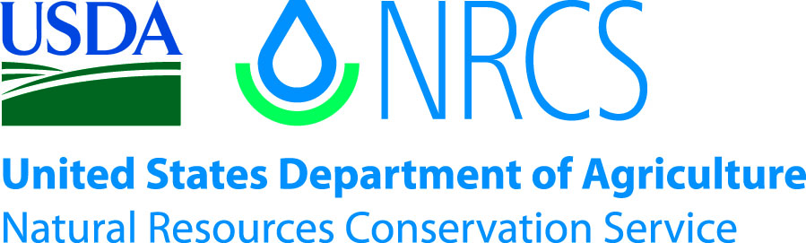

Plant Guide

# Cereal Rye

## Secale cereale L.

Plant Symbol = SECE

*Contributed by*: USDA NRCS Elsberry Plant Materials Center, Missouri

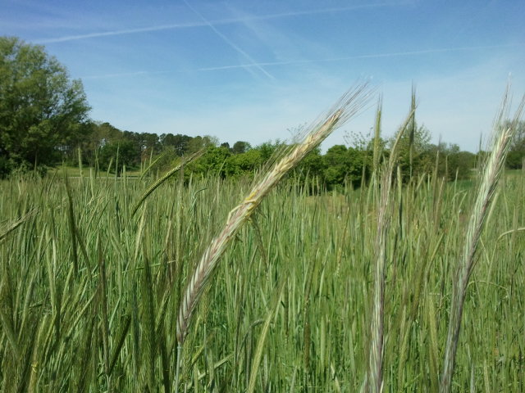

Flowering cereal rye in a cover crop experimental plot in April at Elsberry, Missouri.

### Alternate Names

*Alternate Common Names:* common rye, rye, winter rye, grain rye, cultivated rye

*Alternate Scientific Names: Secale montanum, Secale strictum, Triticum cereale*

### Uses

*Cover crop and green manure:* Cereal rye is often planted in the fall for soil erosion control (Oelke et al., 1990). As a cover crop, cereal rye can scavenge nitrogen, build soil, loosen topsoil (reduce compaction), prevent erosion, and suppress weeds. It can also be used as a livestock forage between cash crops.

Cereal rye absorbs unused soil nitrogen (N) remaining from previously grown row crop. It typically assimilates 25-50 lb/acre N, but can retain as much as 100 lb/acre N (Clark, 2007). Cereal rye is compatible with multiple crop rotation systems in many regions. It can be used as a strip cover crop, overseeded, drilled, and/or broadcast. It overwinters well, and creates a physical barrier to weeds by producing large amounts of biomass (Clark, 2007). It also suppresses weeds chemically by producing allelopathic chemicals (Chase et al., 1991). Generally, cereal rye performs best as a cover crop or green manure crop if it is planted with other species, usually a legume.

*Grain*: Cereal rye is grown as a grain crop for alcoholic beverages, food, livestock feed, and seed (Oelke et al., 1990). Rye flour can be used alone to make leavened bread, but it is more commonly mixed with wheat flour (Bushuk, 2001).

*Annual Pasture:* Cereal rye can be grazed during the late fall or early spring when other forages are not available (Oelke et al., 1990). When used as grazed forage, cereal rye is usually mixed with other cool season species such as triticale.

*Hay*: Cereal rye can be cut for hay when it is in the early heading stage of development (Oelke et al., 1990). It provides the best hay forage when it is grown with other species such as red or crimson clover, or annual ryegrass (Oelke et al., 1990). If used for forage production, cereal rye can contain up to 9% crude protein (Watson et al., 1993).

### Status

Cereal rye is considered a Class C noxious weed in Washington. Please consult the PLANTS Web site and your State Department of Natural Resources for this plant’s current status (e.g., threatened or endangered species, state noxious status, and wetland indicator values).

### Weediness

Cereal rye has the potential to become a weed if it is allowed to produce mature seed (Clark, 2007). It can be killed with herbicides, mowing, chopping, or roller crimping at the correct growth stage (Clark, 2007; Oelke et al., 1990). Please consult with your local NRCS Field Office, Cooperative Extension Service office, state natural resource, or state agriculture department regarding its status and use. Weed information is also available from the PLANTS Web site at <http://plants.usda.gov/>. Please consult the Related Web Sites on the Plant Profile for this species for further information.

**Ethnobotany**

English and Dutch settlers brought cereal rye to the northeastern United States. Flour made from cereal rye is gluten free (Oelke et al., 1990), which makes it an ideal flour for people with celiac disease. It has been historically grown in the North Central states of South Dakota, Nebraska, North Dakota, and Minnesota (Oelke et al., 1990).

The witch hunts and executions that have occurred throughout history may have been the result of a misdiagnosis of rye ergot poisoning (Matossian, 1989). Many of the symptoms of ergot poisoning, such as paranoia, hallucinations, twitches, spasms, cardiovascular trouble, and stillborn children, were also considered signs of witchcraft. Matossian (1989) suggests that at least some outbreaks of the plague that have occurred throughout history could have been the result of a vulnerable immune system because of rye ergot consumption.

### Description

Cereal rye is an upright, cool season, annual grass. It can grow 3 to 6 feet tall, has flat leaf blades, and is topped with awned flower spikes called heads.

*Distribution*: Cereal rye is found in most of the continental U.S. and in Alaska. It is a cultivated introduced species that is thought to have originated from Eurasia (Yatskievych, 1999). For current distribution, please consult the Plant Profile page for this species on the PLANTS Web site.

*Habitat*: Cereal rye is able to grow in a wide variety of climate and soil conditions. In most areas it does not persist well when it escapes cultivation. It grows best when cultivated in light loams or sandy soils, but it will also do well in clay soils. Some varieties can tolerate waterlogging while others do well in dry soils (Clark, 2007).

**Adaptation**

Cereal rye is a cultivated plant and in most regions it does not persist very long in the wild. There are many varieties of cereal rye on the market, each of which is best adapted to a particular geographic area, climate, and soil conditions (Clark, 2007; Oelke et al., 1990). To find the right variety or cultivar for use in your area contact your local NRCS office or Extension Service.

### Establishment

Establishment methods and timing of planting depends on the management objective of the producer. Cereal rye is planted from late summer to midwinter depending on the geographic region (Clark, 2007). Seed should be planted no deeper than 2 inches (Clark, 2007). Cereal rye seed can be drilled, over-seeded into an existing crop, or broadcasted. Seeding rates vary from 50–200 lb/ac, depending on climate and use. It can be planted alone or with other species. For the best seeding rates, methods, and practices for your area contact your local NRCS office or Extension Service.

### Management

Management of cereal rye can vary widely. It can be managed to produce a grain crop to mill for flour, where it can be harvested and threshed using a combine (Oelke et al., 1990). In a cover crop or green manure system, a multitude of management options are available. It can be killed at different times for weed suppression, to prevent nitrogen uptake, or incorporated into soil for organic matter build up. It can be terminated by plowing, disking, mowing, roller crimping, or with herbicides.

### Pests and Potential Problems

Cereal rye is susceptible to some diseases, although it is generally more resistant than other cereal species (Oelke et al., 1990). Ergot, stem or stalk smut, anthracnose, and various rusts of the leaves or stem are the most likely disease problems that will be encountered (Oelke et al., 1990). In the spring, armyworm moths are attracted to cereal rye and may lay eggs on it (MCCC, 2012). It is important to not feed ergot infected rye to humans or animals as it could result in ergotism, which can cause convulsions, miscarriage, hallucinations, and gangrene of the arms, legs, fingers, and toes.

### Environmental Concerns

Caution should be used when planting cereal rye before winter wheat, because volunteer rye could become a weed in the wheat crop. Cereal rye is listed as a Class C noxious weed in Washington and should not be used there.

### Control

Please contact your local agricultural extension specialist or county weed specialist to learn what works best in your area and how to use it safely. Always read label and safety instructions for each control method.

### Seeds and Plant Production

For seed production, the seedbed should be smooth, firm, and weed free. Seeds should be planted 1 to 1.5 inches deep (Government of Alberta, 2011). Seeding rate will vary depending on climatic conditions and variety of rye that is being used. Typical rates average 55-60 lb/acre (Government of Alberta, 2011). Soil tests can determine the amount and timing of any fertilizer application, but can be up to 50 lb N/acre (Government of Alberta, 2011). Rye shatters very easily. It is recommended to swath when moisture is around 40%, dry, and then feed through a combine or thresher to separate the seed from the chaff (Government of Alberta, 2011).

### Cultivars, Improved, and Selected Materials (and area of origin)

Several cultivars of cereal rye are readily available for different geographical regions, climates, soil types, and use. Common varieties of cereal rye are ‘Elbon’, Noble Foundation , Ardmore, Oklahoma; ‘Hancock’, Wisconsin Agricultural Experiment Station; ‘Musketeer’, Agriculture Canada; ‘Rymin’, Minnesota Agricultural Experiment Station; ‘Aroostook’, USDA-NRCS, Cornell University, and Maine Dept. of Agriculture; ‘Cougar’, University of Manitoba; ‘Dankowski Nowe’ (Danko), Dankow-Laski and Choryn experiment stations; ‘Frederick’, South Dakota Agricultural Experiment Station; ‘Metzi’, Nutriseed Company; ‘Puma’, University of Manitoba; and ‘Von Lochow’, obtained from F. Von Lochow-Petkus Ltd. of Germany and released by Minnesota Agricultural Experiment Station; ‘Prima’, used in Canada and is ergot resistant; ‘AC Remington’, used in Canada and is ergot resistant; ‘Maton’; ‘Rosen’; ‘Dakold’. To find the right variety or cultivar for use in your area contact your local NRCS office or Extension Service.

### References

Bushuk, W. 2001. Rye production and uses worldwide. Cereal Foods World 46:70-73.

Chase, W.R., M.G. Nair, and A.R. Putnam. 2,2’-OXO-1,1’-Azobenzene: selective toxicity of rye (*Secale cereal*e L.) allelochemicals to weed and crop species: II. Journal of Chemical Ecology 17:9-19.

Clark, A. (ed.) 2007. Managing cover crops profitably. 3rd ed. Sustainable Agriculture Research and Education (SARE) Handbook Series Book 9. Sustainable Agriculture Research and Education (SARE) Program, College Park, MD.

Government of Alberta. 2011. Fall rye production http://www1.agric.gov.ab.ca/$department/deptdocs.nsf/all/agdex1269 (verified May 2012). Government of Alberta Agriculture and Rural Development. Edmonton, Alberta.

Matossian, M.K. 1989. Poisons of the past. Yale Univ. Press, New Haven.

MCCC (Midwest Cover Crops Council). 2012. Midwest Cover Crops Field Guide. http://plantcovercrops.com/category/types-of-cover-crops/winter-cereal-rye/ (verified May 2012).

Oelke, E.A., E.S. Oplinger, H. Bahri, B.R. Durgan, D.H. Putnam, J.D. Doll, and K.A. Kelling. 1990. Rye. In: Alternative field crops manual [Online]. www.hort.purdue.edu/newcrop/afcm/ (verified May 2012). Univ. of Wisconsin-Extension and Univ. of Minnesota.

Watson, S., D.L. Fjell, J.P. Shroyer, K. Bolsen, and S. Duncan. 1993. Small grain cereals for forage. Kansas State Univ., Manhattan.

Yatskievych, G. 1999. Steyermark’s flora of Missouri: volume 1. Missouri Dept. of Conservation, Jefferson City.

**Prepared By**: P. Allen Casey, USDA-NRCS Elsberry Plant Materials Center, Missouri

### Citation

Casey, P.A. 2012. Plant guide for cereal rye (*Secale cereale)*. USDA-Natural Resources Conservation Service, Plant Materials Center, Elsberry, MO.

Published: May 2012

Edited:03May2012 plsp; 09May2012 aym, 23May2012 cs,

For more information about this and other plants, please contact your local NRCS field office or Conservation District at <http://www.nrcs.usda.gov/> and visit the PLANTS Web site at <http://plants.usda.gov/> or the Plant Materials Program Web site <http://plant-materials.nrcs.usda.gov>.

PLANTS is not responsible for the content or availability of other Web sites.

**USDA IS AN EQUAL OPPORTUNITY PROVIDER AND EMPLOYER**