

Plant Guide

# Awnless bushsunflower

## Simsia calva (Engelm. & A. Gray) A. Gray

Plant Symbol = SICA7

*Contributed by*: USDA NRCS James E. “Bud” Smith Plant Materials Center, Knox City, Texas

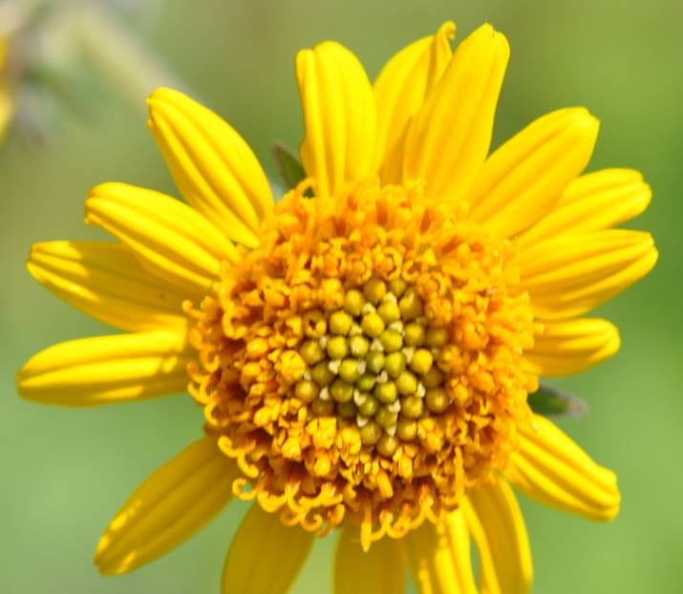USDA-NRCS James E. "Bud" Smith PMC

### Uses

Awnless bushsunflower is a highly palatable plant that is utilized by several classes of livestock and wildlife (USDA-SCS, 1970). Sheep and goats benefit from its high protein and digestibility. It also provides a browse for deer and seed for songbirds. It has a “fair” wildlife index of 3.08 (TPWD, 2010). A study at the James E. “Bud” Smith Plant Materials Center showed an average crude protein of 10% between the months of May through October. The dense foliage provides cover for small mammals, reptiles, and birds. Awnless bushsunflower foliage is also eaten by Border Patch butterfly caterpillars. The flowers attract many other species of pollinators (Ladybird Johnson Wildflower Center, 2010). Awnless bushsunflower can also be added to erosion control mixes for highly erodible areas. It has a “fair” erosion index value of 3.33 (TPWD, 2010).

### Status

Please consult the PLANTS Web site and your State Department of Natural Resources for this plant’s current status (e.g., threatened or endangered species, state noxious status, and wetland indicator values).

### Weediness

This plant may become weedy or invasive in some regions or habitats and may displace desirable vegetation if not properly managed. Please consult with your local NRCS Field Office, Cooperative Extension Service office, state natural resource, or state agriculture department regarding its status and use. Weed information is also available from the PLANTS Web site at <http://plants.usda.gov/>. Please consult the Related Web Sites on the Plant Profile for this species for further information.

### Description

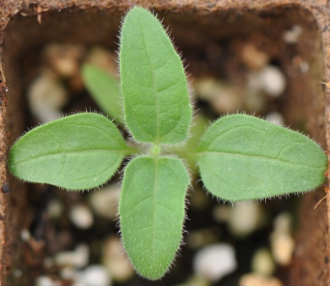Awnless bushsunflower is a native, semi-woody perennial forb. Plants stand 1 ½ to 3 feet tall with multiple branches and a large woody or fleshy taproot. The leaves have an arrowhead appearance with jagged edges. Older leaves at the bottom of the plant measure about 2 inches in length; while the newer leaves at the top of the plant are much shorter. The stem splits into three separate stalks, each with its own flower (USDA-SCS, 1979). The flower is 1 to 1½ inches wide with yellow petals and a yellowish center. Flowering occurs from April through the October (Agrilife, 2010). There are approximately 330,966 seeds per pound.

USDA-NRCS James E. "Bud" Smith PMC

*Distribution*:

For current distribution, please consult the Plant Profile page for this species on the PLANTS Web site.

**Adaptation**

Awnless bushsunflower is primarily adapted to the Edwards Plateau and Rio Grande Plains, but it also performs well in the western Gulf Coast Prairies, and Central Rolling Red and Grand Prairies. It desires full sun and well-drained soils like sandy or clay loams. It can also be found in the understory of brush. It does not tolerate salinity, deep sands, heavy clays, or wet bottomlands.

### Establishment

The full seeding rate for awnless bushsunflower is 2.6 lbs pure live seed/acre (USDA-NRCS, 2012). When planting as a component of a seed mixture, the seeding rate should be adjusted to the desired percent of the mix. Seed should be placed ¼ to ½ inch deep (USDA-SCS, 1979).

Seedbed preparation should begin the year prior to spring planting to reduce weed problems during the first year of establishment. Work the site as necessary during the summer or early fall prior to establishment to create a firm, weed-free seedbed. Work should be completed in the fall to allow time for the soil to settle and accumulate moisture. Minimum and no-till operations should use herbicide applications to control weeds.

### Management

Plantings should be well established before livestock grazing is permitted. Twelve months of grazing deferment should give plants enough time to become established. Established stands of awnless bushsunflower cannot tolerate continuous or heavy grazing. Contact your local U.S. Department of Agriculture-NRCS field office for assistance in planning and applying prescribed grazing plans.

A soil test should be conducted to determine the amount of fertilizer to apply to maintain a medium soil test level. Nitrogen should not be used during the establishment year because it will encourage weed growth. Weeds may be controlled by mowing or with herbicides. Consult your local extension weed specialist for recommendations on herbicides for awnless bushsunflower.

### Pests and Potential Problems

### Awnless bushsunflower is a host plant for the bordered patch butterfly (*Chlosyne lacinia*). The caterpillars have occasionally become a pest in test plots and seed increase fields. White flies have also defoliated plants in the field.

### Seed of Awnless Bushsunflower, Simsia calva, with a ruler as a reference.

USDA-NRCS James E. "Bud" Smith PMC

### Environmental Concerns

### None Known

### Control

Please contact your local agricultural extension specialist or county weed specialist to learn what works best in your area and how to use it safely. Always read label and safety instructions for each control method.

### Seeds and Plant Production

Awnless bushsunflower seed can be harvested using a conventional combine, seed stripper, or by swathing the plant and using a special header attachment for combining the seed. Average seed yield at Knox City is 119 lb/acre. Average seed yield at Kingsville is 159 lbs pls/acre (370 bulk lbs/acre at 43% pls).

### Cultivars, Improved, and Selected Materials (and area of origin)

‘Plateau’ awnless bushsunflower was released from the James E. “Bud” Smith Plant Materials Center in Knox City, Texas in 1987 to provide an adapted forb for inclusion in range mixes. Original seed collection came from a composite collection from Kerr County, Texas.

Venado Germplasm awnless bushsunflower was released by the E. “Kika” de la Garza Plant Materials Center and South Texas Natives in Kingsville, Texas in 2013. This release was made to provide a native forb for rangeland plantings, wildlife habitat improvement plantings, conservation reserve plantings, roadside plantings, pollinator plantings, critical site revegetation including oil and gas field reclamation, native landscaping, and food plot plantings for white-tailed deer. Venado Germplasm is comprised of four collections made from native stands in Medina, Bee, Webb, and La Salle County, Texas.

### References

Lady Bird Johnson Wildflower Center. The University of

Texas at Austin. 2012. Native Plant Information Network. Available at http://www.wildflower.org/ plants/result.php?id_plant=SICA7 Austin, TX, 78739, USA. Accessed 24 Aug. 2012.

Release Brochure for Plateau (*Simsia calva*). USDA-

Natural Resources Conservation Service, James E. “Bud” Smith Plant Materials Center, Knox City, TX 79529. Published March 2012.

Texas AgriLife Research and Extension at Uvalde. 2012.

Texas A&M University. Available at http://uvalde.

tamu.edu/ herbarium/sica.htm 24 College Station, TX. Accessed 24 August 2012.

Texas Parks and Wildlife: Texas Plant Information

Database. 2010. Texas Parks and Wildlife. Available at http://tpid.tpwd.state.tx.us/species_

report.asp?species=228. Austin, TX, 78744, USA. Accessed 24 August 2012.

USDA NRCS. 2009. The PLANTS Database

(http://plants.usda.gov 20 June 2009.) National Plant Data Center, Baton Rouge, LA, 70874-4490, USA.

USDA NRCS. 2012. Release Brochure for ‘Plateau’

Awnless Bushsunflower (Simsia calva). Available at http://www.plant-materials.nrcs.usda.gov/ pubs/txpmcrb10958.pdf. 2012.

USDA SCS. 1979. Planting Guide for Awnless

Bushsunflower (*Simsia calva*). USDA-Soil Conservation Service. February 1979.

USDA SCS. 1970. Technical Notes: Awnless

Bushsunflower (*Simsia calva*). USDA-Soil Conservation Service. May 1970. Fort Worth, Texas.

**Prepared By**

Brandon Carr, USDA NRCS James E. “Bud” Smith Plant Materials Center, Knox City, Texas.

**Citation**

Carr, B., 2013. Plant Guide for Awnless Bushsunflower (*Simsia calva*). USDA-Natural Resources Conservation Service, James E. “Bud” Smith Plant Materials Center. Knox City, TX 79529.

Published: April 2013

Edited: 19July2013 sdm

For more information about this and other plants, please contact your local NRCS field office or Conservation District at <http://www.nrcs.usda.gov/> and visit the PLANTS Web site at <http://plants.usda.gov/> or the Plant Materials Program Web site <http://plant-materials.nrcs.usda.gov>.

PLANTS is not responsible for the content or availability of other Web sites.

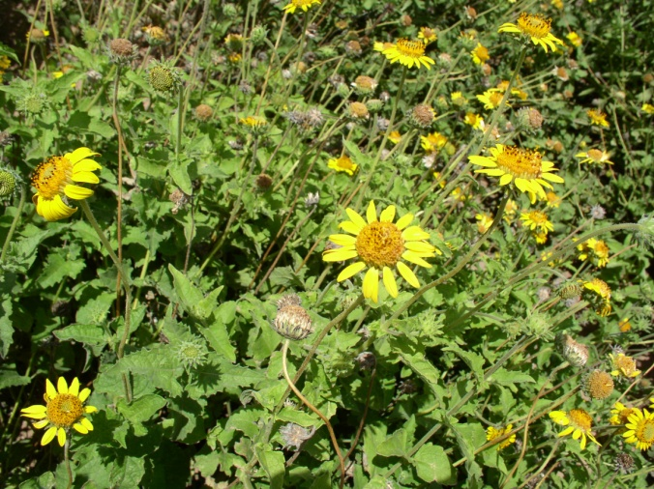

USDA-NRCS James E. "Bud" Smith PMC

**USDA IS AN EQUAL OPPORTUNITY PROVIDER AND EMPLOYER**