

Plant Guide

# gooseberryleaf globemallow

## Sphaeralcea grossulariifolia (Hook. & Arn.) Rydb.

Plant Symbol = SPGR2

#### Contributed by: NRCS Plant Materials Center, Aberdeen, ID

*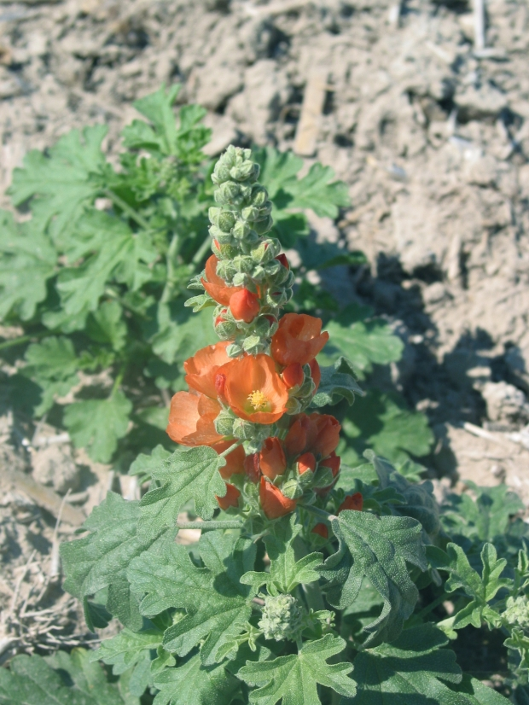Gooseberryleaf globemallow. Photo by Clint Shock. Malheur Experiment Station, Oregon State University.*

### Alternate Names

### Currant-leaf globemallow

### Uses

### *Forage*: Globemallow species are grazed opportunistically by pronghorn antelope, deer, elk, and bighorn sheep (Beale and Smith, 1970; Rumbaugh and others, 1993). The leaves, fruits and seeds are eaten by rodents, rabbits and birds (Pendery and Rumbaugh, 1986). Palatability of globemallow species has been rated desirable to preferred in spring and summer for sheep and antelope and desirable in spring, summer and fall for cattle, horses, deer and elk (Ogle and Brazee, 2009). Globemallow is preferred over grass but not alfalfa during the spring, but is less desirable than grass and alfalfa during the fall (Rumbaugh and others 1993).

### *Pollinator habitat:* Globemallow species flower in the spring and are known to attract numerous species of native bees including *Diadasia*, *Agapostemon, Halictus, Melissodes* and *Calliopsis* (Pendery and Rumbaugh, 1986). Some bee species are specialists which only forage pollen and nectar from *Sphaeralcea* and related taxa of the mallow family (Tepedino, 2011).

*Range revegetation:* Gooseberryleaf globemallow is well adapted to arid to semi-arid environments in the western United States. It establishes from seed and also by transplanting and has been shown to be competitive against cheatgrass and other winter annuals (Stevens and Monsen, 2004).

*Ethnobotanical:* Hopi Indians used boiled or chewed roots for bowel problems and for broken bones (Colton, 1974).

### Status

Consult the PLANTS Web site and your State Department of Natural Resources for this plant’s current status (e.g., threatened or endangered species, state noxious status, and wetland indicator values).

### Description

*General*: Mallow family (Malvaceae). Gooseberryleaf globemallow is a native perennial forb to subshrub with few to many stems arising from a deep, branched woody caudex. Mature plants range from 35 to 75 cm (14 to 30 in) in height. This species is morphologically diverse. Stems and leaves can be white to gray with dense stellate hairs, or green and sparsely hairy. The leaves are typically 3 to 5 lobed with the lobes distinct to the base, the blades 1.2 to 5 cm (0.5 to 2.0 in) long. Flowers are orange or rarely rose pink with 5 petals ranging from 8 to 18 mm (0.3 to 0.7 in) in length. The fruit is a schizocarp with 8 to 20 carpels (Welsh and others, 2003).

*Distribution*: Gooseberryleaf globemallow is native to western North America from Idaho south to New Mexico and west to arid regions of Washington, Oregon and California. For current distribution, consult the Plant Profile page for this species on the PLANTS Web site.

*Habitat*: Gooseberryleaf globemallow occurs in cool and warm desert shrub communities in western North America. It is commonly found in salt desert shrub shadscale and saltbush plant communities. It is also found in the drier portions of sagebrush and pinyon-juniper plant communities (Holmgren and others, 2005; Welsh and others, 2003).

**Adaptation**

Plants can be found in open deserts, playas, hillsides and canyons from 800 to 2,300 m (2,600 to 7,500 ft) elevation in areas receiving 15 to 30 cm (6 to 12 inches) of annual precipitation. Gooseberryleaf globemallow is often found as an early to late seral species in open or disturbed sites. The species is adapted to clay to gravel soils, and is moderately alkali (saline to sodic) tolerant (Pendery and Rumbaugh, 1986).

### Establishment

Gooseberryleaf globemallow should be planted with a drill or broadcast into a weed-free seed bed at a rate of 2.2 kg pure live seed (PLS) per ha (2 lbs PLS per acre) and at a depth of 3 to 6 mm (0.12 to 0.25 in) (Ogle and others 2011; Rawlins and others 2007). When planted in a mix, the seeding rate should be adjusted according to the proportion of this species in the mix. The seed has an impermeable seed coat and should be scarified using boiling water or other treatment prior to planting if a high initial germination rate is desired.

### Management

Gooseberryleaf globemallow should be used as a minor component of restoration seed mixtures. Management strategies should be based on the key species in the established plant community. Grazing should be deferred on seeded lands for at least two growing seasons to allow for full stand establishment.

**Pests and Potential Problems**

Rust (*Puccinia sherardiana*) and powdery mildew (*Leveillula taurica*) have been observed on gooseberryleaf globemallow (Briere and Franc, 1998; Sampangi and others., 2010).

### Environmental Concerns

There are no known environmental concerns associated with this species.

### Seed and Plant Production

Harvested seed can be cleaned by processing with a brush machine or hammer mill and air screening equipment. There are approximately 1,100,000 seeds per kilogram (500,000 seeds per pound) (USDA NRCS, 2011).

Gooseberryleaf globemallow, like other members of the *Sphaeralcea* genus, has an impermeable seed coat which functions as a physical dormancy mechanism and prevents water uptake (Kildisheva, 2011). Little improvement in germination has been obtained with cold-moist stratification alone. Smith and Kratsch (2009) report significant germination improvements for globemallow seed following a combination of scarification (nicking the seed coat) and a 6 week cold stratification. Smith and Kratsch (2009) suggest that *Sphaeralcea* may exhibit a double dormancy with physical and physiological mechanisms.

Germination of Munro’s globemallow (*S. munroana*), thought by some to be the same species or a sub-species of gooseberryleaf globemallow, was significantly improved with scarification (87 %), a combined scarification and 24 hr soak in distilled water (93 %), and scarification plus a 24 hr soak in 100 ppm gibberellic acid (GA3 ) (88%) compared to a non-treated control and treatments of soaking in GA3 without scarification (<20 %) (Kildisheva, 2011).

Mechanical scarification treatments can damage globemallow embryos. Page and others (1966) and Roth and others (1987) suggest Munro’s globemallow seeds lost viability during mechanical scarification in a sandpaper-lined rotating drum, regardless of treatment duration.

Chemical scarification treatments have been shown to be effective for some globemallow species (Page and others., 1966; Sabo and others., 1979; Roth and others., 1987; Smith and Kratsch, 2009). Submergence in 18 M sulfuric acid (H2SO4) for 10 min significantly increased germination of two accessions of gooseberryleaf globemallow (69 % and 62 %) compared to 14 and 32% for the control.

Jones and Whittaker (2011) found immersing globemallow seed in boiling water improved germination, and stratification did not provide a further increase in germination. Kildisheva (2011) **compared** the effects of a10 second submergence in boiling water, tumbling with aluminum oxide, burning, heat application at 80° C for 1 hr, and the combination of burning and heating. Seeds subject to the boiling water treatment reached the highest cumulative germination (49%); while germination of seeds subject to the other treatments did not exceed 20%.

Globemallow fruit ripen indeterminately. Pendery and Rumbaugh ( 1993) recommend harvesting seed when the lowest globes start to split and the majority of fruit is just ready to open.

### Cultivars, Improved, and Selected Materials (and area of origin)

Common wildland collected seed is available through commercial sources. There are currently no commercial releases of gooseberryleaf globemallow.

### References

Beale, D.M. and A.D. Smith. 1970. Forage use, water consumption, and productivity of pronghorn antelope in western Utah. Journal of Wildlife Management 34:570-582.

Briere, S.C. and G.D. Franc. 1998. First report of leaf and stem rust caused by *Puccinia sherardiana* on *Sphaeralcea grossulariaefolia* in North America and *S. munroana* in Wyoming. Plant Disease 82: 831.

Colton, H.S. 1974. Hopi history and ethnobotany. In: D.A. Horr (ed.) Hopi Indians. New York: Garland. 108p.

Holmgren, N.H., P.K. Holmgren, and A. Cronquist. 2005. Intermountain flora: Vascular plants of the Intermountain West. New York: The New York Botanical Garden. 488 p.

Jones, C. and A. Whittaker. 2011. Native Plant Material Development and Cultivation Trials for Native Great Basin Forbs and Grasses. In: Shaw, N and M. Pellant, coordinators and editors. Great Basin Native Plant Selection and Increase Project FY2010 Progress Report. Boise (ID): USDA-Forest Service, Rocky Mountain Research Station and USDI Bureau of Land Management, Great Basin Restoration Initiative. p 57-63.

Kildesheva, O.A. 2011. Restoration strategies for a native perennial: germination and seedling physiology of *Sphaeralcea munroana*. [Msc thesis] Moscow (ID): University of Idaho. 78p.

Ogle, D., D. Tilley, J. Cane, L. St. John, K. Fullen, M. Stannard, and P. Pavek. 2011. Technical Note 2A: Plants for pollinators in the Intermountain West. USDA-NRCS. Boise, ID. ID-TN2A. 40p.

Ogle, D. and B. Brazee. 2009. Technical Note 3: Estimating initial stocking rates. USDA-NRCS. Boise, ID. ID-TN 3. 31p.

Ogle, D., L. St. John, M. Stannard and L. Holzworth. 2011. Technical Note 24: Conservation plant species for the Intermountain West. USDA-NRCS, Boise, ID-Salt Lake City, UT-Spokane, WA. ID-TN 24. 57p.

Page, R.J., D.L. Goodwin, and N. E. West. 1966. Germination requirements of scarlet globemallow. Journal of Range Management 19:145-146.

Pendery, B.M. and M.D. Rumbaugh. 1986. Globemallows: forbs for Utah rangelands. Utah Science 47:41-45.

Pendery, B.M. and M.D. Rumbaugh. 1993. Globemallows. Rangelands 15(3): 127-130.

Roth, T.E., J.L. Holechek, and M.Y. Hussain. 1987. Germination responsee of 3 globemallow species to chemical treatment. Journal of Range Management 40:173-175.

Rumbaugh, M.D., H.F. Mayland, B.M. Pendery, and G.E. Shewmaker. 1993. Utilization of globemallow (*Sphaeralcea*) taxa by sheep. Journal of Range Management. 46:103-109.

Sabo, D.G., G.U. Johnson, W.C. Martin and E.F. Aldon. 1979. Germination requirements of 19 species of arid land plants.USDA Forest Service Research Paper RM-210. Rocky Mountain Forest and Range Experiment Station, Fort Collins, Colorado.

Sampangi, R., Aime, M.C., Mohan, K., and C. Shock. 2010. New and re-emerging rust diseases from Idaho and Oregon. Phytopathology. 100:S113.

Smith, A. and H. Kratsch. 2009. Seed propagation of *Sphaeralcea* (Globemallow). Hortscience 44:1139-1140.

Stevens, R. and S.B. Monsen. 2004. Forbs for seeding range and wildlife habitats. In: S.B. Monsen, R. Stevens, and N.L. Shaw [compilers]. Restoring western ranges and wildlands. Fort Collins, CO: USDA Forest Service, Rocky Mountain Research Station. General Technical Report RMRS-GTR-136-vol-2. p. 425-466.

Tepedino, V. 2011. Globemallow bee (*Diadasia diminuta*). [Online] Available at http://www.fs.fed.us/wildflowers/pollinators/pollinator-of-the-month/globe_mallow_bee.shtml. (Accessed Nov. 11, 2011). ARS **Pollinating Insects-- Biology, Management and Systematics Research**, Logan, UT.

[USDA NRCS] USDA Natural Resources Conservation Service. 2011. The PLANTS Database. URL: http://plants.usda.gov (accessed Nov. 8, 2011). Baton Rouge (LA): National Plant Data Center.

Welsh, S.L., N.D. Atwood, S. Goodrich, and L.C. Higgins. 2003. A Utah flora. Third Edition, revised. Provo, UT: Brigham Young University. 912p.

**Prepared By**

*Derek Tilley*, USDA NRCS Plant Materials Center, Aberdeen, Idaho

*Loren St. John,* USDA NRCS Plant Materials Center, Aberdeen, Idaho

*Dan Ogle,* USDA NRCS, Boise, Idaho

*Nancy Shaw*. USDA-FS. Rocky Mountain Research Station. Boise, Idaho.

#### **Citation**

Tilley, D., St. John, L., Ogle, D., and N. Shaw. 2011. Plant guide for Gooseberryleaf globemallow (*Sphaeralcea grossulariifolia*). USDA Natural Resources Conservation Service. Aberdeen, ID.

Published January 2012

#### Edited: 21Dec2011djt; 8Nov2011dgo; 8Nov2011ls; 21Dec2011ns; 22Dec2011jab

For more information about this and other plants, please contact your local NRCS field office or Conservation District at <http://www.nrcs.usda.gov/> and visit the PLANTS Web site at <http://plants.usda.gov/> or the Plant Materials Program Web site <http://plant-materials.nrcs.usda.gov>.

PLANTS is not responsible for the content or availability of other Web sites.

**USDA IS AN EQUAL OPPORTUNITY PROVIDER AND EMPLOYER**