

Plant Guide

# Prairie Cordgrass

## Spartina pectinata Bosc ex Link

Plant Symbol = SPPE

*Contributed by*: USDA NRCS Rose Lake Michigan, Plant Materials Center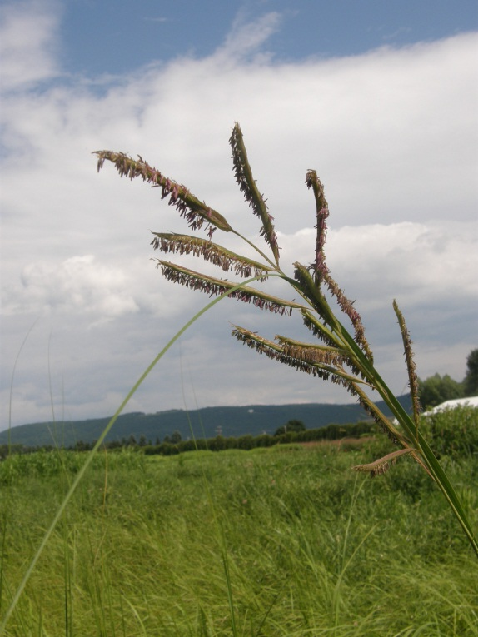

Photograph of prairie cordgrass inflorescence. Photo taken at the Big Flats Plant Materials Center in Big Flats New York, 2013

### Alternate Names

*Common Alternate Names: Ripgut, cordgrass, marsh grass, slough grass, fresh water cordgrass, broadleaf*

### Uses

The stiff stems, vigorous rhizomes and robust size of

this species are useful in stabilizing soil, dissipating wave energy and providing cover.

* wetland restoration and enhancement
* streambank stabilization
* windstrip barrier,
* filterstrip
* riparian buffer
* prairie landscaping
* wildlife habitat – nesting and cover
* forage - very early season only
* spillway and dam cover
* biofeedstock production

### Status

Please consult the PLANTS Web site and your State Department of Natural Resources for this plant’s current status (e.g., threatened or endangered species, state noxious status, and wetland indicator values).

### Weediness

This plant may become weedy or invasive in some regions or habitats and may displace desirable vegetation if not properly managed. Please consult with your local NRCS Field Office, Cooperative Extension Service office, state natural resource, or state agriculture department regarding its status and use. Weed information is also available from the PLANTS Web site at <http://plants.usda.gov/>. Please consult the Related Web Sites on the Plant Profile for this species for further information.

### Description

*General*: Prairie cordgrass is a warm-season

perennial grass. It is native to the tall grass prairies of most of the United States and Canada. It has an average height of 3 to 8 feet (Johnson and Larson). The leaf blades, 3 to 13 mm wide and up to 30 inches long, are coarse, very tough, and thick. The margins of the leaf are serrated and sharp. Stems are stiff. It is strongly rhizomatous with very tough, scaly rhizomes. Seedheads are composed of 10 to 20 spikes attached to the main stem. Each spike has up to 40 spikelets, all growing in two rows on the side of the spike away from the stem. The seeds are flat, paper-like with barbed awns that attach firmly to fur or fabric. There are approximately 183,000 seeds per pound.

**Distribution:**

Prairie cordgrass grows throughout the Northeast, Great Lakes, and Midwest States, as well as most other states throughout the country. For current distribution, please consult the Plant Profile page for this species on the PLANTS Web site.

**Habitat:**

Prairie cordgrass is found in wet meadows, sloughs, potholes, and drainage ways. It is associated with various species including sedges and rushes.

**Adaptation**

Prairie cordgrass has a broad climatic adaptation. It will grow in seasonally dry sites, tolerates alkaline conditions and high water tables but is intolerant of prolonged flooding. It will grow on a wide array of soil types.

### Establishment

**Vegetative propagation*:***

The strong rhizomes can be used for propagation. The ideal piece of vegetative material is a “J” hook piece of rhizomes with buds and 2 to 12 inches of dry stem. Other rhizome pieces can be used us there are roots and at least one bud. The stem length is not critical for growth, but, if attached, makes planting and handling easier.

*Vegetative Source:*

* Local sites such as a ditch or wet meadow
* Nursery propagation bed-Material is usually more uniform and plants tend to be larger and stronger making them easier to handle and improving survival

*Harvest Date:*

* Spring (early April-early June)
* Fall (dormant-October/November)-Rhizomes dug in the fall should be stored in controlled conditions of temperatures near freezing. Do not allow pieces to become dry or warm.

*Harvest Method:* Vegetative material can be dug by hand or with an undercutter, disk, or plow. Depth of digging will vary depending on site conditions. In older stands, the intertwined rhizomes are course, stiff, and have sharp buds. Material most easily processed is from younger growth found on the outside edge of an old stand or from newer plantings. Plants 2 to 3 years old would be the

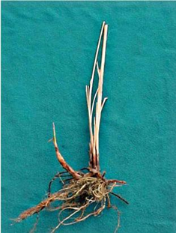

Rhizome (USDA NRCS Bismarck PMC)

easiest material to handle and process. Once rhizomes are dug, pieces should be cut as described above. It is important to keep processed rhizomes cool and moist until planting. Another method of establishment would be to scatter the rhizomes, cover, and firm the planting bed.

*Planting Method:* Rhizomes should be planted with the shoot upright. Roots and at least part of the shoot should be buried. The average planting depth is 3 to 6 inches. Rhizomes have been successfully planted using a tree planted and by hand planting. Air space around the planted rhizomes should be removed by packing.

*Plant Spacing:* This will vary depending on the purpose of the planting and site conditions. Recommended spacing between rows for seed increase fields and nursery beds, is 6 to 15 feet. Suggested spacing within rows is 3 to 6 feet. For streambanks, riparian areas, and other erosion control sites, spacing will also vary depending on slope, stabilization required, mulch, and available plants and resources. Generally, plants are spaced 2 to 10 feet apart and planted in off-set rows. Rhizomes planted along streambanks should be planted several feet beyond the water line. Prairie cordgrass is intolerant to frequent flooding. Ice jams and fluctuating water can wash out plants closer to the water line. Rhizomes planted higher up the slope will readily send shoots down the slope toward the water line.

**Seed Propagation:**

*Seeding Method:*

* Drill
* Broadcast

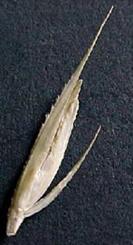

Seed head at harvest. Top glume

longer than lower glume

(USDA NRCS Bismarck PMC)

*Seeding rate:* Based on 183,000 seeds/lb, the following are general seeding rates. Actual rates will vary depending on site locations and purpose of planting. These recommendations are *guidelines* for establishment in the Northern Great Plains;

* 30 seeds/ft2 (7 lbs Pure Live Seed(PLS)/acre)
* ¼ to 1 pound PLS/acre in wet meadow mixes

*Seeding Depth:* ½ to ¾ inches

*Seeding Viability:* Viability of seed decreased when stored under high temperatures and humidity. In controlled storage, germination remains good for about 3 years. Current purity and germination tests (9 months of less) are needed for accurate seeding rates. Germination tests may be difficult to interpret, however, as there are no standardized testing procedures. Dormancy reported on seed tests should be considered in seed viability.

*Seed Flowability:* Debearded or deawned seed is more flowable, and seeding rate and placement is more accurate and consistant than for non-debearded (awned) seed.

*Seed Source:* Most seed of praire cordgrass is produced in the northern regions of North America. Insect predatin inhibits seed production in more southern climates.

Red River Germplasm is the only known release with seed commercially available. Performance consistency in released material is greater than for local ecotypes. Seed can be purchased from native plant nurseries and commercial seed growers or can be harvested from local populations. Seed can be hand stripped or combined in late fall. Seed fill is often poor in native harvests. Filled seeds have a kernel or embryo. Cut seeds crosswise to determine fill.

**Management**

Seedling vigor is only moderate, and seed often germinates throughout the course of the summer.

Seedlings develop slowly. Stands are established more quickly by planting vegetative material compared to seeding. Adequate water at planting time is critical for establishment of seed and vegetative material. Once the stand is established, watering is less critical. Due to the rhizomatous growth and size of the plants, weed competition is not usually a problem in established stands. The first few years of establishment by seed may require weed control if heavily infested. Prairie cordgrass has few management needs. Mowing of prairie cordgrass more than once per season can reduce vigor.

*Seed production fields*: Seed fields established from rhizomes will produce some seed the first year. Seed fields established from seed usually takes 2 to 3 years before producing a seed crop. Seed can be combined after the first frost in northern regions and shattering is generally not a problem. Seed yields at the Bismarck, North Dakota Plant Materials Center have varied from 30 to 75 PLS lbs/acre with wide row spacing. Plantings used for seed production can become quite sodbound after 5 years and seed production inhibited. Rhizomes will need to be separated by some means, or a new field established.

### Pests and Potential Problems

### Pests do not appear to be a problem for vegetative material. Seed predation by insects is a problem in

### most areas except the extreme northern climates of the United States.

### Environmental Concerns

### This plant may become weedy or invasive in some

### regions or habitats and may displace desirable vegetation if not properly managed. Please consult with your local NRCS Field Office, Cooperative Extension Service office, or State natural resource or agriculture department regarding its status and use. Weed information is also available from the PLANTS database.

### Cultivars, Improved, and Selected Materials (and area of origin)

**Red River Germplasm** prairie cordgrass is a selection named and released by the Bismarck, North Dakota Plant Materials Center. It is a composite of plant materials from Grant County, Minnesota; Cass and Grand Forks Counties in North Dakota; and Day County in South Dakota. Select Class seed and vegetative material is available in the commercial market of this selection.

**Atkins Germplasm** prairie cordgrass is a selection named and released by the Manhattan, Kansas Plant Materials Center. Material for this release originated from Washington County, Nebraska. This is a Select Class vegetative release. There is no seed produced or available. Vegetative material is available for increase.

**Kingston Germplasm** prairie cordgrass is a selection named and released by the Big Flats Plant Materials Center, in Big Flats, New York. Material for this release originated from riaparian areas and coastal areas, in Maine, New Hampshire, and Massachusetts. This is a Select Class vegetative release. There is no seed produced or available, currently. Vegetative material is available for increase.

**Southampton Germplasm** prairie cordgrass is a selection named and released by the Cape May Plant Materials Center, in Cape May, New Jersey. Material for this release originated from 3 areas around the Mecox Bay area, New York, in eastern Long Island. This is a Select Class release. Seed and vegetative material is available by contacting the Cape May Plant Materials Center, in Cape May, New Jersey.

### References

Johnson, J.R. and G.E. Larson. 1999. *Grassland plants of South Dakota and the northern Great Plains.* South Dakota State University College of Agriculture and Biological Sciences. B566(rev.) Brookings, South Dakota.

Wynia, Richard. 2003. [personal communication]. USDA NRCS, Plant Materials Center, Manhattan, Kansas.

**Prepared By**:

*Nancy K. Jensen,* USDA NRCS Plant Materials Center, Bismarck, North Dakota.

Edited: 24may06jsp; 17Sept13 SEC

For more information about this and other plants, please contact your local NRCS field office or Conservation District at <http://www.nrcs.usda.gov/> and visit the PLANTS Web site at <http://plants.usda.gov/> or the Plant Materials Program Web site <http://plant-materials.nrcs.usda.gov>.

PLANTS is not responsible for the content or availability of other Web sites.

*The U.S. Department of Agriculture (USDA) prohibits discrimination in all its programs and activities on the basis of race, color, national origin, sex, religion, age, disability, political beliefs, sexual orientation, and marital or family status. (Not all prohibited bases apply to all programs.) Persons with disabilities who require alternative means for communication of progPraireram information (Braille, large print, audiotape, etc.) should contact USDA's TARGET Center at 202-720-2600 (voice and TDD).*

*To file a complaint of discrimination write USDA, Director, Office of Civil Rights, Room 326-W, Whitten Building, 14th and Independence Avenue, SW, Washington, DC 20250-9410 or call 202-720-5964 (voice or TDD). USDA is an equal opportunity provider and employer.*

*Read about Civil Rights at the Natural Resources Convervation Service.*