|  |
| --- |
| bald cypress |
| *Taxodium distichum* (L.) L.C. Rich. |
| Plant Symbol = TADI2 |

Contributed by: USDA NRCS National Plant Data Center

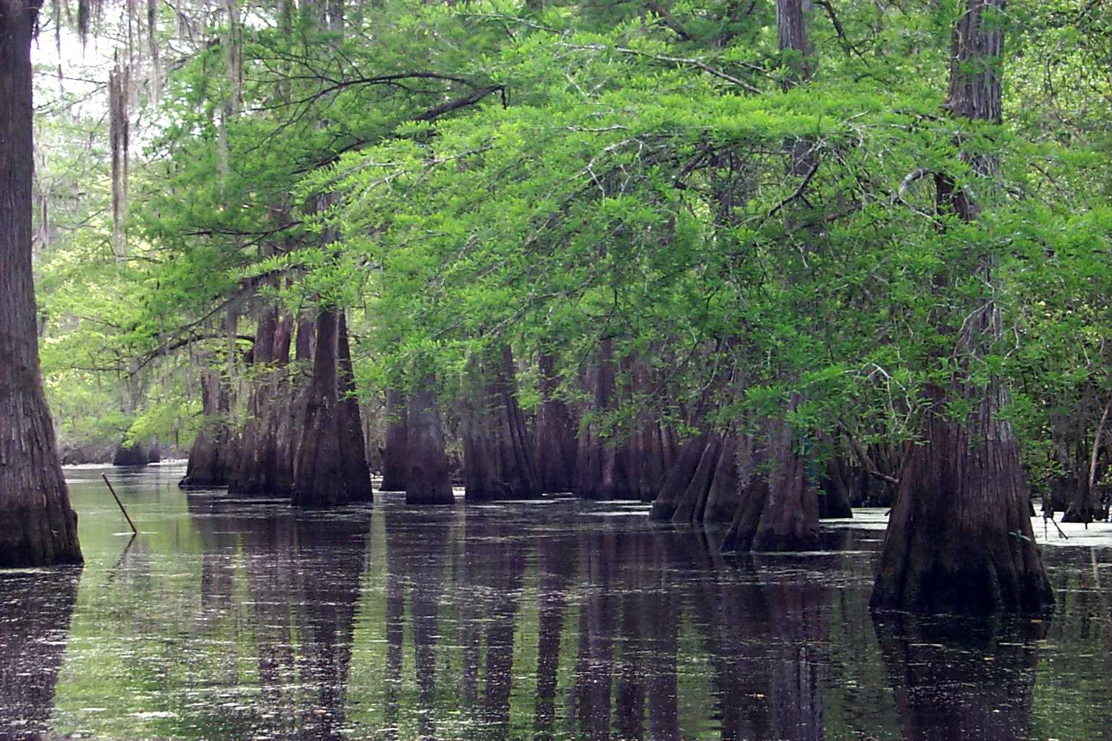

© J.S. Peterson

USDA, NRCS, NPDC

# Alternative Names

Southern-cypress, swamp-cypress, red-cypress, yellow-cypress, white-cypress, tidewater red-cypress, gulf-cypress

# Uses

*Erosion Control*: Riverine swamps of bald cypress reduce damage from floods and act as sediment and pollutant traps as they cause floodwaters to spread out, slow down, and infiltrate the soil.

*Timber*: Bald cypress wood is valuable for building construction, fence posts, planking in boats, river pilings, doors, blinds, flooring, shingles, garden boxes, caskets, interior trim and cabinetry.

*Wildlife*: Wild turkey, wood ducks, evening grosbeak, squirrels, waterfowl and wading birds eat Bald cypress seeds. Cypress domes provide unique watering places for a variety of birds and mammals and breeding sites for frogs, toads, salamanders and other reptiles. Yellow-throated warblers forage in the Spanish moss often found hanging on the branches. Its tops provide nesting sites for bald eagles, ospreys, herons and egrets.

*Site Rehabilitation*: It has potential for rehabilitating margins of surface-mined lakes. Cypress domes can serve as tertiary sewage treatment facilities for improving water quality and recharging groundwater.

*Beautification*: This species has been planted as a water tolerant tree species used for shading and canopy closure in mosquito control programs. It has been successfully planted throughout its range as an ornamental and along roadsides.

# Status

# Please consult the PLANTS Web site and your State Department of Natural Resources for this plant’s current status, such as, state noxious status, and wetland indicator values.

# Description

Cypress Family (Cupressaceae). Bald cypress is a large, slow-growing but long-lived, deciduous conifer, which frequently reaches 100 to 120 feet in height and 3 to 6 feet in diameter. Its trunk is massive, tapered, and buttressed. The leaves are alternate, linear, and flat with blades generally spreading around the twig. The bark is thin and fibrous with an interwoven pattern of narrow flat ridges and narrow furrows. It is monoecious with its male and female flowers forming slender tassle-like structures near the edge of the branchlets. It develops a taproot as well as horizontal roots that lie just below the surface and extend 20 to 50 feet before bending down. It develops knees that grow above water providing additional support.

# Distribution

Bald cypress is widely distributed along the Atlantic Coastal Plain from southern Delaware to southern Florida, westward along the lower Gulf Coast Plain to southeastern Texas. Inland, it grows along streams of the southeastern states and north in the Mississippi valley to southeastern Oklahoma, southeastern Missouri, southern Illinois, and southwestern Indiana.

# Adaptation

Bald cypress is generally restricted to very wet soils consisting of muck, clay, or fine sand where moisture is abundant and fairly permanent. It is usually found on flat or nearly flat topography at elevations less than 100 feet above sea level. Its thin bark offers little protection against fire and during years of drought when swamps are dry, fire kills great numbers of cypress.

# Establishment

Either seeds or sprouts can accomplish bald cypress stands. Seeds are produced annually and good seed production occurs about every three years. Seeds are dispersed more frequently by floodwaters. Under swamp conditions, the best seed germination generally takes place on a sphagnum moss or a wet-muck seedbed. On better-drained soils, seed usually fails to germinate due to lack of surface water. Soil saturated for 1 to 3 months after seedfall is required for germination. Seedlings require light for good growth, thus control of competing vegetation is necessary.

Bald cypress will produce vigorous sprouts from the stumps of both young and old trees, following disturbance.

# Management

The best management practice for regenerating this species is canopy thinning. Through thinning, competition is controlled and overhead light is provided for newly germinated seedlings. Nutria, a swamp rodent, often clips or uproots newly planted seedlings before the root systems are fully established, thus killing them. Control of nutria population is necessary. Severe fire after logging or drainage destroys seeds and roots in the soil, favoring willows and hardwoods to take over.

# Pests

Brown pocket rot known as “pecky cypress” which is caused by the *fungus Stereum taxodi* attacks the heartwood. The forest tent caterpillar (*Malacosma disstria*) and fruit-tree leafroller (*Archips argyrospila*) larvae web and feed on needles causing dieback and eventually death.

# Cultivars, Improved and Selected Materials (and area of origin)

Readily available from nurseries within its range. Contact your local Natural Resources Conservation Service (formerly Soil Conservation Service) office for more information. Look in the phone book under ”United States Government.” The Natural Resources Conservation Service will be listed under the subheading “Department of Agriculture.”

# Prepared By

#### *Lincoln M. Moore*

USDA, NRCS, National Plant Data Center, Baton Rouge, Louisiana

# Species Coordinator

*Lincoln M. Moore*

USDA, NRCS, National Plant Data Center, Baton Rouge, Louisiana

Edited: 10jan02 jsp; 060818 jsp

For more information about this and other plants, please contact your local NRCS field office or Conservation District, and visit the PLANTS Web site<<http://plants.usda.gov>> or the Plant Materials Program Web site <<http://Plant-Materials.nrcs.usda.gov>>

*The U.S. Department of Agriculture (USDA) prohibits discrimination in all its programs and activities on the basis of race, color, national origin, sex, religion, age, disability, political beliefs, sexual orientation, and marital or family status. (Not all prohibited bases apply to all programs.) Persons with disabilities who require alternative means for communication of program information (Braille, large print, audiotape, etc.) should contact USDA's* [*TARGET Center*](http://www.usda.gov/oo/target.htm) *at 202-720-2600 (voice and TDD).*

*To file a complaint of discrimination write USDA, Director, Office of Civil Rights, Room 326-W, Whitten Building, 14th and Independence Avenue, SW, Washington, DC 20250-9410 or call 202-720-5964 (voice or TDD). USDA is an equal opportunity provider and employer.*

*Read about* [*Civil Rights at the Natural Resources Convervation Service*](http://www.nrcs.usda.gov/about/civilrights/)*.*