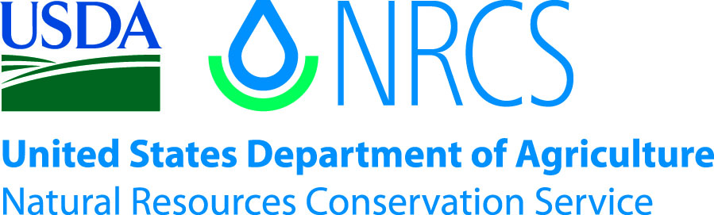

Plant Guide

# shortspine horsebrush

## Tetradymia spinosa Hook. & Arn.

Plant Symbol = TESP2

*Contributed by*: USDA NRCS Idaho Plant Materials Center

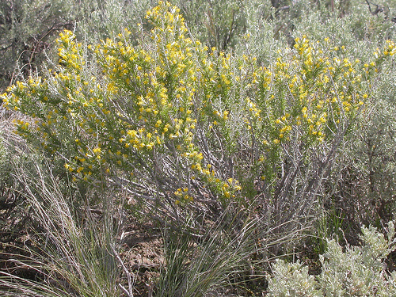

Shortspine horsebrush. Photo by Matt Lavin, Montana State University

### Alternate Names

*Common Alternate Names:* catclaw horsebrush, cottonthorn

### Uses

Shortspine horsebrush is seldom used by livestock or wildlife except in early spring when young shoots and buds may be consumed. Palatability is rated as poor (Howard, 2002). It provides some cover for small animals and helps stabilize soil on erodible desert sites that are sparsely vegetated. The species can be poisonous to domestic sheep. It is pollinated by moths, bees (including honey bees), flies, beetles, and other insects (Howard, 2002).

### Status

Please consult the PLANTS Web site and your State Department of Natural Resources for this plant’s current status (e.g., threatened or endangered species, state noxious status, and wetland indicator values).

**Ethnobotany**

The Western Shoshone Indians used shortspine horsebrush concoctions as external medicine and used the spines as piercing instruments (Howard, 2002).

### Description

*General*: Sunflower Family (Asteraceae). Shortspine horsebrush is a native, deciduous, taprooted, much-branched shrub 5-12 dm (19-47 in) tall and usually as wide as it is tall. Rhizomes extend from the parent plant to about 30 cm (12 in) and it sprouts from the root crown. Primary leaves form into spines 5-25 cm (1.97-9.84 in) long. Secondary leaves are green, glabrous, linear-filiform to spatulate, up to 1 cm (0.39 in) long. One or two bright yellow flowers occur in the axil of the spines. The flower heads have 4-6 bracts. Achenes are very densely pubescent with very long, erect, white hairs that usually conceal the scanty and fragile pappus. Chromosome number is 2n=60. There are 2 varieties recognized, var. *spinosa* and var. *longispina.*

The variety *spinosa* has recurved spines 0.5-1.5 cm (0.20-0.59 in) long and is more common while variety *longispina* has spines mostly 1.5-5 cm (0.59-1.97 in) long and are mostly straight and is found in the southwestern part of the species range (Cronquist et al., 1994; Flora of North America, online; Jepson Flora Project, online).

*Distribution*: Shortspine horsebrush occurs from Montana south to New Mexico and west to the Pacific coast with the exception of Arizona and Washington. For current distribution, please consult the Plant Profile page for this species on the PLANTS Web site.

*Habitat*: Shortspine horsebrush is common throughout the Great Basin and Mojave Desert but does not occur in pure stands. Isolated individuals or small colonies are usually found in saltbush (*Atriplex* spp.) scrub, low elevation sagebrush (*Artemisia* spp.) and pinyon-juniper (*Pinus-Juniperus* spp.) communities. Common associated species in the Great Basin are shadscale (*Atriplex confertifolia*), winterfat (*Krascheninnikovia lanata*) and broom snakeweed (*Gutierrezia sarothrae*). In Nevada and California it is commonly found in black greasewood (*Sarcobatus vermiculatus*) – shadscale communities. It also occurs in sagebrush, creosotebush (*Larrea tridentata*), singleleaf pinyon (*Pinus monophylla*) and Joshua tree (*Yucca brevifolia*) communities in California (Howard, 2002).

**Adaptation**

Shortspine horsebrush occurs on dry, plains, foothills and alkali sinks, often on harsh, bare ground with elevations ranging from 1,400 to 7,900 feet (426-2408 m). It grows on shallow to deep soils with clay and loam textures and pH 6.5-8.2. Average annual precipitation ranges from 8-14 inches (203-356 mm). Flowering occurs from April to June (Howard, 2002; PLANTS database).

### Establishment

Documented establishment of plants from seed is rare. Seedlings have been observed on a prescribed fire in Oregon (Howard, 2002). There is no information on shortspine horsebrush seed production, viability, and seedling establishment. Seed of *Tetradymia* spp. may be pre-chilled for 4-6 weeks to enhance germination (Young and Young, 1992).

### Management

Because shortspine horsebrush is usually scattered as individual plants or in small colonies and is seldom utilized by browsers, it has not caused large losses of sheep. However, all species of *Tetradymia* should be considered toxic*.* The most toxic species is *T. glabrata.* Sheep that feed on horsebrush species just following or in conjunction with consumption of black sagebrush (*Artemisia nova*) or big sagebrush (*A. tridentata*) and then are exposed to bright sunlight may develop a characteristic swelling of the lips, ears, and face, commonly referred to as “bighead”. Sheep grazing horsebrush in the absence of sagebrush may still die without developing bighead. They suffer from swollen, engorged liver with severe fatty changes and low grade nephritis (inflammation of nephrons) of the kidney along with hemorrhaging of the sub-skin and organ linings. Abortions may also occur (Burrows and Tyrl, 2001; Panter et al., 2011). Geographic distribution of the different species of *Tetradymia* generally corresponds to distribution of disease caused from plant consumption (Burrows and Tyrl, 2001).

Most sheep losses occur during stormy periods when sheep change their grazing habits as they are trailed through areas of horsebrush when desirable forage is lacking. Hungry/thirsty sheep may also eat toxic amounts of horsebrush after they are watered. The plant is especially dangerous during the bud stage (Panter et al., 2011). Poisoning has resulted in losses of as many as 1,000 sheep at a time (Burrows and Tyrl, 2001). The best management advice is to avoid these conditions or situations as much as possible.

### Pests and Potential Problems

There are no known pests of shortspine horsebrush.

### Environmental Concerns

Shortspine horsebrush is a native shrub found scattered or in small colonies. It can spread from seed and rhizomes from the root crown. Increased fire frequencies on sagebrush dominated rangelands caused by exclusion of wildfire resulting in invasion of annual grasses may also favor shortspine horsebrush and other sprouting shrubs over sagebrush (Howard, 2002).

### Control

There is no published information on the control of shortspine horsebrush. Please contact your local agricultural extension specialist or county weed specialist to learn what works best in your area and how to use it safely. Always read label and safety instructions for each control method. Trade names and control measures appear in this document only to provide specific information. USDA NRCS does not guarantee or warranty the products and control methods named, and other products may be equally effective.

### Seed and Plant Production

No information on the establishment of shortspine horsebrush was found.

### Cultivars, Improved, and Selected Materials (and area of origin)

There are no commercial releases of shortspine horsebrush. There are several commercial sources of seed and plants (California Native Plant Link, Online).

### References

Burrows, G., Tyrl, R. 2001. Toxic Plants of North America. Iowa State University Press, Ames, Iowa. 1342 p.

California Native Plant Link Exchange. Tetradymia spinosa. [Online]. http://www.cnplx.info/nplx (Accessed April 5, 2012)

Cronquist, A., Holmgren, A. Holmgren N., Reveal, J., Holmgren, P. Asterales. Intermountain Flora. Vascular Plants of the Intermountain West, U.S.A. Volume Five. The New York Botanical Garden, Bronx, New York. 496 p.

Flora of North America. Tetradymia spinosa. [Online] http://www.efloras.org/florataxon.aspx (Accessed April 5, 2012)

Howard, J. 2002. Tetradymia spinosa. In: Fire Effects Information System [Online]. U.S. Department of Agriculture, Forest Service, Rocky Mountain Research Station, Fire Sciences Laboratory. http:www.fs.fed.us/database/feis/plants/shrub/tetspi/all.html (Accessed April 4, 2012)

Jepson Flora Project. Tetradymia spinosa. [Online] http://ucjeps.berkeley.edu/cgi-bin/get (Accessed April 5, 2012)

Panter, K., Ralphs, M., Pfister, J., Gardner, D., Stegelmeier, B., Lee, S., Welch, K., Green, B., Davis, T., Cook, D. 2011. Plants Poisonous to Livestock in the Western States. United States Department of Agriculture, Agricultural Research Service. Agriculture Information Bulletin Number 415. 120 p.

PLANTS Database. *Tetradymia spinosa*. [Online]. http://plants.usda.gov. U.S. Department of Agriculture, Natural Resources Conservation Service. (Accessed April 4, 2012).

Young, J. and Young C. 1992. Seeds of Woody Plants in North America. Dioscorides Press, Portland, Oregon. 407 p.

**Prepared By**:

Loren St. John, USDA NRCS Plant Materials Center, Aberdeen, ID

Derek Tilley, USDA NRCS Plant Materials Center, Aberdeen, ID

### Citation

St. John, L. and D. Tilley. 2012. Plant Guide for shortspine horsebrush (*Tetradymia spinosa).* USDA-Natural Resources Conservation Service, Aberdeen Plant Materials Center. Aberdeen, Idaho 83210.

Published April 2012

Edited: 10Apr2012ls;11Apr2012djt;16Apr2012jab;24Apr2012gm

For more information about this and other plants, please contact your local NRCS field office or Conservation District at <http://www.nrcs.usda.gov/> and visit the PLANTS Web site at <http://plants.usda.gov/> or the Plant Materials Program Web site <http://plant-materials.nrcs.usda.gov>.

PLANTS is not responsible for the content or availability of other Web sites.

**USDA IS AN EQUAL OPPORTUNITY PROVIDER AND EMPLOYER**