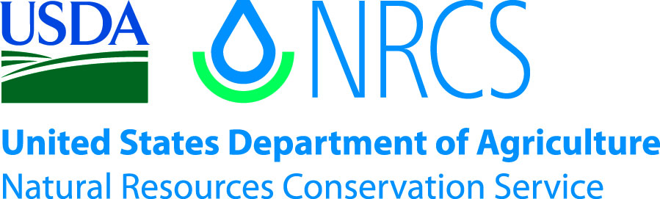

Plant Guide

# frisco clover

## Trifolium friscanum (S.L. Welsh) S.L. Welsh

Plant Symbol = TRFR4

*Contributed by*: USDA NRCS Idaho Plant Materials Program

### frisco clover

**Frisco clover. Daniela Roth, USDI Fish and Wildlife Service**

### Status

In 2007 the US Fish and Wildlife Service (FWS) was petitioned to list Frisco clover as either endangered or threatened. In 2011 FWS announced a determination that listing was warranted; however listing of Frisco clover was precluded by higher priority actions (USDI-FWS 2011). Please consult the PLANTS Web site and your State Department of Natural Resources for this plant’s current status (e.g., threatened or endangered species, state noxious status, and wetland indicator values).

### Description

*General*: Legume family (Fabaceae). Frisco clover is a caespitose, matforming forb with a branched woody taproot. Mature plants reach a height of 3 cm (in). The leaves have a short petiole, 0.3 to 1 cm (in) long. The leaves are divided into three oblanceolate to obovate leaflets with entire to toothed margins. Each leaflet is 3 to 8 mm (in) long and 1.5 to 3.4 mm (in) wide. The flower heads bear 4 to 9 red-purple to pinkish 8 to 9 mm (in) long flowers (Welsh et al. 2008). Flowering occurs from late May to June (USDI-FWS 2011).

*Distribution*: Frisco clover is endemic to the Great Basin. It is known from five populations containing nine sites in Beaver and Millard Counties, Utah. The five populations occur on the San Francisco Mountains, Beaver Lake Mountains, and Wah Wah Mountains in Beaver County, and on the Tunnel Springs Mountains in Millard County.

Population estimates vary widely. The mound-forming nature of the plants makes it difficult to make accurate plant estimates where each mound could be counted as one or several plants. Additionally, several of the known populations exist on privately owned lands where access is restricted. In 2011, FWS estimated the total number of plants at 13,000 with four of the nine sites containing 500 or fewer plants. For current distribution, please consult the Plant Profile page for this species on the PLANTS Web site.

*Habitat*: Frisco clover is found only on soils derived from volcanic gravels, Ordovician limestone, and dolomite outcrops. These rare soils are home to other rare plant species including Frisco buckwheat (*Eriogonum soredium*) and Ostler’s pepperweed (*Lepidium ostleri*). Frisco clover is found on sparsely populated slopes in pinion-juniper and sagebrush communities from 1,720 to 2,570 m (5,600 to 8,400 ft). Other associated species include Mormon tea (*Ephedra* sp.), snakeweed (*Gutierrezia sarothrae*), dwarf mountain mahogany (*Cercocarpus intricatus*), and rock goldenrod (*Petradoria pumila*) (USDI-FWS 2011).

**Adaptation**

Frisco clover is adapted to white limestone outcrops in areas receiving 200 to 300 mm (8 to 12 in) mean annual precipitation. Frisco clover populations cover a very small percentage of suitable habitat. It is unknown if there are other factors limiting Ostler’s pepperweed distribution (USDI FWS 2011).

### Establishment

There is no known seed establishment information for Frisco clover.

### Management

Much of the known habitat for Frisco clover occurs on private mining claims. There are no laws protecting endangered plant species on private, State or Tribal lands in Utah. However, mining operations must prepare State environmental impact assessments and address the potential effects on State and federally listed species for operations that create 5 acres or more surface disturbance.

### Pests and Potential Problems

The greatest threat to Frisco clover comes from mining operations in close proximity to Frisco clover populations. The area has historically been mined for precious metals, and is currently mined for gravel and crushed limestone. These operations are expected to increase in the future due to increased demand (USDI-FWS 2011).

### Environmental Concerns

There are a number of environmental factors which may affect Frisco clover. Prolonged drought due to climate change has the potential to eliminate the small populations of Frisco clover. Additionally, invasion of cheatgrass (*Bromus tectorum*) has the potential to greatly increase the fire return interval in the Great Basin (Whisenant 1990). Frisco clover is adapted to sparsely covered plant communities and is likely not adapted to frequent fires (USDI-FWS 2011.

### Seeds and Plant Production

There is no known plant propagation information for Frisco clover.

### References

USDI Fish and Wildlife Service. 2011. Endangered and threatened wildlife and plants; 12-month finding on a petition to list Astragalus hamiltonii, Penstemon flowersii, Eriogonum soredium, Lepidium ostleri, and Trifolium friscanum as endangered or threatened. Federal Register. 76 (36): 10166-10199.

Welsh, S.L., N.D. Atwood, S. Goodrich, and L.C. Higgins [eds]. 2008. A Utah flora, fourth edition, revised. Provo, Utah: Brigham Young University. 1019 pp.

Whisenant, S. G. 1990. Changing fire frequencies on Idaho's Snake River plains: ecological and  
management implications. In: Proceeding-Symposium on cheatgrass invasion, shrub die-off, and other aspects of shrub biology and management, (Eds., E. D. McArthur, E. M. Romney, S. D. Smith, and P. T. Tueller), USDA Forest Service Intermountain Research Station General Technical Report INT-276:4-10.

**Prepared By**:

Derek Tilley, USDA NRCS Plant Materials Center, Aberdeen, ID

**Citation**

Tilley, D. 2012. Plant Guide for Frisco clover (*Trifolium friscanum*). USDA-Natural Resources Conservation Service, Aberdeen, ID Plant Materials Center. 83210-0296.

Published November 2012

Edited: 16oct2012djt; 17oct2012ls; 01Nov2012jab

For more information about this and other plants, please contact your local NRCS field office or Conservation District at <http://www.nrcs.usda.gov/> and visit the PLANTS Web site at <http://plants.usda.gov/> or the Plant Materials Program Web site <http://plant-materials.nrcs.usda.gov>.

PLANTS is not responsible for the content or availability of other Web sites.

**USDA IS AN EQUAL OPPORTUNITY PROVIDER AND EMPLOYER**